互联网列表大全

[Google Chrome](http://www.techcn.com.cn/index.php?doc-innerlink-Google%20Chrome) (September 2008)

[Windows Server 2008](http://www.techcn.com.cn/index.php?doc-innerlink-Windows%20Server%202008)

[Google sky](http://www.techcn.com.cn/index.php?doc-innerlink-Google%20sky) (August 22, 2007)

[Wikiseek](http://www.techcn.com.cn/index.php?doc-innerlink-Wikiseek) (2007)

[WikiScanner](http://www.techcn.com.cn/index.php?doc-innerlink-WikiScanner) (August 14, 2007)

[Google Base](http://www.techcn.com.cn/index.php?doc-innerlink-Google%20Base) (2007)

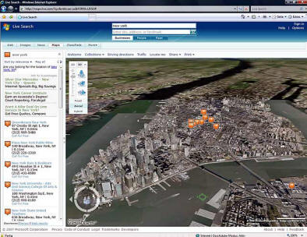

[Virtual Earth 3D](http://www.techcn.com.cn/index.php?doc-innerlink-Virtual%20Earth%203D) (April 2007)



[Google Docs & Spreadsheets](http://www.techcn.com.cn/index.php?doc-innerlink-Google%20Docs%20&%20Spreadsheets) (February 2007)

[Identicons](http://www.techcn.com.cn/index.php?doc-innerlink-Identicons) (January 2007)

[Microsoft Expression Web Designer](http://www.techcn.com.cn/index.php?doc-innerlink-Microsoft%20Expression%20Web%20Designer) (December 2006)

[Google bought youtube](http://www.techcn.com.cn/index.php?doc-innerlink-Google%20bought%20youtube) (October 9, 2006)

[Google Page Creator](http://www.techcn.com.cn/index.php?doc-innerlink-Google%20Page%20Creator) (2006)

[Google Video](http://www.techcn.com.cn/index.php?doc-innerlink-Google%20Video) (2006)

[MS Virtual Earth](http://www.techcn.com.cn/index.php?doc-innerlink-MS%20Virtual%20Earth) (December 2005)

[Joomla!](http://www.techcn.com.cn/index.php?doc-innerlink-Joomla!) (September 2005)

[MS visual web developer 2005](http://www.techcn.com.cn/index.php?doc-innerlink-MS%20visual%20web%20developer%202005)

[Google SiteMaps](http://www.techcn.com.cn/index.php?doc-innerlink-Google%20SiteMaps) (June 2005)

[Google bombing](http://www.techcn.com.cn/index.php?doc-innerlink-Google%20bombing) (May 2005)

[Quaero](http://www.techcn.com.cn/index.php?doc-innerlink-Quaero) (2005) was announced

[Ajax](http://www.techcn.com.cn/index.php?doc-innerlink-Ajax) (February 2005)

[](http://www.youtube.com/)

[youtube](http://www.techcn.com.cn/index.php?doc-innerlink-youtube) (February 2005)

[Windows Live](http://www.techcn.com.cn/index.php?doc-innerlink-Windows%20Live) (2005)

[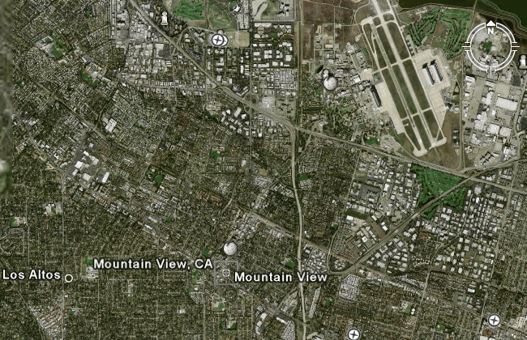](http://earth.google.com/)

[Google Earth](http://www.techcn.com.cn/index.php?doc-innerlink-Google%20Earth) (2005)

[One billion people have access to the internet](http://www.techcn.com.cn/index.php?doc-innerlink-One%20billion%20people%20have%20access%20to%20the%20internet) (2005)

[Digg](http://www.techcn.com.cn/index.php?doc-innerlink-Digg) (November 2004)

[http://www.techcn.com.cn/uploads/201001/1263793139cLvGGC04.gif](http://del.icio.us/post?url=http://arkadien.org/artsandscience.htm)

[Web 2.0](http://www.techcn.com.cn/index.php?doc-innerlink-Web%202.0) (2004)

[Ruby on Rails](http://www.techcn.com.cn/index.php?doc-innerlink-Ruby%20on%20Rails) (2004)

[Wikia](http://www.techcn.com.cn/index.php?doc-innerlink-Wikia) (2004)

[Google books](http://www.techcn.com.cn/index.php?doc-innerlink-Google%20books) (October 2004)

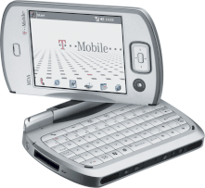

[smartphones](http://www.techcn.com.cn/index.php?doc-innerlink-smartphones) (2004) began to make up an increasingly large part of the mobile phone market

http://www.techcn.com.cn/uploads/201001/1263793139TPKfE8me.gif

[Wi-Fi](http://www.techcn.com.cn/index.php?doc-innerlink-Wi-Fi) (2004)



[the Opte Project](http://www.techcn.com.cn/index.php?doc-innerlink-the%20Opte%20Project) (October 2003)

[http://www.techcn.com.cn/uploads/201001/1263793139EdSKCUAE.jpg](http://e-ducation.net/sitemap.html)

[arkadien.org](http://www.techcn.com.cn/index.php?doc-innerlink-arkadien.org) (September 2003) was launched as a philosophy

 project by [Concordia university](http://www.techcn.com.cn/index.php?doc-innerlink-Concordia%20university) student Sebastian Bohnen

[RTCP](http://www.techcn.com.cn/index.php?doc-innerlink-RTCP) (2003)

[Flash mobs](http://www.techcn.com.cn/index.php?doc-innerlink-Flash%20mobs) (2003) organized over the Net, start in New York and quickly form in cities worlwide

[SWsoft](http://www.techcn.com.cn/index.php?doc-innerlink-SWsoft) (2003) acquired the control panel companies Plesk and Confixx

[social networking websites](http://www.techcn.com.cn/index.php?doc-innerlink-social%20networking%20websites)

[MySpace](http://www.techcn.com.cn/index.php?doc-innerlink-MySpace) (July 2003)

[WPA](http://www.techcn.com.cn/index.php?doc-innerlink-WPA) (2003)

[Podcasting](http://www.techcn.com.cn/index.php?doc-innerlink-Podcasting) (2003)

[One-click hosting](http://www.techcn.com.cn/index.php?doc-innerlink-One-click%20hosting)

[Voice over IP](http://www.techcn.com.cn/index.php?doc-innerlink-Voice%20over%20IP) (200?)

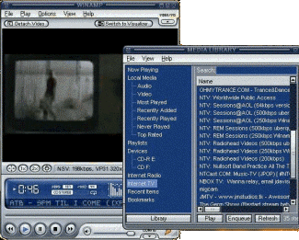

[Nullsoft Streaming Video](http://www.techcn.com.cn/index.php?doc-innerlink-Nullsoft%20Streaming%20Video) (2003)

[the Public Interest Registry](http://www.techcn.com.cn/index.php?doc-innerlink-the%20Public%20Interest%20Registry) (January 2003) took over as .org registry operator.

By giving up .org, VeriSign was able to retain control over .com domains

[gan](http://www.techcn.com.cn/index.php?doc-innerlink-gan) (2002)

[http://www.techcn.com.cn/uploads/201001/1263793139sCUZciR4.png](http://www.flickr.com/)

[Flickr](http://www.techcn.com.cn/index.php?doc-innerlink-Flickr) (2002)

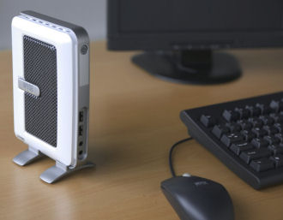

[thin clients](http://www.techcn.com.cn/index.php?doc-innerlink-thin%20clients)



[BitTorrent](http://www.techcn.com.cn/index.php?doc-innerlink-BitTorrent) (2002)

[ASP.NET websites](http://www.techcn.com.cn/index.php?doc-innerlink-ASP.NET%20websites) (2002)

[XAMPP](http://www.techcn.com.cn/index.php?doc-innerlink-XAMPP) (2002)

[Windows SharePoint Services](http://www.techcn.com.cn/index.php?doc-innerlink-Windows%20SharePoint%20Services) (2001)

[GéANT](http://www.techcn.com.cn/index.php?doc-innerlink-G%C3%A9ANT) (October 23, 2001) the pan-European Gigabit Research and Education Network, became

operational, replacing the TEN-155 network which was closed down on November 30, 2001

窗体顶端

|  |  |
| --- | --- |
| [Google](http://www.google.com/) | Enter your search terms Submit search form |
|  | |  |  | | --- | --- | | Search arkadien.org | Web | |

窗体底端

[the Google search engine](http://www.techcn.com.cn/index.php?doc-innerlink-the%20Google%20search%20engine) (2001) rose to prominence. Its success was based in part on

the concept of link popularity and [PageRank](http://www.techcn.com.cn/index.php?doc-innerlink-PageRank). Google, Inc. was established in 1998

300,000,000 computers on the Internet (2001)

[](http://www.wikipedia.org/)

[Wikipedia](http://www.techcn.com.cn/index.php?doc-innerlink-Wikipedia) (January 15, 2001) began as a complement to the expert-written Nupedia. It is

edited by volunteers in wiki fashion, meaning articles are subject to change by nearly anyone

[Network Solutions](http://www.techcn.com.cn/index.php?doc-innerlink-Network%20Solutions) (2000) was acquired by VeriSign, Inc. for $21 billion.

[Drupal](http://www.techcn.com.cn/index.php?doc-innerlink-Drupal) (2000)

[gwin](http://www.techcn.com.cn/index.php?doc-innerlink-gwin) (2000)

[SCTP](http://www.techcn.com.cn/index.php?doc-innerlink-SCTP) (2000)

[](http://www.opera.com/)

[Opera](http://www.techcn.com.cn/index.php?doc-innerlink-Opera) (2000) introduced tabbed browsing

[Plesk](http://www.techcn.com.cn/index.php?doc-innerlink-Plesk) (2000) released the first version of its hosting control panel

http://www.techcn.com.cn/uploads/201001/12637931399tqnkSWP.jpg

[rss](http://www.techcn.com.cn/index.php?doc-innerlink-rss) (2000) is a family of xml formats

[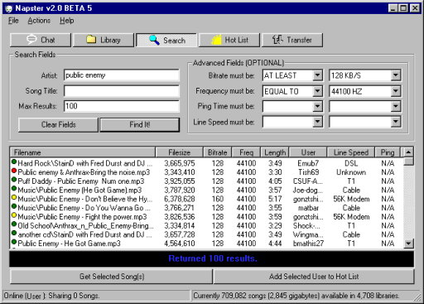](http://www.emule-project.net/home/perl/general.cgi?l=1)

[Napster](http://www.techcn.com.cn/index.php?doc-innerlink-Napster) (1999) was the first peer-to-peer file sharing

network. It was developed by Shawn Fanning

[Al](http://www.techcn.com.cn/index.php?doc-innerlink-Al)



[ADSL](http://www.techcn.com.cn/index.php?doc-innerlink-ADSL) (1999) was introduced in many countries with downstream rates

starting at 256 kbit/s and 8 Mbit/s as the current maximum transfer speed,

[MHTML](http://www.techcn.com.cn/index.php?doc-innerlink-MHTML) (1999)

[MetaFilter](http://www.techcn.com.cn/index.php?doc-innerlink-MetaFilter) (1999)

[SOAP](http://www.techcn.com.cn/index.php?doc-innerlink-SOAP) (1998)

[IPsec](http://www.techcn.com.cn/index.php?doc-innerlink-IPsec) (1998)

[PayPal](http://www.techcn.com.cn/index.php?doc-innerlink-PayPal) (December 1998)

[Domain-Tasting](http://www.techcn.com.cn/index.php?doc-innerlink-Domain-Tasting)

[](http://www.icann.org/)

[ICANN](http://www.techcn.com.cn/index.php?doc-innerlink-ICANN) (September 18, 1998) is the Internet Corporation for Assigned Names and Numbers

[Typo3](http://www.techcn.com.cn/index.php?doc-innerlink-Typo3) (1998)

AudioNet was renamed [Broadcast.com](http://www.techcn.com.cn/index.php?doc-innerlink-Broadcast.com) (1998)

[Hobbes' Internet Timeline](http://www.techcn.com.cn/index.php?doc-innerlink-Hobbes'%20Internet%20Timeline) was released as RFC 2235 & FYI 32 (1998)



[the dot-com frenzy](http://www.techcn.com.cn/index.php?doc-innerlink-the%20dot-com%20frenzy) (1998)

[the Internet Green and White Papers](http://www.techcn.com.cn/index.php?doc-innerlink-the%20Internet%20Green%20and%20White%20Papers) (February 20, 1998)

the [American Registry for Internet Numbers](http://www.techcn.com.cn/index.php?doc-innerlink-American%20Registry%20for%20Internet%20Numbers) was established to handle administration and (1997)

registration of IP numbers to the geographical areas currently handled by Network Solutions (InterNIC)

[Slashdot](http://www.techcn.com.cn/index.php?doc-innerlink-Slashdot) (September 1997)

[MPLS](http://www.techcn.com.cn/index.php?doc-innerlink-MPLS) (late 1990s)

[Internet2](http://www.techcn.com.cn/index.php?doc-innerlink-Internet2) (1997)

[xml](http://www.techcn.com.cn/index.php?doc-innerlink-xml) (1997)

[Macromedia Flash Player](http://www.techcn.com.cn/index.php?doc-innerlink-Macromedia%20Flash%20Player) (1997)

[servlets](http://www.techcn.com.cn/index.php?doc-innerlink-servlets) (1997)

[dhtml](http://www.techcn.com.cn/index.php?doc-innerlink-dhtml) (1990s)

[the Semantic Web](http://www.techcn.com.cn/index.php?doc-innerlink-the%20Semantic%20Web) (mid 1990s)

[the browser wars](http://www.techcn.com.cn/index.php?doc-innerlink-the%20browser%20wars) (mid 1990s)

[RTP](http://www.techcn.com.cn/index.php?doc-innerlink-RTP) (1996)

[SIP](http://www.techcn.com.cn/index.php?doc-innerlink-SIP) (1996)

[IPv6](http://www.techcn.com.cn/index.php?doc-innerlink-IPv6) (1996)

[Active Server Pages](http://www.techcn.com.cn/index.php?doc-innerlink-Active%20Server%20Pages) (1996)

http://www.techcn.com.cn/uploads/201001/1263793139qg881bH2.gif

[Java 1.0](http://www.techcn.com.cn/index.php?doc-innerlink-Java%201.0) (1996) was released after five years of development by James Gosling and colleagues

[http://www.techcn.com.cn/uploads/201001/1263793139Wkp5zH1i.gif](http://www.archive.org/web/web.php)

[the Internet Archive](http://www.techcn.com.cn/index.php?doc-innerlink-the%20Internet%20Archive) (1996)

[](http://www.alexa.com/)

[Alexa Internet](http://www.techcn.com.cn/index.php?doc-innerlink-Alexa%20Internet%20) (1996)

[http://www.techcn.com.cn/uploads/201001/1263793139vKOy6arM.gif](http://www.download.com/)

[cnet's download.com](http://www.techcn.com.cn/index.php?doc-innerlink-cnet's%20download.com) (1996)

[](http://www.webbyawards.com/)

[Webby Awards](http://www.techcn.com.cn/index.php?doc-innerlink-Webby%20Awards) (1996)

[server push](http://www.techcn.com.cn/index.php?doc-innerlink-server%20push)

[ICQ](http://www.techcn.com.cn/index.php?doc-innerlink-ICQ) (November 1996)

[](http://e-ducation.net/qandaservices.htm)

[Ask Jeeves](http://www.techcn.com.cn/index.php?doc-innerlink-Ask%20Jeeves) (1996)

[POP3](http://www.techcn.com.cn/index.php?doc-innerlink-POP3) (1996)

[Hotmail](http://www.techcn.com.cn/index.php?doc-innerlink-Hotmail) (July 4, 1996)

http://www.techcn.com.cn/uploads/201001/1263793139pNodSQs7.png

the Apache HTTP Server (April 1996) became the most popular server on the net

[Netcraft's Web Server Survey](http://www.techcn.com.cn/index.php?doc-innerlink-Netcraft's%20Web%20Server%20Survey)

21,000,000 computers on the Internet (1996)

[Stephen M. Cohen stole sex.com](http://www.techcn.com.cn/index.php?doc-innerlink-Stephen%20M.%20Cohen%20stole%20sex.com) (1995)

[AudioNet](http://www.techcn.com.cn/index.php?doc-innerlink-AudioNet) (1995)

[IPv6](http://www.techcn.com.cn/index.php?doc-innerlink-IPv6) (1995)

[ssh](http://www.techcn.com.cn/index.php?doc-innerlink-ssh) (1995)

[RealAudio](http://www.techcn.com.cn/index.php?doc-innerlink-RealAudio) (1995)

Network Solutions was acquired by Science Applications International Corporation (1995)

[Craigslist](http://www.techcn.com.cn/index.php?doc-innerlink-Craigslist) (1995)

[Chris Lamprecht](http://www.techcn.com.cn/index.php?doc-innerlink-Chris%20Lamprecht%20) (aka "Minor Threat") becomes the first person banned (1995)

from accessing the Internet by a US District Court judge in Texas

[MultiTorg Opera](http://www.techcn.com.cn/index.php?doc-innerlink-MultiTorg%20Opera) (1995)

[](http://www.macromedia.com/devnet/dreamweaver/?promoid=BIOH)

[FrontPage](http://www.techcn.com.cn/index.php?doc-innerlink-FrontPage) (1995) was initially created by the Cambridge, Massachusetts company

Vermeer Technologies Incorporated. Vermeer was acquired by Microsoft in 1996



[VeriSign](http://www.techcn.com.cn/index.php?doc-innerlink-VeriSign) (1995) is a company that operates a diverse array of network

infrastructure, including two of the Internet's thirteen root nameservers

[](http://www.ebay.com/)

[eBay](http://www.techcn.com.cn/index.php?doc-innerlink-eBay) (September 4, 1995) hosted its first auction

[Internet Explorer](http://www.techcn.com.cn/index.php?doc-innerlink-Internet%20Explorer) (August 1995)

[the NSFNET Backbone Service](http://www.techcn.com.cn/index.php?doc-innerlink-the%20NSFNET%20Backbone%20Service), operating since 1987, was successfully transitioned (April 30, 1995)

to a new architecture, where traffic is exchanged at interconnection points called Network access points

http://www.techcn.com.cn/uploads/201001/1263793139pILpLXn4.png

[PHP](http://www.techcn.com.cn/index.php?doc-innerlink-PHP) (June 8, 1995) is one of the most popular server-side scripting systems on the net



[Robots Exclusion Standard](http://www.techcn.com.cn/index.php?doc-innerlink-Robots%20Exclusion%20Standard) (1994)

[Astalavista.box.sk](http://www.techcn.com.cn/index.php?doc-innerlink-Astalavista.box.sk) (1994)

[SSL](http://www.techcn.com.cn/index.php?doc-innerlink-SSL) (1994)

[Search engine optimization](http://www.techcn.com.cn/index.php?doc-innerlink-Search%20engine%20optimization) (mid 1990s)

[webrings](http://www.techcn.com.cn/index.php?doc-innerlink-webrings) (1994)

[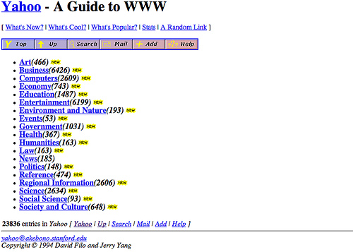](http://www.yahoo.com/)

[Jerry and David's Guide to the World Wide Web](http://www.techcn.com.cn/index.php?doc-innerlink-Jerry%20and%20David's%20Guide%20to%20the%20World%20Wide%20Web) (April 1994) founded in January 1994 was renamed [Yahoo!](http://www.techcn.com.cn/index.php?doc-innerlink-Yahoo!)

[chat rooms](http://www.techcn.com.cn/index.php?doc-innerlink-chat%20rooms) (19??)

[America Online](http://www.techcn.com.cn/index.php?doc-innerlink-America%20Online) (1994) announced that it had reached 1 million subscribers



[Justin Hall](http://www.techcn.com.cn/index.php?doc-innerlink-Justin%20Hall) (1994) who began eleven years of personal blogging while a student at Swarthmore College, is generally

recognized as one of the earliest bloggers. The term "weblog" was coined by Jorn Barger in December 1997

[http://www.techcn.com.cn/uploads/201001/1263793139I1gDKsOW.jpg](http://www.amazon.com/)

[Amazon.com](http://www.techcn.com.cn/index.php?doc-innerlink-Amazon.com) (1994) was one of the first major companies to sell goods over the Internet

[](http://www.w3.org/)

[the World Wide Web Consortium](http://www.techcn.com.cn/index.php?doc-innerlink-the%20World%20Wide%20Web%20Consortium) (1994) creates standards that Web developers should

try to conform to, in order to maximize the ability of others to access their Web sites

[Digital Storytelling](http://www.techcn.com.cn/index.php?doc-innerlink-Digital%20Storytelling)

[CGI](http://www.techcn.com.cn/index.php?doc-innerlink-CGI) (1993)

[http://www.techcn.com.cn/uploads/201001/1263793139bJvmeBV4.gif](http://www.cnet.com/)

[cnet](http://www.techcn.com.cn/index.php?doc-innerlink-cnet) (1993)

[dhcp](http://www.techcn.com.cn/index.php?doc-innerlink-dhcp) (October 1993)

the National Information Infrastructure: Agenda for Action (September 15, 1993) was published in the

United States the publication proposes a framework for the creation of a national “[Information Highway](http://www.techcn.com.cn/index.php?doc-innerlink-Information%20Highway)”

http://www.techcn.com.cn/uploads/201001/1263793139jk4ymu8s.gif

[the World Wide Web Wanderer](http://www.techcn.com.cn/index.php?doc-innerlink-the%20World%20Wide%20Web%20Wanderer) (June, 1993) was a perl based web crawler that was first deployed to

measure the size of the World Wide Web. The Software was developed at MIT by Matthew Gray. Later

in 1993, it was used to generate an index called the "Wandex", providing the first search engine on the web

[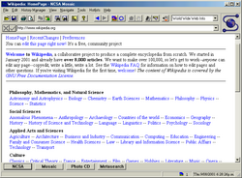](http://browser.netscape.com/ns8/)

[the Mosaic web browser](http://www.techcn.com.cn/index.php?doc-innerlink-the%20Mosaic%20web%20browser) (April 22, 1993) written at the National Center for Supercomputing Applications,

has been described as "the killer application of the 1990s" because it was the first program to provide a slick

multimedia graphical user interface to the Internet's burgeoning wealth of distributed information services (formerly

mostly limited to  FTP, Usenet and Gopher) at a time when access to the Internet was expanding rapidly outside

its previous domain of academia and large industrial research institutions. The company producing the software was

founded as Mosaic Communications Corporation on April 4, 1994 by Marc Andreessen and Jim Clark, and was

the first company to attempt to capitalize on the nascent World Wide Web. It released a web browser called

Mosaic Netscape 0.9 on October 13, 1994. This browser was subsequently renamed Netscape Navigator,

and the company took on the 'Netscape' name on November 14, 1994. In January 1998 Netscape open sourced

 its Web browser as the Mozilla Project. On November 24, 1998 America Online announced it would acquire

Netscape Communications in a tax-free stock-swap valued at US$4.2 billion at the time of the announcement

[](http://www.wired.com/)

[Wired magazine](http://www.techcn.com.cn/index.php?doc-innerlink-Wired%20magazine) (March 1993)

[InterNIC](http://www.techcn.com.cn/index.php?doc-innerlink-InterNIC) was created by the NSF to provide specific Internet services (1993)

[CGI](http://www.techcn.com.cn/index.php?doc-innerlink-CGI) (1993)

[Typosquatting](http://www.techcn.com.cn/index.php?doc-innerlink-Typosquatting)

[Cybersquatting](http://www.techcn.com.cn/index.php?doc-innerlink-Cybersquatting)

[Network Solutions, Inc.](http://www.techcn.com.cn/index.php?doc-innerlink-Network%20Solutions,%20Inc.) (1992) was granted an exclusive contract by the National Science

Foundation to be the sole Domain name registrar for .com, .net and .org Top Level Domain names

the Internet Hunt was started by [Rick Gates](http://www.techcn.com.cn/index.php?doc-innerlink-Rick%20Gates) (1992)

[the Whole Internet User's Guide & Catalog](http://www.techcn.com.cn/index.php?doc-innerlink-the%20Whole%20Internet%20User's%20Guide%20&%20Catalog) by Ed Krol (1992)

Zen and the Art of the Internet by [Brendan Kehoe](http://www.techcn.com.cn/index.php?doc-innerlink-Brendan%20Kehoe) (1992)

the term "surfing the net" (1992) was coined by [Jean Armour Polly](http://www.techcn.com.cn/index.php?doc-innerlink-Jean%20Armour%20Polly)

1 million computers online (1992)



the Internet Society (1992) is the parent corporation of the Internet

[Architecture Board](http://www.techcn.com.cn/index.php?doc-innerlink-Architecture%20Board) and [the Internet Engineering Task Force](http://www.techcn.com.cn/index.php?doc-innerlink-the%20Internet%20Engineering%20Task%20Force)

[web crawler](http://www.techcn.com.cn/index.php?doc-innerlink-web%20crawler)

[the Gopher protocol](http://www.techcn.com.cn/index.php?doc-innerlink-the%20Gopher%20protocol) (1991)

[mapi](http://www.techcn.com.cn/index.php?doc-innerlink-mapi%20) (1991)

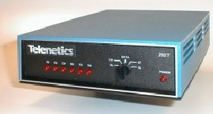

the SupraFax 14400 (1991) ran at the 14.4 kbit/s rate

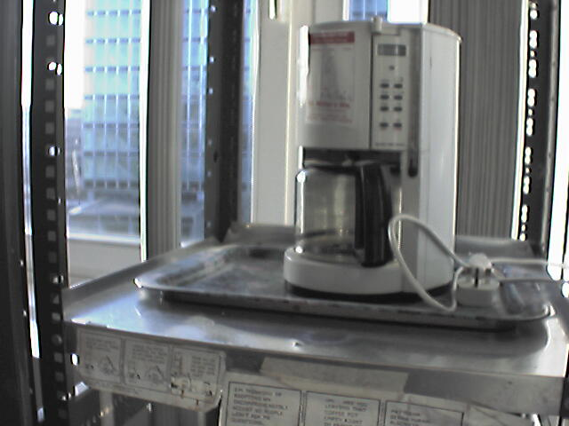

[the Trojan room coffee pot](http://www.techcn.com.cn/index.php?doc-innerlink-the%20Trojan%20room%20coffee%20pot) (1991) was the inspiration for the world's first webcam

[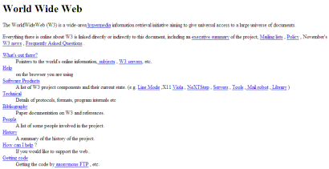](http://www.w3.org/History/19921103-hypertext/hypertext/WWW/TheProject.html)

[the first web page](http://www.techcn.com.cn/index.php?doc-innerlink-the%20first%20web%20page) (August 6, 1991)



[Pretty Good Privacy](http://www.techcn.com.cn/index.php?doc-innerlink-Pretty%20Good%20Privacy) (1991)

[phishing](http://www.techcn.com.cn/index.php?doc-innerlink-phishing) (1990s)

[the Archie search engine](http://www.techcn.com.cn/index.php?doc-innerlink-the%20Archie%20search%20engine) (1990)

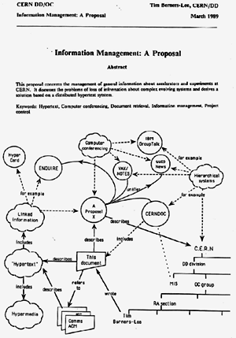

the [www](http://www.techcn.com.cn/index.php?doc-innerlink-www) (1990) as well as [http](http://www.techcn.com.cn/index.php?doc-innerlink-%20http), [html](http://www.techcn.com.cn/index.php?doc-innerlink-html) and [urls](http://www.techcn.com.cn/index.php?doc-innerlink-urls) were invented by Tim Berners-Lee at Cern

the first dial-up [internet service provider](http://www.techcn.com.cn/index.php?doc-innerlink-internet%20service%20provider) (1989) was world.std.com

100.000 computers online (1989)

[the Morris worm](http://www.techcn.com.cn/index.php?doc-innerlink-the%20Morris%20worm)(November 2, 1988)

[IRC](http://www.techcn.com.cn/index.php?doc-innerlink-IRC) (August 1988)

[e-mail clients](http://www.techcn.com.cn/index.php?doc-innerlink-e-mail%20clients) (1988)

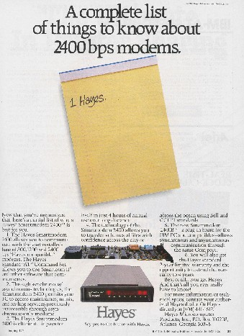

most dialup modems follow [the Hayes Command Set](http://www.techcn.com.cn/index.php?doc-innerlink-the%20Hayes%20Command%20Set) (1988) it was originally developed for the Hayes Smartmodem 2400

10.000 computers online (1987)

[Fred the Computer](http://www.techcn.com.cn/index.php?doc-innerlink-Fred%20the%20Computer) (1987)

[IMAP](http://www.techcn.com.cn/index.php?doc-innerlink-IMAP) (1986)

[WELL](http://www.techcn.com.cn/index.php?doc-innerlink-WELL) (1985)



[the File Transfer Protocol](http://www.techcn.com.cn/index.php?doc-innerlink-the%20File%20Transfer%20Protocol) (October 1985) was first developed in 1971 for

implementation on hosts at M.I.T. In 1985 ftp was defined by the RFC 959 documnet

[dfn](http://www.techcn.com.cn/index.php?doc-innerlink-dfn) (1984)

[LISTSERV](http://www.techcn.com.cn/index.php?doc-innerlink-LISTSERV) was the first electronic mailing list software application (1984)



[FidoNet](http://www.techcn.com.cn/index.php?doc-innerlink-FidoNet) (1984) was started by Tom Jennings of San Francisco, California as a means to

network together BBSes or mailboxes (like MausNet) that used his own "Fido" BBS software

[Whois](http://www.techcn.com.cn/index.php?doc-innerlink-Whois) (early 1980s)

[Symbolics.com](http://www.techcn.com.cn/index.php?doc-innerlink-Symbolics.com)

[the Domain Name System](http://www.techcn.com.cn/index.php?doc-innerlink-the%20Domain%20Name%20System) (1984) was introduced by Paul Mockapetris.

Symbolics.com became the first registered commercial domain name

[ping](http://www.techcn.com.cn/index.php?doc-innerlink-ping) (December, 1983)

[Kerberos](http://www.techcn.com.cn/index.php?doc-innerlink-Kerberos) (1983)

[Name server](http://www.techcn.com.cn/index.php?doc-innerlink-Name%20server) (1983)

[the Internet Activities Board](http://www.techcn.com.cn/index.php?doc-innerlink-the%20Internet%20Activities%20Board) (1983) replaced the [ICCB](http://www.techcn.com.cn/index.php?doc-innerlink-ICCB)

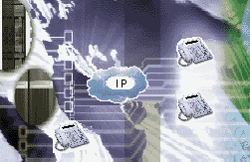

[the TCP/IP protocol](http://www.techcn.com.cn/index.php?doc-innerlink-the%20TCP/IP%20protocol)(January 1, 1983) began to be used for [ARPAnet](http://www.techcn.com.cn/index.php?doc-innerlink-ARPAnet) and the Defense Data Network

:-)

[emoticons](http://www.techcn.com.cn/index.php?doc-innerlink-emoticons) (1982)

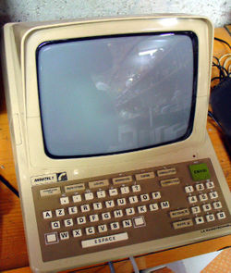

[Minitel](http://www.techcn.com.cn/index.php?doc-innerlink-Minitel) (1982)

[Bitnet](http://www.techcn.com.cn/index.php?doc-innerlink-Bitnet) (1981)

[Data Mining and Knowledge Discovery](http://www.techcn.com.cn/index.php?doc-innerlink-Data%20Mining%20and%20Knowledge%20Discovery) (1980s)

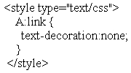

[Cascading Style Sheets](http://www.techcn.com.cn/index.php?doc-innerlink-Cascading%20Style%20Sheets) (1980)

http://www.techcn.com.cn/uploads/201001/12637931396oiEp0AU.jpg

[SGML](http://www.techcn.com.cn/index.php?doc-innerlink-SGML) (1980)



[Ethernet](http://www.techcn.com.cn/index.php?doc-innerlink-Ethernet) (1980)

Tim Berners-Lee (1980) wrote a hyperlinking program called

[Enquire](http://www.techcn.com.cn/index.php?doc-innerlink-Enquire) which eventually evolved into the World Wide Web

the first router was created at Stanford University (January 1980) by a staff researcher named [William Yeager](http://www.techcn.com.cn/index.php?doc-innerlink-William%20Yeager)

ARPA established [the Internet Configuration Control Board](http://www.techcn.com.cn/index.php?doc-innerlink-the%20Internet%20Configuration%20Control%20Board)(1979)

[delivermail](http://www.techcn.com.cn/index.php?doc-innerlink-delivermail) (1979)

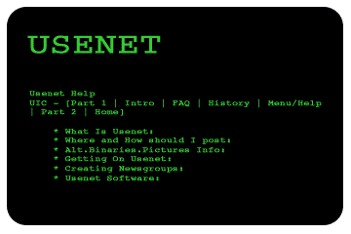

[Usenet](http://www.techcn.com.cn/index.php?doc-innerlink-Usenet) (1979)

[TCP](http://www.techcn.com.cn/index.php?doc-innerlink-TCP) split into TCP and [IP](http://www.techcn.com.cn/index.php?doc-innerlink-IP)  (March 1978)

[UUCP](http://www.techcn.com.cn/index.php?doc-innerlink-UUCP) (1978) stands for Unix to Unix Copy Protocol, and is a computer program and protocol allowing remote

execution of commands and transfer of files, email and netnews between Unix computers not connected to the Internet proper

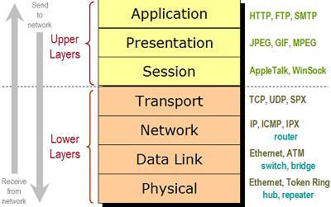

[the OSI model](http://www.techcn.com.cn/index.php?doc-innerlink-the%20OSI%20model) (1977)

[public key infrastructure](http://www.techcn.com.cn/index.php?doc-innerlink-public%20key%20infrastructure) (1976)

the name internet was coined (1974) by [Vint Cerf](http://www.techcn.com.cn/index.php?doc-innerlink-Vint%20Cerf%20) and

[Bob Kahn](http://www.techcn.com.cn/index.php?doc-innerlink-Bob%20Kahn) in a paper on Transmission Control Protocol

[BBN](http://www.techcn.com.cn/index.php?doc-innerlink-BBN) opened [Telenet](http://www.techcn.com.cn/index.php?doc-innerlink-Telenet), the first public packet data service (a commercial version of ARPANET) (1974)

RFC 527: [ARPAWOCKY](http://www.techcn.com.cn/index.php?doc-innerlink-ARPAWOCKY) (1973)

[Project Gutenberg](http://www.techcn.com.cn/index.php?doc-innerlink-Project%20Gutenberg) (1971)

ARPANET hosts started using [Network Control Protocol](http://www.techcn.com.cn/index.php?doc-innerlink-Network%20Control%20Protocol) (1970)

[Requests for Comments](http://www.techcn.com.cn/index.php?doc-innerlink-Requests%20for%20Comments) (1969)

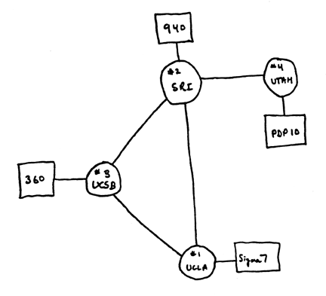

the 4-node [ARPAnet](http://www.techcn.com.cn/index.php?doc-innerlink-ARPAnet) (December 1969) [UCLA](http://www.techcn.com.cn/index.php?doc-innerlink-UCLA), Stanford Research Institute,

University of California Santa Barbara and University of Utah

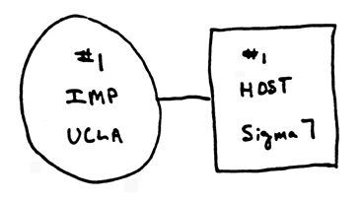

the ARPAnet (October 29, 1969)

[CICS](http://en.wikipedia.org/wiki/CICS) (1969)

[Compuserve](http://en.wikipedia.org/wiki/Compuserve) (1969) was founded as a company in the computer time-sharing industry

[x25](http://en.wikipedia.org/wiki/X.25) (late 1960s)

[J. C. R. Licklider's](http://en.wikipedia.org/wiki/Licklider) Libraries of the future (1965) hinted at the Internet and World Wide Web of the future

Paul Baran's paper on [packet-switching](http://en.wikipedia.org/wiki/Packet-switching) (1962)

the [Galactic Network](http://en.wikipedia.org/wiki/Galactic_Network) concept (1962)

[Project Xanadu](http://en.wikipedia.org/wiki/Project_Xanadu) (1960) was founded by Ted Nelson as the original hypertext project

the USSR launched Sputnik, the first artificial earth satellite. In response, the US formed the [Advanced Research Projects Agency](http://en.wikipedia.org/wiki/Advanced_Research_Projects_Agency) (1958)

within the Department of Defense (DoD) to establish US lead in science and technology applicable to the military



[Vannevar Bush's essay As We May Think](http://en.wikipedia.org/wiki/As_We_May_Think) (July 1945)

the World Brain by  H.G. Wells (1938)