计算机科学列表大全

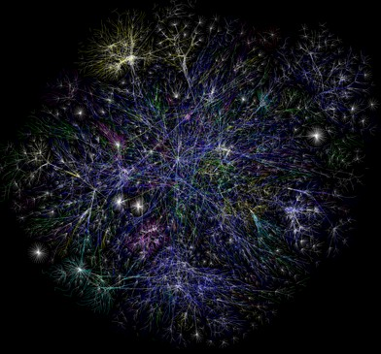

[webometrics](http://www.techcn.com.cn/index.php?doc-innerlink-webometrics) (2004)



[computational visualistics](http://www.techcn.com.cn/index.php?doc-innerlink-computational%20visualistics) (1996)

[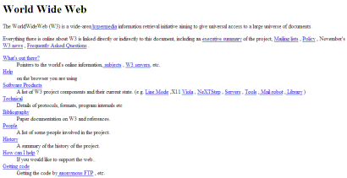](http://datapeak.net/internet.html)

[web design](http://www.techcn.com.cn/index.php?doc-innerlink-web%20design) (1991)

[medieninformatik](http://www.techcn.com.cn/index.php?doc-innerlink-medieninformatik) (1990)

[http://www.techcn.com.cn/uploads/201001/1263794125ofjslFjR.gif](http://www.ioi2008.org/)

[International Olympiad in Informatics](http://www.techcn.com.cn/index.php?doc-innerlink-International%20Olympiad%20in%20Informatics) (1989)

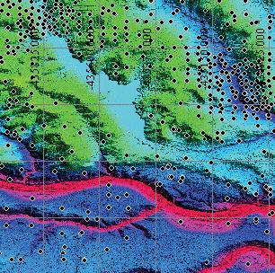

[visual analytics](http://www.techcn.com.cn/index.php?doc-innerlink-visual%20analytics) (1987)

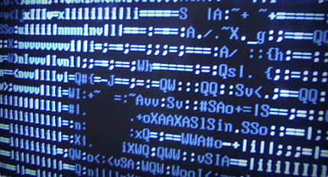

[data mining](http://www.techcn.com.cn/index.php?doc-innerlink-data%20mining) (1980s)



[human-computer interaction](http://www.techcn.com.cn/index.php?doc-innerlink-human-computer%20interaction) (1982)



[computer-aided software engineering](http://www.techcn.com.cn/index.php?doc-innerlink-computer-aided%20software%20engineering) (1982)

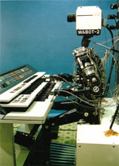

[computer vision](http://www.techcn.com.cn/index.php?doc-innerlink-computer%20vision) (late 1970s)

[information engineering](http://www.techcn.com.cn/index.php?doc-innerlink-information%20engineering) (1976)

http://www.techcn.com.cn/uploads/201001/1263794125u7WPMCbP.gif

[quantum computing theory](http://www.techcn.com.cn/index.php?doc-innerlink-quantum%20computing%20theory) (1970s)

[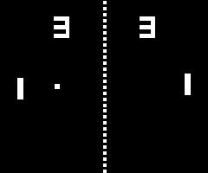](http://e-ducation.net/computergames.htm)

[game programming](http://www.techcn.com.cn/index.php?doc-innerlink-game%20programming) (1970s)

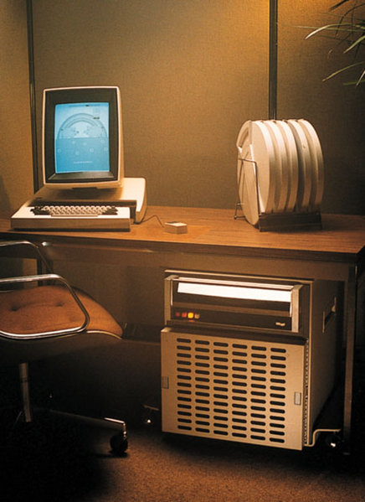

[it](http://www.techcn.com.cn/index.php?doc-innerlink-it) (1970s)

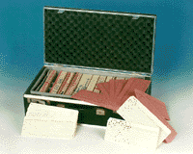

[business informatics](http://www.techcn.com.cn/index.php?doc-innerlink-business%20informatics) (1970s)

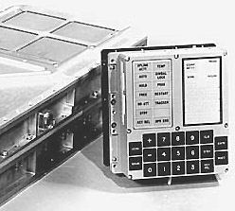

[computer engineering](http://www.techcn.com.cn/index.php?doc-innerlink-computer%20engineering) (1971)

http://www.techcn.com.cn/uploads/201001/1263794125S7OfLCFr.gif

[computer algebra systems](http://www.techcn.com.cn/index.php?doc-innerlink-computer%20algebra%20systems) (early 1970s)

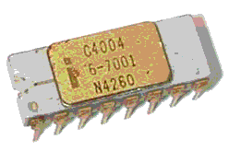

[microprocessor manufacturing and design](http://www.techcn.com.cn/index.php?doc-innerlink-microprocessor%20manufacturing%20and%20design) (early 1970s)

[mechatronics](http://www.techcn.com.cn/index.php?doc-innerlink-mechatronics) (1969)

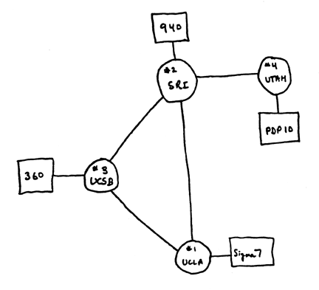

[network topology](http://www.techcn.com.cn/index.php?doc-innerlink-network%20topology) (1969)

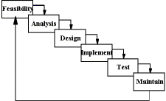

[software engineering](http://www.techcn.com.cn/index.php?doc-innerlink-software%20engineering) (1968)

[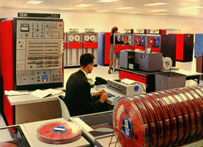](http://datapeak.net/operatingsystems.html)

[operating systems](http://www.techcn.com.cn/index.php?doc-innerlink-operating%20systems) (1964)

[the acm computing classification system](http://www.techcn.com.cn/index.php?doc-innerlink-the%20acm%20computing%20classification%20system) (1964)

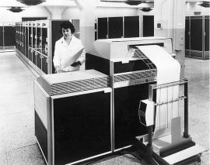

[networking](http://www.techcn.com.cn/index.php?doc-innerlink-networking) (early 1960s)

[](http://e-ducation.net/databases.htm)

[databases](http://www.techcn.com.cn/index.php?doc-innerlink-databases) (1963)



[computer science](http://www.techcn.com.cn/index.php?doc-innerlink-computer%20science) (1960s) began to be established as a distinct academic discipline

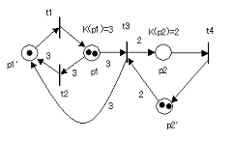

[formal methods](http://www.techcn.com.cn/index.php?doc-innerlink-formal%20methods) (1962)

[informatics](http://www.techcn.com.cn/index.php?doc-innerlink-informatics) (1962)

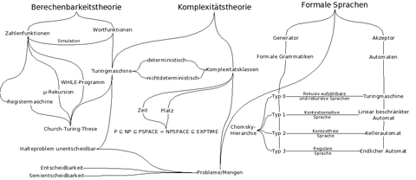

[computational complexity theory](http://www.techcn.com.cn/index.php?doc-innerlink-computational%20complexity%20theory) (1960)

[machine learning](http://www.techcn.com.cn/index.php?doc-innerlink-machine%20learning)

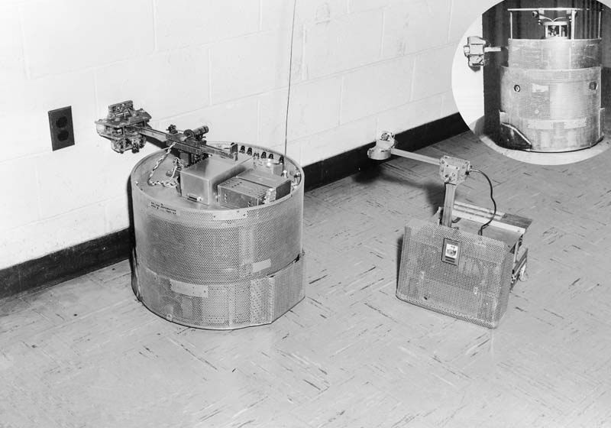

[artificial intelligence](http://www.techcn.com.cn/index.php?doc-innerlink-artificial%20intelligence) (late 1950s)

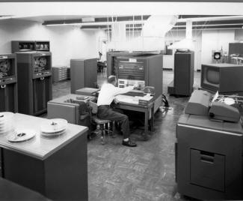

[computational linguistics](http://www.techcn.com.cn/index.php?doc-innerlink-computational%20linguistics) (1950s)

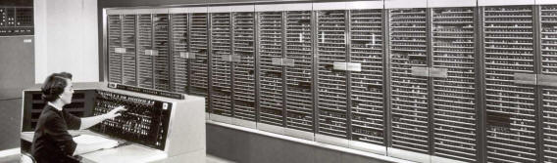

[scientific computing](http://www.techcn.com.cn/index.php?doc-innerlink-scientific%20computing) (1950s)

[systems analysis](http://www.techcn.com.cn/index.php?doc-innerlink-systems%20analysis)

[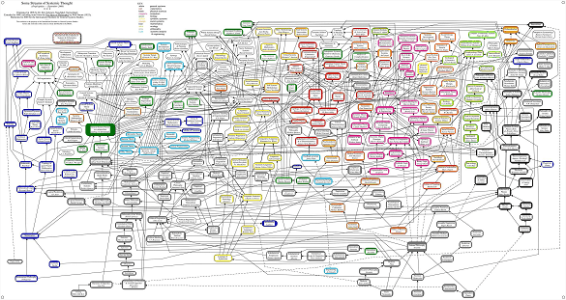](http://www.iigss.net/gPICT.jpg)

[systems theory](http://www.techcn.com.cn/index.php?doc-innerlink-systems%20theory) (1950s)

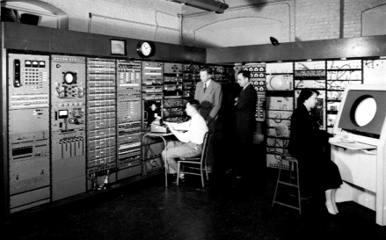

[computer graphics](http://www.techcn.com.cn/index.php?doc-innerlink-computer%20graphics) (1952)

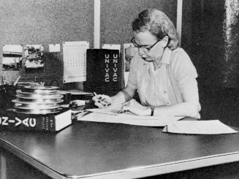

[compilers](http://www.techcn.com.cn/index.php?doc-innerlink-compilers) (1952)

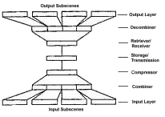

[coding theory](http://www.techcn.com.cn/index.php?doc-innerlink-coding%20theory) (1949)

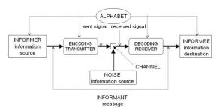

[information theory](http://www.techcn.com.cn/index.php?doc-innerlink-information%20theory) (1948)

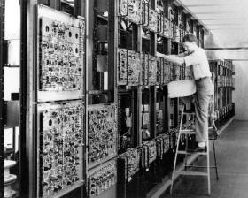

[microarchitecture](http://www.techcn.com.cn/index.php?doc-innerlink-microarchitecture) (1947)

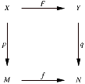

[category theory](http://www.techcn.com.cn/index.php?doc-innerlink-category%20theory) (1942)

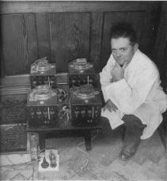

[cybernetics](http://www.techcn.com.cn/index.php?doc-innerlink-cybernetics) (1940s)

[automata theory](http://www.techcn.com.cn/index.php?doc-innerlink-automata%20theory)

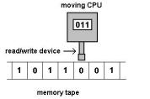

[computability theory](http://www.techcn.com.cn/index.php?doc-innerlink-computability%20theory) (1936)

λ x. x + 1

[programming language theory](http://www.techcn.com.cn/index.php?doc-innerlink-programming%20language%20theory) (1930s)

[theoretical computer science](http://www.techcn.com.cn/index.php?doc-innerlink-theoretical%20computer%20science)

[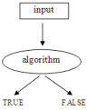](http://e-ducation.net/theoreticalcomputerscience.htm)

[theory of computation](http://www.techcn.com.cn/index.php?doc-innerlink-theory%20of%20computation) (1928)

[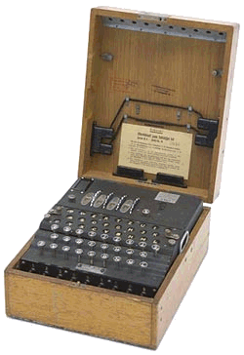](http://e-ducation.net/cryptology.htm)

[cryptoanalysis](http://www.techcn.com.cn/index.php?doc-innerlink-cryptoanalysis) (1914)

http://www.techcn.com.cn/uploads/201001/1263794125KuujZsww.gif

[type theory](http://www.techcn.com.cn/index.php?doc-innerlink-type%20theory) (1903)

[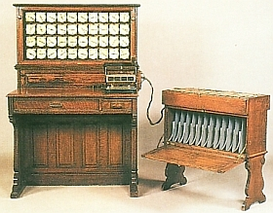](http://e-ducation.net/computer.htm)

[electronic data processing](http://www.techcn.com.cn/index.php?doc-innerlink-electronic%20data%20processing) (1890)

http://www.techcn.com.cn/uploads/201001/1263794125uo756A09.gif

[mathematical logic](http://www.techcn.com.cn/index.php?doc-innerlink-mathematical%20logic) (1887)

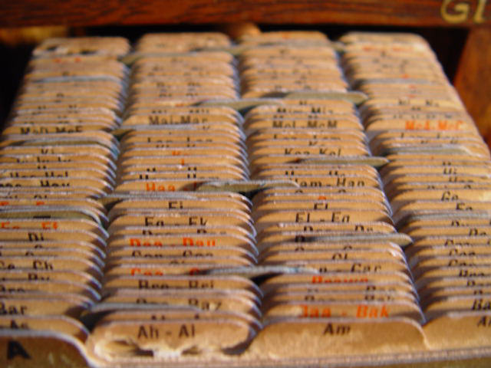

[data structures](http://www.techcn.com.cn/index.php?doc-innerlink-data%20structures)

[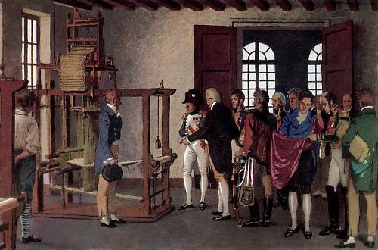](http://e-ducation.net/programminglanguages.htm)

[programming](http://www.techcn.com.cn/index.php?doc-innerlink-programming) (1801)

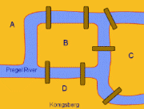

[graph theory](http://www.techcn.com.cn/index.php?doc-innerlink-graph%20theory) (1736)

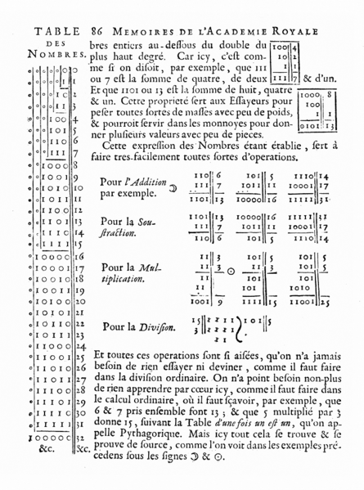

[binary arithmetic](http://www.techcn.com.cn/index.php?doc-innerlink-binary%20arithmetic) (1679)

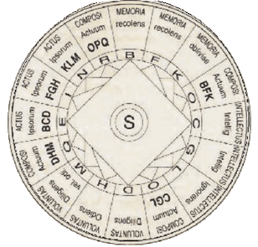

[information science](http://www.techcn.com.cn/index.php?doc-innerlink-information%20science) (1305)

[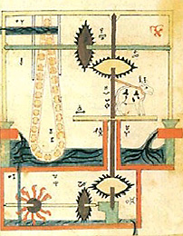](http://e-ducation.net/robotics.htm)

[robotics](http://www.techcn.com.cn/index.php?doc-innerlink-robotics) (1205)

[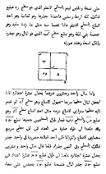](http://e-ducation.net/algorithms.htm)

[algorithms](http://www.techcn.com.cn/index.php?doc-innerlink-algorithms)

[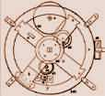](http://e-ducation.net/computer.htm)

[hardware development](http://www.techcn.com.cn/index.php?doc-innerlink-hardware%20development)

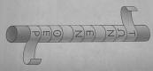

[cryptography](http://www.techcn.com.cn/index.php?doc-innerlink-cryptography)

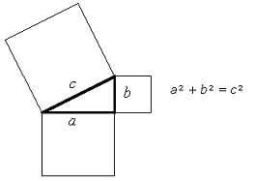

[number theory](http://www.techcn.com.cn/index.php?doc-innerlink-number%20theory) (1st millenium bc)

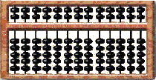

[computer architecture](http://www.techcn.com.cn/index.php?doc-innerlink-computer%20architecture)

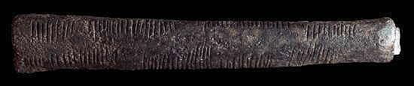

[computer science](http://www.techcn.com.cn/index.php?doc-innerlink-computer%20science)