Multi Protocol Audio Controller
(MPAC)
User Manual

Ver. 0.3

Rudolf Usselmann
rudi@asics.ws

Draft – Subject to change without notice !

Table of Contents
1. Introduction 6
2. Architecture 7
3. Protocols 8
3.1. I2S protocol 8
3.2. TDM Protocol 8
3.3. AC97 Protocol 9
4. Data Alignment and Packing 10
4.1. Data Alignment 10
4.1.1. Right Justified samples in a 32 bit frame (CFG.ALIGN = 0) 10
4.1.2. Left Justified samples in a 32 bit frame (CFG.ALIGN = 1) 10
4.2. Data Packing 11
4.2.1. Example 16 bit sample packing 11
4.2.2. Example 18 bit sample packing 11
4.2.3. Example 20 bit sample packing 12
4.2.4. Example 24 bit sample packing 12
5. Operation 13
5.1. Introduction 13
6. Core Registers 14
6.1. Register Address Map 14
6.2. Control and status register (CSR) 15
6.3. Version Register (VER) 15
6.4. Mute Register (MUTE) 16
6.5. Mute Value Register (MVAL) 16
6.6. Configuration Register (CFG) 16
6.7. In buffer status (IB_STAT) 17
6.8. Out buffer status (OB_STAT) 18
6.9. Buffer overflow/underflow (BF_OVUN) 19
6.10. Buffer overflow/underflow Interrupt Enable (BO_INT_EN) 20
6.11. Interrupt mask (INT_MASK) 20
6.12. Interrupt source (INT_SRC) 21
6.13. Timer Register (TIMER) 21
7. Core Parameters 22
7.1. NO_IN_CH 22
7.2. NO_IN_CH 22
7.3. MAX_FIFO_DEPTH 22
8. Core IOs 23
8.1. General System Inputs 23
8.2. AXI Interconnect Signals 23
8.2.1. AXI Lite Register File Interface 23
8.2.2. AXI Light Streaming Interface 24
8.3. I2S Interface 25
Appendix A: Sample Rates 26

Change Log

Revision | Modifications
0.1  March 5, 2018 | - Initial Draft
0.3  Marcg 17, 2018 | - Updated doc

License

Copyright 2018, ASICS World Services, LTD

Redistribution and use in source and binary forms, with or without modification, are permitted provided that the following conditions are met:
- Redistribution of source code must retain the above copyright notice, this list of conditions and the following disclaimer.
- Redistribution in binary form must reproduce the above copyright notice, this list of conditions and the following disclaimer in the documentation and/or other materials provided with the distribution.
- Neither the name of the copyright holder nor the names of its contributors may be used to endorse or promote products derived from this software without specific prior written permission.

THIS SOFTWARE IS PROVIDED BY THE COPYRIGHT HOLDERS AND CONTRIBUTORS "AS IS" AND ANY EXPRESS OR IMPLIED WARRANTIES, INCLUDING, BUT NOT LIMITED TO, THE IMPLIED WARRANTIES OF MERCHANTABILITY AND FITNESS FOR A PARTICULAR PURPOSE ARE DISCLAIMED. IN NO EVENT SHALL THE COPYRIGHT HOLDER OR CONTRIBUTORS BE LIABLE FOR ANY DIRECT, INDIRECT, INCIDENTAL, SPECIAL, EXEMPLARY, OR CONSEQUENTIAL DAMAGES (INCLUDING, BUT NOT LIMITED TO, PROCUREMENT OF SUBSTITUTE GOODS OR SERVICES; LOSS OF USE, DATA, OR PROFITS; OR BUSINESS INTERRUPTION) HOWEVER CAUSED AND ON ANY THEORY OF LIABILITY, WHETHER IN CONTRACT, STRICT LIABILITY, OR TORT (INCLUDING NEGLIGENCE OR OTHERWISE) ARISING IN ANY WAY OUT OF THE USE OF THIS SOFTWARE, EVEN IF ADVISED OF THE POSSIBILITY OF SUCH DAMAGE.

Introduction

This IP Core provide a standard interface to external codecs and other audio devices.
It allows a internal controller to stream one or multiple audio channel from or to the controller with minimal CPU intervention.

Some of the main features are:
- Multiple protocol support: I2S, TDM, AC97
- 16, 18, 20, 24 and 32 bit Sample Size Support
- up to 8 Output Channels
- up to 8 input Channels
- Configurable Internal buffers
- External DMA Engine Support
- AXI Light interface for registers
- AXI Streaming interface for data

Architecture

. . .
AXI
Stream I/F
FIFO N
AXI
Light I/F
Register
File
Data
Formatter
Protocol
Engine
Serializer/
Deserializer
FIFO 0
AXI
Stream
AXI
Light
I2S

Din
Dout
Bit Clk
WC/Sync

Protocols
The Audio Master Controller supports 3 main protocols: I2S, TDM and AC97.

I2S protocol
The I2S mode is equivalent the TDM mode, except only two channels are used.. Typically the channels are Right & Left. I2S support a variety of sample sizes: 16, 18, 20, 24 and 32 bit.

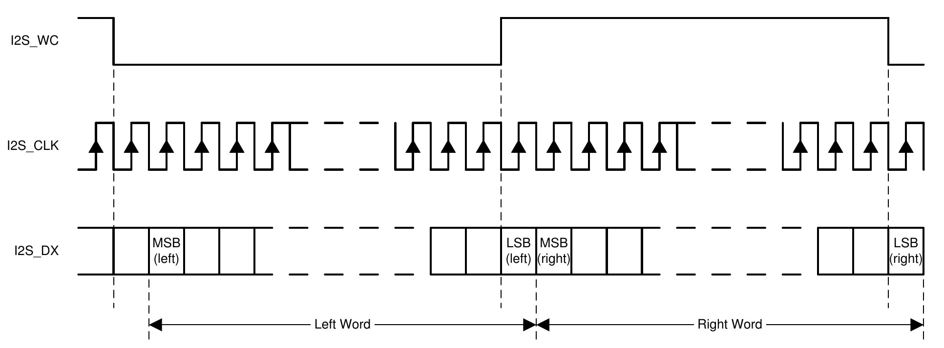

TDM Protocol
In the Time Division Mode (TDM), up to 16 input and output channels can be configured.

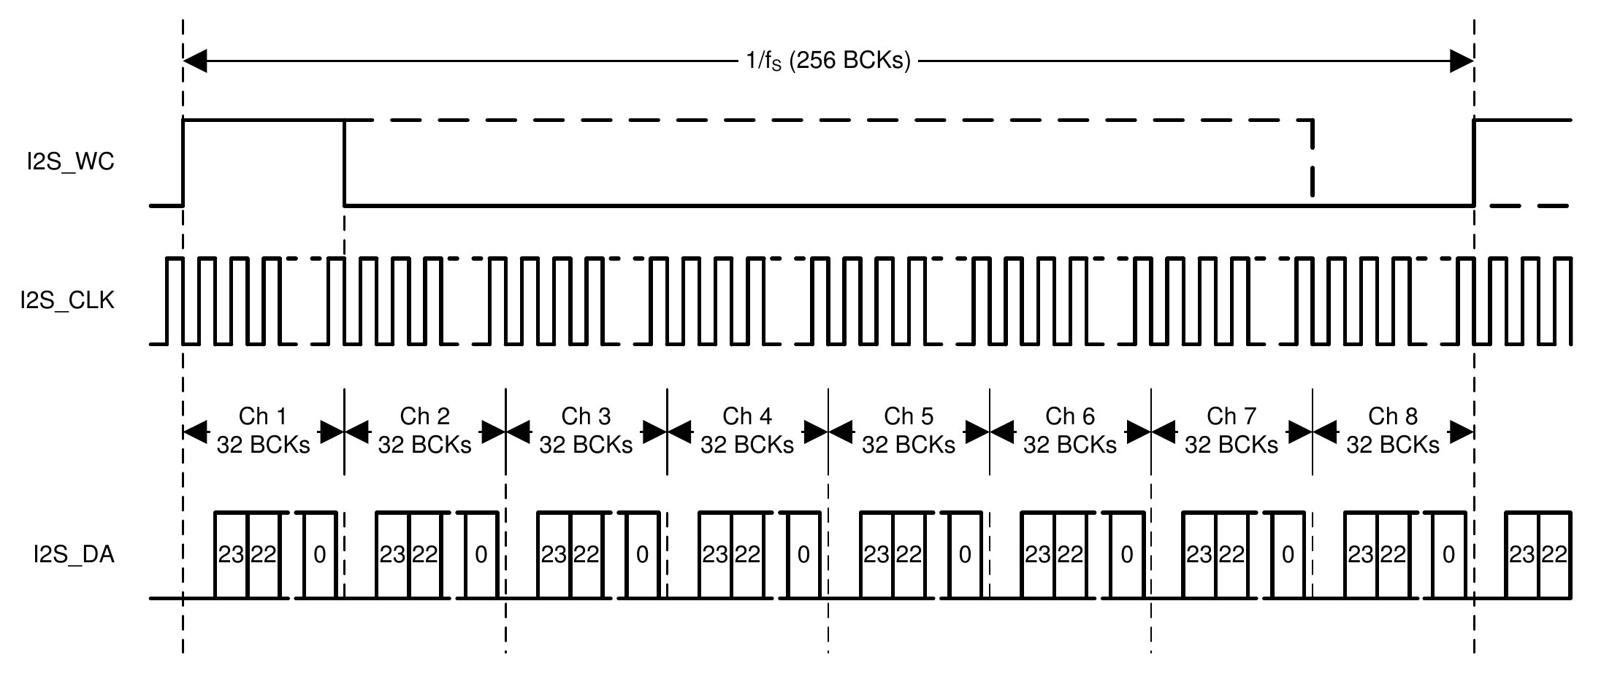

AC97 Protocol
In the AC97 mode, the standard AC97 channel layout and communication are supported.

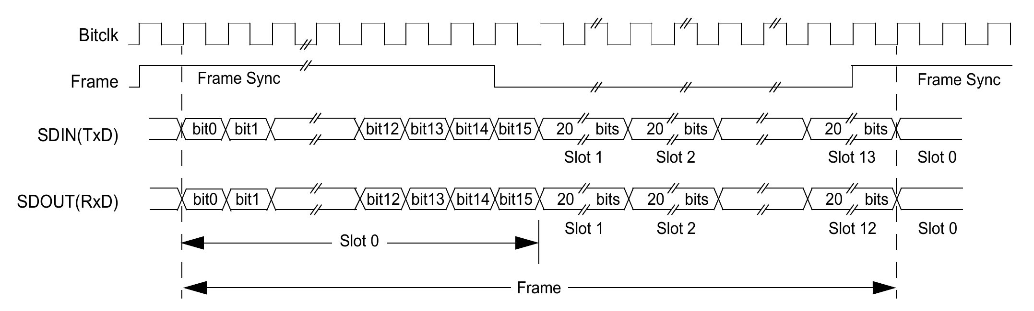

Data Alignment and Packing

Data Alignment
All internal data of the MPAC is right (lsb) aligned. If the system however uses left (msb) aligned data, the ALIGN bit can be sat to change the alignment of the streams between the MPAC and the system.

Right Justified samples in a 32 bit frame (CFG.ALIGN = 0)
31 | 30 | 29 | 28 | 27 | 26 | 25 | 24 | 23 | 22 | 21 | 20 | 19 | 18 | 17 | 16 | 15 | 14 | 13 | 12 | 11 | 10 | 09 | 08 | 07 | 06 | 05 | 04 | 03 | 02 | 01 | 00
UNUSED (all zeros) |  |  |  |  |  |  |  |  |  |  |  |  |  |  |  | 16 bit sample
UNUSED (all zeros) |  |  |  |  |  |  |  |  |  |  |  |  |  | 18 bit sample
UNUSED (all zeros) |  |  |  |  |  |  |  |  |  |  |  | 20 bit sample
UNUSED (all zeros) |  |  |  |  |  |  |  | 24 bit sample
32 bit sample

Left Justified samples in a 32 bit frame (CFG.ALIGN = 1)
31 | 30 | 29 | 28 | 27 | 26 | 25 | 24 | 23 | 22 | 21 | 20 | 19 | 18 | 17 | 16 | 15 | 14 | 13 | 12 | 11 | 10 | 09 | 08 | 07 | 06 | 05 | 04 | 03 | 02 | 01 | 00
16 bit sample |  |  |  |  |  |  |  |  |  |  |  |  |  |  |  | UNUSED (all zeros)
18 bit sample |  |  |  |  |  |  |  |  |  |  |  |  |  |  |  |  |  | UNUSED (all zeros)
20 bit sample |  |  |  |  |  |  |  |  |  |  |  |  |  |  |  |  |  |  |  | UNUSED (all zeros)
24 bit sample |  |  |  |  |  |  |  |  |  |  |  |  |  |  |  |  |  |  |  |  |  |  |  | UNUSED (all zeros)
32 bit sample

Data Packing
The data stream between the MPAC and SoC is 32 bits wide. It can however hold sample in different packed modes.

Example 16 bit sample packing
31 | 30 | 29 | 28 | 27 | 26 | 25 | 24 | 23 | 22 | 21 | 20 | 19 | 18 | 17 | 16 | 15 | 14 | 13 | 12 | 11 | 10 | 09 | 08 | 07 | 06 | 05 | 04 | 03 | 02 | 01 | 00
Sample 1 |  |  |  |  |  |  |  |  |  |  |  |  |  |  |  | Sample 0
Sample 3 |  |  |  |  |  |  |  |  |  |  |  |  |  |  |  | Sample 2
Sample 5 |  |  |  |  |  |  |  |  |  |  |  |  |  |  |  | Sample 4

Example 18 bit sample packing
31 | 30 | 29 | 28 | 27 | 26 | 25 | 24 | 23 | 22 | 21 | 20 | 19 | 18 | 17 | 16 | 15 | 14 | 13 | 12 | 11 | 10 | 09 | 08 | 07 | 06 | 05 | 04 | 03 | 02 | 01 | 00
S1 [13:0] |  |  |  |  |  |  |  |  |  |  |  |  |  | S0
S3 [9:0] |  |  |  |  |  |  |  |  |  | S2 |  |  |  |  |  |  |  |  |  |  |  |  |  |  |  |  |  | S1 [17:14]
S5 [5:0] |  |  |  |  |  | S4 |  |  |  |  |  |  |  |  |  |  |  |  |  |  |  |  |  | S3 [17:10]
S7 [1:0] |  | S6 |  |  |  |  |  |  |  |  |  |  |  |  |  |  |  |  |  | S5 [17:6]
S8 [15:0] |  |  |  |  |  |  |  |  |  |  |  |  |  |  |  | S7 [17:2]
S10 [11:0] |  |  |  |  |  |  |  |  |  |  |  | S9 |  |  |  |  |  |  |  |  |  |  |  |  |  |  |  |  |  | S8 [17:16]
S12 [7:0] |  |  |  |  |  |  |  | S11 |  |  |  |  |  |  |  |  |  |  |  |  |  |  |  |  |  | S10 [17:12]
S14 [3:0] |  |  |  | S13 |  |  |  |  |  |  |  |  |  |  |  |  |  |  |  |  |  | S12 [17:8]
S15 |  |  |  |  |  |  |  |  |  |  |  |  |  |  |  |  |  | S14 [17:4]

Example 20 bit sample packing
31 | 30 | 29 | 28 | 27 | 26 | 25 | 24 | 23 | 22 | 21 | 20 | 19 | 18 | 17 | 16 | 15 | 14 | 13 | 12 | 11 | 10 | 09 | 08 | 07 | 06 | 05 | 04 | 03 | 02 | 01 | 00
S1 [11:0] |  |  |  |  |  |  |  |  |  |  |  | S0
S3 [3:0] |  |  |  | S2 |  |  |  |  |  |  |  |  |  |  |  |  |  |  |  |  |  |  |  | S1 [19:12]
S4 [15:0] |  |  |  |  |  |  |  |  |  |  |  |  |  |  |  | S3 [19:4]
S6 [7:0] |  |  |  |  |  |  |  | S5 |  |  |  |  |  |  |  |  |  |  |  |  |  |  |  |  |  |  |  | S4 [19:16]
S7 |  |  |  |  |  |  |  |  |  |  |  |  |  |  |  |  |  |  |  | S6 [19:8]

Example 24 bit sample packing
31 | 30 | 29 | 28 | 27 | 26 | 25 | 24 | 23 | 22 | 21 | 20 | 19 | 18 | 17 | 16 | 15 | 14 | 13 | 12 | 11 | 10 | 09 | 08 | 07 | 06 | 05 | 04 | 03 | 02 | 01 | 00
S1 [7:0] |  |  |  |  |  |  |  | S0
S2 [15:0] |  |  |  |  |  |  |  |  |  |  |  |  |  |  |  | S1 [23:8]
S3 |  |  |  |  |  |  |  |  |  |  |  |  |  |  |  |  |  |  |  |  |  |  |  | S2 [23:16]

Operation

Introduction

Core Registers

Register Address Map
All RESERVED and unspecified/missing bits should always be written with zero. Reading RESERVED and unspecified/missing bits will return undefined values. Software should follow this model to be compatible to future releases of this core.
Address  Offset | Register Name | Description
0x00 | CSR | Control and status register
0x04 | VER | Version register
0x08 | MUTE | Mute register
0x0C | MVAL | Mute Value
0x10 | CFG | Configuration Register
0x14 |  | RESERVED
0x18 | IB_STAT | In buffer status
0x1c | OB_STAT | Out buffer status
0x20 | BF_OVUN | Buffer overflow/underflow
0x24 | BO_INT_EN | Buffer overflow/underflow interrupt enable
0x28 | INT_MASK | Interrupt mask register
0x2c | INT_SRC | Interrupt source register
0x30 |  | RESERVED
0x34 | TIMER | Timer register
0x38

Control and status register (CSR)
This register provides basic configuration and control.
Field | Bit(s) | Access | Description
SRST | 31 | WO | Soft Reset  Writing a '1' to this bits resets the IP Core
RESERVED | 30:16 | RO | RESERVED
OCH_CNT | 15:12 | RW | Number of output channels to use (less one)
ICH_CNT | 11:8 | RW | Number of input channels to use (less one)
RESERVED | 7:1 | RO | RESERVED
ENABLE | 0 | RW | Enable IP Core

Version Register (VER)
This register holds the hardware revision number as well as various hardware configuration options.
Field | Bit(s) | Access | Description
RESERVED | 31:25 | RO | RESERVED
HAVE_TIMER | 24 | RO | Indicated whether the timer module is present or not
HW_OCH | 23:20 | RO | Number of max output channels supported by hardware, less one
HW_ICH | 19:16 | RO | Number of max input channels supported by hardware, less one
HW_FD | 15:12 | RO | Buffer FIFOs depth (for each channel)
VER | 11:0 | RO | Hardware revision MAJ[11:8].MIN[7:0]

Mute Register (MUTE)
This register the muting of channels.
Field | Bit(s) | Access | Description
RESERVED | 31:24 | RO | RESERVED
IMUTE | 31:16 | RW | Mute bits for input channels 15-0  A '1' will force the Mute Value to be written to the corresponding input channel
OMUTE | 15:0 | RW | Mute bits for output channels 15-0  A '1' will force the Mute Value to be written to the corresponding output channel

Mute Value Register (MVAL)
This register the muting of channels.
Field | Bit(s) | Access | Description
MAVL | 31:0 | RW | Mute Value

Configuration Register (CFG)
This register configures various internal parameters.
Field | Bit(s) | Access | Description
RESERVED | 31:27 | RO | RESERVED
PROT_SEL | 26:24 | RW | Protocol Select  0 – I2S/TDM  1 – AC97  2-7 – Reserved
RESERVED | 31:24 | RO | RESERVED
SYS_SS | 20:18 | RW | System Sample size  0 – 16 bit  1 – 18 bit  2 – 20 bit  3 – 24 bit  4 – 32 bit  5-7 – Reserved
ALIGN | 17 | RW | Sample alignment  0 – Left (LSB)  1 – Right (MSB)
PACKED | 16 | RW | Samples are packed  0 – One Sample per DW  1 – Samples are packed
RESERVED | 15:11 | RO | RESERVED
SL_WI | 10:8 | RW | Output slot width  0 – 16 bit  1 – 18 bit  2 – 20 bit  3 – 24 bit  4 – 32 bit  5-7 – Reserved
RESERVED | 7:5 | RO | RESERVED
SYNC_STAR | 4:3 | RW | Sync start  0 – Aligned with first data bit  1 – One cycle before first data bit
SYNC_WIDTH | 2:1 | RW | Sync duration  0 – Active one cycle at the beginning  1 – 50% duty cycle  2 – One cycle in-active at the end  3 - Reserved
SYNC_INV | 0 | RW | Invert Sync  0 – Not inverted (high-low)  1 – Inverted (low-high)

In buffer status (IB_STAT)
This register provide the fill status of the input buffers. Unused/not implemented buffers should be ignored.
The status encoding is:
Value | Description
0 | 0-25% empty
1 | 25-50% empty
2 | 50-75% empty
3 | 75-100% empty
Field | Bit(s) | Access | Description
ICH15_STAT | 31:30 | RO | In channel 15 status
ICH14_STAT | 29:28 | RO | In channel 14 status
ICH13_STAT | 27:26 | RO | In channel 13 status
ICH12_STAT | 25:24 | RO | In channel 12 status
ICH11_STAT | 23:22 | RO | In channel 11 status
ICH10_STAT | 21:20 | RO | In channel 10 status
ICH9_STAT | 19:18 | RO | In channel 9 status
ICH8_STAT | 17:16 | RO | In channel 8 status
ICH7_STAT | 15:14 | RO | In channel 7 status
ICH6_STAT | 13:12 | RO | In channel 6 status
ICH5_STAT | 11:10 | RO | In channel 5 status
ICH4_STAT | 9:8 | RO | In channel 4 status
ICH3_STAT | 7:6 | RO | In channel 3 status
ICH2_STAT | 5:4 | RO | In channel 2 status
ICH1_STAT | 3:2 | RO | In channel 1 status
ICH0_STAT | 1:0 | RO | In channel 0 status

Out buffer status (OB_STAT)
This register provide the fill status of the output buffers. Unused/not implemented buffers should be ignored.
The status encoding is:
Value | Description
0 | 0-25% full
1 | 25-50% full
2 | 50-75% full
3 | 75-100% full
Field | Bit(s) | Access | Description
OCH15_STAT | 31:30 | RO | Out channel 15 status
OCH14_STAT | 29:28 | RO | Out channel 14 status
OCH13_STAT | 27:26 | RO | Out channel 13 status
OCH12_STAT | 25:24 | RO | Out channel 12 status
OCH11_STAT | 23:22 | RO | Out channel 11 status
OCH10_STAT | 21:20 | RO | Out channel 10 status
OCH9_STAT | 19:18 | RO | Out channel 9 status
OCH8_STAT | 17:16 | RO | Out channel 8 status
OCH7_STAT | 15:14 | RO | Out channel 7 status
OCH6_STAT | 13:12 | RO | Out channel 6 status
OCH5_STAT | 11:10 | RO | Out channel 5 status
OCH4_STAT | 9:8 | RO | Out channel 4 status
OCH3_STAT | 7:6 | RO | Out channel 3 status
OCH2_STAT | 5:4 | RO | Out channel 2 status
OCH1_STAT | 3:2 | RO | Out channel 1 status
OCH0_STAT | 1:0 | RO | Out channel 0 status

Buffer overflow/underflow (BF_OVUN)
This register contains buffer overflow/underflow conditions.
Field | Bit(s) | Access | Description
IN_OVFL | 31:16 | RW | Indicates a overflow condition on the in channels. This occurs when the FIFOs are full while we try to latch a new sample from the I2S bus.  Write a '1' to clear this condition.
OUT_UNFL | 15:0 | RW | Indicates a underflow condition on the in channels. This occurs when the FIFOs are empty while we try to latch a new sample to the I2S bus serializer.  Write a '1' to clear this condition.

Buffer overflow/underflow Interrupt Enable (BO_INT_EN)
This register contains buffer overflow/underflow interrupt enables.
Field | Bit(s) | Access | Description
IN_OVFL_IE | 31:16 | RW | Interrupt Enable for input channel overflow conditions. Each bit corresponds to a channel.
OUT_UNFL_IE | 15:0 | RW | Interrupt Enable for output channel underflow conditions. Each bit corresponds to a channel.

Interrupt mask (INT_MASK)
This register contains buffer overflow/underflow conditions.
Field | Bit(s) | Access | Description
RESERVED | 31:10 | RO | RESERVED
IN_OFL_INT | 9 | RO | In buffer overflow interrupt enable
OUT_UFL_INT | 8 | RO | Out buffer underflow interrupt enable
RESERVED | 7:1 | RO | RESERVED
TIMER_INT | 0 | RW | Timer Interrupt enable

Interrupt source (INT_SRC)
This register contains buffer overflow/underflow conditions.
Field | Bit(s) | Access | Description
RESERVED | 31:10 | RO | RESERVED
IN_OFL_INT | 9 | RO | In buffer overflow interrupt occurred
OUT_UFL_INT | 8 | RO | Out buffer underflow interrupt occurred
RESERVED | 7:1 | RO | RESERVED
TIMER_INT | 0 | RW | Timer Interrupt occurred

Timer Register (TIMER)
The Timer register provides a basic timer implementation. It allows for generation of .
Bit # | Access | Description
31:0 | R | Current Timer Value
31 | W | Enable Interrupt
29:28 | W | Pre-scalar  00 – Timer runs of System Clock (divided by 1)  01 – Timer runs of System Clock divided by 2  10 – Timer runs of System Clock divided by 4  11 – Timer runs of System Clock divided by 8
27:0 | W | Timer Interrupt Value

Core Parameters
When instantiating this IP Core, it is important to set the configuration parameters to appropriate values.

NO_IN_CH
This parameter specifies the maximum number of input channels the hardware can support. Actual number that is used is set in the configuration register. Valid values are 1-16.

NO_IN_CH
This parameter specifies the maximum number of output channels the hardware can support. Actual number that is used is set in the configuration register. Valid values are 1-16.

MAX_FIFO_DEPTH
This parameter specifies the maximum FIFO buffer depth (for each channel) as log2. The size specifies the number of DW entries in the buffer. Afor example, a value of 6, sets the FIFO depth to 64 (2^6) DW, or 256 bytes, There is no hardware limitation to the FIFO buffer size.
The FIFO buffer size should be chosen carefully, considering the highest audio sample rate and the frequency of interrupt to re-fill the buffers.

Core IOs
This IP Core offers the choice of native WISHBONE or native AXI Light SoC interfaces. The PHY and GPIO interfaces remain unchanged regardless of the SoC interface.
All signals are active high unless noted otherwise. The 'Dir' column illustrates the direction of the signals. 'I' indicates an input to the IP Core, 'O' indicates an output from the IP Core.

General System Inputs
Name | Width | Dir. | Description
clock_i | 1 | I | main core clock
reset_i | 1 | I | system reset

AXI Interconnect Signals
The AXI interface is compliant to the AXI Lite 4.0 Interface Specification. All AXI Interfaces run at the SoC clock (clock_i) and use SoC reset (reset_i).

AXI Lite Register File Interface
This interface is used to access the register file.
Name | Width | Dir. | Description
AXI Light Write Channel
axl_awaddr_i | 32 | I | Master Write address (byte address)
axl_awprot_i | 3 | I | Master Protection type
axl_awvalid_i | 1 | I | Master Write address valid
axl_awready_o | 1 | O | Slave Write address ready
axl_wdata_i | 32 | I | Master Write data
axl_wstrb_i | 4 | I | Master Write strobes
axl_wvalid_i | 1 | I | Master Write valid
axl_wready_o | 1 | O | Slave Write ready
axl_bresp_o | 2 | O | Slave Write response
axl_bvalid_o | 1 | O | Slave Write response valid
axl_bready_i | 1 | I | Master Response ready
AXI Light Read Channel
axl_araddr_i | 32 | I | Master Read address (byte address)
axl_arprot_i | 3 | I | Master Protection type
axl_arvalid_i | 1 | I | Master Read address valid
axl_arready_o | 1 | O | Slave Read address ready
axl_rdata_o | 32 | O | Slave Read data
axl_rresp_o | 2 | O | Slave Read response
axl_rvalid_o | 1 | O | Slave Read valid
axl_rready_i | 1 | I | Master Read ready

AXI Light Streaming Interface
This Interface is used for high speed data transfer, from and to the internal data FIFOs.
Name | Width | Dir. | Description
AXI Stream Transmit Data Channel
axs_tx_tid_i | 4 | I | Transmit data channel ID
axs_tx_tvalid_o | 1 | O | Transmit data channel valid
axs_tx_tready_i | 1 | I | Transmit data channel ready
axs_tx_tlast_o | 1 | O | Transmit data channel last word
axs_tx_tdata_o | 32 | O | Transmit data channel data
AXI Stream Receive Data Channel
axs_rx_tid_i | 4 | I | Receive data channel ID
axs_rx_tvalid_i | 1 | I | Receive data channel valid
axs_rx_tready_o | 1 | O | Receive data channel ready
axs_rx_tlast_i | 1 | I | Receive data channel last word
axs_rx_tdata_i | 32 | I | Receive data channel data

I2S Interface
This Interface is used for connection to an external Codec.
Name | Width | Dir. | Description
i2s_clk | 1 | I/O TBD | Bit Clock
i2s_wc | 1 | O | Word/Frame/LR/Sync Clock
i2s_di | 1 | I | Serial Data Input
i2s_do | 1 | O | Serial Data Output

Appendix A: Sample Rates
This table illustrates some of the possible sampling rates and associated timings.

