PanchVedi Dynamic Messaging Engine
Product Requirements Document (Version 1.1)
Adds architecture and flow for the rollout-ready conscious gameboard experience.

1. Objective
Design a dynamic, personalized in-game messaging system for the Snakes & Ladders experience using PanchVedi as the guide. The engine should combine player selections, board events, and broader moment-feel context to produce messages that feel reflective, fun, culturally rooted, and lightly witty without becoming offensive or overly deterministic.

2. Product Vision
Dimension | Intent
Hyper-personal play | Use player name, animal, color, DOB-derived traits, and box meaning to make each turn feel tailored.
Conscious gameboard | Turn each landing event into a tiny mirror of mood, choice, and environment.
Fun + reflection | Blend wisdom, curiosity, and gentle sarcasm so the experience stays playful.
Safe upliftment | Avoid harmful targeting or harsh judgment; reframe toward insight and encouragement.

3. Core Inputs

3.1 Player-specific inputs
- Name — used for direct, personal address in the popup message.
- Animal archetype — symbolic flavor layer such as Tiger, Owl, Elephant, Monkey, Turtle, or Peacock.
- Color choice — emotional tone layer such as Red (boldness), Blue (calm), Green (growth), Yellow (curiosity), Purple (transformation), or White (clarity).
- DOB — retained for future numerology or life-path enrichment; optional in rollout version.
- Optional mood toggle — manual or inferred mood tag for later versions.

3.2 Game-specific inputs
- Box number — numeric position where the player lands.
- Box property — semantic type of the square, such as Karma, Ego, Gratitude, Discipline, Wisdom, Temptation, Luck, Duality, Challenge, or Breakthrough.
- Event type — neutral / ladder / snake / bonus / penalty.

3.3 Context inputs
- Moment feel — broad contextual mood, not literal clock time.
- Environment / location tone — optional setting flavor such as festival, quiet day, crowded city, or calm evening.
- Social mood / trend signal — optional high-level world context for future versions.

4. Architecture Overview
The engine sits between the board event and the message popup. It receives player context, box context, and moment-feel context, applies dictionary lookups and tone guardrails, then sends the final line to the UI layer along with any PanchVedi reaction or tooltip state.
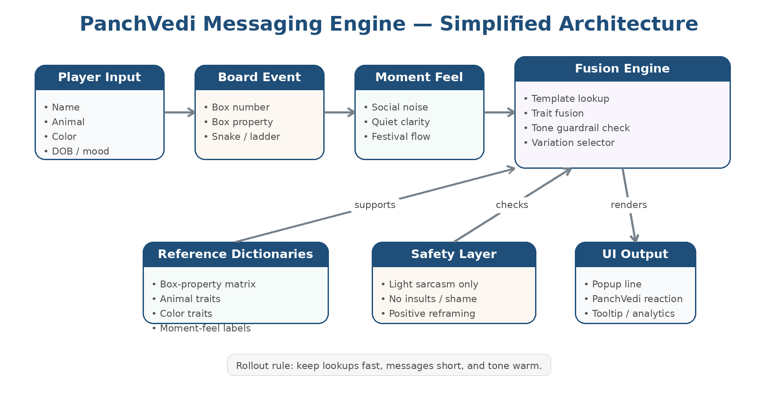
Figure 1. Simplified system architecture for the PanchVedi messaging engine.

5. Runtime Flow
At runtime, the system should generate a message only after the landing event is finalized. The first release should prefer fast lookups and simple fusion rules over complex inference so that gameplay remains responsive.
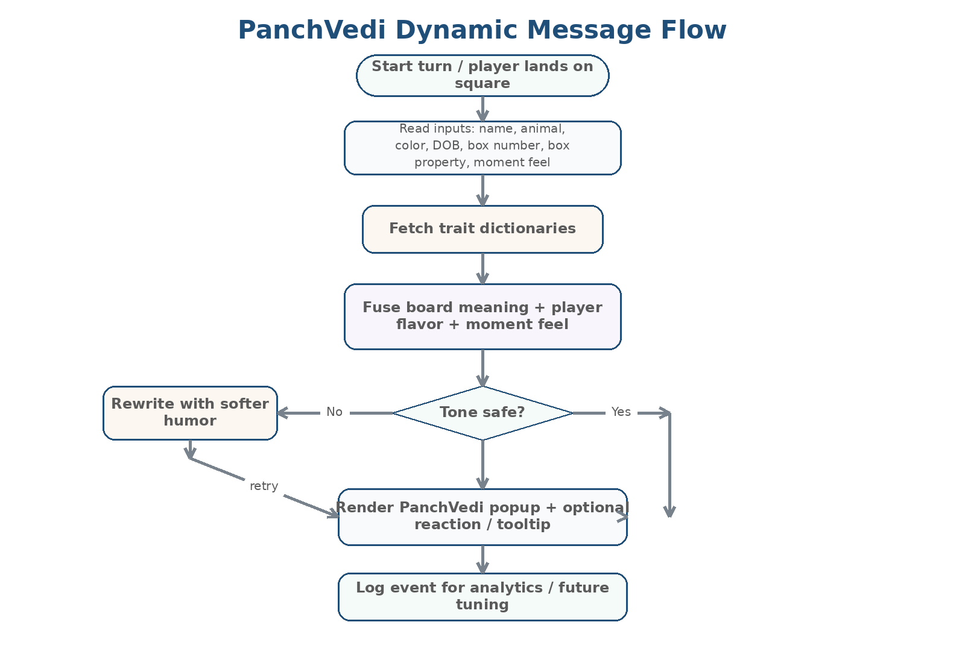
Figure 2. Message-generation flow from landing event to on-screen popup.

6. Box Property Matrix
Property | Positive Tone | Shadow | Message Direction
Karma | Balance | Consequence | Action meets echo.
Ego | Identity | Pride | Pause before performance.
Gratitude | Humility | Entitlement | Recognize what remains.
Discipline | Structure | Rigidity | Steady is sacred.
Wisdom | Awareness | Arrogance | Learn, then soften.
Temptation | Desire | Impulse | Want wisely.
Luck | Surprise | Dependence | Flow, do not chase.
Duality | Contrast | Conflict | Opposites are teachers.
Challenge | Growth | Fear | Rise or retreat?
Breakthrough | Realization | Shock | Something clicks.

7. Archetype Dictionary
Layer | Option | Usage hint
Animal | Tiger | Fierce energy; action and urgency.
Animal | Owl | Vision; quiet seeing and discernment.
Animal | Elephant | Grounded memory; patience and grace.
Animal | Monkey | Quick wit; playful instability.
Animal | Turtle | Slow resilience; depth and steadiness.
Animal | Peacock | Confidence; beauty and self-display.
Color | Red | Boldness; heat, passion, assertion.
Color | Blue | Calm; clarity and restraint.
Color | Green | Growth; openness and renewal.
Color | Yellow | Joy; curiosity and brightness.
Color | Purple | Mystery; transformation and self-discovery.
Color | White | Clarity; reset and renewal.

8. Moment-feel Labels
- Collective Exhaustion: Everyone feels a little worn out; softer, reassuring lines fit best.
- Social Noise: Debates, drama, or overstimulation dominate; messages should encourage pause.
- Quiet Clarity: Calm window for insight; quieter, cleaner messages work well.
- Inner Conflict: The player may feel torn; messages can validate tension without dramatizing it.
- Curious Uncertainty: Open-minded but slightly unsettled; good for reflective nudges.
- Festival Flow: Light, joyful, socially open energy; keep tone playful and bright.

9. Message Logic (Rollout Version)
- Step 1 — resolve box property from the square landed on.
- Step 2 — read the selected player layers (name, animal, color, optional DOB-derived trait).
- Step 3 — resolve moment feel from environment context or the app’s current mode.
- Step 4 — choose a message template by box property, then enrich it with animal/color flavor and the player name.
- Step 5 — pass the line through tone guardrails so it remains witty, warm, and non-harmful.
- Step 6 — send the final string to the popup component and optionally trigger a PanchVedi reaction.

10. Tone Guardrails
- Do use mild sarcasm when it feels playful and non-targeting.
- Do keep PanchVedi wise, calm, and lightly cheeky rather than harsh.
- Do prefer encouragement and reframing over criticism.
- Do not generate insulting, shaming, or sensitive-personalized claims.
- Do not overstate astrology, numerology, or environment data as fixed truth.
- Do keep messages short enough for a mobile popup and readable in one glance.

11. Sample Output
- “Ashmika, even a Tiger can roar too loud in the chaos. This Ego square is asking for a whisper, not a war cry.”
- “Temptation glitters, Ashmika. But the Peacock inside you already shines. Choose curiosity, not craving.”
- “Ashmika, the Owl sees beyond. In this quiet clarity, your Breakthrough arrives not with a bang, but with truth.”

12. Success Metrics
- Popup acceptance: players do not dismiss the message as irrelevant or repetitive.
- Session delight: messages increase curiosity and emotional attachment to PanchVedi.
- Replay value: variation is high enough that repeat players still find the system fresh.
- Safety: no offensive or unsettling messages are generated in common play paths.

13. Future Enhancements
- Lottie-based PanchVedi reactions tied to message tone.
- Deeper numerology / kundali enrichment with explicit opt-in.
- More nuanced moment-feel mapping using location, calendar, and festival context.
- A/B testing of message lengths, sarcasm intensity, and archetype weighting.
- Localized Hindi and bilingual runtime messaging packs.

