Git Version Control Experiment Report
Experiment Name | Git Version Control and GitHub Remote Repository | Student ID | _____20243007020_______
Name | ______Wang__Jiahao____

1. Experiment Objectives
(1) Master the basic installation and configuration of the Git version control tool.
(2) Understand the working principle of Git local version control and master the use of basic commands such as add, commit, and status.
(3) Master the creation and management of GitHub remote repositories.
(4) Master the association of local and remote repositories, code push (push), and version verification operations.
2. Experiment Environment
Operating System: Android Studio Built-in Terminal (Linux/Windows/macOS)
Version Control Tool: Git
Remote Repository Platform: GitHub (https://github.com)
Development Project: Android project created in Android Studio (Practical3_GitHub)
3. Experiment Steps
(1) Initialize Git Local Repository
In the Terminal of Android Studio, navigate to the project root directory and execute the following command to initialize the Git repository:
git init
After successful execution, a .git hidden folder will be generated in the project root directory, indicating that the Git repository has been created successfully.
(2) Configure Git User Information
Configure Git username and email (consistent with GitHub account):
git config --global user.name "Your GitHub Username"
git config --global user.email "Your GitHub Registered Email"
(3) Add Files and Commit
Add project files to the staging area and commit to the local repository:
git add .
git commit -m "Commit 001: Created initial UI with a text view \"Welcome Back\", two edit text views \"Username\" and \"Password\" and a button view \"Log IN\""
(4) Create GitHub Remote Repository
Log in to the GitHub website, click the "+" button in the upper right corner and select "New repository" to create a new remote repository:
Repository Name: 20243007020-VersionControlSystem
Access Permission: Public
Initialization Option: Do not check "Add a README file" (because code already exists locally)
(5) Associate Remote Repository
Associate the local repository with the GitHub remote repository:
git remote set-url origin https://github.com/www123-rgb/20243007020-VersionControlSystem.git
(6) Push Code to Remote Repository
Execute the following commands to push all branches and tags to the GitHub remote repository:
git push -u origin --all
git push -u origin --tags
(7) Verify Push Results
Open the GitHub repository page in a browser, check the file list and commit history to confirm that the code has been pushed successfully.
4. Experiment Results
(1) Terminal Execution Results
After executing the above commands in the Terminal in sequence, the terminal output is as follows (please replace with screenshot):
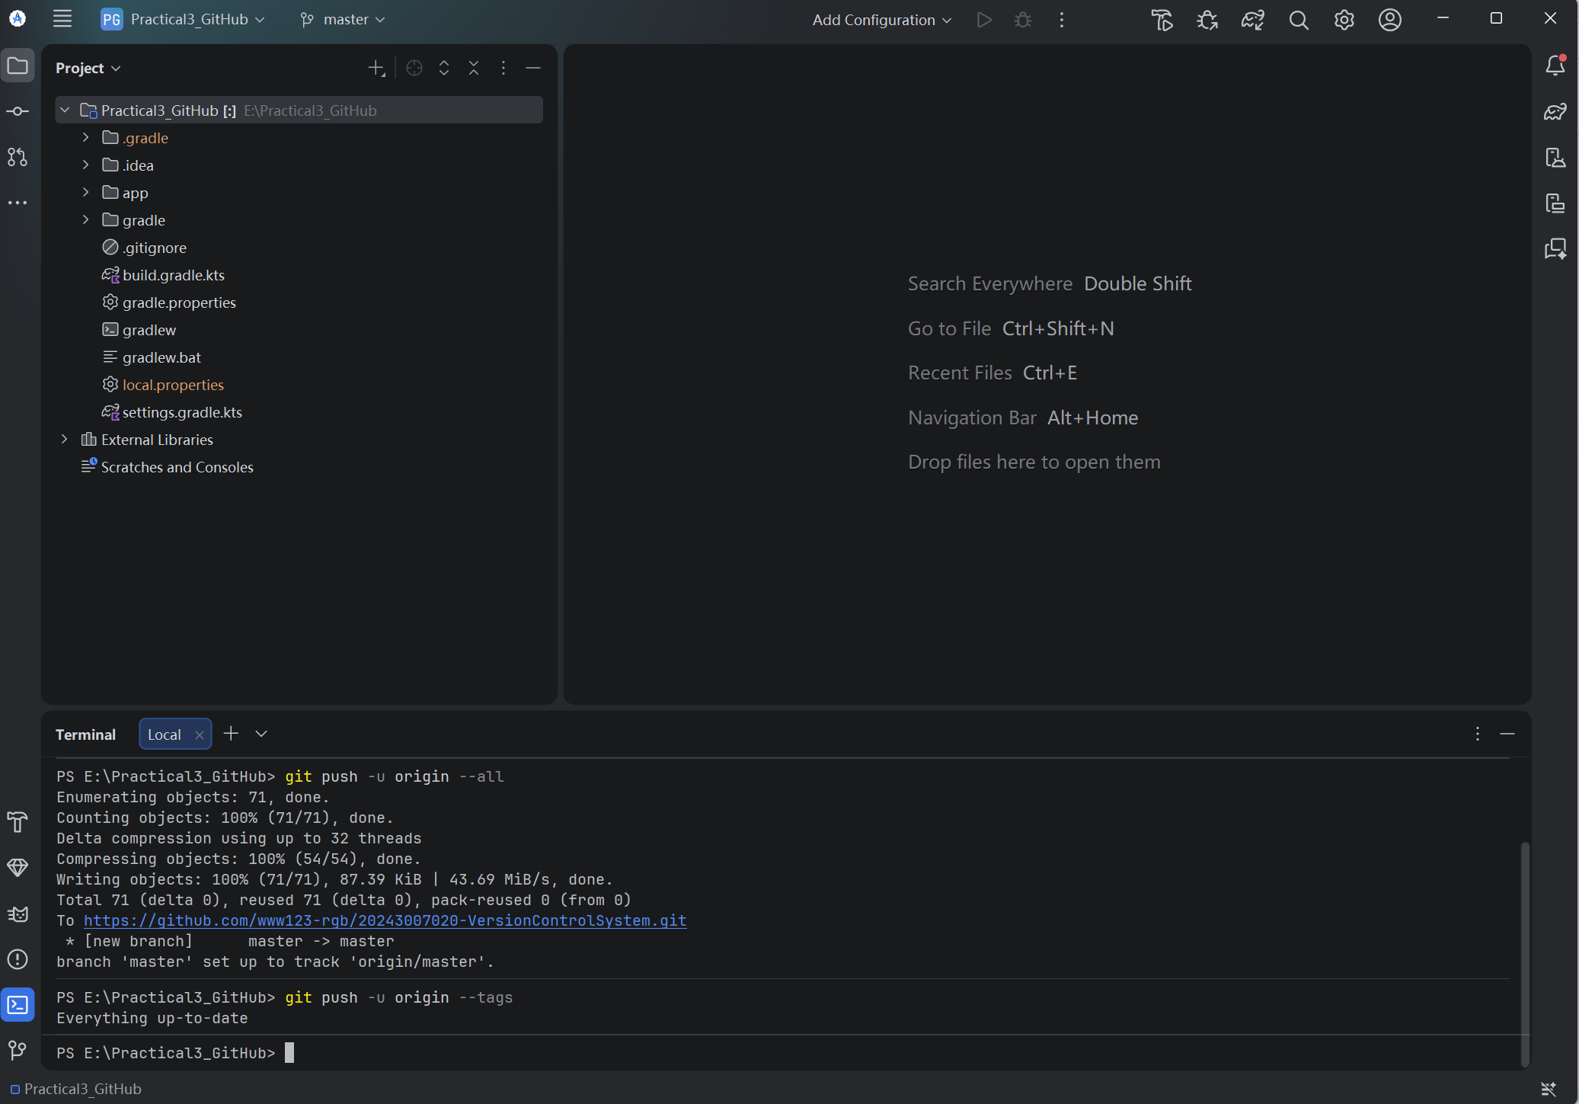
Figure 1: Screenshot of git command execution results in Terminal
(2) GitHub Repository Page Verification
Open the GitHub repository homepage and confirm that the file list is complete and commit history is displayed correctly (please replace with screenshot):
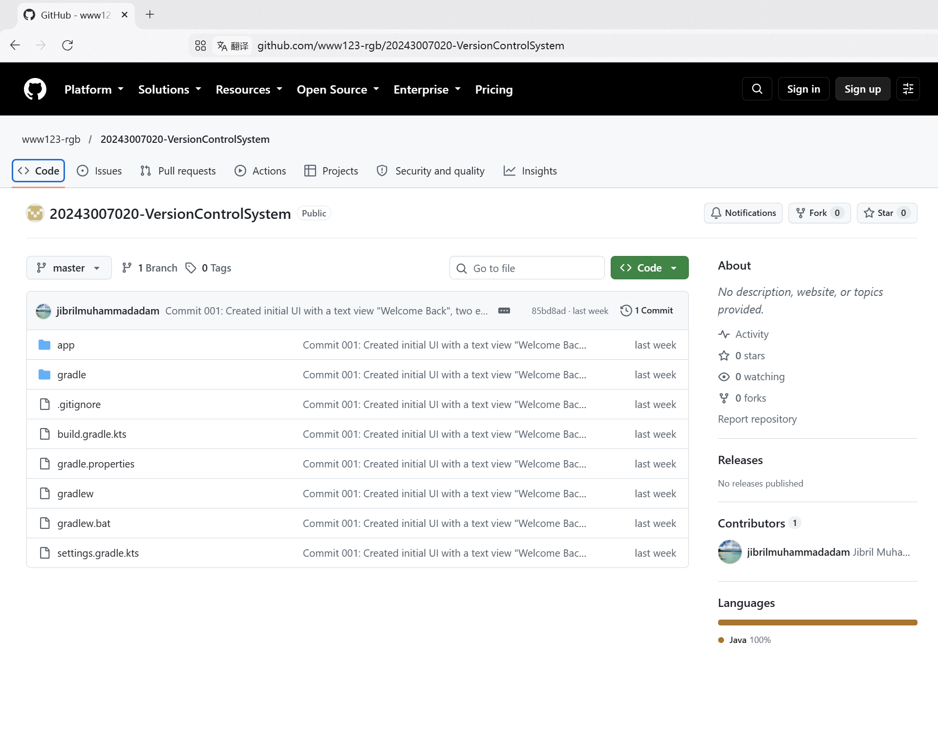
Figure 2: GitHub repository homepage screenshot (file list and commit summary)
(3) Commit Detail Verification
Click the commit record to view details and confirm the file change count and commit message are correct (please replace with screenshot):
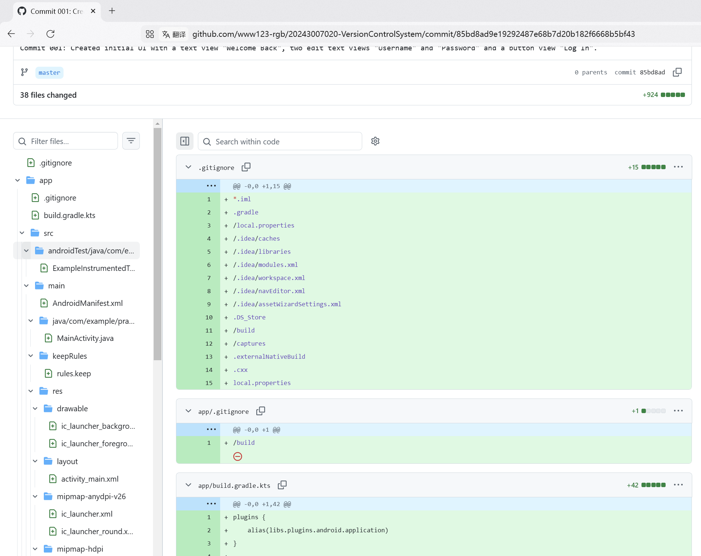
Figure 3: Commit detail page screenshot (file changes and code diffs)
5. Experiment Summary
Through this experiment, I have mastered the basic usage of the Git version control tool, including local repository initialization, file staging and committing, remote repository association, and code pushing — all core operations.
During the experiment, I encountered a problem with remote repository address configuration. The initial push failed because the remote address was not set correctly. After executing the "git remote set-url origin" command to update the remote address, the push was successful. This made me deeply understand the importance of the "remote" concept in Git — the local repository needs to know clearly which remote address the code should be pushed to.
In addition, by verifying the commit history through the GitHub web interface, I intuitively saw the power of version control: every code change is traceable, and you can revert to any historical version at any time. This is crucial for team collaborative development.
This experiment enabled me to initially establish engineering thinking about version control, laying the foundation for subsequent learning of branch management, merge conflict resolution, and other advanced Git operations.

