Installation Steps
Project Address:https://github.com/ashraf-kabir/travel-agency
- Start Apache and MySQL in phpStudy.
- Extract the downloaded source code to the www directory (you can rename the folder if needed).
- Create a database named "tagency" via the visual database management panel.
- Import the SQL file from the extracted package. The file is named "tagency.sql" and located in the sql folder.
- Access the Online Travel Agency System through a browser, e.g., http://localhost/travel/
- If you encounter the error as shown in the figure below, simply copy the "includes" folder to the "admin_area" directory.
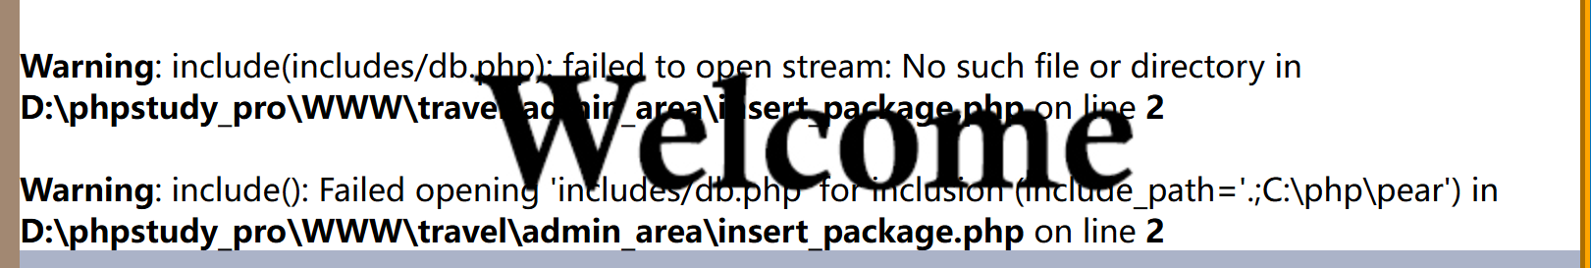
Admin Access Information:
to access admin panel: http://localhost/travel/admin_area/
Email: admin@gmail.com
Password: admin
Vulnerability Information
Vulnerability Type: File Upload Vulnerability
Vulnerability URL: http://localhost/travel/customer_register.php
Vulnerability Testing:
When accessing this page, you will see a registration form that allows file uploads. The page display is as follows:
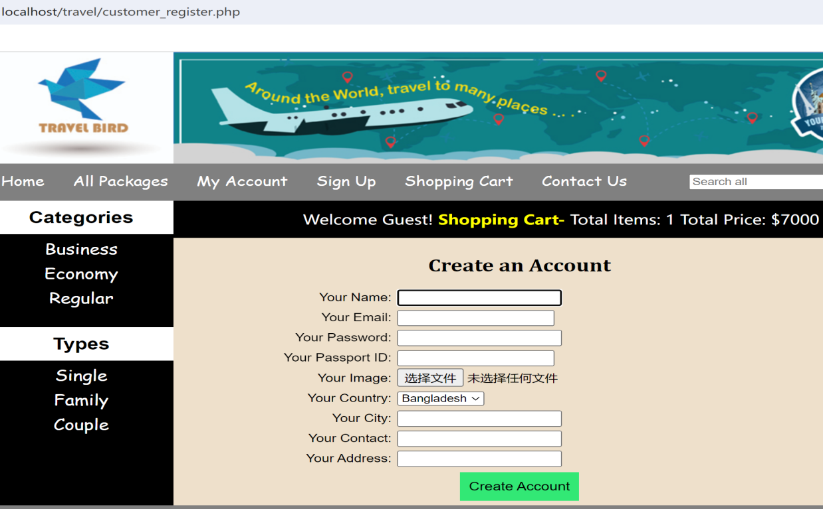
It is found that a PHP file can be uploaded.
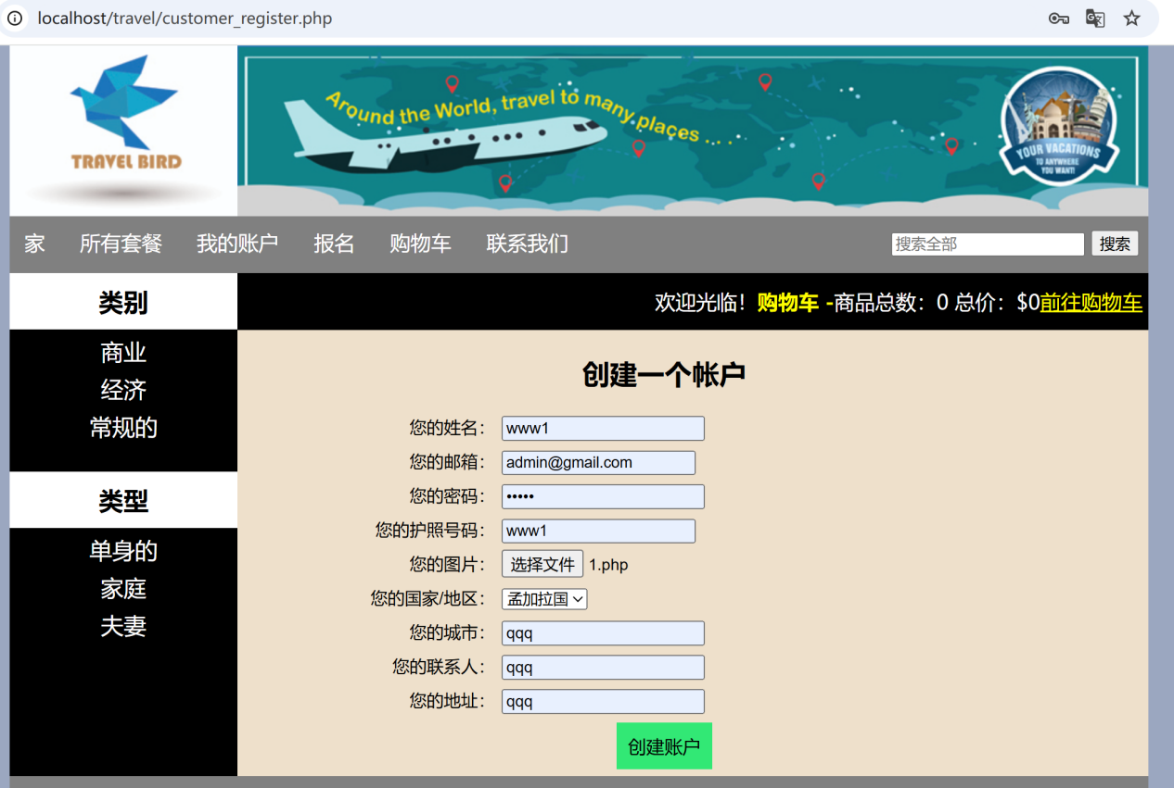
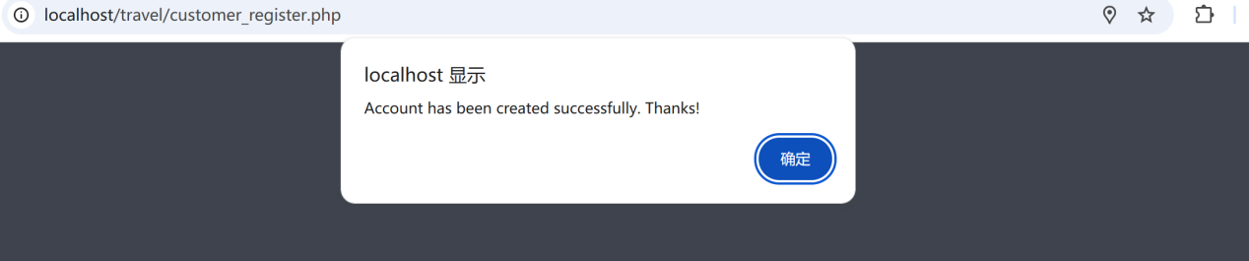
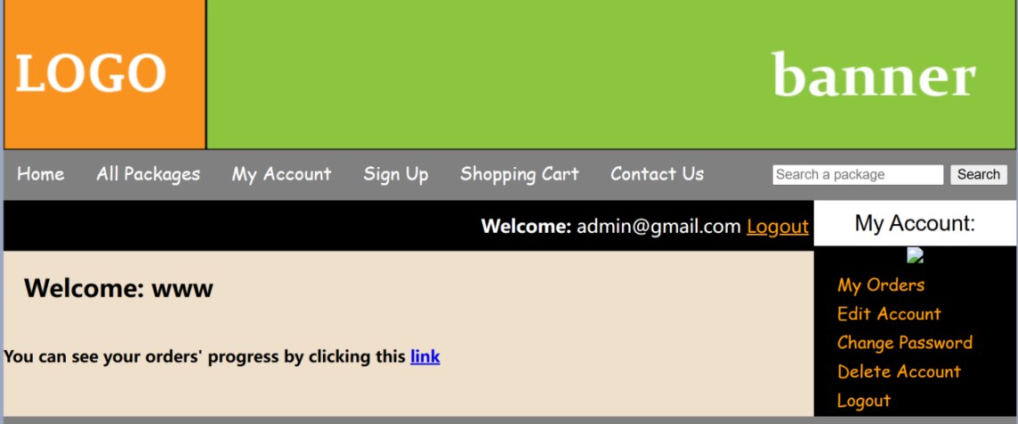
Successfully connected using AntSword.
