IOT SLIP SOLUTIONS

QUE1: BLINK LEDs

# Import the required modules

import RPi.GPIO as GPIO

import time

# Set up the GPIO channels

GPIO.setwarnings(False) # Disable warnings for GPIO setup

GPIO.setmode(GPIO.BCM) # Use Broadcom chip-specific pin numbers

# Set up pin 4 as an output pin

GPIO.setup(4, GPIO.OUT)

# This loop runs forever

while True:

GPIO.output(4, GPIO.HIGH) # Turn on the LED

time.sleep(3) # Wait for 3 seconds

GPIO.output(4, GPIO.LOW) # Turn off the LED

time.sleep(3) # Wait for 3 seconds

QUE2: TURN ON/OFF BUZZER

import RPi.GPIO as GPIO

import time

# Set up GPIO pins

GPIO.setwarnings(False)

GPIO.setmode(GPIO.BCM) # Use Broadcom SOC channel numbers

GPIO.setup(17, GPIO.OUT) # Set GPIO pin 17 as an output

try:

while True:

GPIO.output(17, GPIO.HIGH) # Turn buzzer ON

time.sleep(1) # Buzzer stays ON for 1 second

GPIO.output(17, GPIO.LOW) # Turn buzzer OFF

time.sleep(1) # Buzzer stays OFF for 1 second

except KeyboardInterrupt:

GPIO.cleanup() # Clean up GPIO settings if you stop the script manually

QUE3: TOGGLE 2 LEDs

import RPi.GPIO as GPIO

import time

# Set up GPIO pins

GPIO.setwarnings(False)

GPIO.setmode(GPIO.BCM) # Use Broadcom SOC channel numbering

GPIO.setup(17, GPIO.OUT) # Set GPIO pin 17 as an output for LED 1

GPIO.setup(27, GPIO.OUT) # Set GPIO pin 27 as an output for LED 2

# Initial state for LEDs

GPIO.output(17, GPIO.LOW)

GPIO.output(27, GPIO.LOW)

# Main loop

while True:

GPIO.output(17, GPIO.HIGH) # Turn LED 1 ON

GPIO.output(27, GPIO.LOW) # Turn LED 2 OFF

time.sleep(1) # Wait for 1 second

GPIO.output(17, GPIO.LOW) # Turn LED 1 OFF

GPIO.output(27, GPIO.HIGH) # Turn LED 2 ON

time.sleep(1) # Wait for 1 second

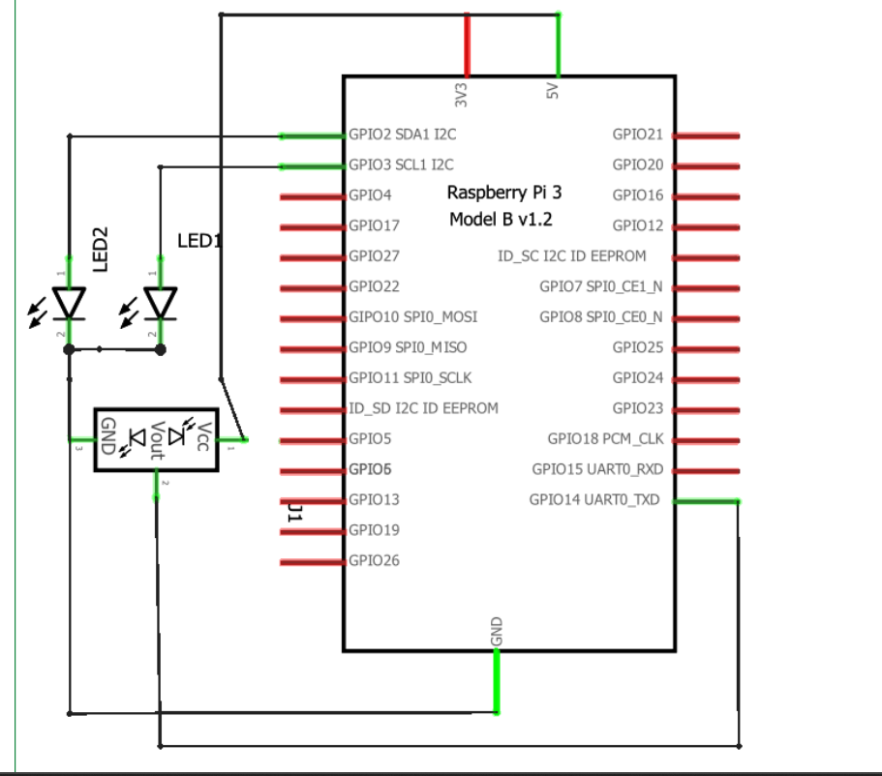

**block diagram of Raspberry-Pi board interfacing with IR sensor**

**Programs given by natasha:**

**Program1: Python program to blink LED**

import RP1. GPIO as GPIO import time

GPIO. setwarnings (False)

GPIO. setmode (GPIO. BCM) #assign numbering for the GPIO using BCM #GPIO. setmode (GPIO. BOARD) #assingn number for the GPIO using Board

# Import Raspberry Pi GPIO library

# Import time module

# Ignore warning for now

cnt = 0

Blink Time = 1

RED LED = 14

GPIO. setup (RED_LED, GPIO. OUT) while True:

if cnt ==

GPIO.output (RED_LED, False)

else:

GPIO. output (RED_LED, True)

ent = 0

time. sleep (Blink_Time)

GPIO. cleanup ()

Program2: Python program to toggle two LED's.

import RPi.GPIO

as GPIO # Import Raspberry Pi GPIO library

from time import sleep

# Import the sleep

function from the time module

GPIO. setwarnings (False)

# Ignore warning for now

GPIO. setmode (GPIO. BOARD) # Use physical pin numbering

RED LED = 14

GREEN LED = 15

GPIO. setup (RED_LED, GPIO.OUT, initial=GPIO. LOW) GPIO. setup (GREEN_LED, GPIO.OUT, initial=GPIO.LOW)

while

True:

* Run forever

GPIO. output (RED_LED, True)

# Turn ON

GPIO.output (GREEN_LED, False) # Turn OFF

sleep (1) # Sleep for 1 second

GPIO.output (RED_LED, False) # Turn OFF GPIO. output (GREEN_LED, True) # Turn ON

sleep (1) # Sleep for 1 second

Program3: Python program to turn ON/OFF buzzer.

import Pi,GPIO as GPIO # Import Raspberry Pi GPIO library from time import sleep

# Import the sleep function from the time module

GPIO. setwarnings (False)

# Ignore warning for now

GPIO. setmode (GPIO. BOARD) # Use physical pin numbering

Buzzer = 18

GPIO. setup (Buzzer, GPIO.OUT, initial=GPIO. LOW)

while True:

* Run forever

GPIO.output (Buzzer, True) # Turn ON sleep (1) # Sleep for 1 second GPIO.output (Buzzer,

False) # Turn OFF

Steps to create new project in proteus:

STEP 1 :- Open Proteus Software STEP 2 :- Select “ New Project “ Option , and click next option till this slide…STEP 3 :-Select “Create Firmware Project”

STEP 4 :-Select “Raspberri pi” in Family Section and click next . STEP 5 :- You Will See this Interface“Schematic Capture” for Circuit Design and “Source Code” for coding.STEP 6: After opening Schemaic Capture and Source code window ,You will see one circuit in Schematic Capture ,this is IC of Raspberry pi in software . Write the python code for LED Interfacing With Raspberry pi in Source code section and for initialize the LED in it …do following Steps. Right Click on RPI3 and Select Add PeripheralsSelect Breakout Peripherals in CategorySelect LED of any colour in Breakout Peripherals