-- 1. 查看订单表、支付表和评价表的行数
SELECT '订单表' AS 表名, COUNT(*) AS 行数
FROM olist_orders_dataset
UNION ALL
SELECT '支付表' AS 表名, COUNT(*) AS 行数
FROM olist_order_payments_dataset
UNION ALL
SELECT '评价表' AS 表名, COUNT(*) AS 行数
FROM olist_order_reviews_dataset;
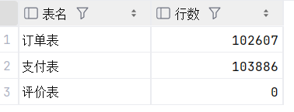
-- 2. 查看订单状态分布
SELECT order_status AS 订单状态,
COUNT(*) AS 订单数
FROM olist_orders_dataset
GROUP BY order_status
ORDER BY 订单数 DESC;
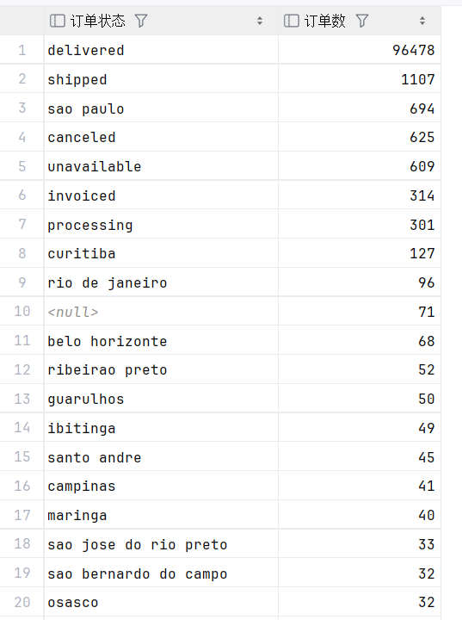
-- 3. 统计总订单数、总客户数和已完成订单数
SELECT COUNT(*) AS 总订单数,
COUNT(DISTINCT customer_id) AS 总客户数,
SUM(CASE WHEN order_status = 'delivered' THEN 1 ELSE 0 END) AS 已完成订单数
FROM olist_orders_dataset;
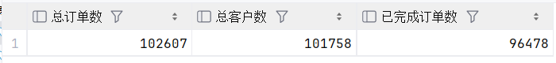
-- 4. 统计不同支付方式的订单数量和支付金额
SELECT payment_type AS 支付方式,
COUNT(DISTINCT order_id) AS 订单数,
ROUND(SUM(payment_value), 2) AS 支付金额
FROM olist_order_payments_dataset
GROUP BY payment_type
ORDER BY 支付金额 DESC;
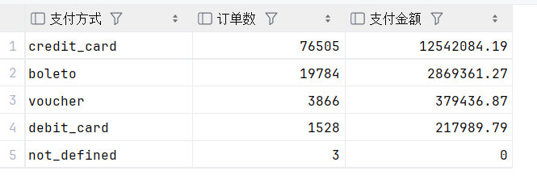
-- 5. 统计每个月的订单数量
SELECT DATE_FORMAT(order_purchase_timestamp, '%Y-%m') AS 月份,
COUNT(*) AS 订单数
FROM olist_orders_dataset
GROUP BY DATE_FORMAT(order_purchase_timestamp, '%Y-%m')
ORDER BY 月份;
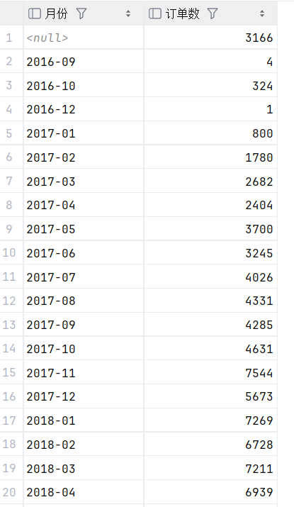
-- 6. 统计每个月的支付金额
SELECT DATE_FORMAT(o.order_purchase_timestamp, '%Y-%m') AS 月份,
ROUND(SUM(p.payment_value), 2) AS 支付金额
FROM olist_orders_dataset o
JOIN olist_order_payments_dataset p
ON o.order_id = p.order_id
GROUP BY DATE_FORMAT(o.order_purchase_timestamp, '%Y-%m')
ORDER BY 月份;
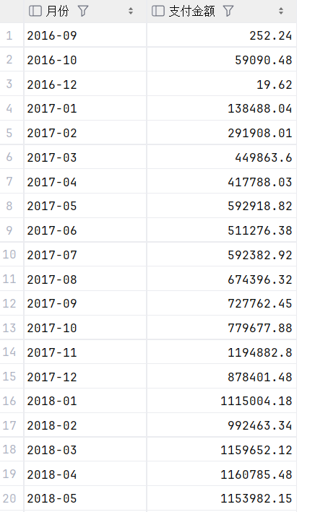
-- 7. 查看商品分类的销售金额排名
SELECT p.product_category_name AS 商品分类,
COUNT(i.order_id) AS 商品订单数,
ROUND(SUM(i.price), 2) AS 商品销售金额
FROM olist_order_items_dataset i
JOIN olist_products_dataset p
ON i.product_id = p.product_id
GROUP BY p.product_category_name
ORDER BY 商品销售金额 DESC
LIMIT 10;
