-- 统计各电商平台数据表的总行数，并汇总合计
SELECT 'jing_dong' AS 平台, COUNT(*) AS 行数 FROM jing_dong
UNION ALL
SELECT '1688' AS 平台, COUNT(*) AS 行数 FROM `1688`
UNION ALL
SELECT 'pin_duo_duo' AS 平台, COUNT(*) AS 行数 FROM pin_duo_duo
UNION ALL
SELECT 'su_zhu_yi_gou' AS 平台, COUNT(*) AS 行数 FROM su_ning_yi_gou
UNION ALL
SELECT 'tao_bao' AS 平台, COUNT(*) AS 行数 FROM tao_bao
UNION ALL
SELECT 'tian_mao' AS 平台, COUNT(*) AS 行数 FROM tian_mao
UNION ALL
SELECT '合计' AS 平台, SUM(行数) AS 行数
FROM (
SELECT COUNT(*) AS 行数 FROM `1688`
UNION ALL
SELECT COUNT(*) AS 行数 FROM jing_dong
UNION ALL
SELECT COUNT(*) AS 行数 FROM pin_duo_duo
UNION ALL
SELECT COUNT(*) AS 行数 FROM su_ning_yi_gou
UNION ALL
SELECT COUNT(*) AS 行数 FROM tao_bao
UNION ALL
SELECT COUNT(*) AS 行数 FROM tian_mao
) AS t;

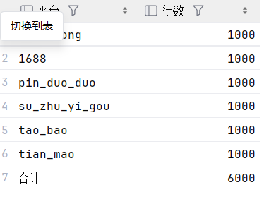

-- 检查各平台关键字段是否存在空值（NULL）
SELECT '1688' AS 平台,
COUNT(*) AS 总行数,
SUM(CASE WHEN `用户ID` IS NULL THEN 1 ELSE 0 END) AS 用户ID空值数,
SUM(CASE WHEN `商品ID` IS NULL THEN 1 ELSE 0 END) AS 商品ID空值数,
SUM(CASE WHEN `单价` IS NULL THEN 1 ELSE 0 END) AS 单价空值数,
SUM(CASE WHEN `购买时间` IS NULL THEN 1 ELSE 0 END) AS 购买时间空值数,
SUM(CASE WHEN `购买数量` IS NULL THEN 1 ELSE 0 END) AS 购买数量空值数,
SUM(CASE WHEN `消费金额` IS NULL THEN 1 ELSE 0 END) AS 消费金额空值数,
SUM(CASE WHEN `用户城市` IS NULL THEN 1 ELSE 0 END) AS 用户城市空值数,
SUM(CASE WHEN `用户性别` IS NULL THEN 1 ELSE 0 END) AS 用户性别空值数,
SUM(CASE WHEN `用户年龄` IS NULL THEN 1 ELSE 0 END) AS 用户年龄空值数
FROM `1688`
UNION ALL
SELECT 'jing_dong' AS 平台,
COUNT(*) AS 总行数,
SUM(CASE WHEN `用户ID` IS NULL THEN 1 ELSE 0 END) AS 用户ID空值数,
SUM(CASE WHEN `商品ID` IS NULL THEN 1 ELSE 0 END) AS 商品ID空值数,
SUM(CASE WHEN `单价` IS NULL THEN 1 ELSE 0 END) AS 单价空值数,
SUM(CASE WHEN `购买时间` IS NULL THEN 1 ELSE 0 END) AS 购买时间空值数,
SUM(CASE WHEN `购买数量` IS NULL THEN 1 ELSE 0 END) AS 购买数量空值数,
SUM(CASE WHEN `消费金额` IS NULL THEN 1 ELSE 0 END) AS 消费金额空值数,
SUM(CASE WHEN `用户城市` IS NULL THEN 1 ELSE 0 END) AS 用户城市空值数,
SUM(CASE WHEN `用户性别` IS NULL THEN 1 ELSE 0 END) AS 用户性别空值数,
SUM(CASE WHEN `用户年龄` IS NULL THEN 1 ELSE 0 END) AS 用户年龄空值数
FROM jing_dong
UNION ALL
SELECT 'pin_duo_duo' AS 平台,
COUNT(*) AS 总行数,
SUM(CASE WHEN `用户ID` IS NULL THEN 1 ELSE 0 END) AS 用户ID空值数,
SUM(CASE WHEN `商品ID` IS NULL THEN 1 ELSE 0 END) AS 商品ID空值数,
SUM(CASE WHEN `单价` IS NULL THEN 1 ELSE 0 END) AS 单价空值数,
SUM(CASE WHEN `购买时间` IS NULL THEN 1 ELSE 0 END) AS 购买时间空值数,
SUM(CASE WHEN `购买数量` IS NULL THEN 1 ELSE 0 END) AS 购买数量空值数,
SUM(CASE WHEN `消费金额` IS NULL THEN 1 ELSE 0 END) AS 消费金额空值数,
SUM(CASE WHEN `用户城市` IS NULL THEN 1 ELSE 0 END) AS 用户城市空值数,
SUM(CASE WHEN `用户性别` IS NULL THEN 1 ELSE 0 END) AS 用户性别空值数,
SUM(CASE WHEN `用户年龄` IS NULL THEN 1 ELSE 0 END) AS 用户年龄空值数
FROM pin_duo_duo
UNION ALL
SELECT 'su_ning_yi_gou' AS 平台,
COUNT(*) AS 总行数,
SUM(CASE WHEN `用户ID` IS NULL THEN 1 ELSE 0 END) AS 用户ID空值数,
SUM(CASE WHEN `商品ID` IS NULL THEN 1 ELSE 0 END) AS 商品ID空值数,
SUM(CASE WHEN `单价` IS NULL THEN 1 ELSE 0 END) AS 单价空值数,
SUM(CASE WHEN `购买时间` IS NULL THEN 1 ELSE 0 END) AS 购买时间空值数,
SUM(CASE WHEN `购买数量` IS NULL THEN 1 ELSE 0 END) AS 购买数量空值数,
SUM(CASE WHEN `消费金额` IS NULL THEN 1 ELSE 0 END) AS 消费金额空值数,
SUM(CASE WHEN `用户城市` IS NULL THEN 1 ELSE 0 END) AS 用户城市空值数,
SUM(CASE WHEN `用户性别` IS NULL THEN 1 ELSE 0 END) AS 用户性别空值数,
SUM(CASE WHEN `用户年龄` IS NULL THEN 1 ELSE 0 END) AS 用户年龄空值数
FROM su_ning_yi_gou
UNION ALL
SELECT 'tao_bao' AS 平台,
COUNT(*) AS 总行数,
SUM(CASE WHEN `用户ID` IS NULL THEN 1 ELSE 0 END) AS 用户ID空值数,
SUM(CASE WHEN `商品ID` IS NULL THEN 1 ELSE 0 END) AS 商品ID空值数,
SUM(CASE WHEN `单价` IS NULL THEN 1 ELSE 0 END) AS 单价空值数,
SUM(CASE WHEN `购买时间` IS NULL THEN 1 ELSE 0 END) AS 购买时间空值数,
SUM(CASE WHEN `购买数量` IS NULL THEN 1 ELSE 0 END) AS 购买数量空值数,
SUM(CASE WHEN `消费金额` IS NULL THEN 1 ELSE 0 END) AS 消费金额空值数,
SUM(CASE WHEN `用户城市` IS NULL THEN 1 ELSE 0 END) AS 用户城市空值数,
SUM(CASE WHEN `用户性别` IS NULL THEN 1 ELSE 0 END) AS 用户性别空值数,
SUM(CASE WHEN `用户年龄` IS NULL THEN 1 ELSE 0 END) AS 用户年龄空值数
FROM tao_bao
UNION ALL
SELECT 'tian_mao' AS 平台,
COUNT(*) AS 总行数,
SUM(CASE WHEN `用户ID` IS NULL THEN 1 ELSE 0 END) AS 用户ID空值数,
SUM(CASE WHEN `商品ID` IS NULL THEN 1 ELSE 0 END) AS 商品ID空值数,
SUM(CASE WHEN `单价` IS NULL THEN 1 ELSE 0 END) AS 单价空值数,
SUM(CASE WHEN `购买时间` IS NULL THEN 1 ELSE 0 END) AS 购买时间空值数,
SUM(CASE WHEN `购买数量` IS NULL THEN 1 ELSE 0 END) AS 购买数量空值数,
SUM(CASE WHEN `消费金额` IS NULL THEN 1 ELSE 0 END) AS 消费金额空值数,
SUM(CASE WHEN `用户城市` IS NULL THEN 1 ELSE 0 END) AS 用户城市空值数,
SUM(CASE WHEN `用户性别` IS NULL THEN 1 ELSE 0 END) AS 用户性别空值数,
SUM(CASE WHEN `用户年龄` IS NULL THEN 1 ELSE 0 END) AS 用户年龄空值数
FROM tian_mao;
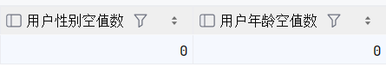

-- 各平台总销售额、总订单数、总用户数
SELECT '1688' AS 平台,
ROUND(SUM(`消费金额`), 2) AS 总销售额,
COUNT(*) AS 总订单数,
COUNT(DISTINCT `用户ID`) AS 总用户数
FROM `1688`
UNION ALL
SELECT 'jing_dong' AS 平台,
ROUND(SUM(`消费金额`), 2) AS 总销售额,
COUNT(*) AS 总订单数,
COUNT(DISTINCT `用户ID`) AS 总用户数
FROM jing_dong
UNION ALL
SELECT 'pin_duo_duo' AS 平台,
ROUND(SUM(`消费金额`), 2) AS 总销售额,
COUNT(*) AS 总订单数,
COUNT(DISTINCT `用户ID`) AS 总用户数
FROM pin_duo_duo
UNION ALL
SELECT 'su_ning_yi_gou' AS 平台,
ROUND(SUM(`消费金额`), 2) AS 总销售额,
COUNT(*) AS 总订单数,
COUNT(DISTINCT `用户ID`) AS 总用户数
FROM su_ning_yi_gou
UNION ALL
SELECT 'tao_bao' AS 平台,
ROUND(SUM(`消费金额`), 2) AS 总销售额,
COUNT(*) AS 总订单数,
COUNT(DISTINCT `用户ID`) AS 总用户数
FROM tao_bao
UNION ALL
SELECT 'tian_mao' AS 平台,
ROUND(SUM(`消费金额`), 2) AS 总销售额,
COUNT(*) AS 总订单数,
COUNT(DISTINCT `用户ID`) AS 总用户数
FROM tian_mao;
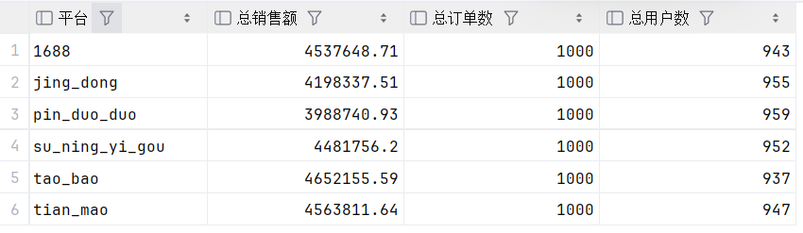
-- 各平台平均客单价及排名（客单价 = 总销售额 / 总订单数）
SELECT 平台,
总销售额,
总订单数,
总用户数,
客单价,
ROW_NUMBER() OVER(ORDER BY 客单价 DESC) AS 客单价排名
FROM (
SELECT '1688' AS 平台,
ROUND(SUM(`消费金额`), 2) AS 总销售额,
COUNT(*) AS 总订单数,
COUNT(DISTINCT `用户ID`) AS 总用户数,
ROUND(SUM(`消费金额`) / COUNT(*), 2) AS 客单价
FROM `1688`
UNION ALL
SELECT 'jing_dong' AS 平台,
ROUND(SUM(`消费金额`), 2) AS 总销售额,
COUNT(*) AS 总订单数,
COUNT(DISTINCT `用户ID`) AS 总用户数,
ROUND(SUM(`消费金额`) / COUNT(*), 2) AS 客单价
FROM jing_dong
UNION ALL
SELECT 'pin_duo_duo' AS 平台,
ROUND(SUM(`消费金额`), 2) AS 总销售额,
COUNT(*) AS 总订单数,
COUNT(DISTINCT `用户ID`) AS 总用户数,
ROUND(SUM(`消费金额`) / COUNT(*), 2) AS 客单价
FROM pin_duo_duo
UNION ALL
SELECT 'su_ning_yi_gou' AS 平台,
ROUND(SUM(`消费金额`), 2) AS 总销售额,
COUNT(*) AS 总订单数,
COUNT(DISTINCT `用户ID`) AS 总用户数,
ROUND(SUM(`消费金额`) / COUNT(*), 2) AS 客单价
FROM su_ning_yi_gou
UNION ALL
SELECT 'tao_bao' AS 平台,
ROUND(SUM(`消费金额`), 2) AS 总销售额,
COUNT(*) AS 总订单数,
COUNT(DISTINCT `用户ID`) AS 总用户数,
ROUND(SUM(`消费金额`) / COUNT(*), 2) AS 客单价
FROM tao_bao
UNION ALL
SELECT 'tian_mao' AS 平台,
ROUND(SUM(`消费金额`), 2) AS 总销售额,
COUNT(*) AS 总订单数,
COUNT(DISTINCT `用户ID`) AS 总用户数,
ROUND(SUM(`消费金额`) / COUNT(*), 2) AS 客单价
FROM tian_mao
) AS t
ORDER BY 客单价 DESC;
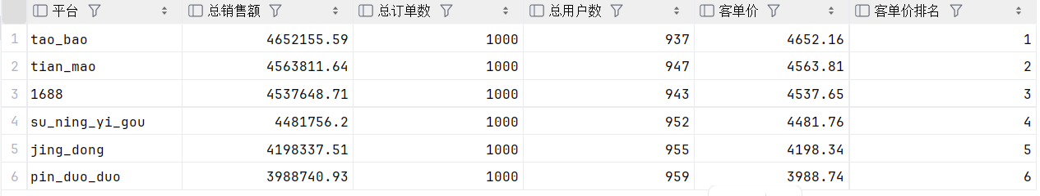
-- 各平台用户性别比例及平均年龄
SELECT '1688' AS 平台,
COUNT(DISTINCT `用户ID`) AS 总用户数,
COUNT(DISTINCT CASE WHEN `用户性别` = '男' THEN `用户ID` END) AS 男性用户数,
COUNT(DISTINCT CASE WHEN `用户性别` = '女' THEN `用户ID` END) AS 女性用户数,
ROUND(COUNT(DISTINCT CASE WHEN `用户性别` = '男' THEN `用户ID` END) * 100.0 / COUNT(DISTINCT `用户ID`), 2) AS 男性占比,
ROUND(COUNT(DISTINCT CASE WHEN `用户性别` = '女' THEN `用户ID` END) * 100.0 / COUNT(DISTINCT `用户ID`), 2) AS 女性占比,
ROUND(AVG(`用户年龄`), 2) AS 平均年龄
FROM `1688`
UNION ALL
SELECT 'jing_dong' AS 平台,
COUNT(DISTINCT `用户ID`) AS 总用户数,
COUNT(DISTINCT CASE WHEN `用户性别` = '男' THEN `用户ID` END) AS 男性用户数,
COUNT(DISTINCT CASE WHEN `用户性别` = '女' THEN `用户ID` END) AS 女性用户数,
ROUND(COUNT(DISTINCT CASE WHEN `用户性别` = '男' THEN `用户ID` END) * 100.0 / COUNT(DISTINCT `用户ID`), 2) AS 男性占比,
ROUND(COUNT(DISTINCT CASE WHEN `用户性别` = '女' THEN `用户ID` END) * 100.0 / COUNT(DISTINCT `用户ID`), 2) AS 女性占比,
ROUND(AVG(`用户年龄`), 2) AS 平均年龄
FROM jing_dong
UNION ALL
SELECT 'pin_duo_duo' AS 平台,
COUNT(DISTINCT `用户ID`) AS 总用户数,
COUNT(DISTINCT CASE WHEN `用户性别` = '男' THEN `用户ID` END) AS 男性用户数,
COUNT(DISTINCT CASE WHEN `用户性别` = '女' THEN `用户ID` END) AS 女性用户数,
ROUND(COUNT(DISTINCT CASE WHEN `用户性别` = '男' THEN `用户ID` END) * 100.0 / COUNT(DISTINCT `用户ID`), 2) AS 男性占比,
ROUND(COUNT(DISTINCT CASE WHEN `用户性别` = '女' THEN `用户ID` END) * 100.0 / COUNT(DISTINCT `用户ID`), 2) AS 女性占比,
ROUND(AVG(`用户年龄`), 2) AS 平均年龄
FROM pin_duo_duo
UNION ALL
SELECT 'su_ning_yi_gou' AS 平台,
COUNT(DISTINCT `用户ID`) AS 总用户数,
COUNT(DISTINCT CASE WHEN `用户性别` = '男' THEN `用户ID` END) AS 男性用户数,
COUNT(DISTINCT CASE WHEN `用户性别` = '女' THEN `用户ID` END) AS 女性用户数,
ROUND(COUNT(DISTINCT CASE WHEN `用户性别` = '男' THEN `用户ID` END) * 100.0 / COUNT(DISTINCT `用户ID`), 2) AS 男性占比,
ROUND(COUNT(DISTINCT CASE WHEN `用户性别` = '女' THEN `用户ID` END) * 100.0 / COUNT(DISTINCT `用户ID`), 2) AS 女性占比,
ROUND(AVG(`用户年龄`), 2) AS 平均年龄
FROM su_ning_yi_gou
UNION ALL
SELECT 'tao_bao' AS 平台,
COUNT(DISTINCT `用户ID`) AS 总用户数,
COUNT(DISTINCT CASE WHEN `用户性别` = '男' THEN `用户ID` END) AS 男性用户数,
COUNT(DISTINCT CASE WHEN `用户性别` = '女' THEN `用户ID` END) AS 女性用户数,
ROUND(COUNT(DISTINCT CASE WHEN `用户性别` = '男' THEN `用户ID` END) * 100.0 / COUNT(DISTINCT `用户ID`), 2) AS 男性占比,
ROUND(COUNT(DISTINCT CASE WHEN `用户性别` = '女' THEN `用户ID` END) * 100.0 / COUNT(DISTINCT `用户ID`), 2) AS 女性占比,
ROUND(AVG(`用户年龄`), 2) AS 平均年龄
FROM tao_bao
UNION ALL
SELECT 'tian_mao' AS 平台,
COUNT(DISTINCT `用户ID`) AS 总用户数,
COUNT(DISTINCT CASE WHEN `用户性别` = '男' THEN `用户ID` END) AS 男性用户数,
COUNT(DISTINCT CASE WHEN `用户性别` = '女' THEN `用户ID` END) AS 女性用户数,
ROUND(COUNT(DISTINCT CASE WHEN `用户性别` = '男' THEN `用户ID` END) * 100.0 / COUNT(DISTINCT `用户ID`), 2) AS 男性占比,
ROUND(COUNT(DISTINCT CASE WHEN `用户性别` = '女' THEN `用户ID` END) * 100.0 / COUNT(DISTINCT `用户ID`), 2) AS 女性占比,
ROUND(AVG(`用户年龄`), 2) AS 平均年龄
FROM tian_mao;
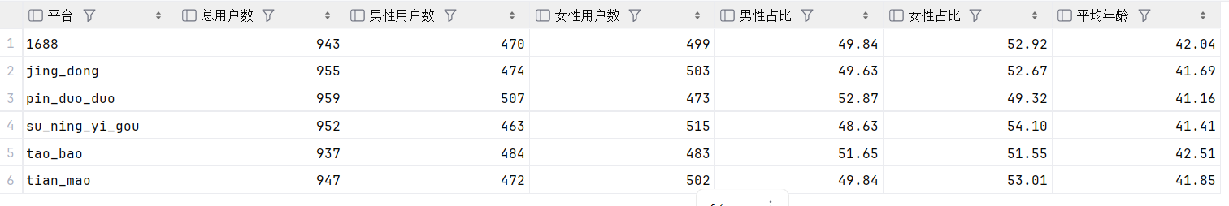
-- 各平台销量最高的前3个商品类别
SELECT 平台,
商品类别,
总销量,
类别内排名
FROM (
SELECT '1688' AS 平台,
`商品类别` AS 商品类别,
SUM(`购买数量`) AS 总销量,
ROW_NUMBER() OVER(PARTITION BY '1688' ORDER BY SUM(`购买数量`) DESC) AS 类别内排名
FROM `1688`
GROUP BY `商品类别`
UNION ALL
SELECT 'jing_dong' AS 平台,
`商品类别` AS 商品类别,
SUM(`购买数量`) AS 总销量,
ROW_NUMBER() OVER(PARTITION BY 'jing_dong' ORDER BY SUM(`购买数量`) DESC) AS 类别内排名
FROM jing_dong
GROUP BY `商品类别`
UNION ALL
SELECT 'pin_duo_duo' AS 平台,
`商品类别` AS 商品类别,
SUM(`购买数量`) AS 总销量,
ROW_NUMBER() OVER(PARTITION BY 'pin_duo_duo' ORDER BY SUM(`购买数量`) DESC) AS 类别内排名
FROM pin_duo_duo
GROUP BY `商品类别`
UNION ALL
SELECT 'su_ning_yi_gou' AS 平台,
`商品类别` AS 商品类别,
SUM(`购买数量`) AS 总销量,
ROW_NUMBER() OVER(PARTITION BY 'su_ning_yi_gou' ORDER BY SUM(`购买数量`) DESC) AS 类别内排名
FROM su_ning_yi_gou
GROUP BY `商品类别`
UNION ALL
SELECT 'tao_bao' AS 平台,
`商品类别` AS 商品类别,
SUM(`购买数量`) AS 总销量,
ROW_NUMBER() OVER(PARTITION BY 'tao_bao' ORDER BY SUM(`购买数量`) DESC) AS 类别内排名
FROM tao_bao
GROUP BY `商品类别`
UNION ALL
SELECT 'tian_mao' AS 平台,
`商品类别` AS 商品类别,
SUM(`购买数量`) AS 总销量,
ROW_NUMBER() OVER(PARTITION BY 'tian_mao' ORDER BY SUM(`购买数量`) DESC) AS 类别内排名
FROM tian_mao
GROUP BY `商品类别`
) AS ranked
WHERE 类别内排名 <= 3
ORDER BY 平台, 类别内排名;
