Graphing Data and Statistical Analysis with Excel

*Instructions*: In this exercise, you will apply your basic knowledge of Microsoft Excel to analyze data using Excel graphing tools and its built-in statistical functions. From the data tables, you will create plots, calculate and graph averages and standard deviations, compute other central tendency numbers, and calculate *p*-values using the T-distribution.

*Set up a work session:*

1. Open a new Excel session. Use a full screen window.
2. Use the data set provided below. Alternately, open the workbook posted on Blackboard.

**Guided Practice: *Average Faculty Salaries, Males vs. Females***

*Instructions*. For the next data set, *Average Faculty Salaries, Males vs. Females*, perform Exercises 1 - 6. Correctly label all your formatted graphs and tables with results.

Save your practice in an Excel file named like this: Salaries_YourFullName_Period.xls.

|  |  |  |
| --- | --- | --- |
| **College** | **Males** | **Females** |
| C-1 | 34.5 | 33.9 |
| C-2 | 30.5 | 31.2 |
| C-3 | 35.1 | 35.0 |
| C-4 | 35.7 | 34.2 |
| C-5 | 31.5 | 32.4 |
| C-6 | 34.4 | 34.1 |
| C-7 | 32.1 | 32.7 |
| C-8 | 30.7 | 29.9 |
| C-9 | 33.7 | 31.2 |
| C-10 | 35.3 | 35.5 |
| C-11 | 30.7 | 30.2 |
| C-12 | 34.2 | 34.8 |
| C-13 | 39.6 | 38.7 |
| C-14 | 30.5 | 30.0 |
| C-15 | 33.8 | 33.8 |
| C-16 | 31.7 | 32.4 |
| C-17 | 32.8 | 31.7 |
| C-18 | 38.5 | 38.9 |
| C-19 | 40.5 | 41.2 |
| C-20 | 25.3 | 25.5 |
| C-21 | 28.6 | 28.0 |
| C-22 | 35.8 | 35.1 |

***Exercises:***

1. *Creating a graph*

For the paired data set 1, create a line graph. Place this graph *as a new sheet.*

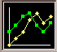(Hint: Select data columns *Males – Female*s ► ) To make the values in column *College* be the *x*-values in this graph:

►

►

* + In the Chart Wizard – Step 2 of 4 – Chart Source Data , select tab Series.
  + Click on box: **click here**



* + Using the mouse, select only the data in column *College* ► press Enter.

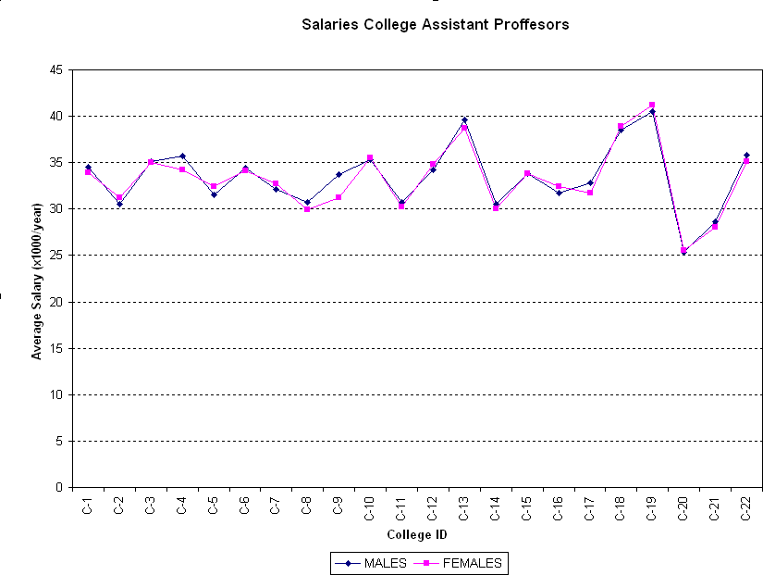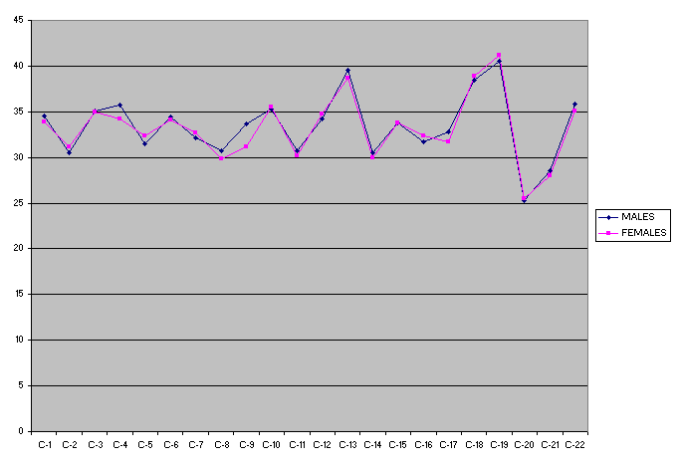

**Example Exercise 2 graph**

2. *Formatting a graph*

**Example Exercise 1 graph**

1. Place the graph legend at the bottom of the graph.
2. (If using Excel 2007 or earlier) Eliminate the plot area default gray color. (*Hint*: Click on Plot Area ► Format ► Select Plot Area or double click on Plot Area.)
3. Change the major gridlines to a broken line. (*Hint*: *Double click in one of the gridlines.*)
4. Insert the next labels. For *x*-axis: *College ID*; for *y*-axis: *Average Salary* (x*1,000/year*) (*Hint:* Chart ► Chart Options ► Titles)
5. Include in the graph title: *College Assistant Professor Salaries. Males vs. Females*
6. 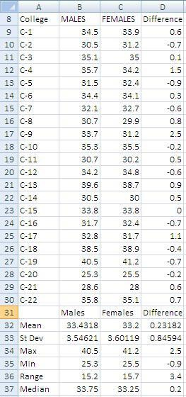*Calculating statistics*
   1. Compute the data differences.
   2. Compute samples/differences means. [*Hint*: use function =average()]
   3. Compute sample/differences standard deviations. [*Hint*: use function =stdev()]
   4. Find the sample/differences maximum values. [*Hint*: use function =max()]
   5. Find the sample/differences minimum values. [*Hint*: use function =min()]
   6. Find the sample/differences ranges.
   7. Find the sample/differences medians. [*Hint*: use function =median()]

**Example Exercise 3 results**

1. *Graphing data differences*

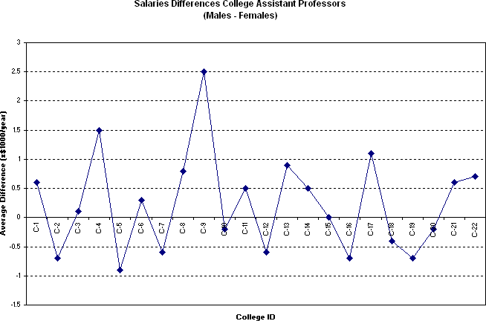

Repeat Exercises 1 and 2 for the data differences obtained in Exercise 3, with the next changes:

* 1. Delete the graph legend.
  2. Add a y-axis label: *Average Differences* (x

*$*1,000*/year*)

* 1. Title the graph: *College Assistant Professor Salary Differences: Males vs. Females*

**Example Exercise 4 results**

1. *Graphing mean and standard deviation for the differences*
   1. Include in the graph a horizontal line representing the sample mean.

(*Hint:* Create a list with *mean values,* then Chart ► Source Data ► Add [*Select created data*].)

* 1. Include in the graph horizontal lines representing mean ± 1 standard deviation. (Hint: Create list with ± SD, then ► Source Data ► Add [*Select created data].*)
  2. 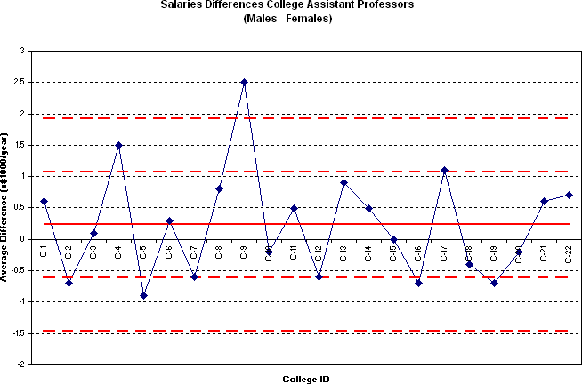Include in the graph a horizontal line representing mean ± 2 standard deviations.
  3. Format the sample mean line: Change the color to red and select the next thicker line. (*Hint*: Double click on line.)
  4. Format the standard deviation lines: Change the color to red and select a broken thicker line (*Hint*: Double click on line.)

**Example Exercise 5 graph**

1. *Compute the sample differences t-value, p-value and sampling standard deviation*

Test whether the difference in salaries is statistically significant i.e. test

Ho: (Mean (Males) - Mean(Females)) = 0

Vs

Ha: Mean (Males) > Mean(Females)

* 1. Compute the sample associated *t*-value or sample test statistic.

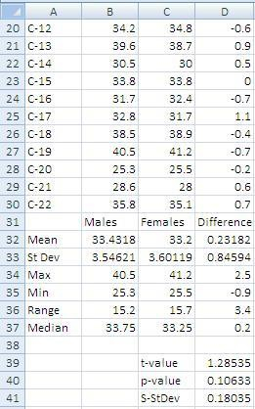

**Example Exercise 6 results**

*Use equation: t*  (*d – 0)*  / *sd* , *where d is difference mean, n is*

*n*

*sample size*, *and Sd is difference standard deviation. Using the values in the table:*

𝑡 = 0.23182 ∙ √22 = 1.28535 0.84594

* 1. Compute *p*-value using T-distribution.

*We can use the function*

=tdist(D32,21,1)

*where* “1” *indicates one-tail test.*

*Alternately, use function ttest*() *with the values in table shown in step* 2

=ttest(B8:B30,C8:C30,1,1)

*where the first* “1” *indicates one-tail test, and the second* “1”

*indicates a paired test.*

* 1. Compute the sampling standard deviation for this difference.

*Use equation*: *sd*  *sd* / :

*n*

*sd* = 0.84594 = 0.18035

√22

* 1. Do your results support the claim that no significant salary difference exists between male and female college professors…

…at the 5% level of significance?

…at the 10% level of significance?

Because *p*-value = 0.10633 is greater than 0.05 or 0.10, we have no evidence at the 5% or 10% level of significance to reject the original assumption (*H*0) that female assistant professors receive, on average, the same as the male assistant professors.