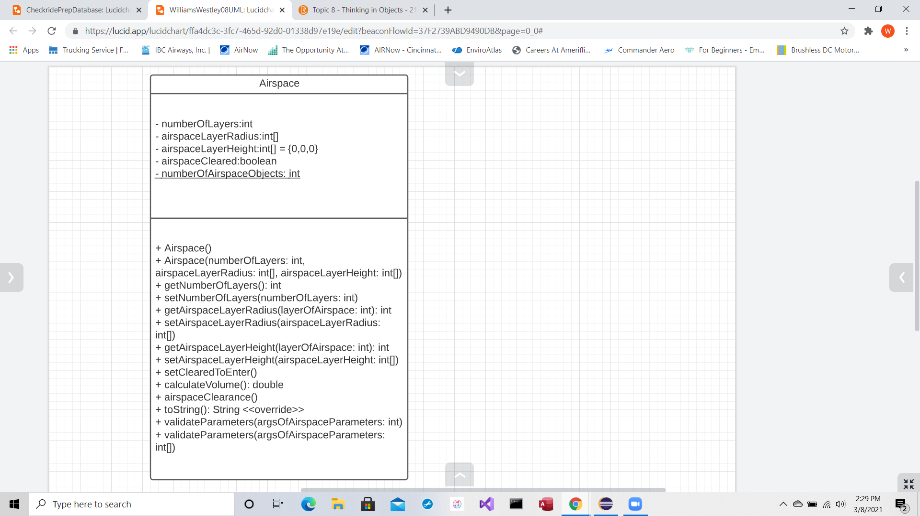Westley Williams  
UML Diagram, Assignment 08