**Do Birth Rates Affect Total Population in the Top Ten Economies?**

Wiley Winters

Regis University Anderson College of Business and Computing

MSDS 670 Data Visualization

Mr. John Koenig

February 11, 2024

**Abstract**

This paper describes research that was conducted to determine if birth and death rates of the top ten economies effect total population growth or decline in those countries. The findings indicated that all the top economies are experiencing a decrease in birth rates and death rates increased slightly in most of them around the 2020 timeframe. The effect on population growth tended to stabilize with two countries displaying a decline in population.

**Do Birth Rates and Death Effect Total Population in the Top Ten Economies?**

**Reasearch Question**

Recently, media and other sources have reported that many developed and economically stable countries have experienced reduced birth rates with slight increase in death rates due to the COVID-19 pandemic. Much attention has been given to these countries' birth rates and how they affect their overall population. This brings me to the question I want to answer with this study: Do birth and death rates affect total population in the top ten economies?

**Data**

The data for this study was extracted from the Data Bank’s Population Estimates and Projections database using its website query interface (Data Bank, 2020). Countries were limited to the top ten economies as defined in a 2024 Forbes India article (Forbes, 2024). The counties are: United States, China, Germany, Japan, India, United Kingdom, France, Italy, Brazil, and Canada. When the query was completed and downloaded into a CSV file, the data set was grouped by country with each series getting its own row. An example is below.

|  |  |  |  |  |  |  |
| --- | --- | --- | --- | --- | --- | --- |
| Country | Country Code | Series Name | Series Code | 1960 [YR1960] | 1965 [YR1965] | Later years |
| Brazil | BRA | Birth rate, . . . | SP.DYN.CBRT.IN | 43.86 | 40.106 | . . . . |
| Brazil | BRA | Death rate, . . . | SP.DYN.CDRT.IN | 14.025 | 12.279 | . . . . |
| Brazil | BRA | Population ages over 65 . . . | SP.POP.65UP.TO | 1921246 | 2437203 | . . . . |
| Brazil | BRA | Population growth . . . | SP.POP.GROW | -- | 2.8295 | . . . . |
| Canada | CAN | Birth rate, . . . | SP.DYN.CBRT.IN | 26.7 | 21.3 | . . . . |
| . . . . | . . . . | . . . . | . . . . | . . . . | . . . . |  |

Raw data and metadata are available in this projects github repository found at [MSDS 670 Data](https://github.com/wwwinters/MSDS-670-MidTerm-Project/tree/main/data)

**Methodology**

Using Data Bank’s web interface, the Population Estimates and Projections database was queried, and the results downloaded into a CSV file. The download also included the metadata for the raw dataset. The dataset was then loaded into a Pandas DataFrame using Jupyter Lab and a quick EDA was performed. It was determined that comments were added to the raw dataset, and these were manually removed using an editor. After cleaning the dataset, it was reloaded into a Pandas DataFrame and basic EDA performed again. It was discovered that two periods “..” were used to indicate null values. The dataset was loaded again to convert “..” to numpy NaN values to simply processing. After EDA and data cleaning, the dataframe was separated into sub-dataframes for each country of this study. Each dataframe was analyzed separately and data visualizations created for birth/death rates, total population, population over 65, and percent of population change from year to year.

**Results**

The visualizations illustrate a general decline in birth rates for all the top ten economies and during the COVID-19 pandemic an uptick in the death rate; otherwise, death rates have been steady. Populations grew rapidly since 1960, but the data indicates that for most of the countries the growth has peaked around 2020 and are now experiencing little to negative growth. Another factor studied is how low birth rates cause a population’s age to rise. For all the countries in this study, the population of people 65 and order has remained relatively stable except for Japan, which has a noticeable increase in this population demographic. Of the countries studied only Japan and Italy showed a decrease in total population as of 2020. The following table shows population trends for each country.

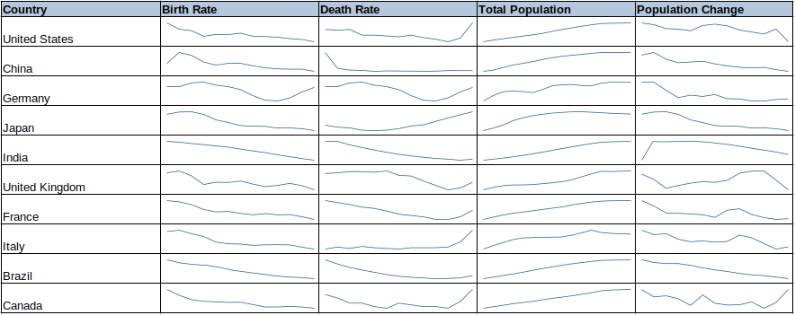**Conclusions**

Birth and death rates do influence population growth in the top ten economies. Eight out of the ten counties experience a population peak where growth is stabilizing and is no longer showing an upward trend. Japan and Italy are showing a decline in population and the others apart from Canada have growth rates less than one percent. If the low birth rate trend continues in the countries in this study, then the trend will be for population growth to stop and start to decline with the possibilities of an aging population to consider.

References

Data Bank Population Estimates and Projections. (2020, January 1). Retrieved February 2, 2024,.

Forbes India. (2024, February 7). *The top 10 largest economies in the world in 2024*. The Top 10 Largest Economies in the World 2024 . <https://www.forbesindia.com/article/explainers/top-10-largest-economies-in-the-world/86159/1>