DEPARTMENT OF BIOLOGICAL, CHEMICAL, AND PHYSICAL SCIENCE
ILLINOIS INSTITUTE OF TECHNOLOGY
PHYSICS 221

Simple DC Circuits and Resistors

Lab #3
Thales Ramier
Date of Experiment: 29 September 05
Due Date: 19 October 05
Lab section 003
Statement of Objective

This experiment was intended to affirm Ohm’s Law and Kirchhoff’s Laws through the use of circuits and resistors. Using the theoretical results (derived from the laws) and comparing them to the experimental results it can be proven that the laws are correct.

Theory

Ohm’s Law states:

V=IR

Where I is the current through a resistor, R is the resistance, and V is the potential difference of energy across the resistor. Each resistor is color coded with 4 color bands to determine its R value. Each color represents a known value that can be looked up. R is calculated by the formula:

R=AB*10^{C}± D%.

A is the value for the first color, B is the value of the second color, C is the third, and D is the fourth value.

Kirchhoff’s Laws are used to find the resistance, current, and voltage for a circuit. His first law states that the current entering a junction is equal to the current leaving the junction. His second law states that the sum of all the voltage drops around a closed circuit is zero. Kirchhoff’s laws can be applied to both parallel and series circuits.

In a series circuit where there are no junctions the current entering each of the resistors is identical, I=I₁=I₂=I₃=…I_{n}, and Appling Kirchhoff’s Second Law it can be found that:

V-V₁-V₂-V₃-…V_{n}=0 or V=V₁+V₂+V₃…V_{n}

Ohm’s Law can be substituted in giving:

IR=I₁R₁+ I₂R₂+ I₃R₃+ I_{n}R_{n}

Also since all the currents are equal it can be said that:

R= R₁+ R₂+ R₃+ R_{n}

Parallel circuits are a little different since the changes break off and go through different processes. Starting with:

I= I₁+ I₂+ I₃+…I_{n}

In this case the potential difference for each resistor remains the same. Thus:

V=V₁= V₂= V₃=…V_{n}

and due to Ohm’s Law it becomes:

V/R=V₁/R₁+ V₂/R₂+ V₃/R₃+ …V_{n}/R_{n} or 1/R=1/R₁+1/R₂+1/R₃+…1/R_{n}

These equations allow for the mathematical analysis of parallel and series circuits that have only resistors in them.
Equipment List

- Circuit board with resistors
- Multi-meter
- DC power supply
- Connecting wires
- Ammeter

Procedure

Part A

First construct the circuit in accordance with the lab manual and checking the polarity of the meters to make sure that there are no negative readings. Make the volts across the resistor read 1 V, and record the current. Then do the same thing for V= 2, 3, 4, and 5 volts. Again repeat the experiment after adjusting the circuit arrangement in accordance with the lab manual.

Part B₁

Make a circuit in accordance with the lab manual hook the multi-meter up across R₁. Set the power supply to 10 volts. Measure and record the potential across R₁, R₂, R₃, and across all 3. Switch off the circuit and find the resistance of all the resistors as in part A.

Part B₂

Make a circuit in accordance with the lab manual and hook up the multi-meter to measure I₁. Set the power supply to 10 volts. Measure V and I₁, I₂, and I₃. Connect the ammeter in series with the battery and resistors and measure the total current I.

Part C

Make a circuit in accordance with the lab manual using a multi-meter and an ammeter and find I₁ and V₁ through I₃ and V₃.

Data

Part A
V (V) | I(A) | R=V/I
1 | 0.003 | 333.33
2 | 0.0062 | 322.58
3 | 0.0092 | 326.09
4 | 0.012 | 333.33
5 | 0.015 | 333.33
Circuit as in Figure 2

V (V) | I(A) | R=V/I
1 | 0.0027 | 370.37
2 | 0.0052 | 384.62
3 | 0.008 | 375
4 | 0.012 | 333.33
5 | 0.014 | 357.14
Circuit as in Figure 3
The resistor has a resistance of 140 + 14 Ohms.

Part B

I=.554A | V (V)
V1 | 0.594
V2 | 3
V3 | 5.92
Resistors in a series

V=9.8 V | I (A)
I1 | 0.0094
I2 | 0.0019
I3 | 0.001
Resistors in parallel

The total voltage in the first case was 9.5 V, and the total current for the second case was .011A. Resistors in part B had the following resistances in Ohms: 1 + .05, 5 + .25, and 10 + .5.

Analyze Data

Part A
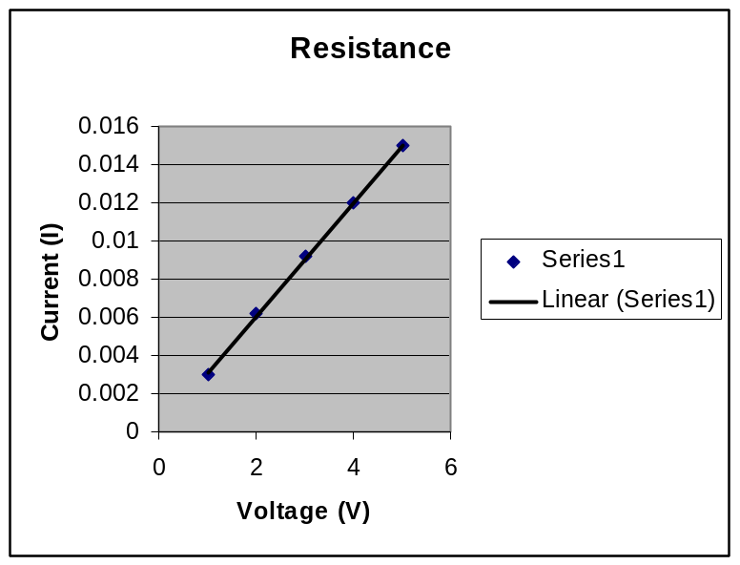
For figure 2
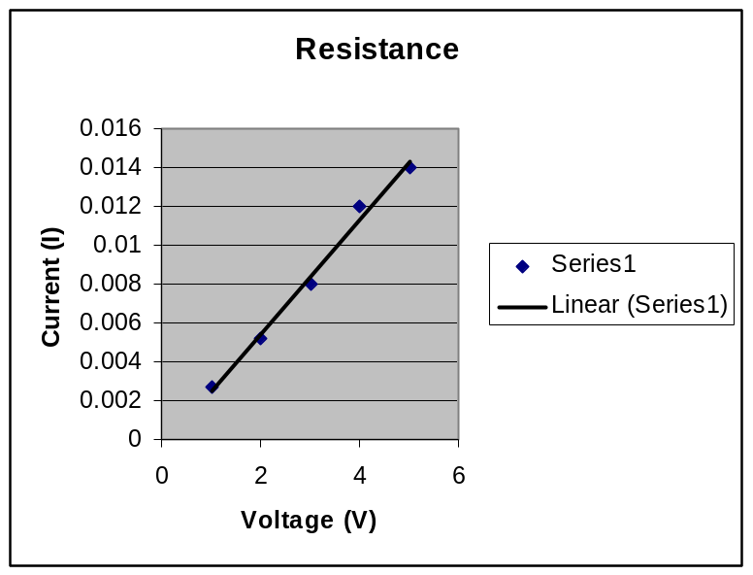
For figure 3
Resistance is equal to voltage divided by current. With the plot of V vs I, R will equal the slope of the best fit line. In the first case R is 335.4 Ohms and in the second R is 337.13 Ohms.

Part B
V=9.514V which is very close to the measured value. The total R value was calculated to be 17.2 Ohms. The total I value was found to be .0123 A and from that the total R value for the circuit was found to be 797 Ohms (obviously there was some mistake in the collection of data in order for this to be so extremely off).

Part C
Here R₁ = 11,800 ohms, R₂ = 5,650 ohms, R₃ = 1,829 ohms. The currents across R₁ to R₃ respectively are .021 A, .0024A, and .0024 A. The Voltage across the system is 30.1 and the voltages across R₁ to R₃ respectively in volts are 26.9, 3.2, 3.2.

Conclusion
Part A was used to confirm Ohm’s Law. The calculated resistance (using the slope of the graph) was very close to the measured R with minimal error, and there by confirming the relationship V=IR. In Part B, we investigated a parallel circuit and a series circuit. The resistance values were not anywhere near the same ball park and I can only attribute this to poor data gathering as well as maybe some internal resistance and experimental errors. Finally in part C, a complex circuit was constructed and the values for I_{1,} I₂, I₃, V, V₁, V₂, and V₃ were gathered. Here things seemed to go a little smother and the values jived; the theoretical and experimental values were quite close. Despite some errors the lab did its over all objective of confirming Ohm’s Law and Kirchhoff’s Laws.

