DEPARTMENT OF BIOLOGICAL, CHEMICAL, AND PHYSICAL SCIENCE
ILLINOIS INSTITUTE OF TECHNOLOGY
PHYSICS 221

Magnetic Fields

Lab #5
Thales Ramier
Date of Experiment: 2 November 05
Due Date: 17 November 05
Lab section 003
Statement of Objective

The objective in part A of this lab was to calibrate the Hall probe so that it is accurate when used in the later parts of this lab. The objective in part B was to measure the magnetic field at an incremented distance away from the coil, and to determine the relationship between distance and the magnetic field. For part C, the objective was to measure the magnetic field at the center of a Helmholtz coil. This involved setting up two current loops with the same number of turns and the same radius, and then measuring the magnetic field between the two loops at a varied distance. The objective for part D was to study and measure the force exerted on a length of current carrying wire with a varying current and a varying wire length. The current flows throw prefabricated loops and exert a force on the magnet, creating a change in weight of the magnet.

Theory

Electric fields and magnetic fields share many of the same properties. As a result, it has been thought that they are interconnected and related in an electromagnetic way. Magnetic fields are found natural, such as the field affecting the compass, as are electric fields. This lab will test how magnetic fields are affected by an inducting current, and also how magnetic fields affect charged electric particles.

Equipment List

For part A of the lab we needed a probe, a digital volt meter, and an amplifier. For part B we needed a coil of wire, a DC power source, an ammeter, and a Hall probe. For part C, we needed a probe, a Helmholtz coil, and a DC power supply. For part D, we needed the box of current loops, a main unit, a scale, a power supply, an ammeter, and the magnet assembly.

Procedure

To begin part A, the balance knob on the amplifier was to be set to 100. The digital volt meter was attached to the output terminals of the amplifier and the probe was also attached to the amplifier. The calibration was performed by inserting the probe perpendicular to the direction of the magnetic field into the slot containing a permanent magnet with a known field of 0.075 T (750 Gauss). The gain on the amplifier was then adjusted to give the calibrated output of 7.5 V.
In Part B the number or turns of the coil and the radius were recorded. A current of 1 A was passed through the coil. The magnetic field was measured using the Hall Probe till both sides of the probe read zero. From this the magnetic field and axes distance can be calculated.
Part C began with measuring the radius of the Helmholtz coil and recording the number of turns, which was given to us. The coil was connected to the DC power supply, and an ammeter was connected to the circuit as well to accurately measure the current. The magnetic field was measured with the Hall probe at the center of the coil and for the current values from 0 A to 1 A in 0.1 A increments. We then recorded the values for the current and the magnetic field.
For part D1, we began by selecting the longest current loop and plugging it into the ends of the main unit, with the foil extending down. We placed the magnet assembly on the scale, and positioned it so that the current loop hung right in the pole section of the magnet. However, it did not ever actually touch the magnet. The scale was calibrated, and the magnet was weighed without any current running through the current loop. The power supply and ammeter were then connected to the circuit, and we began flowing current through the current loop in 0.5 A increments, up to 4.0 A. The mass of the magnet assembly was measured at each 0.5 A increment. The current values and their corresponding changes in mass were recorded on the data sheet.
For part D2, the same apparatus was used as in D1. The current was set to 3.0 A, and the mass was recorded. The current was then set to zero, and the main arm of the main unit was raised out of the magnetic field. The current loop was changed to one with a different length, and the arm was lowered back into place. The current was increased back to 3.0 A, and the mass was recorded again. This was repeated for the remaining current loops. The length of the current loop and the mass were recorded on the data sheet.

Data

Part A:

There was no data for this part of the lab.

Part B:

Z (cm) | B
2.05 | 0.21
3.15 | 0.16
4.8 | 0.13
6.45 | 0.09
The average value of the magnetic field came out to be 1.79 tesla

Part C:

R = 3 in. = 7.62 cm = 0.0762 m

I (Amps) | B (volts) | B (mTesla)
0.0 A | 0.02 V | 0.2 mT
0.1 | 0.03 | 0.3
0.2 | 0.04 | 0.4
0.3 | 0.06 | 0.6
0.4 | 0.07 | 0.7
0.5 | 0.09 | 0.9
0.6 | 0.10 | 1.0
0.7 | 0.12 | 1.2
0.8 | 0.13 | 1.3
0.9 | 0.15 | 1.5
1.0 | 0.16 | 1.6

Part D1:

SF42 = 8.4 cm = 0.084 m

I (Amps) | Mass (grams) | Δ Mass (grams) | F = Δ Mass x g (N)
0.0 A | 161.2 g | 0.0 g | 0.0 N
0.5 | 161.5 | 0.3 | 0.00294
1.0 | 161.8 | 0.6 | 0.00588
1.5 | 162.0 | 0.8 | 0.00784
2.0 | 162.3 | 1.1 | 0.01078
2.5 | 162.6 | 1.4 | 0.01372
3.0 | 162.9 | 1.7 | 0.01666
3.5 | 163.2 | 2.0 | 0.0196
4.0 | 163.5 | 2.3 | 0.02254

Part D2:

I = 3 Amps (constant)

Current Loop | Mass (grams) | Δ Mass (grams) | Length | F = Δ Mass x g
SF38 | 162.1 g | 0.9 g | 4.2 cm | 0.00882 N
SF39 | 161.9 | 0.7 | 3.2 | 0.00686
SF40 | 161.5 | 0.3 | 1.2 | 0.00294
SF41 | 162.5 | 1.3 | 6.4 | 0.01274
SF42 | 162.9 | 1.7 | 8.4 | 0.01666

Analyze Data

B(z) = (μ₀IR²N) / (2(R² + z²)^{3/2}) [1]
B(z = 0) = [8/(5√5)][(u₀IN)/R] [2]
F = Il x B [3]
F = IlBsinθ [4]
F = IlB [5]

Part C:
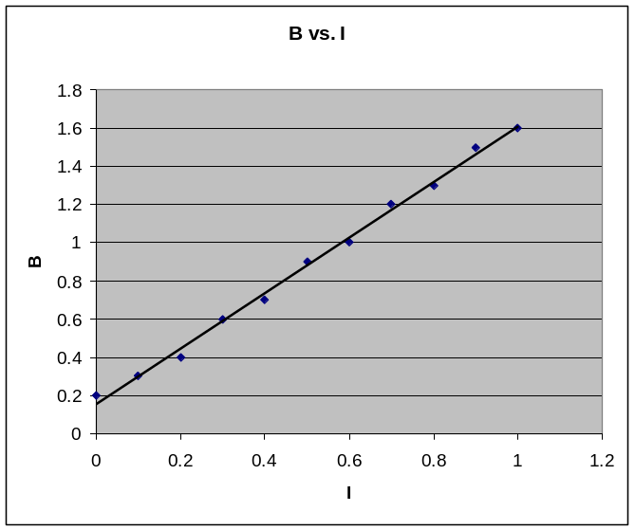
The slope of the line turned out to be 1.4545. This is fairly close to the calculated value of 1.3137 using equation [2].

Error:
ΔS = ½(S_{L} – S_{H}) = 0.151

Part D1:
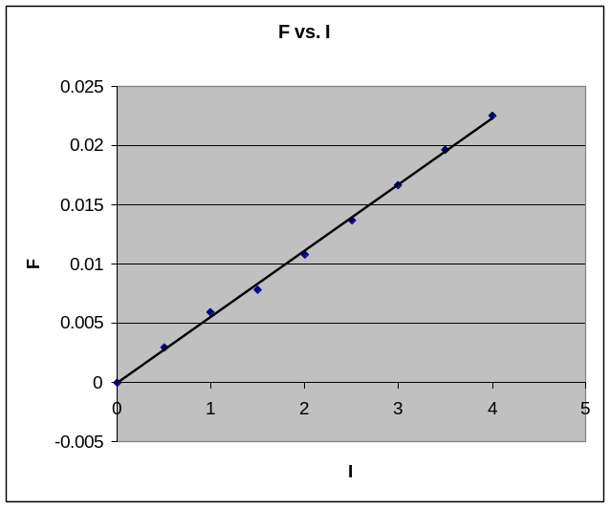

The slope of the best fit line turned out to be 0.0056. From this the value of the magnetic field can be found. As a result, the magnetic field should be equal to 0.0667 mT.

Error:
ΔS = ½(S_{L} – S_{H}) = 0.000045
ΔB = ΔS/L = 0.000045/0.084m = 0.00054

Part D2:
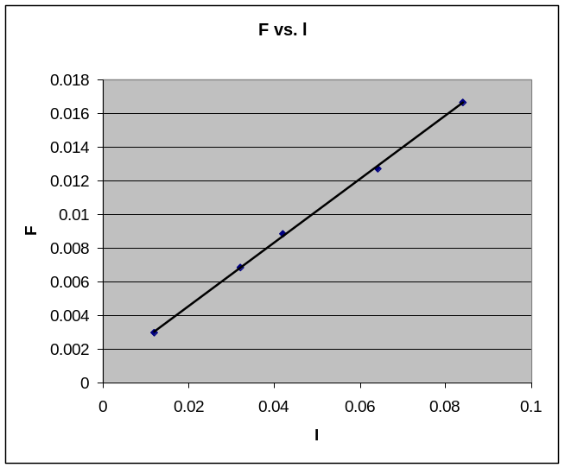

The slope of the trend line is 0.1892 for this graph. Dividing this number by the current, 3 amps, yields a magnetic field of 0.0630, which is very close to the value in D1 and the theoretical value.

Error:
ΔS = ½(S_{L} – S_{H}) = 0.0013
ΔB = ΔS/I = 0.0013/3A = 0.00043

Conclusion
The aim of the experiment was met. The errors were within acceptable limits, and everything seemed to work ok. The only problem I had with the lab was that there was so much variation on how to hold the sensor that could resulted in poor reading… there must be a more accurate way to fix the way it is held.

