DEPARTMENT OF BIOLOGICAL, CHEMICAL, AND PHYSICAL SCIENCE
ILLINOIS INSTITUTE OF TECHNOLOGY
PHYSICS 221

Electrons in Magnetic Fields/ AC Circuits

Lab #6
Thales Ramier
Date of Experiment: 17 November 05
Due Date: 08 December 05
Lab section 003
Statement of Objective

The objective in part A of this lab was to find the current for the different potential voltage values and for the different distances to the pins in the Bainbridge tube. Part B was meant to familiarize us with the analysis of an LRC circuit understanding its properties.

Theory

Equations Used:

e / m = v / (rB) [1]

e / m = (2V) / (r²B²) [2]

B = (8 / 5√5) . (μ₀IN / R) [3]

e / m = (125 / 32) . (VR² / μ₀²N²r²) [4]

I² = 1/(e/m) .(125 / 32) . (VR² / μ₀²N²r²) [5]

In a magnetic field, a moving charged particle will experience a force perpendicular to its motion. A particle will always be deflected if the magnetic field is perpendicular to its initial direction. IT can be observed that the particle travels in a circle, in centripetal motion. Electrons emerge from a cathode with a negligible initial velocity. When a potential difference V is applied, the electron’s speed increases. Upon getting to the anode, its kinetic energy is equal to its potential energy eV. The circuit in Part B is just simple LRC circuit that can be analyzed using the equations above.

Equipment List

Part A
- Helmholtz coil
- Bainbridge tube
- Ammeter
- Voltmeter

Part B
- Oscilloscope
- Resistor, Capacitor, Inductor
- LRC Circuit

Procedure

Part A

We first measured the diameter of the Helmholtz coil. Next, we made sure the Helmholtz coil and the Bainbridge were both connected as required, and set the current and voltage knobs to their minimum value before turning on the apparatus. We turned on the power supply for the Bainbridge tube, and adjusted the filament current to between 3.5 and 4.0 A. The accelerating potential was slowly increased to 30 V, where it stayed for the first set of readings. The power supply for the Helmholtz coil was then turned on, and the power was adjusted until the electron beam struck the first metal pin inside the Bainbridge tube. We changed the power until the beam hit each of the pins inside the Bainbridge tube. The experiment was then repeated with the increased accelerating potential values of 50, 70, and 90 V. The current information was recorded on the datasheet.

Part B

The circuit was made in accordance with the lab manual. The capacitance and the inductance were recorded. The frequency generator was placed at 500 Hertz and the outputs from Channel 1 and Channel 2 were made to be in phase. The circuit was then altered so that Channel 1 calculated the voltage across the resistor and Channel 2 calculated the voltage across the whole circuit. Then the phase difference between V_{R} and V_{LRC} was logged. The frequency where the voltage was a maximum was then found to be the resonant frequency of the circuit.

Data

A) Measure of charge/mass ratio

d (diameter) | 30 V | 50.17 V | 70.1 V | 90.2 V
65 mm | 1.86 A | 2.45 A | 2.85 A | 3.28 A
78 mm | 1.55 A | 2.04 A | 2.43 A | 2.74 A
90 mm | 1.34 A | 1.75 A | 2.08 A | 2.38 A
103 mm | 1.19 A | 1.54 A | 1.83 A | 2.09 A
115 mm | 1.04 A | 1.37 A | 1.61 A | 1.86 A

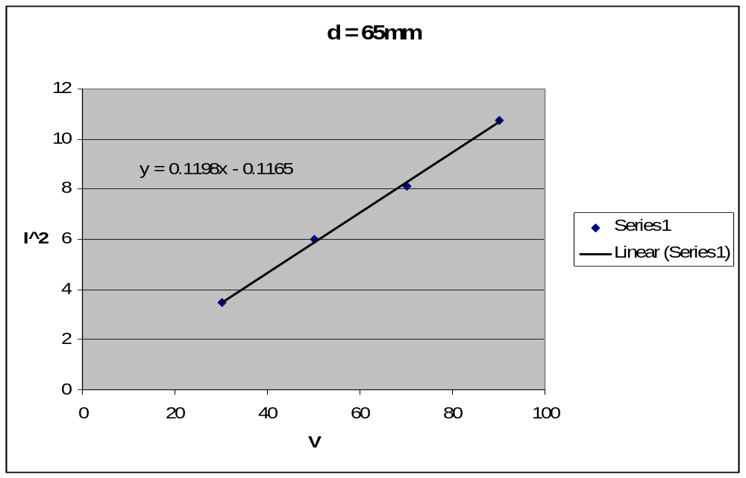

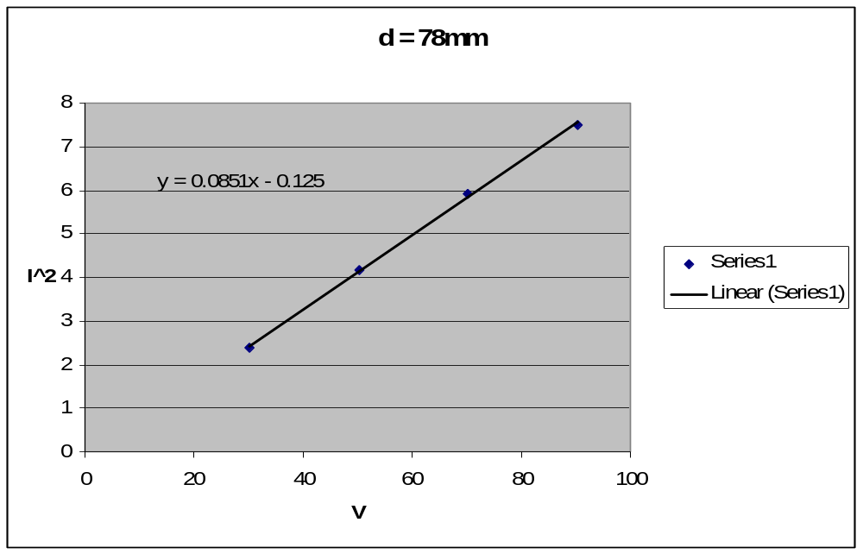

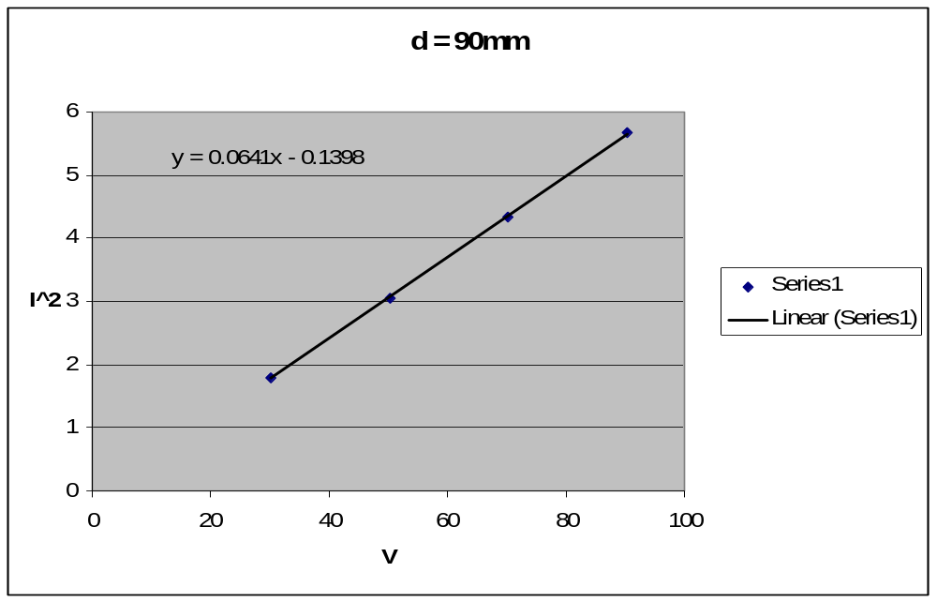

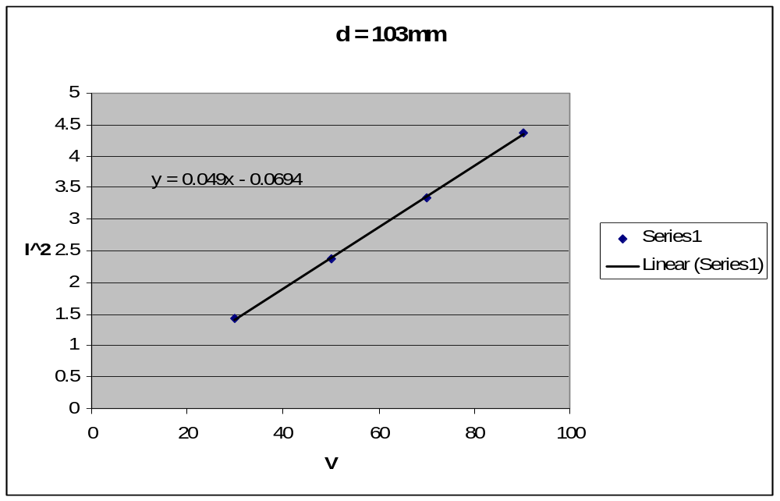

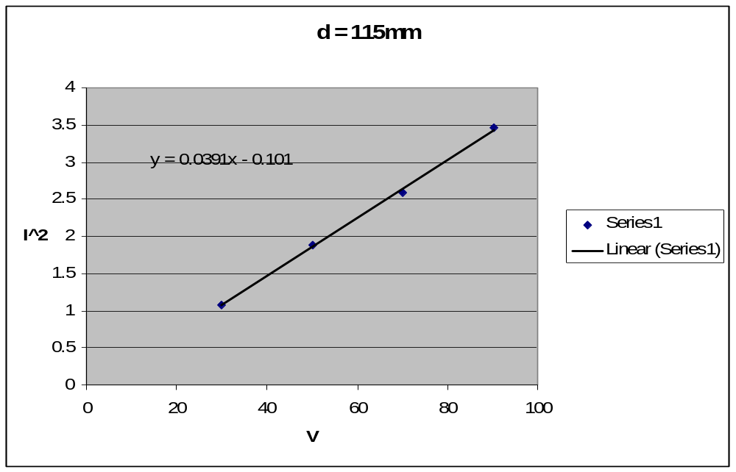

Part B

Resistor – 46.5k Ohms
Capacitor – 7.58 nF
Inductor – 0.506 H

Frequency for maximum current across the resistor – 1250 Hz
Frequency to achieve a correct Lissajous figure – 2445 Hz

Analyze Data

Given:
e / m = 1/s . (125 / 32) . (R² / μ₀²N²r²)
N = 100
R = 12.5 in = 0.3175 m

e / m₁ = 1/0.1198 . (125 / 32) . (0.3175² / ((1.26x10⁻⁶) ^{2 .}100^{2 .} (0.0325)²)) = 1.96x10¹¹
e / m₂ = 1/0.0851 . (125 / 32) . (0.3175² / ((1.26x10⁻⁶) ^{2 .}100^{2 .} (0.0390)²)) = 1.92x10¹¹
e / m₃ = 1/0.0641 . (125 / 32) . (0.3175² / ((1.26x10⁻⁶) ^{2 .}100^{2 .} (0.0450)²)) = 1.91x10¹¹
e / m₄ = 1/0.0490 . (125 / 32) . (0.3175² / ((1.26x10⁻⁶) ^{2 .}100^{2 .} (0.0515)²)) = 1.91x10¹¹
e / m₅ = 1/0.0391 . (125 / 32) . (0.3175² / ((1.26x10⁻⁶) ^{2 .}100^{2 .} (0.0575)²)) = 1.92x10¹¹

Average e/m = 1.92x10¹¹

Standard Deviation = Δ(e/m) = √( (1/5) . (Σ (e/m₁ – e/m_{avg})²…… ) = 1.9x10⁹

NOTE:
The theoretical value is 1.76x10¹¹; this does not agree with experimental value within the standard deviation; however this can easily be contributed to error in both human observation and equipment.

Part B

Using the equation below, one can find the resonant frequency of an LRC circuit.

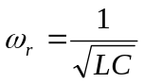

Using the said values and equations, the theoretical resonant frequency of our LRC circuit is 2570 Hz. The measured frequency for maximum current was only 1250 Hz, about half of the resonant frequency. The measured frequency to achieve resonance was 2445 Hz, which is very close to the theoretical resonant frequency.

Conclusion

The results of Part A of the experiment were very close. Any errors that are found in the calculations are most likely human error or the weak glow of the Bainbridge tube. The results of Part 2 are also within the acceptable error margin.

