DEPARTMENT OF BIOLOGICAL, CHEMICAL, AND PHYSICAL SCIENCE
ILLINOIS INSTITUTE OF TECHNOLOGY
PHYSICS 221

WAVES

Lab #2
Thales Ramier
Date of Experiment: 15 September 05
Due Date: 29 September 05
Lab section 003
Statement of Objective

This lab was used to examine the relationships and properties of standing waves using a wire, and interfering waves using sound waves. The properties and relationships will be proved using the measured data collected in the lab.

Theory

Waves are an intricate part of everyday life. Standing waves consist of waves with fixed points that do not move. These points are called nodes. There is also an anti node, which is found half way between each node. The number of anti nodes in any given wave is called the n and denotes the harmonic of that wave. Finding the harmonic and frequency of any standing wave one can determine at what velocity tha wave is moving by the equation:
Equipment List

- Spring
- Stand
- Weights
- String
- Timer

Procedure

Refer to Phys 221 Lab Manual Lab 1 for the procedure.

Data

Part A
The time it took a weight of mass M to oscillate 10 times on a spring.
Mass (g) Time (s)
50 | 9.724
55 | 9.895
65 | 10.696
85 | 12.224
105 | 13.239

Part B
The time it took to make 10 periods with a pendulum with a 20g weight, and a varying length.
Length (cm)
56 | 14.781
47 | 13.399
39 | 12.258
30 | 10.562
22 | 9.440

Analyze Data

Part A
The period T of the springs oscillation is:
Mass (g) Time (s) Period (s) T Period² (s²) T²
50 | 9.724 | .9724 | .9456
55 | 9.895 | .9895 | .9791
65 | 10.696 | 1.0696 | 1.144
85 | 12.224 | 1.2224 | 1.494
105 | 13.239 | 1.3239 | 1.753

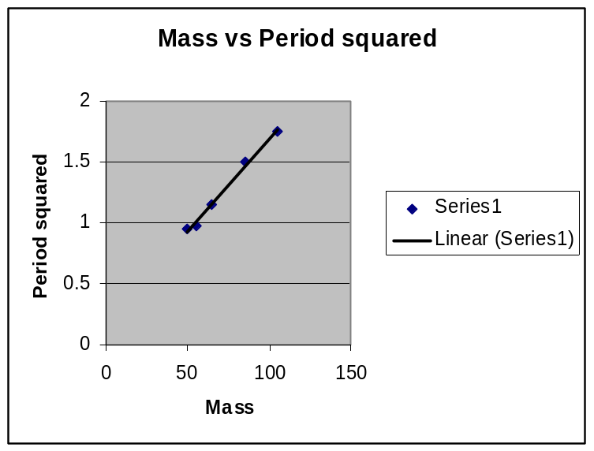
Equation 7 states:
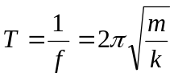
Therefore
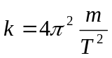
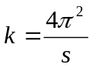
Where 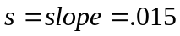
This makes k = 2.631 kg/s².

Part B
The period T of the strings motion is:
Length Time Period Period Sq.
56 | 14.781 | 1.4781 | 2.185
47 | 13.399 | 1.3399 | 1.795
39 | 12.258 | 1.2258 | 1.503
30 | 10.562 | 1.0562 | 1.108
22 | 9.44 | 0.944 | 0.891

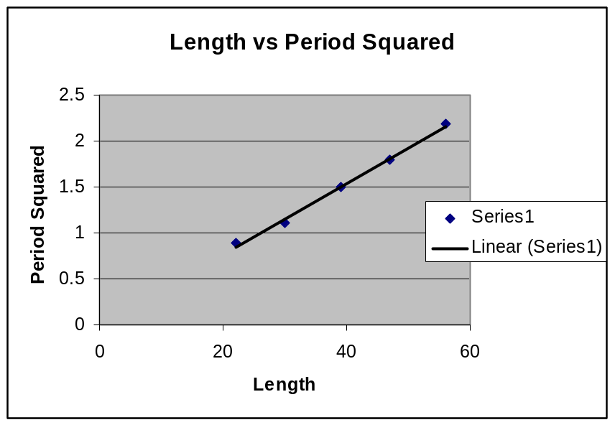

Equation 12 is:
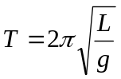
Therefore
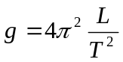
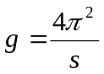
Where s = slope = .038
This makes the measured value for g = 1032.5 m/s².

Discussion of Analysis

The result for g in the second portion of the experiment is entirely off and not at all accurate. This may be owing to the fact that in order to measure the oscillation an angle must be made which distorts the correct reading of the period T. The results from part A are also off from the human interference factor.
Conclusion

Although the proper g was not found this lab still allowed the study of harmonic motion and facilitated the exploration of the oscilloscope where the smooth wave had a frequency of 1 mHz
with an amplitude of 20 volts. The square wave has an amplitude of 2 volts and a period of .66 mS.

