DEPARTMENT OF BIOLOGICAL, CHEMICAL, AND PHYSICAL SCIENCE
ILLINOIS INSTITUTE OF TECHNOLOGY
PHYSICS 221

WAVES

Lab #2
Thales Ramier
Date of Experiment: 15 September 05
Due Date: 29 September 05
Lab section 003
Statement of Objective

This lab was used to examine the relationships and properties of standing waves using a wire, and interfering waves using sound waves. The properties and relationships will be proved using the measured data collected in the lab.

Theory

Waves are an intricate part of everyday life. Standing waves consist of waves with fixed points that do not move. These points are called nodes. There is also an anti node, which is found half way between each node. The number of anti nodes in any given wave is called the n and denotes the harmonic of that wave. Finding the harmonic and frequency of any standing wave one can determine at what velocity the wave is moving by the equation:

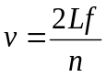
If you plotted a graph of frequency f versus the harmonics n the slope would be equal to the velocity divided by two times the length of the string.

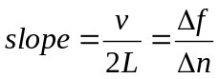

Interfering waves occur everywhere in two major forms; constructive waves when in phase, and destructive waves when out of phase. If the difference between the distances the two waves travel to the same point (S₁b) is:

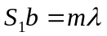

then the waves are constructive, but if the difference is:

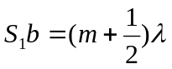

then the waves will be destructive. By plotting the sin θ vs. m the wavelength of these waves can be found using:

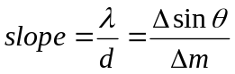

Where d is the distance between the waves and the point P when it is centered between the wave’s points of origin.

Equipment List

Part A
- Power supply
- Transistor
- Magnet
- Hanging mass
- Amp meter
- Sine generator
- Wire string
- Pulley setup
- Anchor post
- Measuring stick
Part B
- Two speakers
- One microphone
- Two anchor tracks
- Oscilloscope
- Frequency generator
- Measuring stick

Procedure

Refer to Phys 221 Lab Manual Lab 2 for the procedure.

Data

Part A
Frequencies for waves with n nodes
n | f_{theoretical} | F_{experimental} | % differance
3 | 60.8 Hz | 60.0 Hz | 1.3 %
4 | 81.1 Hz | 83.1 Hz | 2.4 %
5 | 101.4 Hz | 101.4 Hz | 0.0 %
7 | 141.9 Hz | 142.5 Hz | 0.4 %

Part B
Distance from center where waves interfere with each other
M | X_{R} | X_{R} | (X_{R}+X_{L})/2 | θ
1 | 5.4 cm | 8 cm | 6.7 cm | 6.9°
2 | 11.7 cm | 14.1 cm | 12.9 cm | 13.1°
3 | 18.5 cm | 21.6 cm | 20.05 cm | 19.9°

Analyze Data

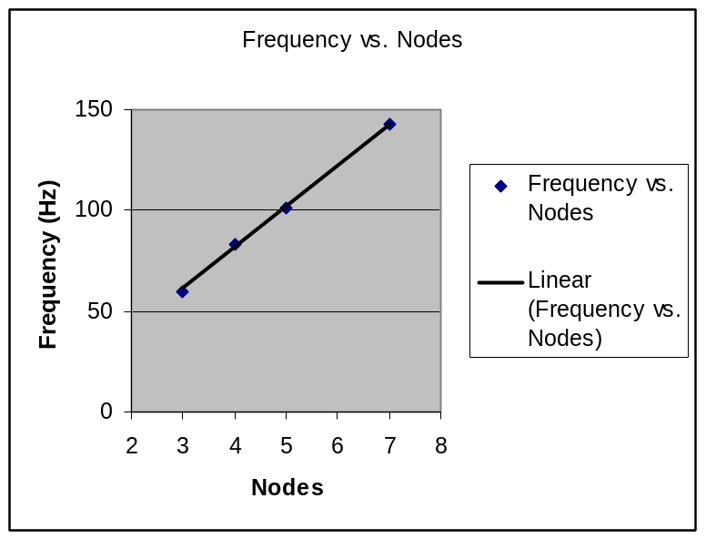

The theoretical speed of the wave should be 36.1 m/s. The experimental speed found using 20.47 as f/n is 36.34 m/s, a less than 1 % difference.

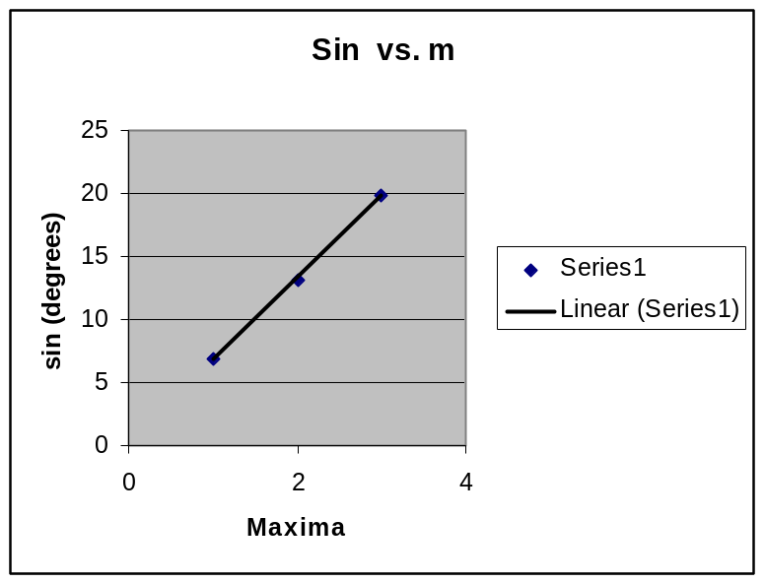

By using the room temperature of 296.5K and the equation for v = 20.05(T)^{1/2}, the theoretical speed if 345.24 m/s. The wavelength is .0084 m, where as the experimental wavelength is .00825 and speed of 338.25 m/s, which is only 2 % off.

Discussion of Analysis

The results of part A found a wave velocity of 36.34 m/s with a difference of .24 m/s from the theoretical value. The experimental result was less than 1% off. The results from Part B yielded a wave velocity of 338.25 m/s and a wavelength of .00825. the experimental results were within 2% of the theoretical values.

Conclusion

The velocity of a transverse wave on a string can be calculated from the length, frequency, and number of nodes on the string. The velocity of ultrasonic waves can be found by using interference.

