DEPARTMENT OF BIOLOGICAL, CHEMICAL, AND PHYSICAL SCIENCE
ILLINOIS INSTITUTE OF TECHNOLOGY
PHYSICS 221

Capacitors

Lab #4
Thales Ramier
Date of Experiment: 19 October 05
Due Date: 2 November 05
Lab section 003
Statement of Objective

This lab was designed to measure the time constant to display how a capacitor discharges, as well as to find the voltage across a discharging capacitor. In addition, determining the voltage across a capacitor as it discharges.

Theory

Capacitors in parallel can be added together and capacitors in series can be combined by using the following equation:
1/C = 1/C₁ + 1/C₂ + … + 1/C_{n}
When determining the effective capacitance. The later have of the lab requires the user of this formula:
Ln V(t) = Ln Vo(t)-(t/τ)
The equation refers to the potential at time t of the discharg of a capacitor in an RC circuit.

Equipment List
- Capacitors
- Capacimeter
- Electrolytic capacitor
- Multi-Meter
- Power supply
- Timer
- Square wave voltage generator
- Oscilloscope
- Ohmmeter
- Pasco counter
- Resistor

Procedure

Part A

1. Using a capacimeter, measure the capacitance of each of the three capacitors given.
2. Connect them in series and in parallel and measure the effective capacitance of each combination.
3. Compare the experimental values with the ones calculated using Equations 2 and3

Part B

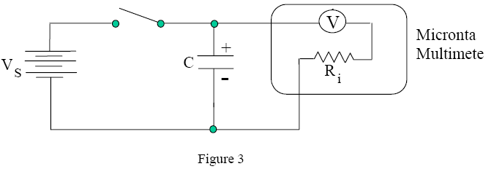

1. Using a capacimeter, find the capacitance of the given capacitor for the part.
2. Construct the circuit as shown in Figure 3, making sure the electrolytic capacitor is connected with correct polarity.
3. Use the 10 V setting of the voltmeter even though the meter may be somewhat overloaded.
4. Charge the capacitor by closing the switch.
5. Open the switch and start time (t = 0) when the voltmeter reads exactly 10 V.
6. Create a two-column data table. The first column is for time and the second column for voltage.
Part C

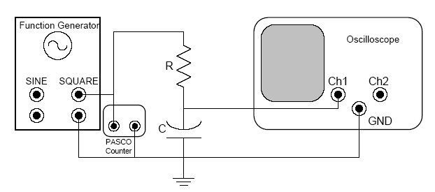

Setup for part C

1. Using a capacimeter and an Ohmmeter, find the capacitance and resistance of the capacitor and resistor given for this part.
2. Connect the RC circuit as shown in Figure 4.
3. The oscilloscope should be set in the NORM trigger mode, to display the signal from CH1.
4. Switch on the function generator and set it to 250 Hz.
5. Adjust the vertical and horizontal positioning knob, the time/div scale, and the V/div scale for Channel 1 until you obtain the charging/discharging trace.
Expand the trace so that it extends across the whole 8 divisions of the screen, only making visible one complete period of the square wave.
6. Now record the value of t when the charging voltage is 63% of the highest voltage. Similarly, record t when the discharging voltage is 37% of the initial voltage.
7. Compare this with the product of RC obtained from the individual values of R and C found earlier.

Data

Part A

C1 = 7.64nF
C2 = 10.37nF
C3 = 5.51nF
Measured Series effective capacitance = 2.45nF
Measured Parallel effective capacitance = 23.6nF

Part B

V | T(s)
10 | 0
9 | 11
8 | 24
7 | 39
6 | 57
5 | 76
4 | 104
3 | 140
2 | 194
1 | 286
C = 433 μF
Ri = 250k ohm

Part C

Frequency= 155hz
C = 8.39 nf
R = 46.9k ohm
Time at 63% of charge = 0.2ms
Time at 37% of discharge = 0.25ms

Analyze Data

Part A

The parallel capacitors calculated value was 23.52nF meaning that the measured results were within one percent accuracy. The series capacitors calculated value was 2.44nF meaning that the measured results were also within less than one percent accuracy. These results verify the two capacitor laws concerning series and parallel (see above) are true.

Part B

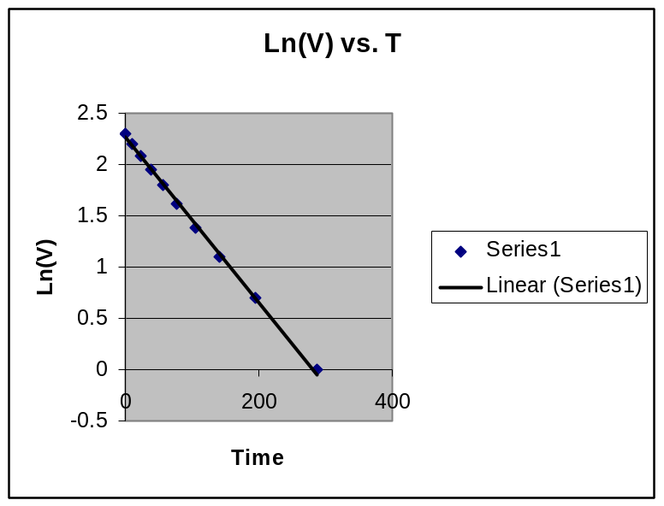

Looking at the graph of ln(V(t)) vs t, it is observed that the inverse of the graphs slope was the same as the time constant, which was found to be 32. The calculated value 108 which gives the experimental value a 70% accuracy.

Part C

The measured time constant was 0.225ms, while the calculated was .47ms. The results were within a 50% error.

Conclusion
The percentage errors in part A clearly support a successful lab proving the objective with results that are within 1%. In part B and C there seemed to be a strangely large percentage error. After observing RC circuits and their functioning there is a high understanding of how to determine capacitance values experimentally, and an understanding of the theories of capacitance giving light to the applications of electric circuits and their theory.

