尚硅谷大数据技术之Griffin

(作者：尚硅谷大数据研发部)

版本：V2.0

# 第1章 Griffin入门

## 1.1 Griffin概述

Apache Griffin是一个开源的大数据数据质量解决方案，它支持批处理和流模式两种数据质量检测方式，可以从不同维度度量数据资产，从而提升数据的准确度和可信度。例如：离线任务执行完毕后检查源端和目标端的数据数量是否一致，源表的数据空值等。

## 1.2 Griffin架构原理



# 第2章 Griffin安装及使用

## 2.1 安装前环境准备

### 2.1.1 安装ES5.2

1）上传elasticsearch-5.2.2.tar.gz到hadoop102的/opt/software目录，并解压到/opt/module目录

[atguigu@hadoop102 software]$ tar -zxvf elasticsearch-5.2.2.tar.gz -C /opt/module/

2）修改/opt/module/elasticsearch-5.2.2/config/elasticsearch.yml配置文件

[atguigu@hadoop102 config]$ vim elasticsearch.yml

network.host: hadoop102

http.port: 9200

http.cors.enabled: true

http.cors.allow-origin: "*"

bootstrap.memory_lock: false

bootstrap.system_call_filter: false

3）修改Linux系统配置文件/etc/security/limits.conf

[atguigu@hadoop102 elasticsearch-5.2.2]$ sudo vim /etc/security/limits.conf

#添加如下内容

* soft nproc 65536

* hard nproc 65536

* soft nofile 65536

* hard nofile 65536

[atguigu@hadoop102 elasticsearch-5.2.2]$ sudo vim /etc/sysctl.conf

#添加

vm.max_map_count=655360

[atguigu@hadoop102 elasticsearch-5.2.2]$ sudo vim /etc/security/limits.d/90-nproc.conf

#修改配置

* soft nproc 2048

[atguigu@hadoop102 elasticsearch-5.2.2]$ sudo sysctl -p

4）需要重新启动虚拟机

[atguigu@hadoop102 elasticsearch-5.2.2]$ su root

root@hadoop102 elasticsearch-5.2.2]# reboot

5）在/opt/module/elasticsearch-5.2.2路径上，启动ES

[atguigu@hadoop102 elasticsearch-5.2.2]$ nohup /opt/module/elasticsearch-5.2.2/bin/elasticsearch &

6）在ES里创建griffin索引

[atguigu@hadoop102 ~]$ curl -XPUT http://hadoop102:9200/griffin -d '

{

"aliases": {},

"mappings": {

"accuracy": {

"properties": {

"name": {

"fields": {

"keyword": {

"ignore_above": 256,

"type": "keyword"

}

},

"type": "text"

},

"tmst": {

"type": "date"

}

}

}

},

"settings": {

"index": {

"number_of_replicas": "2",

"number_of_shards": "5"

}

}

}

'

### 2.1.2 启动HDFS & Yarn服务

[atguigu@hadoop102 hadoop-2.7.2]$ sbin/start-dfs.sh

[atguigu@hadoop103 hadoop-2.7.2]$ sbin/start-yarn.sh

### 2.1.3 修改Hive 配置

注意：Hive版本至少2.2及以上

3）将Mysql的mysql-connector-java-5.1.27-bin.jar拷贝到/opt/module/hive/lib/

[atguigu@hadoop102 module]$ cp /opt/software/mysql-libs/mysql-connector-java-5.1.27/mysql-connector-java-5.1.27-bin.jar /opt/module/hive/lib/

4）在/opt/module/hive/conf路径上，修改hive-site.xml文件，添加红色部分。（注意mysql的密码要正确，否则元数据连接不上）

[atguigu@hadoop102 conf]$ vim hive-site.xml

#添加如下内容

<?xml version="1.0"?>

<?xml-stylesheet type="text/xsl" href="configuration.xsl"?>

<configuration>

<property>

<name>javax.jdo.option.ConnectionURL</name>

<value>jdbc:mysql://hadoop102:3306/metastore?createDatabaseIfNotExist=true</value>

<description>JDBC connect string for a JDBC metastore</description>

</property>

<property>

<name>javax.jdo.option.ConnectionDriverName</name>

<value>com.mysql.jdbc.Driver</value>

<description>Driver class name for a JDBC metastore</description>

</property>

<property>

<name>javax.jdo.option.ConnectionUserName</name>

<value>root</value>

<description>username to use against metastore database</description>

</property>

<property>

<name>javax.jdo.option.ConnectionPassword</name>

<value>123456</value>

<description>password to use against metastore database</description>

</property>

<property>

<name>hive.metastore.warehouse.dir</name>

<value>/user/hive/warehouse</value>

<description>location of default database for the warehouse</description>

</property>

<property>

<name>hive.cli.print.header</name>

<value>true</value>

</property>

<property>

<name>hive.cli.print.current.db</name>

<value>true</value>

</property>

<property>

<name>hive.metastore.schema.verification</name>

<value>false</value>

</property>

<property>

<name>datanucleus.schema.autoCreateAll</name>

<value>true</value>

</property>

<property>

<name>hive.metastore.uris</name>

<value>thrift://hadoop102:9083</value>

</property>

</configuration>

3）启动服务

[atguigu@hadoop102 hive]$ nohup /opt/module/hive/bin/hive --service metastore &

[atguigu@hadoop102 hive]$ nohup /opt/module/hive/bin/hive --service hiveserver2 &

注意：hive2.x版本需要启动两个服务metastore和hiveserver2，否则会报错Exception in thread "main" java.lang.RuntimeException: org.apache.hadoop.hive.ql.metadata.HiveException: java.lang.RuntimeException: Unable to instantiate org.apache.hadoop.hive.ql.metadata.SessionHiveMetaStoreClient

4）服务启动完毕后在启动Hive

[atguigu@hadoop102 hive]$ /opt/module/hive/bin/hive

### 2.1.4 安装Spark2.4.6

注意：Spark版本至少2.2.1及以上

1）把spark-2.4.6-bin-hadoop2.7.tgz上传到/opt/software目录，并解压到/opt/module

[atguigu@hadoop102 software]$ tar -zxvf spark-2.4.6-bin-hadoop2.7.tgz -C /opt/module/

2）修改名称/opt/module/spark-2.4.6-bin-hadoop2.7名称为spark

[atguigu@hadoop102 module]$ mv spark-2.4.3-bin-hadoop2.7/ spark

3）修改/opt/module/spark/conf/spark-defaults.conf.template名称为spark-defaults.conf

[atguigu@hadoop102 conf]$ mv spark-defaults.conf.template spark-defaults.conf

4）在spark-default.conf文件中配置Spark日志路径

[atguigu@hadoop102 conf]$ vim spark-defaults.conf

#添加如下配置

spark.eventLog.enabled true

spark.eventLog.dir hdfs://hadoop102:9000/spark_directory

5）修改配置文件slaves名称

[atguigu@hadoop102 conf]$ mv slaves.template slaves

6）修改slave文件，添加work节点：

[atguigu@hadoop102 conf]$ vim slaves

hadoop102

hadoop103

hadoop104

7）修改/opt/module/spark/conf/spark-env.sh.template名称为spark-env.sh

[atguigu@hadoop102 conf]$ mv spark-env.sh.template spark-env.sh

8）在/opt/module/spark/conf/spark-env.sh文件中配置YARN配置文件路径、配置历史服务器相关参数

[atguigu@hadoop102 conf]$ vim spark-env.sh

#添加如下参数

YARN_CONF_DIR=/opt/module/hadoop-2.7.2/etc/hadoop

export SPARK_HISTORY_OPTS="-Dspark.history.ui.port=18080

-Dspark.history.retainedApplications=30

-Dspark.history.fs.logDirectory=hdfs://hadoop102:9000/spark_directory"

SPARK_MASTER_HOST=hadoop102

SPARK_MASTER_PORT=7077

9）在hadoop集群上提前创建spark_directory日志路径

[atguigu@hadoop102 spark]$ hadoop fs -mkdir /spark_directory

10）把Hive中/opt/module/hive/lib/datanucleus-*.jar包拷贝到Spark的/opt/module/spark/jars路径

[atguigu@hadoop102 lib]$ cp /opt/module/hive/lib/datanucleus-*.jar /opt/module/spark/jars/

9）把Hive中/opt/module/hive/conf/hive-site.xml包拷贝到Spark的/opt/module/spark/conf路径

[atguigu@hadoop102 conf]$ cp /opt/module/hive/conf/hive-site.xml /opt/module/spark/conf/

10）修改hadoop配置文件yarn-site.xml,添加如下内容：

[atguigu@hadoop102 hadoop]$ vi yarn-site.xml

<!--是否启动一个线程检查每个任务正使用的物理内存量，如果任务超出分配值，则直接将其杀掉，默认是true -->

<property>

<name>yarn.nodemanager.pmem-check-enabled</name>

<value>false</value>

</property>

<!--是否启动一个线程检查每个任务正使用的虚拟内存量，如果任务超出分配值，则直接将其杀掉，默认是true -->

<property>

<name>yarn.nodemanager.vmem-check-enabled</name>

<value>false</value>

</property>

11）分发spark & yarn-site.xml

[atguigu@hadoop102 conf]$ xsync /opt/module/hadoop-2.7.2/etc/hadoop/yarn-site.xml

[atguigu@hadoop102 conf]$ xsync /opt/module/spark

10）测试环境

[atguigu@hadoop102 spark]$ bin/spark-shell

scala>spark.sql("show databases").show

### 2.1.5 安装Livy0.3

1）上传livy-server-0.3.0.zip到hadoop102的/opt/software目录下，并解压到/opt/module

[atguigu@hadoop102 software]$ unzip livy-server-0.3.0.zip -d /opt/module/

2）修改/opt/module/livy-server-0.3.0文件名称为livy

[atguigu@hadoop102 module]$ mv livy-server-0.3.0/ livy

3）修改/opt/module/livy/conf/livy-env.sh文件，添加livy环境相关参数

export HADOOP_CONF_DIR=/opt/module/hadoop-2.7.2/etc/hadoop/

export SPARK_HOME=/opt/module/spark/

3）修改/opt/module/livy/conf/livy.conf文件，配置livy与spark相关参数

livy.server.host = hadoop102

livy.spark.master =yarn

livy.spark.deployMode = client

livy.repl.enableHiveContext = true

livy.server.port = 8998

4）配置需要的环境变量

[atguigu@hadoop102 conf]$ sudo vim /etc/profile

#SPARK_HOME

export SPARK_HOME=/opt/module/spark

export PATH=$PATH:$SPARK_HOME/bin

[atguigu@hadoop102 conf]$ source /etc/profile

5）在/opt/module/livy/路径上，启动livy服务

[atguigu@hadoop102 livy]$ bin/livy-server start

### 2.1.6 初始化MySQL 数据库

1）上传Init_quartz_mysql_innodb.sql 到hadoop102的/opt/software目录

2）使用mysql创建quartz库，执行脚本初始化表信息

[atguigu@hadoop102 ~]$ mysql -uroot -p123456

mysql> create database quartz;

mysql> use quartz;

mysql> source /opt/software/Init_quartz_mysql_innodb.sql

mysql> show tables;

## 2.2 编译Griffin（不选择）

### 2.2.1 安装Maven

1）Maven下载：https://maven.apache.org/download.cgi

2）把apache-maven-3.6.1-bin.tar.gz上传到linux的/opt/software目录下

3）解压apache-maven-3.6.1-bin.tar.gz到/opt/module/目录下面

[atguigu@hadoop102 software]$ tar -zxvf apache-maven-3.6.1-bin.tar.gz -C /opt/module/

4）修改apache-maven-3.6.1的名称为maven

[atguigu@hadoop102 module]$ mv apache-maven-3.6.1/ maven

5）添加环境变量到/etc/profile中

[atguigu@hadoop102 module]$ sudo vim /etc/profile

#MAVEN_HOME

export MAVEN_HOME=/opt/module/maven

export PATH=$PATH:$MAVEN_HOME/bin

6）测试安装结果

[atguigu@hadoop102 module]$ source /etc/profile

[atguigu@hadoop102 module]$ mvn -v

7）修改setting.xml，指定为阿里云

[atguigu@hadoop102 maven]$ cd conf

[atguigu@hadoop102 maven]$ vim settings.xml

<!-- 添加阿里云镜像-->

<mirror>

<id>nexus-aliyun</id>

<mirrorOf>central</mirrorOf>

<name>Nexus aliyun</name>

<url>http://maven.aliyun.com/nexus/content/groups/public</url>

</mirror>

<mirror>

<id>UK</id>

<name>UK Central</name>

<url>http://uk.maven.org/maven2</url>

<mirrorOf>central</mirrorOf>

</mirror>

<mirror>

<id>repo1</id>

<mirrorOf>central</mirrorOf>

<name>Human Readable Name for this Mirror.</name>

<url>http://repo1.maven.org/maven2/</url>

</mirror>

<mirror>

<id>repo2</id>

<mirrorOf>central</mirrorOf>

<name>Human Readable Name for this Mirror.</name>

<url>http://repo2.maven.org/maven2/</url>

</mirror>

8）在/home/atguigu目录下创建.m2文件夹

[atguigu@hadoop102 ~]$ mkdir .m2

### 2.2.2 修改配置文件:

1）上传griffin-master.zip到hadoop102的/opt/software目录，并解压tar.gz包到/opt/module

[atguigu@hadoop102 software]$ unzip griffin-master.zip -d /opt/module/

2）修改/opt/module/griffin-master/ui/pom.xml文件，添加node和npm源。

[atguigu@hadoop102 ui]$ vim pom.xml

<!-- It will install nodejs and npm -->

<execution>

<id>install node and npm</id>

<goals>

<goal>install-node-and-npm</goal>

</goals>

<configuration>

<nodeVersion>${node.version}</nodeVersion>

<npmVersion>${npm.version}</npmVersion>

<nodeDownloadRoot>http://nodejs.org/dist/</nodeDownloadRoot>

<npmDownloadRoot>http://registry.npmjs.org/npm/-/</npmDownloadRoot>

</configuration>

</execution>

2）修改/opt/module/griffin-master/service/pom.xml文件，注释掉org.postgresql，添加mysql依赖。

[atguigu@hadoop102 service]$ vim pom.xml

<!--

<dependency>

<groupId>org.postgresql</groupId>

<artifactId>postgresql</artifactId>

<version>${postgresql.version}</version>

</dependency>

-->

<dependency>

<groupId>mysql</groupId>

<artifactId>mysql-connector-java</artifactId>

</dependency>

注意:版本号删除掉

3）修改/opt/module/griffin-master/service/src/main/resources/application.properties文件

[atguigu@hadoop102 service]$ vim /opt/module/griffin-master/service/src/main/resources/application.properties

# Apache Griffin应用名称

spring.application.name=griffin_service

# MySQL数据库配置信息

spring.datasource.url=jdbc:mysql://hadoop102:3306/quartz?autoReconnect=true&useSSL=false

spring.datasource.username=root

spring.datasource.password=000000

spring.jpa.generate-ddl=true

spring.datasource.driver-class-name=com.mysql.jdbc.Driver

spring.jpa.show-sql=true

# Hive metastore配置信息

hive.metastore.uris=thrift://hadoop102:9083

hive.metastore.dbname=default

hive.hmshandler.retry.attempts=15

hive.hmshandler.retry.interval=2000ms

# Hive cache time

cache.evict.hive.fixedRate.in.milliseconds=900000

# Kafka schema registry按需配置

kafka.schema.registry.url=http://hadoop102:8081

# Update job instance state at regular intervals

jobInstance.fixedDelay.in.milliseconds=60000

# Expired time of job instance which is 7 days that is 604800000 milliseconds.Time unit only supports milliseconds

jobInstance.expired.milliseconds=604800000

# schedule predicate job every 5 minutes and repeat 12 times at most

#interval time unit s:second m:minute h:hour d:day,only support these four units

predicate.job.interval=5m

predicate.job.repeat.count=12

# external properties directory location

external.config.location=

# external BATCH or STREAMING env

external.env.location=

# login strategy ("default" or "ldap")

login.strategy=default

# ldap

ldap.url=ldap://hostname:port

ldap.email=@example.com

ldap.searchBase=DC=org,DC=example

ldap.searchPattern=(sAMAccountName={0})

# hdfs default name

fs.defaultFS=

# elasticsearch

elasticsearch.host=hadoop102

elasticsearch.port=9200

elasticsearch.scheme=http

# elasticsearch.user = user

# elasticsearch.password = password

# livy

livy.uri=http://hadoop102:8998/batches

# yarn url

yarn.uri=http://hadoop103:8088

# griffin event listener

internal.event.listeners=GriffinJobEventHook

4）修改/opt/module/griffin-master/service/src/main/resources/sparkProperties.json文件

[atguigu@hadoop102 service]$ vim /opt/module/griffin-master/service/src/main/resources/sparkProperties.json

{

"file": "hdfs://hadoop102:9000/griffin/griffin-measure.jar",

"className": "org.apache.griffin.measure.Application",

"name": "griffin",

"queue": "default",

"numExecutors": 2,

"executorCores": 1,

"driverMemory": "1g",

"executorMemory": "1g",

"conf": {

"spark.yarn.dist.files": "hdfs://hadoop102:9000/home/spark_conf/hive-site.xml"

},

"files": [

]

}

5）修改/opt/module/griffin-master/service/src/main/resources/env/env_batch.json文件

[atguigu@hadoop102 service]$ vim /opt/module/griffin-master/service/src/main/resources/env/env_batch.json

{

"spark": {

"log.level": "INFO"

},

"sinks": [

{

"type": "CONSOLE",

"config": {

"max.log.lines": 10

}

},

{

"type": "HDFS",

"config": {

"path": "hdfs://hadoop102:9000/griffin/persist",

"max.persist.lines": 10000,

"max.lines.per.file": 10000

}

},

{

"type": "ELASTICSEARCH",

"config": {

"method": "post",

"api": "http://hadoop102:9200/griffin/accuracy",

"connection.timeout": "1m",

"retry": 10

}

}

],

"griffin.checkpoint": []

}

6）修改/opt/module/griffin-master/service/src/main/resources/env/env_streaming.json文件

[atguigu@hadoop102 service]$ vim /opt/module/griffin-master/service/src/main/resources/env/env_streaming.json

{

"spark": {

"log.level": "WARN",

"checkpoint.dir": "hdfs:///griffin/checkpoint/${JOB_NAME}",

"init.clear": true,

"batch.interval": "1m",

"process.interval": "5m",

"config": {

"spark.default.parallelism": 4,

"spark.task.maxFailures": 5,

"spark.streaming.kafkaMaxRatePerPartition": 1000,

"spark.streaming.concurrentJobs": 4,

"spark.yarn.maxAppAttempts": 5,

"spark.yarn.am.attemptFailuresValidityInterval": "1h",

"spark.yarn.max.executor.failures": 120,

"spark.yarn.executor.failuresValidityInterval": "1h",

"spark.hadoop.fs.hdfs.impl.disable.cache": true

}

},

"sinks": [

{

"type": "CONSOLE",

"config": {

"max.log.lines": 100

}

},

{

"type": "HDFS",

"config": {

"path": "hdfs://hadoop102:9000/griffin/persist",

"max.persist.lines": 10000,

"max.lines.per.file": 10000

}

},

{

"type": "ELASTICSEARCH",

"config": {

"method": "post",

"api": "http://hadoop102:9200/griffin/accuracy"

}

}

],

"griffin.checkpoint": [

{

"type": "zk",

"config": {

"hosts": "zk:2181",

"namespace": "griffin/infocache",

"lock.path": "lock",

"mode": "persist",

"init.clear": true,

"close.clear": false

}

}

]

}

7）修改/opt/module/griffin-master/service/src/main/resources/quartz.properties文件

[atguigu@hadoop102 service]$ vim /opt/module/griffin-master/service/src/main/resources/quartz.properties

org.quartz.scheduler.instanceName=spring-boot-quartz

org.quartz.scheduler.instanceId=AUTO

org.quartz.threadPool.threadCount=5

org.quartz.jobStore.class=org.quartz.impl.jdbcjobstore.JobStoreTX

# If you use postgresql as your database,set this property value to org.quartz.impl.jdbcjobstore.PostgreSQLDelegate

# If you use mysql as your database,set this property value to org.quartz.impl.jdbcjobstore.StdJDBCDelegate

# If you use h2 as your database, it's ok to set this property value to StdJDBCDelegate, PostgreSQLDelegate or others

org.quartz.jobStore.driverDelegateClass=org.quartz.impl.jdbcjobstore.StdJDBCDelegate

org.quartz.jobStore.useProperties=true

org.quartz.jobStore.misfireThreshold=60000

org.quartz.jobStore.tablePrefix=QRTZ_

org.quartz.jobStore.isClustered=true

org.quartz.jobStore.clusterCheckinInterval=20000

### 2.2.3 执行编译

1）在/opt/module/griffin-master路径执行maven命令，开始编译Griffin源码

[atguigu@hadoop102 griffin-master]$ mvn -Dmaven.test.skip=true clean install

2）见到如下页面，表示编译成功。（大约需要1个小时左右）

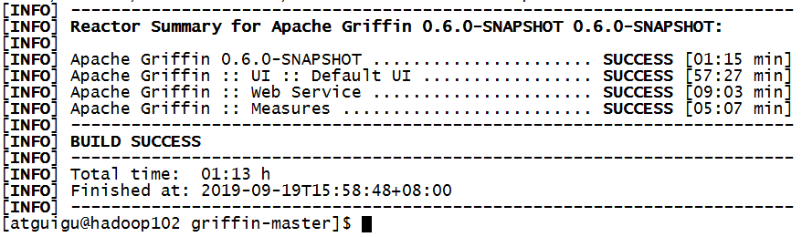

## 2.3 直接使用编译好的 Griffin 包（选择）

### 2.3.1 修改jar配置文件

Griffin编译完成后，会在Service和Measure模块的target目录下分别看到service-0.6.0.jar和measure-0.6.0.jar两个jar包。因为我们使用的是直接编译好的jar包，所以需要将service-0.6.0.jar 中的配置文件修改成与环境一致。

1）使用WinRaR等解压工具打开service-0.6.0.jar（注意：是打开不是解压）

2）修改BOOT-INF/classes/application.properties

# Apache Griffin应用名称

spring.application.name=griffin_service

# MySQL数据库配置信息

spring.datasource.url=jdbc:mysql://hadoop102:3306/quartz?autoReconnect=true&useSSL=false

spring.datasource.username=root

spring.datasource.password=123456

spring.jpa.generate-ddl=true

spring.datasource.driver-class-name=com.mysql.jdbc.Driver

spring.jpa.show-sql=true

# Hive metastore配置信息

hive.metastore.uris=thrift://hadoop102:9083

hive.metastore.dbname=default

hive.hmshandler.retry.attempts=15

hive.hmshandler.retry.interval=2000ms

# Hive cache time

cache.evict.hive.fixedRate.in.milliseconds=900000

# Kafka schema registry按需配置

kafka.schema.registry.url=http://hadoop102:8081

# Update job instance state at regular intervals

jobInstance.fixedDelay.in.milliseconds=60000

# Expired time of job instance which is 7 days that is 604800000 milliseconds.Time unit only supports milliseconds

jobInstance.expired.milliseconds=604800000

# schedule predicate job every 5 minutes and repeat 12 times at most

#interval time unit s:second m:minute h:hour d:day,only support these four units

predicate.job.interval=5m

predicate.job.repeat.count=12

# external properties directory location

external.config.location=

# external BATCH or STREAMING env

external.env.location=

# login strategy ("default" or "ldap")

login.strategy=default

# ldap

ldap.url=ldap://hostname:port

ldap.email=@example.com

ldap.searchBase=DC=org,DC=example

ldap.searchPattern=(sAMAccountName={0})

# hdfs default name

fs.defaultFS=

# elasticsearch

elasticsearch.host=hadoop102

elasticsearch.port=9200

elasticsearch.scheme=http

# elasticsearch.user = user

# elasticsearch.password = password

# livy

livy.uri=http://hadoop102:8998/batches

# yarn url

yarn.uri=http://hadoop103:8088

# griffin event listener

internal.event.listeners=GriffinJobEventHook

2）修改BOOT-INF/classes/sparkProperties.json

{

"file": "hdfs://hadoop102:9000/griffin/griffin-measure.jar",

"className": "org.apache.griffin.measure.Application",

"name": "griffin",

"queue": "default",

"numExecutors": 2,

"executorCores": 1,

"driverMemory": "1g",

"executorMemory": "1g",

"conf": {

"spark.yarn.dist.files": "hdfs://hadoop102:9000/home/spark_conf/hive-site.xml"

},

"files": [

]

}

3）修改BOOT-INF/classes/hive-site.xml

<?xml version="1.0"?>

<?xml-stylesheet type="text/xsl" href="configuration.xsl"?>

<configuration>

<property>

<name>javax.jdo.option.ConnectionURL</name>

<value>jdbc:mysql://hadoop102:3306/metastore?createDatabaseIfNotExist=true</value>

<description>JDBC connect string for a JDBC metastore</description>

</property>

<property>

<name>javax.jdo.option.ConnectionDriverName</name>

<value>com.mysql.jdbc.Driver</value>

<description>Driver class name for a JDBC metastore</description>

</property>

<property>

<name>javax.jdo.option.ConnectionUserName</name>

<value>root</value>

<description>username to use against metastore database</description>

</property>

<property>

<name>javax.jdo.option.ConnectionPassword</name>

<value>123456</value>

<description>password to use against metastore database</description>

</property>

<property>

<name>hive.metastore.warehouse.dir</name>

<value>/user/hive/warehouse</value>

<description>location of default database for the warehouse</description>

</property>

<property>

<name>hive.cli.print.header</name>

<value>true</value>

</property>

<property>

<name>hive.cli.print.current.db</name>

<value>true</value>

</property>

<property>

<name>hive.metastore.schema.verification</name>

<value>false</value>

</property>

<property>

<name>datanucleus.schema.autoCreateAll</name>

<value>true</value>

</property>

<!--

<property>

<name>hive.execution.engine</name>

<value>tez</value>

</property>

-->

<property>

<name>hive.metastore.uris</name>

<value>thrift://hadoop102:9083</value>

</property>

</configuration>

4）修改BOOT-INF/classes/application-mysql.properties

#Data Access Properties

spring.datasource.url=jdbc:mysql://192.168.1.102:3306/quartz?autoReconnect=true&useSSL=false

spring.datasource.username=root

spring.datasource.password=123456

spring.jpa.generate-ddl=true

spring.datasource.driver-class-name=com.mysql.jdbc.Driver

spring.jpa.show-sql=true

spring.jpa.hibernate.ddl-auto=update

5）修改BOOT-INF/classes/env/env_batch.json

{

"spark": {

"log.level": "INFO"

},

"sinks": [

{

"type": "CONSOLE",

"config": {

"max.log.lines": 10

}

},

{

"type": "HDFS",

"config": {

"path": "hdfs://hadoop102:9000/griffin/persist",

"max.persist.lines": 10000,

"max.lines.per.file": 10000

}

},

{

"type": "ELASTICSEARCH",

"config": {

"method": "post",

"api": "http://hadoop102:9200/griffin/accuracy",

"connection.timeout": "1m",

"retry": 10

}

}

],

"griffin.checkpoint": []

}

6）修改BOOT-INF/classes/env/env_streaming.json

{

"spark": {

"log.level": "WARN",

"checkpoint.dir": "hdfs:///griffin/checkpoint/${JOB_NAME}",

"init.clear": true,

"batch.interval": "1m",

"process.interval": "5m",

"config": {

"spark.default.parallelism": 4,

"spark.task.maxFailures": 5,

"spark.streaming.kafkaMaxRatePerPartition": 1000,

"spark.streaming.concurrentJobs": 4,

"spark.yarn.maxAppAttempts": 5,

"spark.yarn.am.attemptFailuresValidityInterval": "1h",

"spark.yarn.max.executor.failures": 120,

"spark.yarn.executor.failuresValidityInterval": "1h",

"spark.hadoop.fs.hdfs.impl.disable.cache": true

}

},

"sinks": [

{

"type": "CONSOLE",

"config": {

"max.log.lines": 100

}

},

{

"type": "HDFS",

"config": {

"path": "hdfs://hadoop102:9000/griffin/persist",

"max.persist.lines": 10000,

"max.lines.per.file": 10000

}

},

{

"type": "ELASTICSEARCH",

"config": {

"method": "post",

"api": "http://hadoop102:9200/griffin/accuracy"

}

}

],

"griffin.checkpoint": [

{

"type": "zk",

"config": {

"hosts": "zk:2181",

"namespace": "griffin/infocache",

"lock.path": "lock",

"mode": "persist",

"init.clear": true,

"close.clear": false

}

}

]

}

## 2.4 上传执行Griffin

### 2.4.1 修改名称并上传HDFS

命令执行完成后，会在Service和Measure模块的target目录下分别看到service-0.6.0.jar和measure-0.6.0.jar两个jar包。

1）修改/opt/module/griffin-master/measure/target/measure-0.6.0-SNAPSHOT.jar名称

[atguigu@hadoop102 measure]$ mv measure-0.6.0-SNAPSHOT.jar griffin-measure.jar

2）上传griffin-measure.jar到HDFS文件目录里

[atguigu@hadoop102 measure]$ hadoop fs -mkdir /griffin/

[atguigu@hadoop102 measure]$ hadoop fs -put griffin-measure.jar /griffin/

注意：这样做的目的主要是因为Spark在YARN集群上执行任务时，需要到HDFS的/griffin目录下加载griffin-measure.jar，避免发生类org.apache.griffin.measure.Application找不到的错误。

3）上传hive-site.xml文件到HDFS的/home/spark_conf/路径

[atguigu@hadoop102 ~]$ hadoop fs -mkdir -p /home/spark_conf/

[atguigu@hadoop102 ~]$ hadoop fs -put /opt/module/hive/conf/hive-site.xml /home/spark_conf/

### 2.4.2 执行Griffin

1）确保其他服务已经启动

① 启动 HDFS & YARN ：

[atguigu@hadoop102 module]$ /opt/module/hadoop-2.7.2/sbin/start-dfs.sh

[atguigu@hadoop103 module]$ /opt/module/hadoop-2.7.2/sbin/start-yarn.sh

② 启动 elasticsearch 服务：

[atguigu@hadoop102 module]$ nohup /opt/module/elasticsearch-5.2.2/bin/elasticsearch &

③ 启动 hive 服务：

[atguigu@hadoop102 hive]$ nohup /opt/module/hive/bin/hive --service metastore &

[atguigu@hadoop102 hive]$ nohup /opt/module/hive/bin/hive --service hiveserver2 &

④ 启动 livy 服务：

[atguigu@hadoop102 livy]$ /opt/module/livy/bin/livy-server start

2）进入到/opt/module/griffin-master/service/target/路径，运行service-0.6.0-SNAPSHOT.jar

控制台启动：控制台打印信息

[atguigu@hadoop102 target]$ java -jar /opt/module/griffin/service-0.6.0-SNAPSHOT.jar

后台启动：启动后台并把日志归写倒service.out

[atguigu@hadoop102 ~]$ nohup java -jar service-0.6.0-SNAPSHOT.jar>service.out 2>&1 &

### 2.4.3 浏览器访问

http://hadoop102:8080 默认账户和密码都是无

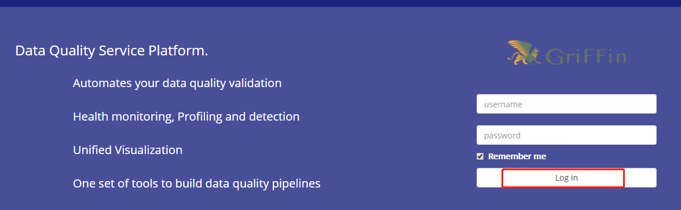

# 第3章 案例实操

## 3.1 生产测试数据

获取官网测试数据。在/opt/module/目录下创建data文件夹，并下载相关测试数据

[atguigu@hadoop102 moudle]$ mkdir data

[atguigu@hadoop102 data]$

wget http://griffin.apache.org/data/batch/gen_demo_data.sh

wget http://griffin.apache.org/data/batch/gen_delta_src.sh

wget http://griffin.apache.org/data/batch/demo_basic

wget http://griffin.apache.org/data/batch/delta_tgt

wget <http://griffin.apache.org/data/batch/insert-data.hql.template>

wget <http://griffin.apache.org/data/batch/gen-hive-data.sh>

wget http://griffin.apache.org/data/batch/create-table.hql

wget <http://griffin.apache.org/data/batch/delta_src>

wget [http://griffin.apache.org/data/batch/](http://griffin.apache.org/data/batch/delta_src)delta_tgt

[atguigu@hadoop102 data]$ chmod 777 ../data -R

#生成临时文件

[atguigu@hadoop102 data]$ ./gen_demo_data.sh

#生产测试数据

[atguigu@hadoop102 data]$ ./gen-hive-data.sh

## 3.2 UI创建Measure

注意根据官网描述，目前UI创建Measure只支持Accuracy的Measure，UI界面上虽然有其他选项但是无法运行job。

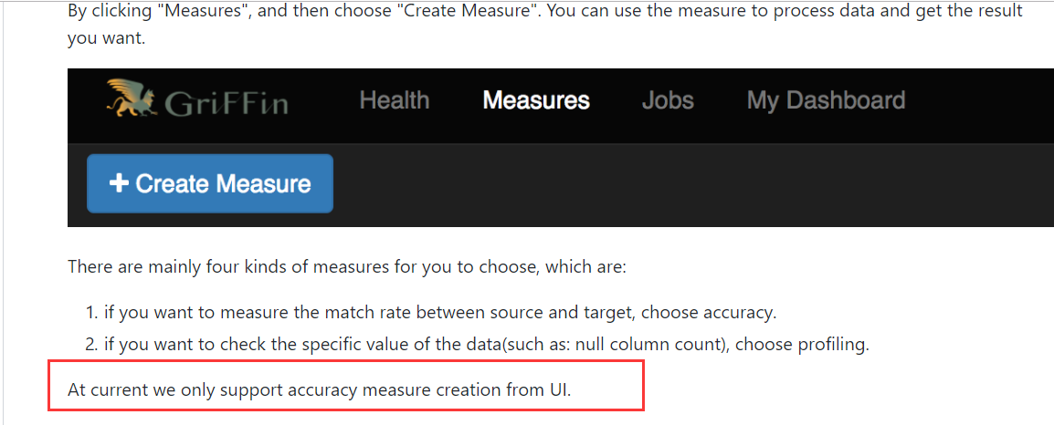

### 3.2.1 添加一个新的Measure

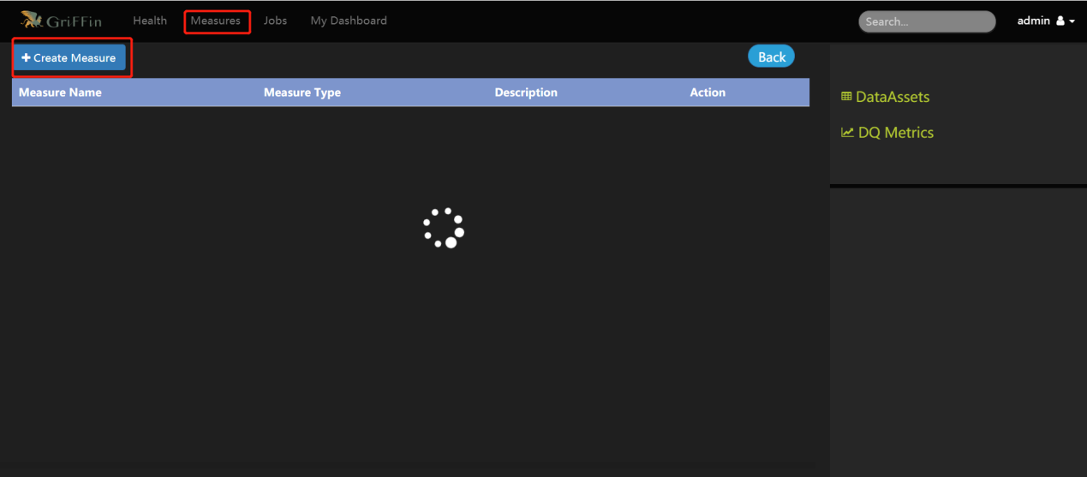

### 3.2.2 选择准确度Accuracy

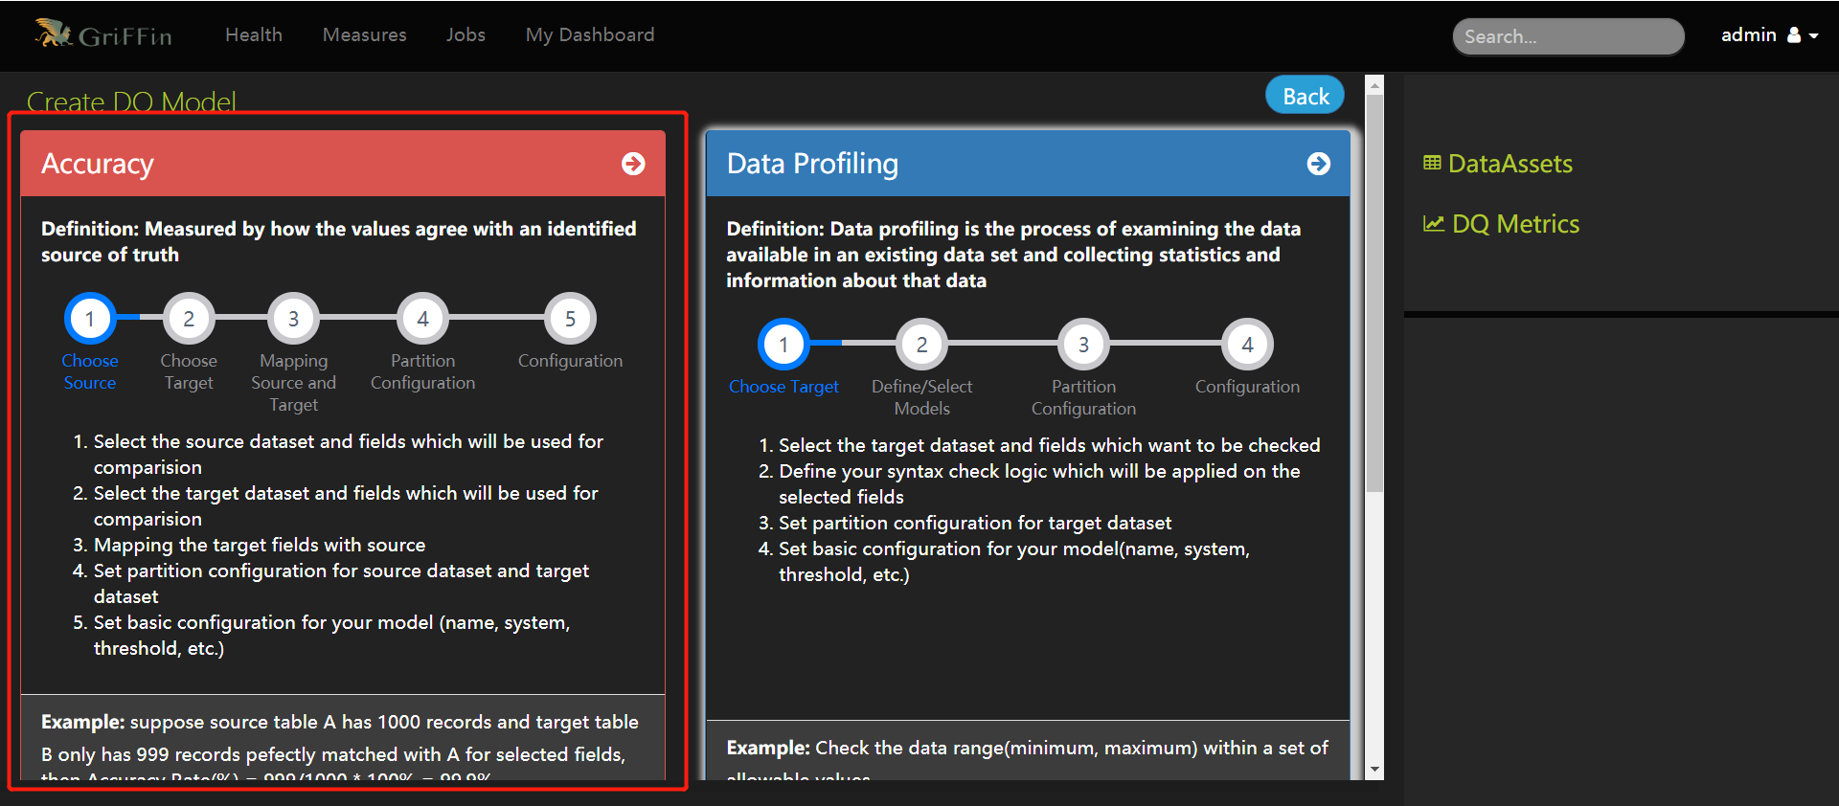

### 3.2.3 选择数据源的字段

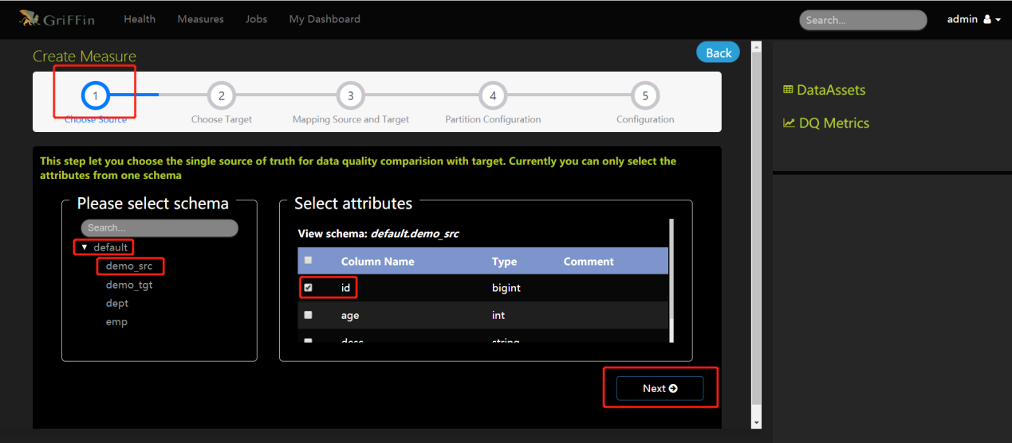

### 3.2.4 选择目标表的字段

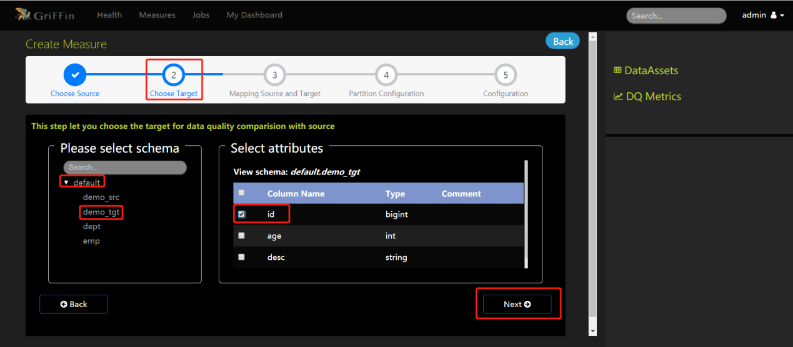

### 3.2.5 选择条件

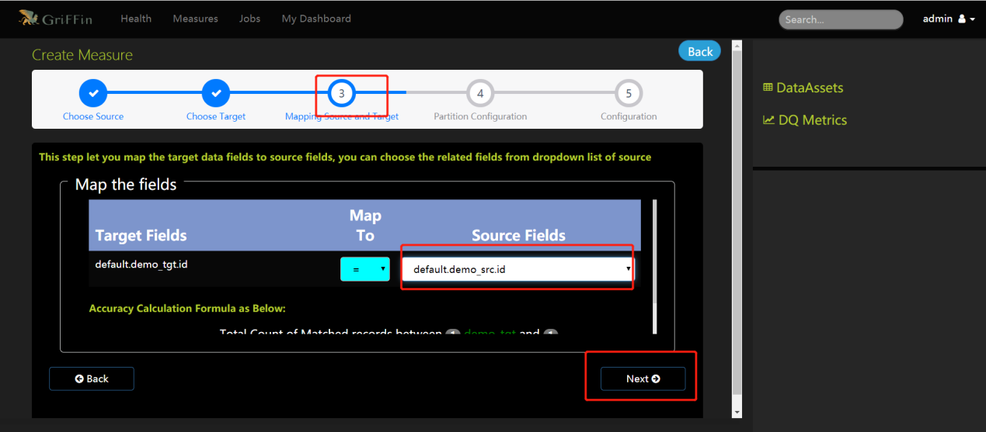

### 3.2.6 选择时间格式和分区尺度

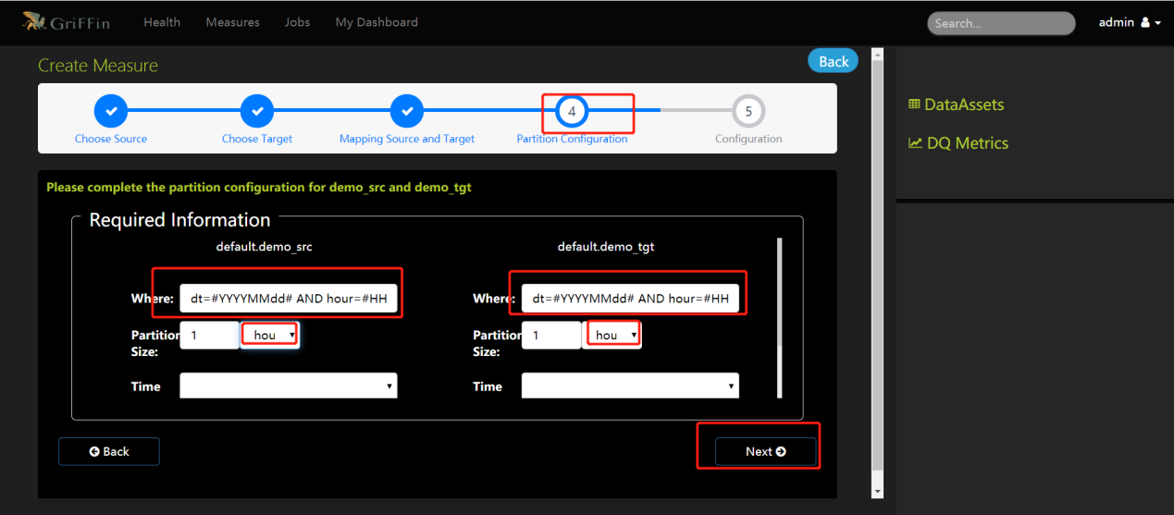

### 3.2.7 添加Measure名称和描述

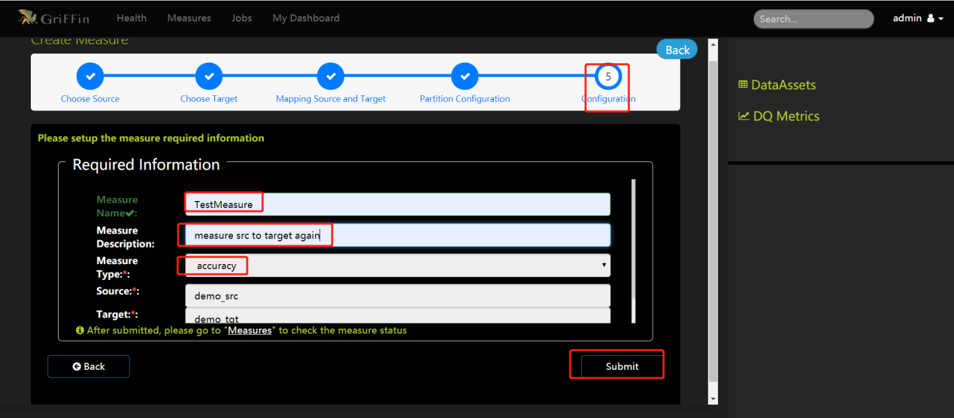

## 3.3 UI创建Job

### 3.3.1 新建一个Job

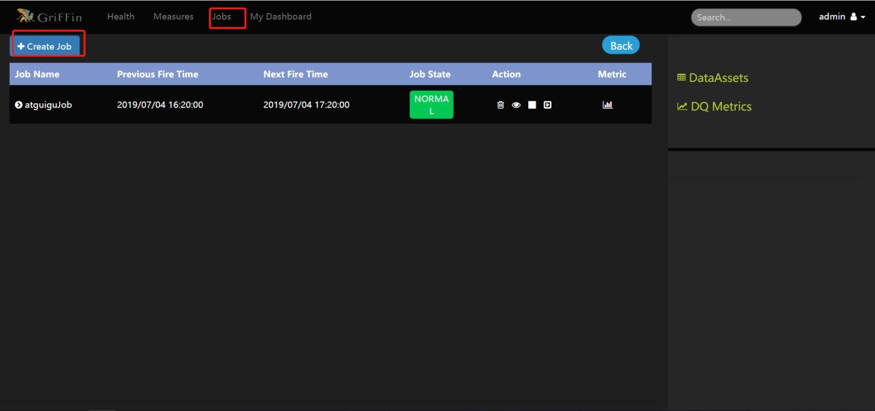

### 3.3.2 与Measure结合并调度任务执行

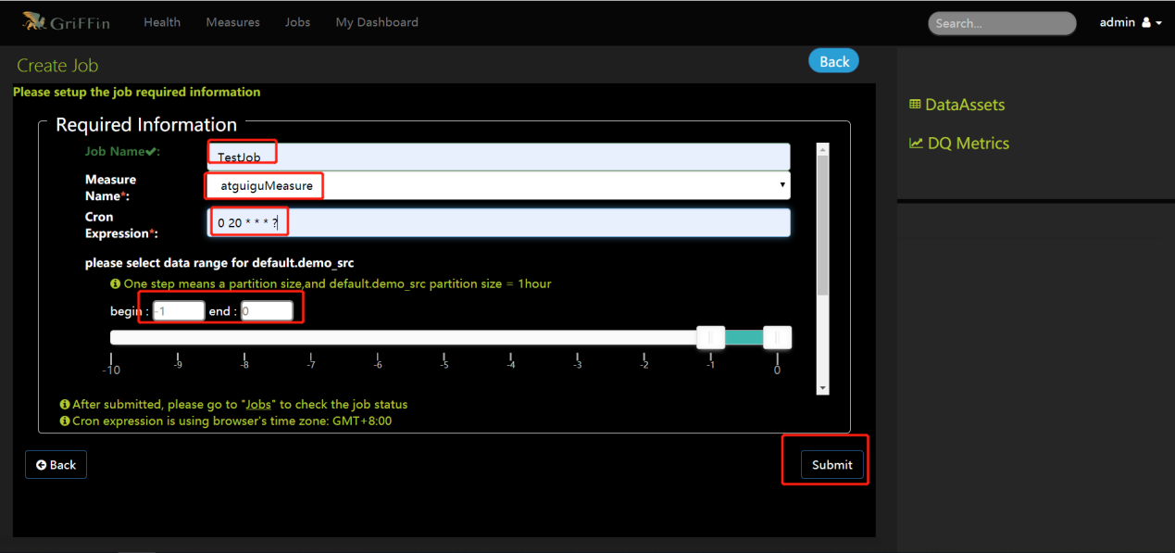

### 3.3.3 查看运行结果单击“DQ指标”

[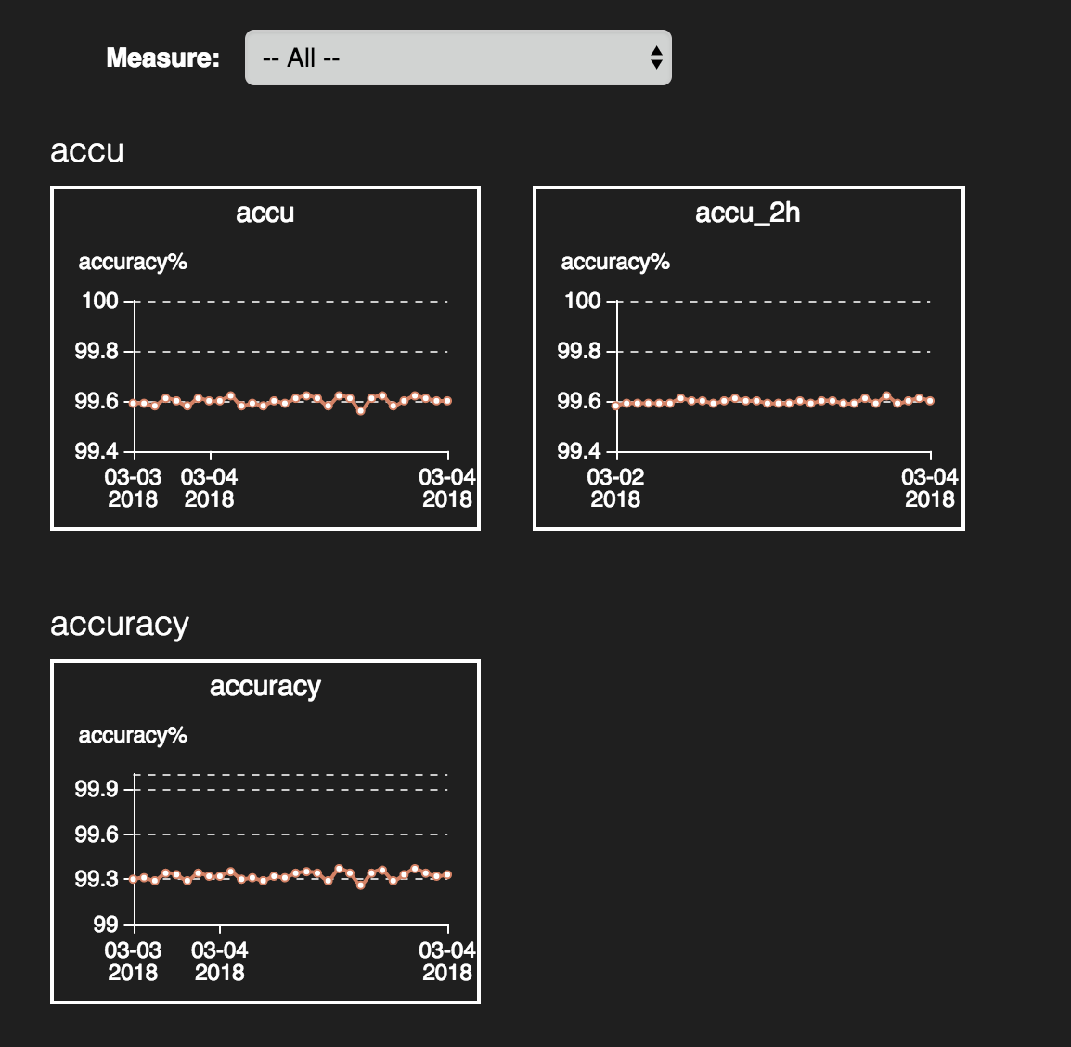](https://github.com/apache/griffin/blob/master/griffin-doc/img/userguide/metrics%20dashboard.png)

单击放大图片

[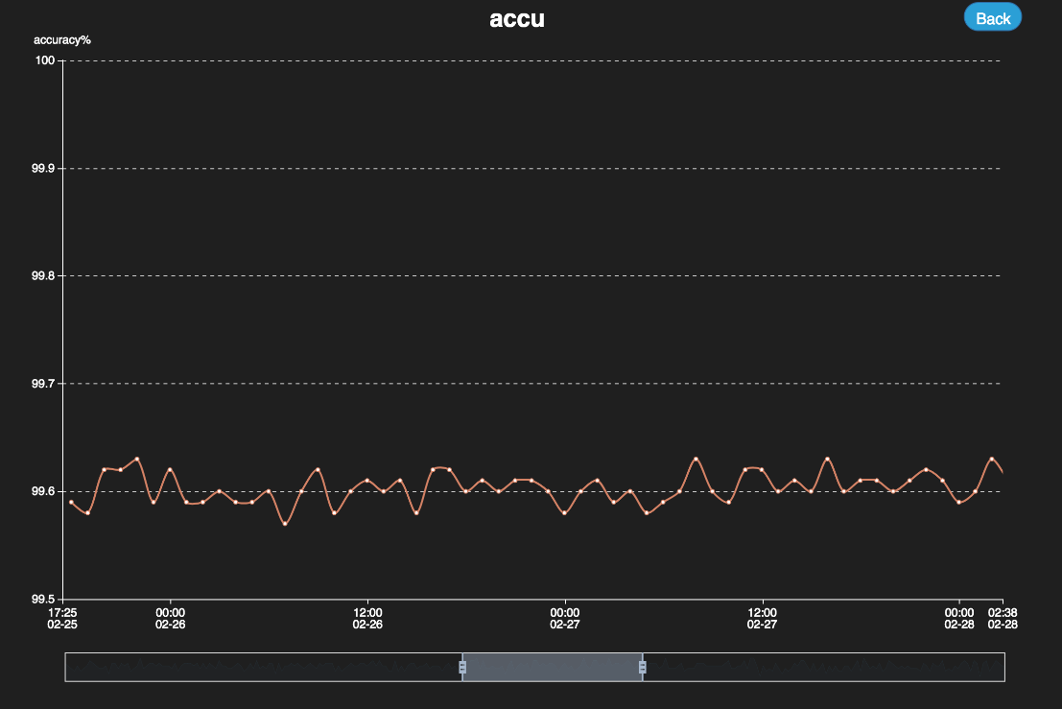](https://github.com/apache/griffin/blob/master/griffin-doc/img/userguide/dashboard%20big.png)

# 第4章 数据校验

## 4.1 ODS层校验

### 4.1.1数据校验通用脚本

通过shell脚本调用hive，检验当日分区增加的记录数量是否在合理的范围之内，同时检验关键字段为空的记录的记录数量，根据生成的指标结合Griffin进行数据质量监控与管理。

1）创建数据检查脚本文件夹，用于存放数据校验shell脚本和azkaban的job文件

[atguigu@hadoop102 module]$ mkdir -p data_check/sh

[atguigu@hadoop102 module]$ mkdir -p data_check/job

[atguigu@ hadoop102 sh]$ pwd

/opt/module/data_check/sh

[atguigu@ hadoop102 sh]$ pwd

/opt/module/data_check/job

2）在Hive中创建表数据质量校验记录表，记录数据校验的各个指标：

[atguigu@atguigu data_check]$ hive

创建数据库：

hive (default)> create database datacheck;

创建数据表：

hive (default)> create table datacheck.table_count_add_standard(

data_date string comment '数据时间分区dt',

database_name string comment '库名',

table_name string comment '表名',

table_type string comment '表类型（全量/增量）',

add_count bigint comment '当日增量数据的记录数',

null_count bigint comment '表空值记录数',

total_count bigint comment '全表记录数'

);

3）在路径/opt/module/data_check/sh下创建数据检验增量表通用shell脚本

[atguigu@hadoop102 sh]$ vim increment_data_check_public.sh

在脚本中编写如下内容：

#!/bin/bash

do_date=$1

table_name=$2

null_column=$3

null_where_sql_str=''

array=(${null_column//,/ })

for(( i=0;i<${#array[@]};i++)) do

if [ $i -eq 0 ];then

null_where_sql_str=" where ${array[i]} is null "

else

null_where_sql_str="$null_where_sql_str or ${array[i]} is null "

fi

done;

add_count_query_result=`hive -e "select count(*) from gmall.$table_name where dt='$do_date'"`

add_count=${add_count_query_result:3}

total_count_query_result=`hive -e "select count(*) from gmall.$table_name"`

total_count=${total_count_query_result:3}

table_null_query_result=`hive -e "select count(*) from gmall.$table_name $null_where_sql_str"`

null_count=${table_null_query_result:3}

hive -e "insert into datacheck.table_count_add_standard values('$do_date','gmall','$table_name','increment_table',$add_count,$null_count,'$total_count')"

脚本参数注释：

第一个参数：传入时间分区参数( dt )

第二个参数：需要进行数据校验的表名( table_name )

第三个参数：需要判断是否为空值的字段名称用逗号‘ ，’隔开，例如：col1,col2,col3

脚本执行示例：

[atguigu@hadoop102 data_check]$

./increment_data_check_public.sh 2020-03-10 ods_activity_rule id,activity_id

4）在路径/opt/module/data_check/sh下创建数据检验全量表通用shell脚本

[atguigu@hadoop102 sh]$ vim total_data_check_public.sh

在脚本中编写如下内容：

#!/bin/bash

do_date=$1

table_name=$2

null_column=$3

null_where_sql_str=''

array=(${null_column//,/ })

for(( i=0;i<${#array[@]};i++)) do

if [ $i -eq 0 ];then

null_where_sql_str=" where ${array[i]} is null "

else

null_where_sql_str="$null_where_sql_str or ${array[i]} is null "

fi

done;

table_count_query_result=`hive -e "select count(*) from gmall.$table_name"`

table_count=${table_count_query_result:3}

table_null_query_result=`hive -e "select count(*) from gmall.$table_name $null_where_sql_str"`

null_count=${table_null_query_result:3}

hive -e "insert into datacheck.table_count_add_standard values('$do_date','gmall','$table_name','total_table',null,$null_count,'$table_count')"

脚本参数注释：

第一个参数：传入数据校验日期( dt )

第二个参数：需要进行数据校验的表名( table_name )

第三个参数：需要判断是否为空值的字段名称用逗号’ , ‘隔开，例如：col1,col2,col3

脚本执行示例：

[atguigu@hadoop102 data_check]$ ./ total_data_check_public.sh 2020-03-10 ods_activity_rule id,activity_id

### 4.1.2 ODS层各表检验

1. 涉及表

增量检查

（1）订单详情表（ods_order_detail）

（2）用户表（ods_user_info）

（3）支付流水表（ods_payment_info）

（4）订单状态表（ods_order_status_log）

（5）商品评论表（ods_comment_info）

（6）退单表（ods_order_refund_info）

（7）活动订单关联表（ods_activity_order）

全量检查

（1）订单表（ods_order_info）

（2）SKU商品表（ods_sku_info）

（3）商品一级分类表（ods_base_category1）

（4）商品二级分类表（ods_base_category2）

（5）商品三级分类表（ods_base_category3）

（6）品牌表（ods_base_trademark）

（7）SPU商品表（ods_spu_info）

（8）加购表（ods_cart_info）

（9）商品收藏表（ods_favor_info）

（10）优惠券领用表（ods_coupon_use）

（11）优惠券表（ods_coupon_info）

（12）活动表（ods_activity_info）

（13）优惠规则表（ods_activity_rule）

（14）编码字典表（ods_base_dic）

2. ODS层数据检查脚本

1）在路径/opt/module/data_check/sh下创建ODS层数据检查脚本

[atguigu@atguigu sh]$ pwd

/opt/module/data_check/sh

[atguigu@atguigu sh]$ vim ods_data_check.sh

在脚本中编写如下内容：

#!/bin/bash

data_date=$1

# 增量检查

# 订单详情表

/opt/module/data_check/sh/increment_data_check_public.sh $data_date ods_order_detail id,order_id,user_id,sku_id,sku_name,order_price,sku_num,create_time

# 用户表

/opt/module/data_check/sh/increment_data_check_public.sh $data_date ods_user_info id,name,birthday,gender,email,user_level,create_time,operate_time

# 支付流水表

/opt/module/data_check/sh/increment_data_check_public.sh $data_date ods_payment_info id,out_trade_no,order_id,user_id,alipay_trade_no,total_amount,subject,payment_type,payment_time

# 订单状态表

/opt/module/data_check/sh/increment_data_check_public.sh $data_date ods_order_status_log id,order_id,order_status,operate_time

# 商品评论表

/opt/module/data_check/sh/increment_data_check_public.sh $data_date ods_comment_info id,user_id,sku_id,spu_id,order_id,appraise,create_time

# 退单表

/opt/module/data_check/sh/increment_data_check_public.sh $data_date ods_order_refund_info id,user_id,order_id,sku_id,refund_type,refund_num,refund_amount,refund_reason_type,create_time

# 活动订单关联表

/opt/module/data_check/sh/increment_data_check_public.sh $data_date ods_activity_order id,activity_id,order_id,create_time

# 全量检查

# 订单表

/opt/module/data_check/sh/total_data_check_public.sh $data_date ods_order_info id,final_total_amount,order_status,user_id,out_trade_no,create_time,operate_time,province_id,benefit_reduce_amount,original_total_amount,feight_fee

# SKU商品表

/opt/module/data_check/sh/total_data_check_public.sh $data_date ods_sku_info id,spu_id,price,sku_name,sku_desc,weight,tm_id,category3_id,create_time

# 商品一级分类表

/opt/module/data_check/sh/total_data_check_public.sh $data_date ods_base_category1 id,name

# 商品二级分类表

/opt/module/data_check/sh/total_data_check_public.sh $data_date ods_base_category2 id,name,category1_id

# 商品三级分类表

/opt/module/data_check/sh/total_data_check_public.sh $data_date ods_base_category3 id,name,category2_id

# 品牌表

/opt/module/data_check/sh/total_data_check_public.sh $data_date ods_base_trademark tm_id,tm_name

# SPU商品表

/opt/module/data_check/sh/total_data_check_public.sh $data_date ods_spu_info id,spu_name,category3_id,tm_id

# 加购表

/opt/module/data_check/sh/total_data_check_public.sh $data_date ods_cart_info id,user_id,sku_id,cart_price,sku_num,sku_name,create_time,operate_time,is_ordered,order_time

# 商品收藏表

/opt/module/data_check/sh/total_data_check_public.sh $data_date ods_favor_info id,user_id,sku_id,spu_id,is_cancel,create_time,cancel_time

# 优惠券领用表

/opt/module/data_check/sh/total_data_check_public.sh $data_date ods_coupon_use id,coupon_id,user_id,order_id,coupon_status,get_time,using_time,used_time

# 优惠券表

/opt/module/data_check/sh/total_data_check_public.sh $data_date ods_coupon_info id,coupon_name,coupon_type,condition_amount,condition_num,activity_id,benefit_amount,benefit_discount,create_time,range_type,spu_id,tm_id,category3_id,limit_num,operate_time,expire_time

# 活动表

/opt/module/data_check/sh/total_data_check_public.sh $data_date ods_activity_info id,activity_name,activity_type,start_time,end_time,create_time

# 优惠规则表

/opt/module/data_check/sh/total_data_check_public.sh $data_date ods_activity_rule id,activity_id,condition_amount,condition_num,benefit_amount,benefit_discount,benefit_level

# 编码字典表

/opt/module/data_check/sh/total_data_check_public.sh $data_date ods_base_dic dic_code,dic_name,parent_code,create_time,operate_time

## 4.2 DWD层校验

### 4.2.1使用Griffin进行数据质量监控管理

1. 浏览器访问Griffin的Web页面

<http://hadoop102:8080/>

2. 创建DWD层的数据校验规则Measure和定时任务Job

1）用户行为事件表

* 1. 商品点击表

数据源表：dwd_base_event_log

源表字段：mid_id,user_id,version_code,version_name,lang,source,os,area,model,brand,sdk_version,gmail,height_width,app_time,network,lng,lat,server_time

数据目标表：dwd_display_log

目标表字段：mid_id,user_id,version_code,version_name,lang,source,os,area,model,brand,sdk_version,gmail,height_width,app_time,network,lng,lat,server_time

分区：dt='2020-03-10'

1）设置Measure的数据对比规则

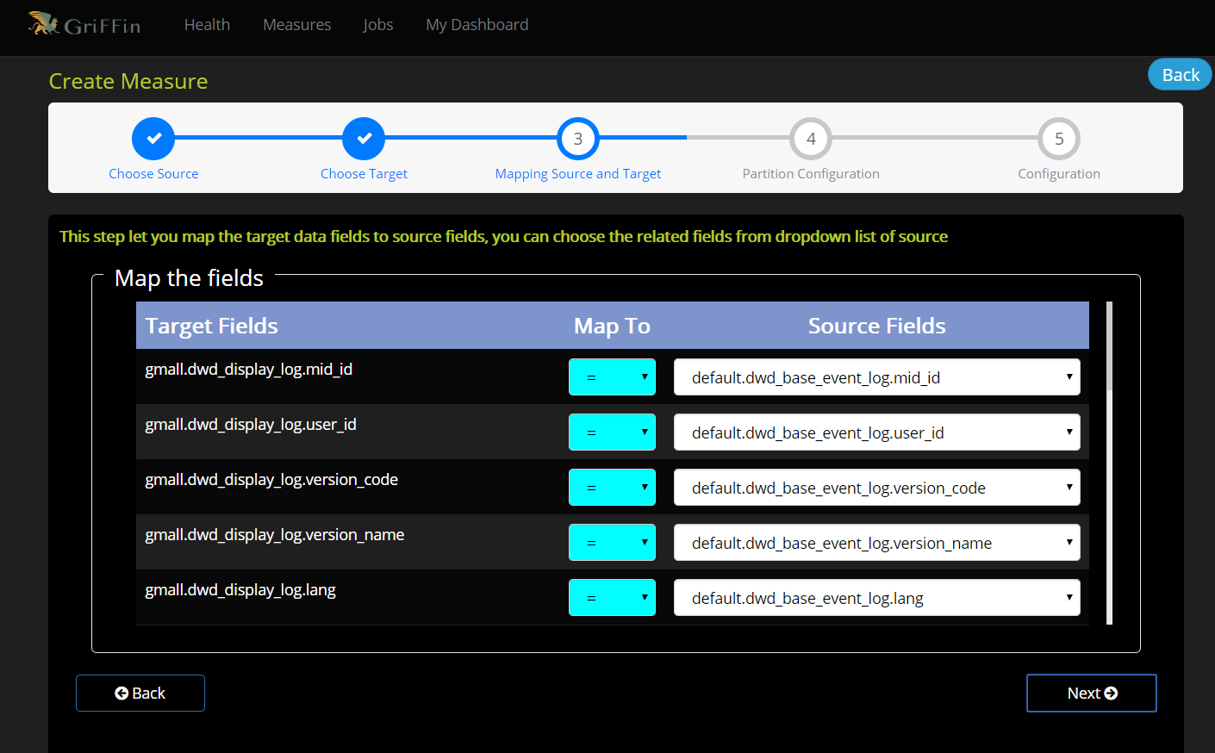

2）设置分区

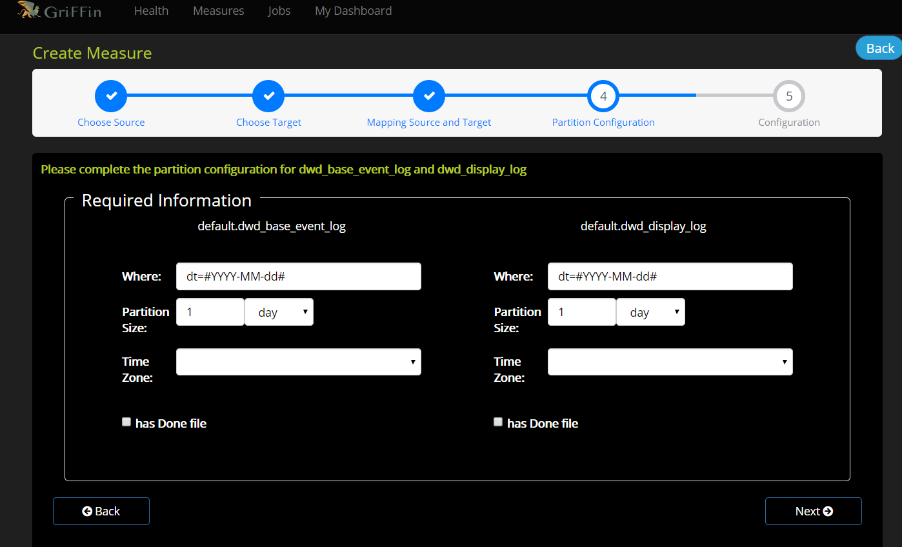

3）设置Measure名称和描述

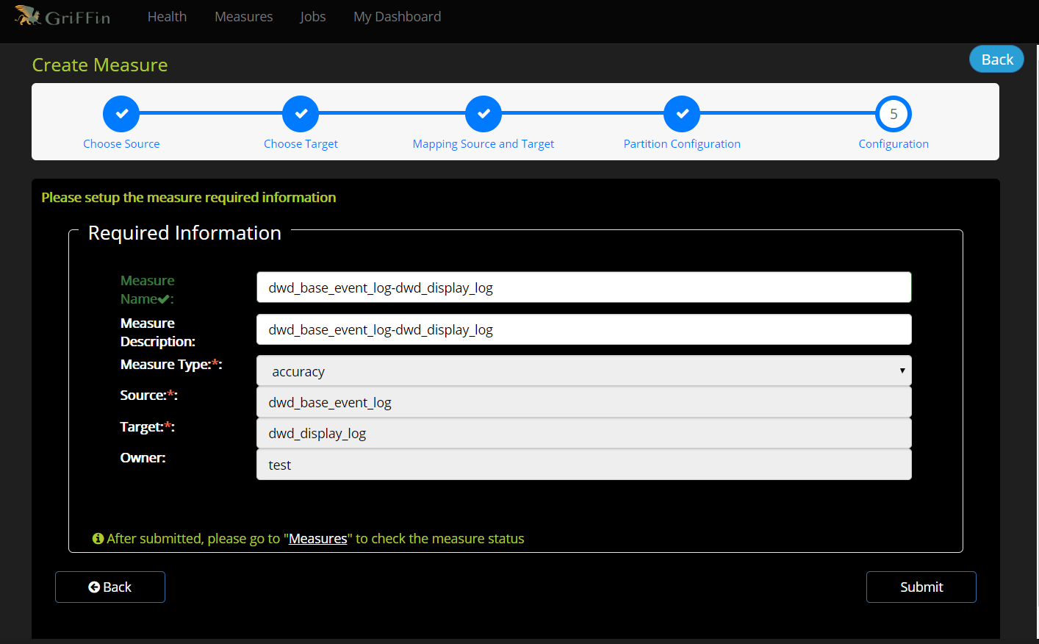

4）设置定时数据校验任务job

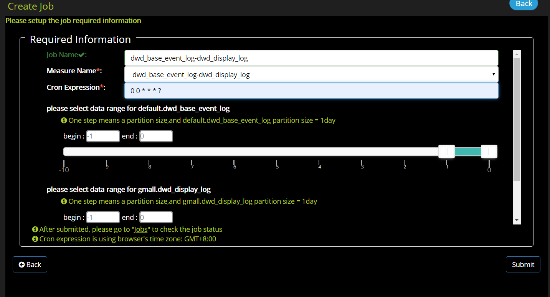

ps：以下表均按上述操作。

* 1. 商品详情页表

数据源表：dwd_base_event_log

源表字段：mid_id,user_id,version_code,version_name,lang,source,os,area,model,brand,sdk_version,gmail,height_width,app_time,network,lng,lat,server_time

数据目标表：dwd_newsdetail_log

目标表字段：mid_id,user_id,version_code,version_name,lang,source,os,area,model,brand,sdk_version,gmail,height_width,app_time,network,lng,lat,server_time

分区：dt='2020-03-10'

* 1. 商品列表页表

数据源表：dwd_base_event_log

源表字段：mid_id,user_id,version_code,version_name,lang,source,os,area,model,brand,sdk_version,gmail,height_width,app_time,network,lng,lat,server_time

数据目标表：dwd_loading_log

目标表字段：mid_id,user_id,version_code,version_name,lang,source,os,area,model,brand,sdk_version,gmail,height_width,app_time,network,lng,lat,server_time

分区：dt='2020-03-10'

* 1. 广告表

数据源表：dwd_base_event_log

源表字段：mid_id,user_id,version_code,version_name,lang,source,os,area,model,brand,sdk_version,gmail,height_width,app_time,network,lng,lat,server_time

数据目标表：dwd_ad_log

目标表字段：mid_id,user_id,version_code,version_name,lang,source,os,area,model,brand,sdk_version,gmail,height_width,app_time,network,lng,lat,server_time

分区：dt='2020-03-10'

* 1. 消息通知表

数据源表：dwd_base_event_log

源表字段：mid_id,user_id,version_code,version_name,lang,source,os,area,model,brand,sdk_version,gmail,height_width,app_time,network,lng,lat,server_time

数据目标表：dwd_notification_log

目标表字段：mid_id,user_id,version_code,version_name,lang,source,os,area,model,brand,sdk_version,gmail,height_width,app_time,network,lng,lat,server_time

分区：dt='2020-03-10'

* 1. 用户后台活跃表

数据源表：dwd_base_event_log

源表字段：mid_id,user_id,version_code,version_name,lang,source,os,area,model,brand,sdk_version,gmail,height_width,app_time,network,lng,lat,server_time

数据目标表：dwd_active_background_log

目标表字段：mid_id,user_id,version_code,version_name,lang,source,os,area,model,brand,sdk_version,gmail,height_width,app_time,network,lng,lat,server_time

分区：dt='2020-03-10'

* 1. 评论表

数据源表：dwd_base_event_log

源表字段：mid_id,user_id,version_code,version_name,lang,source,os,area,model,brand,sdk_version,gmail,height_width,app_time,network,lng,lat,server_time

数据目标表：dwd_comment_log

目标表字段：mid_id,user_id,version_code,version_name,lang,source,os,area,model,brand,sdk_version,gmail,height_width,app_time,network,lng,lat,server_time

分区：dt='2020-03-10'

* 1. 收藏表

数据源表：dwd_base_event_log

源表字段：mid_id,user_id,version_code,version_name,lang,source,os,area,model,brand,sdk_version,gmail,height_width,app_time,network,lng,lat,server_time

数据目标表：dwd_favorites_log

目标表字段：mid_id,user_id,version_code,version_name,lang,source,os,area,model,brand,sdk_version,gmail,height_width,app_time,network,lng,lat,server_time

分区：dt='2020-03-10'

* 1. 点赞表

数据源表：dwd_base_event_log

源表字段：mid_id,user_id,version_code,version_name,lang,source,os,area,model,brand,sdk_version,gmail,height_width,app_time,network,lng,lat,server_time

数据目标表：dwd_praise_log

目标表字段：mid_id,user_id,version_code,version_name,lang,source,os,area,model,brand,sdk_version,gmail,height_width,app_time,network,lng,lat,server_time

分区：dt='2020-03-10'

* 1. 错误日志表

数据源表：dwd_base_event_log

源表字段：mid_id,user_id,version_code,version_name,lang,source,os,area,model,brand,sdk_version,gmail,height_width,app_time,network,lng,lat,server_time

数据目标表：dwd_error_log

目标表字段：mid_id,user_id,version_code,version_name,lang,source,os,area,model,brand,sdk_version,gmail,height_width,app_time,network,lng,lat,server_time

分区：dt='2020-03-10'

2）业务数据表

1. 优惠券信息表

数据源表：ods_coupon_info

源表字段：id,coupon_name,coupon_type,condition_amount,condition_num,activity_id,benefit_amount,benefit_discount,create_time,range_type,spu_id,tm_id,category3_id,limit_num,operate_time,expire_time

数据目标表：dwd_dim_coupon_info

目标表字段：id,coupon_name,coupon_type,condition_amount,condition_num,activity_id,benefit_amount,benefit_discount,create_time,range_type,spu_id,tm_id,category3_id,limit_num,operate_time,expire_time

分区：dt='2020-03-10'

1. 订单明细事实表

数据源表：ods_order_detail

源表字段：id,order_id,user_id,sku_id,sku_name,order_price,sku_num,create_time

数据目标表：dwd_fact_order_detail

目标表字段：id,order_id,user_id,sku_id,sku_name,order_price,sku_num,create_time

分区：dt='2020-03-10'

1. 支付事实表

数据源表：ods_payment_info

源表字段：id,out_trade_no,order_id,user_id,alipay_trade_no,total_amount,subject,payment_type,payment_time

数据目标表：dwd_fact_payment_info

目标表字段：id,out_trade_no,order_id,user_id,alipay_trade_no,payment_amount,subject,payment_type,payment_time

分区：dt='2020-03-10'

1. 退款事实表

数据源表：ods_order_refund_info

源表字段：id,user_id,order_id,sku_id,refund_type,refund_num,refund_amount,refund_reason_type,create_time

数据目标表：dwd_fact_order_refund_info

目标表字段：id,user_id,order_id,sku_id,refund_type,refund_num,refund_amount,refund_reason_type,create_time

分区：dt='2020-03-10'

1. 评价事实表

数据源表：ods_comment_info

源表字段：id,user_id,sku_id,spu_id,order_id,appraise,create_time

数据目标表：dwd_fact_comment_info

目标表字段：id,user_id,sku_id,spu_id,order_id,appraise,create_time

分区：dt='2020-03-10'

1. 加购事实表

数据源表：ods_cart_info

源表字段：id,user_id,sku_id,cart_price,sku_num,sku_name,create_time,operate_time,is_ordered,order_time

数据目标表：dwd_fact_cart_info

目标表字段：id,user_id,sku_id,cart_price,sku_num,sku_name,create_time,operate_time,is_ordered,order_time

分区：dt='2020-03-10'

1. 收藏事实表

数据源表：ods_favor_info

源表字段：id,user_id,sku_id,spu_id,is_cancel,create_time,cancel_time

数据目标表：dwd_fact_favor_info

目标表字段：id,user_id,sku_id,spu_id,is_cancel,create_time,cancel_time

分区：dt='2020-03-10'

3. 部分任务截图

1）Measure列表

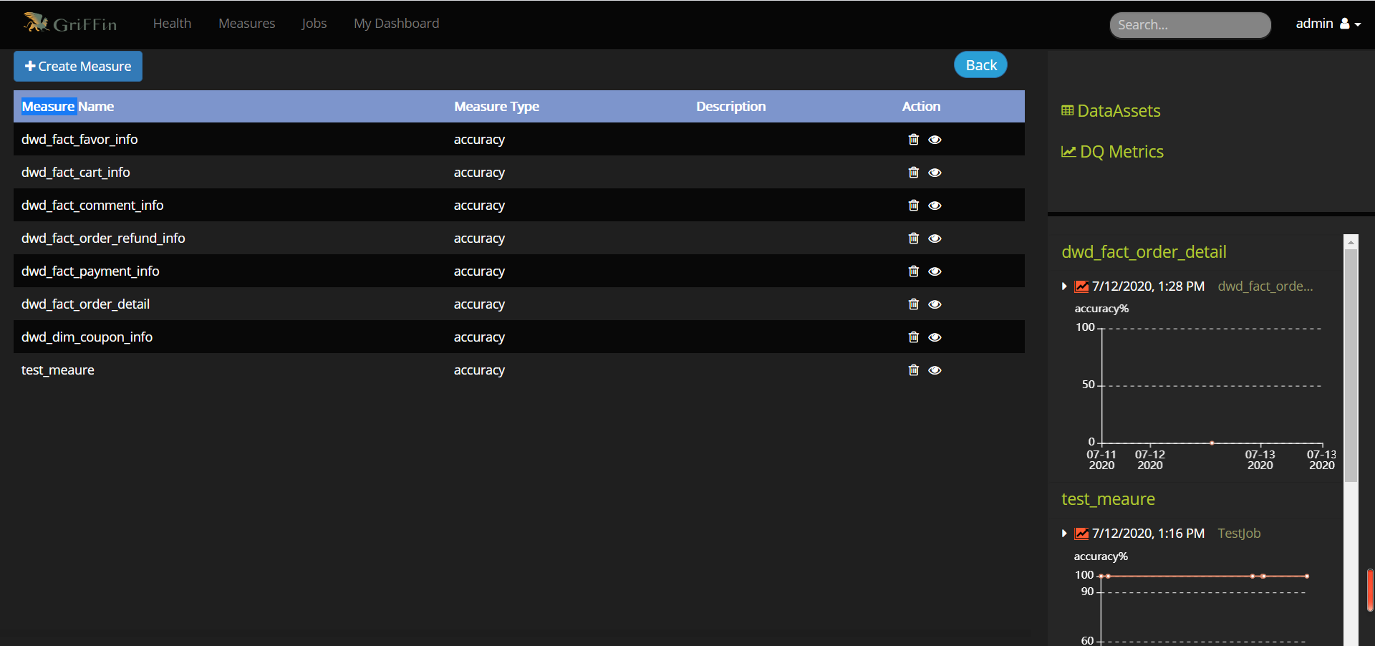

1. Job列表

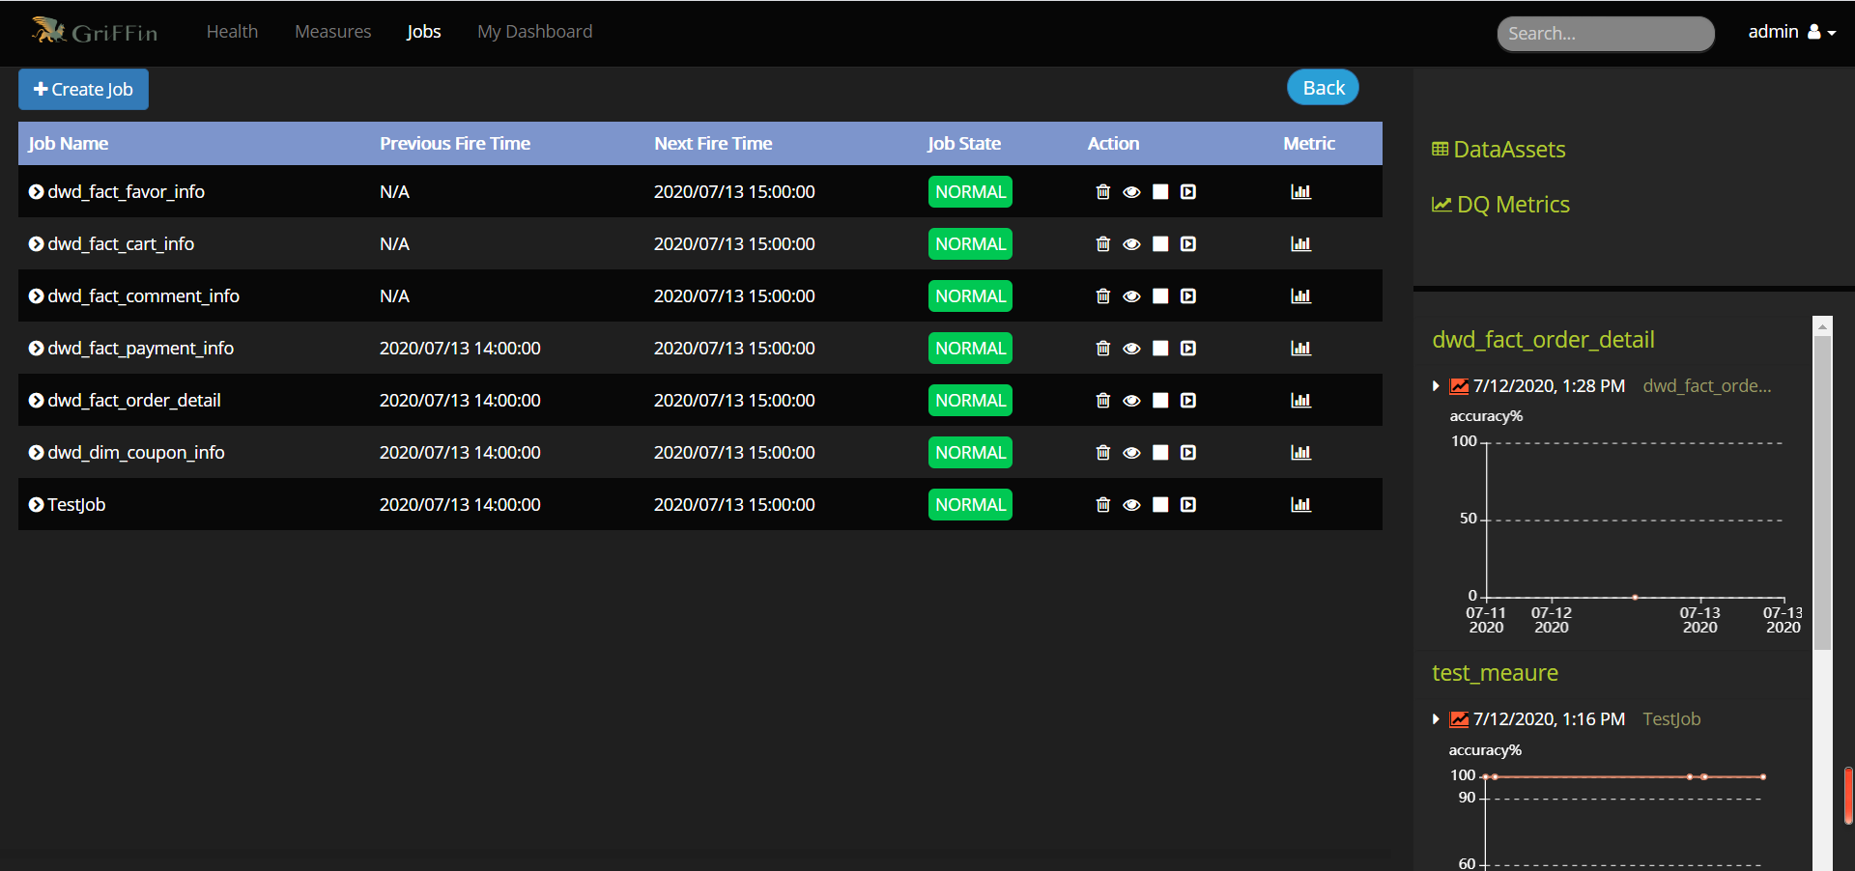

1. 监控仪表盘面板

