**Separating primaries and multiples using hyperbolic radon transform with deep learning**

*Harpreet Kaur, Nam Pham, and Sergey Fomel, The University of Texas at Austin.*

1．

Downloaded 10/15/20 to 114.222.109.73. Redistribution subject to SEG license or copyright; see Terms of Use at https://library.seg.org/page/policies/terms DOI:10.1190/segam2020-3419762.1

We propose a deep neural network (DNN) framework for com- puting hyperbolic Radon transform for separating primary re- ﬂections and multiples. The basic idea is to compute the weights associated with the inverse Hessian using the DNN for training data sets, which can then be applied to the adjoint transform of test data sets to obtain an initial model close to the true model. The output of the DNN can then be used as an input to the least-squares framework to obtain an output equivalent to the least-squares solution, but at a signiﬁcantly reduced cost. Field data examples verify the effectiveness of the proposed approach.

2．

# INTRODUCTION

The Radon transform (Radon, 1917) is a tool that maps the overlaping events to a tranformed domain, where the events can be separated. The transform is used to focus events with linear, parabolic and hyperbolic shapes. The major difference between these transforms is that the linear and parabolic trans- forms are time-invariant and thus can be applied in the fre- quency domain using fourier transforms whereas the hyper- bolic transform being time-variant has to be computed in the time domain. The parabolic Radon transform is a powerful tool but it is not perfectly suited for separating hyperbolic events. Since both primaries and multiples are hyperbolic in the time- space domain of a CMP gather, hyperbolic radon transform (also known as velocity stack or velocity transform) is applied to map them to different regions in the Radon domain corre- sponding to their respective velocities. After muting multi- ples in the Radon domain, multiple-free data can be recon- structed back to the time-space domain using inverse hyper- bolic radon transform, which can then be used for further pro- cessing. Since an adjoint operation does not reconstruct data exactly, several possible solutions have been proposed to this problem, e.g., the use of weighting functions (Larner, 1979), and the use of taper windows (Blackman and Tukey, 1958). These methods reduce lateral smear of events but still have some coherent streaks remaining on the panel. Thorson and Claerbout (1985) proposed iterative least-squares inversion for- mulation which does not suffer from the above mentioned short- comings. However, inversion is an expensive process and can be rather difﬁcult to apply, especially with 3D data (Guitton, 2004). Several other methods have been proposed by differ- ent authors for separating primaries and multiples using Radon transforms (Hampson, 1986; Yilmaz, 1989; Foster and Mosher, 1992; Moore and Kostov, 2002; Hargreaves et al., 2003).

We propose to compute hyperbolic Radon transform similar to the least-squares formulation by estimating the inverse Hes- sian using a DNN and thus, achieve convergence at a signif- icantly reduced cost. We further use the DNN output as an

initial model to a least-squares framework to obtain the ﬁnal output with fewer iterations as compared to the iterative inver- sion. The proposed method facilitates accurate reconstruction of data to time-space domain of a CMP gather and eliminates the need for applying a large number of iterative inversions to each CMP gather. This adaptive non-linear model makes the algorithm highly ﬂexible and shows universitality with differ- ent data sets.

3．

# THEORY

Velocity stack is deﬁned by the following equation (Thorson and Claerbout, 1985):

*uw* (*p*, τ) ≡ ∞0 w(*h*)*d*(*h*, *t* = �τ2 + *p*2 *h*2*dh* (1) where *p* is the slowness, w(*h*) is the weighting function, *d*(*h*, *t*)

is the input to velocity stack, and (*p*, τ) denotes the output. In operator notation with w(*h*) = 1, it is given as:

*u* = *LT d* (2)

The offset time pair *h*, *t* denotes the coordinate axes of the CMP gather and the slowness pair *p*, τ denotes the coordi- nate axes of the corresponding velocity panel. In this transfor- mation, there are functions belonging to two different spaces, offset space or data space, which includes all the functions de- ﬁned over the *h*, *t* domain, and velocity space or model space, which includes all the functions deﬁned over the *p*, τ do-

( )

( )

( )

( )

main. Velocity stacking performed by operator *LT* using equa-

tion (2) produces lateral coherence or smearing of events in ve- locity panel (Thorson and Claerbout, 1985). Various choices of weighting functions are proposed by different authors to re- duce the problem of smearing of events. Larner (1979) pro- poses a more general weighing function w *h* to reduce trun- cation effects at far offsets. Blackman and Tukey (1958) pro- pose a spectral method. Even with these techniques, coherent streaks still remain on the velocity stack. Thorson and Claer- bout (1985) proposed least-squares formulation for this prob- lem, which asserts that the CMP gather *d*(*h*, *t*) is the result of some transformation on a function *u*0(*p*, τ) in velocity space

( )

with *d*(*h*, *t*) as :

*d* = *Lu*0 + *n* (3)

Least-squares approach to equation (3) estimates *u* to *u*0 that minimizes energy in the noise term n and is given as:

*u* = (*LT L*)−1 *LT d* (4)

The problem here is to ﬁnd the inverse Hessian. We propose an algorithm using DNN to compute the inverse Hessian us- ing equation (2) and equation (4) as inputs for training. We use a small portion of a given dataset for training and once the network learns to compute the weights associated with the in- verse Hessian for training data sets, we apply learned weights to equation (2) for test data sets which are not a part of training.

Downloaded 10/15/20 to 114.222.109.73. Redistribution subject to SEG license or copyright; see Terms of Use at https://library.seg.org/page/policies/terms DOI:10.1190/segam2020-3419762.1

The DNN output is much closer to the true model as compared to the adjoint transform, which we then use in the least-squares framework to obtain an output equivalent to the least-squares output equation (4) with fewer iterations, thus signiﬁcantly re- ducing the computational cost.

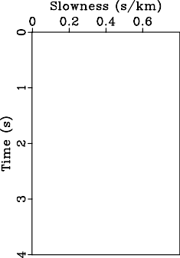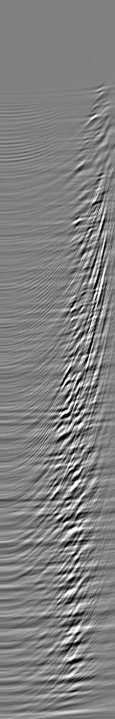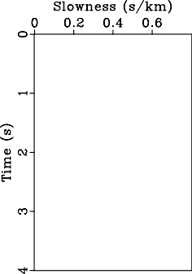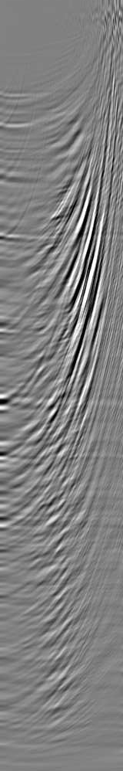

(a) (b)

Figure 1: Velocity transform (a) Using the adjoint. (b) Using iterative least-squares.

# IMPLEMENTATION OF THE PROPOSED ALGORITHM

We implement Generative Adversarial Networks (GANs) (Good- fellow et al., 2014; Zhu et al., 2017) which implicitly learn

a latent, low dimensional representation of an arbitrary high dimension data. GANs are basicaly composed of two net- works: a generator (*G*) that outputs synthesized image and a Discriminator (*D*) that outputs the probability between 0 and 1 corresponding to the samples being fake or real. The net- works that represent the generator and the discriminator are implemented by multilayered networks consisting of convolu- tion and/or fully connected layers (Creswell et al., 2018) where generator (*G*) tries to map samples from the source distribution (the adjoint velocity transform) to the target distribution (the velocity transform using iterative inversion) and discriminator

(*D*) determines if the sample is from the actual distribution or produced by the generator. The generator and discriminator are trained in a joint framework where the generator eventually learns to approximate the underlying distribution completely, and the discriminator is left guessing randomly. Further, the network uses a loss function to reduce the space of possible mapping functions (Kaur et al., 2019).

4．

# EXAMPLES

For training and validation of the algorithm we use the Viking Graben data set consisting of common mid point (CMP) gath- ers. We divide this data set into training data consisting of ﬁve CMP gathers and test data consisting of 95 CMP gath- ers. For training we divide the CMP gathers into patches of 160*160 samples. We train the network in the model domain

using the velocity transform with the adjoint operator *LT d*

( )

and the velocity transform with the least-squares inverse oper- ator (*LT L*)−1 *LT d* such that the network learns the relationship

between the two, i.e., the weights associated with the inverse Hessian (*LT L* −1 operator. For creating the training data we start with a CMP gather, perform a velocity transform using the adjoint operator as shown in Figure 1a, as well as a veloc- ity transform using a least-squares inversion with 20 conjugate gradient iterations as shown Figure 1b. Using these two inputs, DNN learns to compute the inverse Hessian, which we then ap- ply to the adjoint velocity transform to obtain a least-squares velocity transform. After training, we test the efﬁciency of the algorithm with the CMP gathers unseen during the training process which comprise the test data set. Figure 2b shows one of the test CMP gathers with the velocity transform using the adjoint operator applied to the CMP gather shown in Figure

2a. Coherent streaks in Figure 2b produced by *LT* are arti-

)

facts resulting primarily from the truncation of events at the highest offset trace on the CMP gather. The network applies the inverse Hessian operator learned during training to the ad- joint velocity transform shown in Figure 2b to obtain results as shown in Figure 2c which are close to the least-squares solu- tion. The DNN output shown in Figure 2c needs further im- provement, therefore we use this as an initial model to an itera- tive least-squares framework and call the output the deep neu- ral network least-squares solution (DNNLS). The DNNLS out- put is shown in Figure 2d which is similar to the least-squares inversion solution as shown in Figure 2e. Data reconstructed using the adjoint transform (ﬁltered back projection), the in- verse transform using DNNLS, and the inverse transform using iterative inversion are shown in Figure 2f, 2g, and 2h, respec- tively. The CPU time for the adjoint operation is 5.85 s and

* 1. s for the iterative inversion using 20 iterations. DNN test runs in only 0.31 s of CPU time for each cmp gather. To make it faster, we can further use a fast butterﬂy algorithm for the adjoint part (Hu et al., 2013) and use the proposed algo- rithm to achieve results similar to the iterative inversion. The fast butterﬂy algorithm takes 3.87 s for the adjoint part com- pared to 5.85 s taken by the conventional algorithm. Figure 3a and 3b show the separated signal (primary reﬂections) us- ing DNNLS and iterative inversion, respectively with velocity analysis using the semblance scan with DNNLS and the iter- ative inversion shown in Figure 3c and 3d. Separated noise (multiple reﬂections) using DNNLS and the iterative inversion are shown in Figure 3e and 3f with velocity analysis using sem- blance scan for multiples with DNNLS and iterative inversion shown in Figure 3g and 3h. Normal moveout- corrected signal using the DNNLS picked primary velocity is shown in Figure 3i.

5．

# CONCLUSIONS

We have introduced a novel way of estimating hyperbolic radon transforms using a deep neural network to achieve faster con- vergence at a signiﬁcantly reduced cost. A ﬁeld example demon- strates that the proposed algorithm signiﬁcantly reduces the lateral smearing of events in the model space and is capable of reconstructing data space from model space with accuracy similar to the least-squares inversion. The proposed algorithm is cost effective and efﬁcient, hence, it can be used in the ap- plication of the separation of primaries and multiples.

REFERENCES

6．

Downloaded 10/15/20 to 114.222.109.73. Redistribution subject to SEG license or copyright; see Terms of Use at https://library.seg.org/page/policies/terms DOI:10.1190/segam2020-3419762.1

Blackman, R. B., and J. W. Tukey, 1958, The measurement of power spectra: Dover Publications Inc.

Creswell, A., T. White, V. Dumoulin, K. Arulkumaran, B. Sengupta, and A. A. Bharath, 2018, Generative adversarial networks: An overview: IEEE Signal Processing Magazine, 35, 53–65, doi: [https://doi.org/10.1109/MSP.2017.2765202](http://dx.doi.org/10.1109/MSP.2017.2765202).

Foster, D. J., and C. C. Mosher, 1992, Suppression of multiple reflections using the Radon transform: Geophysics, 57, 386–395, doi: [https://doi.org/10](http://dx.doi.org/10.1190/1.1443253)

[.1190/1.1443253](http://dx.doi.org/10.1190/1.1443253).

Goodfellow, I., J. Pouget-Abadie, M. Mirza, B. Xu, D. Warde-Farley, S. Ozair, A. Courville, and Y. Bengio, 2014, Generative adversarial nets: Advances in Neural Information Processing Systems, 2672–2680.

Guitton, A., 2004, Amplitude and kinematic corrections of migrated images for nonunitary imaging operators: Geophysics, 69, 1017–1024, doi: [https://doi.org/10.1190/1.1778244](http://dx.doi.org/10.1190/1.1778244).

Hampson, D., 1986, Inverse velocity stacking for multiple elimination: 56th Annual International Meeting, SEG, Expanded Abstracts, 422–424, doi: [https://doi.org/10.1190/1.1893060](http://dx.doi.org/10.1190/1.1893060).

Hargreaves, N., B. verWest, R. Wombell, and D. Trad, 2003, Multiple attenuation using an apex-shifted Radon transform: 73rd Annual International Meeting, SEG, Expanded Abstracts, 1929–1932, doi: [https://doi.org/10.4043/16944-MS](http://dx.doi.org/10.4043/16944-MS).

Hu, J., S. Fomel, L. Demanet, and L. Ying, 2013, A fast butterfly algorithm for generalized Radon transforms: Geophysics, 78, no. 4, U41–U51, doi: [https://doi.org/10.1190/geo2012-0240.1](http://dx.doi.org/10.1190/geo2012-0240.1).

Kaur, H., N. Pham, and S. Fomel, 2019, Seismic data interpolation using CycleGAN: 89th Annual International Meeting, SEG, Expanded Abstracts, 2202–2206, doi: [https://doi.org/10.1190/segam2019-3207424.1](http://dx.doi.org/10.1190/segam2019-3207424.1).

Larner, K., 1979, Optimum-weight CDP stacking: Western Geophysical Co.: unpublished notes. Moore, I., and C. Kostov, 2002, Stable, efficient, high-resolution Radon transforms: 64th Conference and Exhibition, EAGE, Extended Abstracts, cp–

5.

Radon, J., 1917, On the determination of functions from their integrals along certain manifolds: Ber. Verh, Sachs Akad Wiss., 69, 262–277. Thorson, J. R., and J. F. Claerbout, 1985, Velocity-stack and slant-stack stochastic inversion: Geophysics, 50, 2727–2741, doi: [https://doi.org/10.1190/](http://dx.doi.org/10.1190/1.1441893)

[1.1441893](http://dx.doi.org/10.1190/1.1441893).

Yilmaz, Ö., 1989, Velocity-stack processing1: Geophysical Prospecting, 37, 357–382, doi: [https://doi.org/10.1111/j.1365-2478.1989.tb02211.x](http://dx.doi.org/10.1111/j.1365-2478.1989.tb02211.x). Zhu, J.-Y., T. Park, P. Isola, and A. A. Efros, 2017, Unpaired image-to-image translation using cycle-consistent adversarial networks: arXiv preprint.