Instructions for EasyPHP (DevServer 14.1 VC9)

How to setup the database, the user and the tables for Assignment 3 in EasyPHP
You have been provided with the necessary SQL script (paintingPortal.sql) that you will need to import into MySQL (easiest to use phpMyAdmin). You can import the zip file directly via phpMyAdmin. After importing the SQL script, ‘paintingportal’ database will be created that will contain all database tables required for this assignment.
The detailed instructions are as follows:
- Run ‘EasyPHP’ on your PC/Laptop.
- Right click on the EasyPHP icon and then click ‘Administration’.

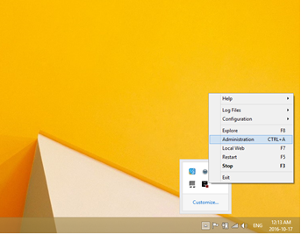

- Click on ‘Open’ on the following screen to enter ‘MySQL Administration: PhpMyAdmin’.

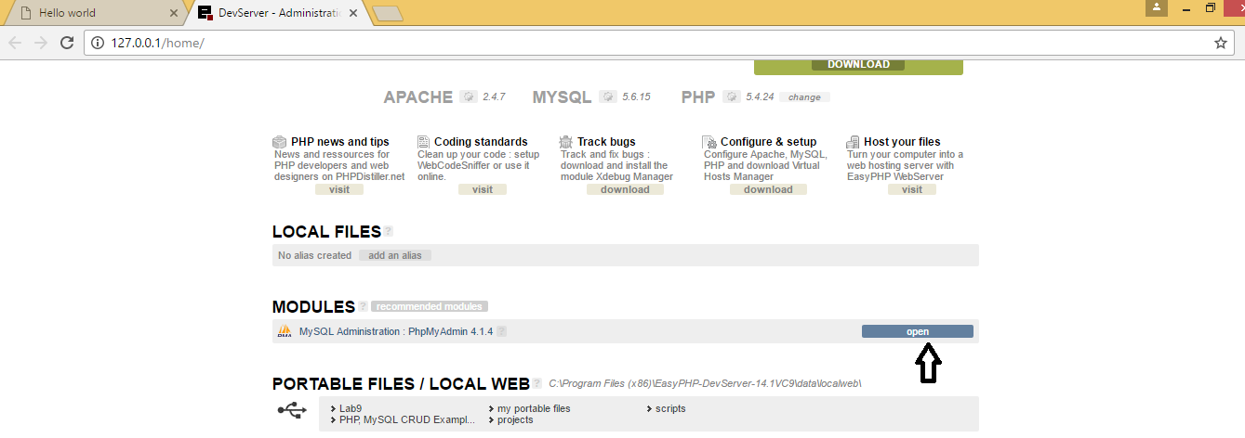

- Click ‘Import’ tab on the following screen.
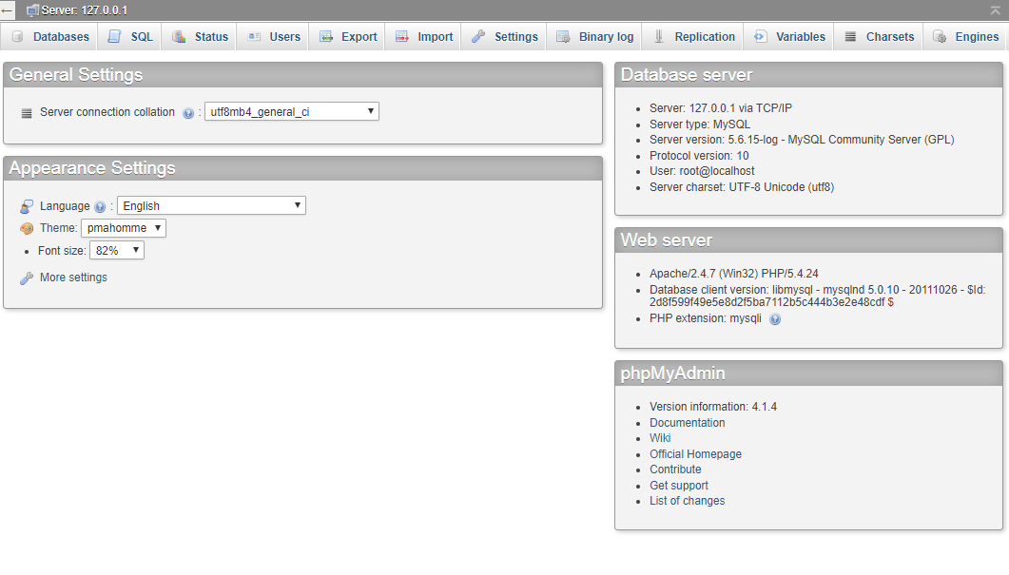

- Then choose the SQL script file (paintingPortal.sql) from your laptop and click ‘GO’ on the following screen to import the SQL script.
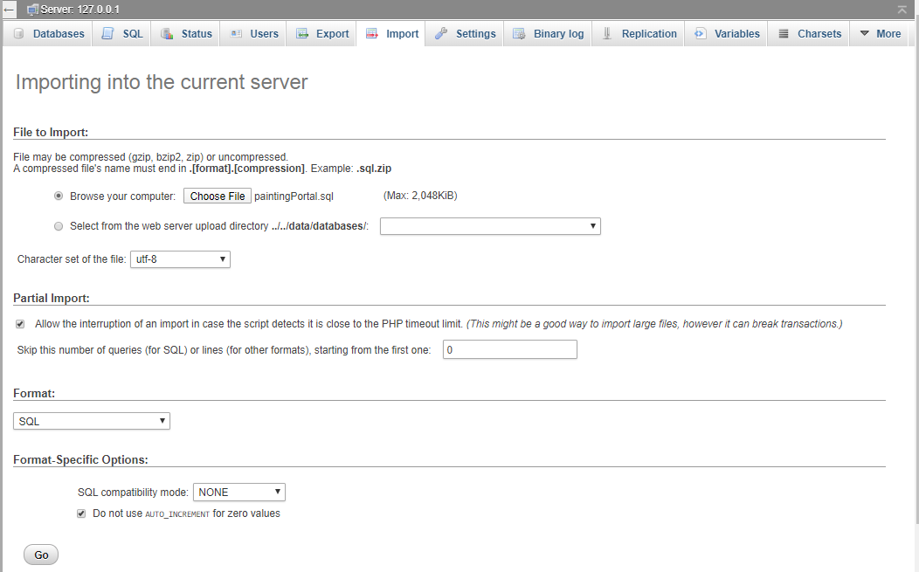

- It takes few minutes to import the SQL script. After ‘Import’ has been finished successfully, ‘paintingportal’ database will be created which consists of the following tables:
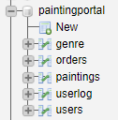

- Click ‘SQL’ tab on the following screen.


- ‘SQL command window’ will be displayed as follows.
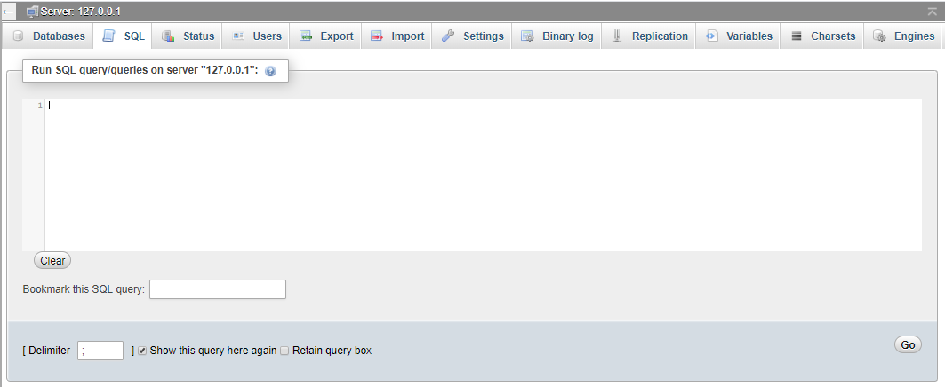

- Type the following SQL command in the ‘SQL Command Window’ to grant permission so that the user (portaluser) can access the database (paintingportal) using a password (portal@user).
GRANT USAGE ON *.* TO portaluser@localhost IDENTIFIED BY 'portal@user';
GRANT ALL PRIVILEGES ON paintingportal.* TO portaluser@localhost;
FLUSH PRIVILEGES;

- After typing the above SQL command, click on ‘Go’ in the following screen.
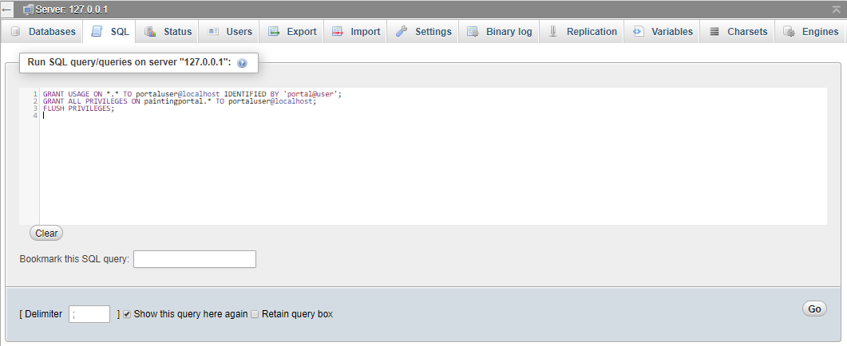

Access to MySQL database
Each database application must have a configuration file to connect your application with MySQL database.
Before we can get started using MySQL on the webserver we need a few pieces of information.
- Host
  - The host variable should contain the value “localhost”.
  - Example: $host = “localhost”;
  - NOTE: Localhost is a networking term meaning ‘this computer’
- Username
  - The Username to access YOUR database is: portaluser
  - Example: $username = “portaluser”;
- Password
  - The password is any legitimate password you choose
  - Example: $password = “portal@user”;
- Database Name
  - The name of your database is: paintingportal
  - Example: $database = “paintingportal”

You have been provided with a configuration file (i.e. config.php) that is required to connect your application with MySQL database.

