| **Analysis of Maximum Likelihood Estimates** | | | | | | |
| --- | --- | --- | --- | --- | --- | --- |
| **Parameter** |  | **DF** | **Estimate** | **Standard Error** | **Wald Chi-Square** | **Pr > ChiSq** |
| **Intercept** |  | 1 | 0.2478 | 2.3328 | 0.0113 | 0.9154 |
| **Age** |  | 1 | -0.0172 | 0.0235 | 0.5361 | 0.4641 |
| **BMI** |  | 1 | 0.0228 | 0.0857 | 0.0708 | 0.7902 |
| **procedure** | **ALIF** | 1 | -0.7672 | 0.8708 | 0.7762 | 0.3783 |
| **procedure** | **ALIF+Post** | 1 | -2.0546 | 1.0718 | 3.6744 | 0.0553 |
| **level** | **L4-L5** | 1 | 0.8099 | 0.6027 | 1.8054 | 0.1791 |
| **procmonth** |  | 1 | 0.4039 | 0.1225 | 10.8800 | 0.0010 |

| **Odds Ratio Estimates** | | | |
| --- | --- | --- | --- |
| **Effect** | **Point Estimate** | **95% Wald Confidence Limits** | |
| **Age** | 0.983 | 0.939 | 1.029 |
| **BMI** | 1.023 | 0.865 | 1.210 |
| **procedure ALIF vs ALIF+Plate** | 0.464 | 0.084 | 2.559 |
| **procedure ALIF+Post vs ALIF+Plate** | 0.128 | 0.016 | 1.047 |
| **level L4-L5 vs L5-S1** | 2.248 | 0.690 | 7.324 |
| **procmonth** | 1.498 | 1.178 | 1.904 |

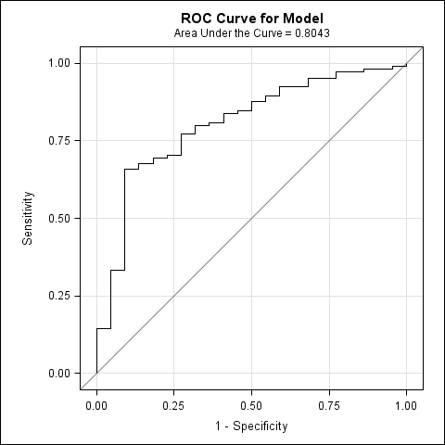

| **Hosmer and Lemeshow Goodness-of-Fit Test** | | |
| --- | --- | --- |
| **Chi-Square** | **DF** | **Pr > ChiSq** |
| 5.2822 | 8 | 0.7270 |