| **obese** | **Variable** | **N** | **Mean** | **Std Dev** | **Median** | **Lower 95% CL for Mean** | **Upper 95% CL for Mean** |
| --- | --- | --- | --- | --- | --- | --- | --- |
| **BMI<25** | |  | | --- | | **RAD Time (sec)** | | **GY (RADIATION EXPOSURE)** | | **GY/RAD** | | |  | | --- | | 98 | | 98 | | 98 | | |  | | --- | | 17.2 | | 3.212744 | | 0.42 | | |  | | --- | | 11.9 | | 4.938859 | | 1.57 | | |  | | --- | | 15.5 | | 0.775843 | | 0.061 | | |  | | --- | | 14.8 | | 2.222565 | | 0.10 | | |  | | --- | | 19.6 | | 4.202923 | | 0.73 | |
| **25=<BMI<30** | |  | | --- | | **RAD Time (sec)** | | **GY (RADIATION EXPOSURE)** | | **GY/RAD** | | |  | | --- | | 102 | | 102 | | 102 | | |  | | --- | | 15.4 | | 4.019717 | | 0.56 | | |  | | --- | | 11.3 | | 6.990059 | | 2.06 | | |  | | --- | | 13.0 | | 1.108687 | | 0.082 | | |  | | --- | | 13.15 | | 2.646740 | | 0.16 | | |  | | --- | | 17.59 | | 5.392695 | | 0.97 | |
| **BMI>=30** | |  | | --- | | **RAD Time (sec)** | | **GY (RADIATION EXPOSURE)** | | **GY/RAD** | | |  | | --- | | 124 | | 124 | | 124 | | |  | | --- | | 17.4 | | 4.325648 | | 0.51 | | |  | | --- | | 10.7 | | 7.354810 | | 1.94 | | |  | | --- | | 16.0 | | 1.304743 | | 0.085 | | |  | | --- | | 15.6 | | 3.018266 | | 0.16 | | |  | | --- | | 19.3 | | 5.633031 | | 0.85 | |

Wilcoxon-Mann-Whitney Test (excluded BMI<25):

1. Compare RAD Time: p=0.040
2. Compare GY: p=0.85
3. Compare GY/RAD: p=0.52

* For BMI<25:

| **Spearman Correlation Coefficients, N = 98  Prob > |r| under H0: Rho=0** | | | | |
| --- | --- | --- | --- | --- |
|  | **BMI** | **rad** | **gy** | **gy_rad** |
| |  | | --- | | **BMI** | | BMI | | |  | | --- | | 1.00000 | |  | | |  | | --- | | 0.09242 | | 0.3654 | | |  | | --- | | 0.10124 | | 0.3212 | | |  | | --- | | 0.11188 | | 0.2727 | |
| |  | | --- | | **rad** | | RAD Time (sec) | | |  | | --- | | 0.09242 | | 0.3654 | | |  | | --- | | 1.00000 | |  | | |  | | --- | | 0.46503 | | <.0001 | | |  | | --- | | -0.03369 | | 0.7419 | |
| |  | | --- | | **gy** | | GY (RADIATION EXPOSURE) | | |  | | --- | | 0.10124 | | 0.3212 | | |  | | --- | | 0.46503 | | <.0001 | | |  | | --- | | 1.00000 | |  | | |  | | --- | | 0.80454 | | <.0001 | |
| |  | | --- | | **gy_rad** | | GY/RAD | | |  | | --- | | 0.11188 | | 0.2727 | | |  | | --- | | -0.03369 | | 0.7419 | | |  | | --- | | 0.80454 | | <.0001 | | |  | | --- | | 1.00000 | |  | |

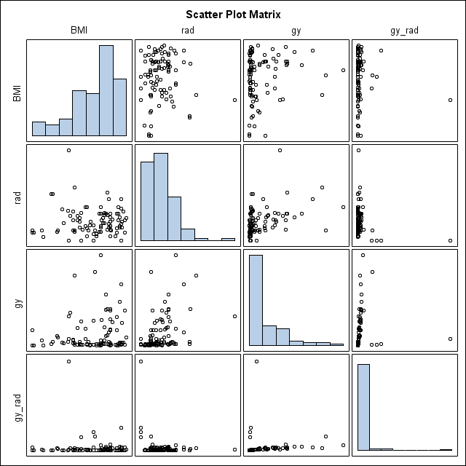

* For 25<=BMI<30:

| **Spearman Correlation Coefficients, N = 102  Prob > |r| under H0: Rho=0** | | | | |
| --- | --- | --- | --- | --- |
|  | **BMI** | **rad** | **gy** | **gy_rad** |
| |  | | --- | | **BMI** | | BMI | | |  | | --- | | 1.00000 | |  | | |  | | --- | | 0.01611 | | 0.8724 | | |  | | --- | | 0.02970 | | 0.7670 | | |  | | --- | | 0.01602 | | 0.8730 | |
| |  | | --- | | **rad** | | RAD Time (sec) | | |  | | --- | | 0.01611 | | 0.8724 | | |  | | --- | | 1.00000 | |  | | |  | | --- | | 0.37421 | | 0.0001 | | |  | | --- | | -0.07992 | | 0.4246 | |
| |  | | --- | | **gy** | | GY (RADIATION EXPOSURE) | | |  | | --- | | 0.02970 | | 0.7670 | | |  | | --- | | 0.37421 | | 0.0001 | | |  | | --- | | 1.00000 | |  | | |  | | --- | | 0.84311 | | <.0001 | |
| |  | | --- | | **gy_rad** | | GY/RAD | | |  | | --- | | 0.01602 | | 0.8730 | | |  | | --- | | -0.07992 | | 0.4246 | | |  | | --- | | 0.84311 | | <.0001 | | |  | | --- | | 1.00000 | |  | |

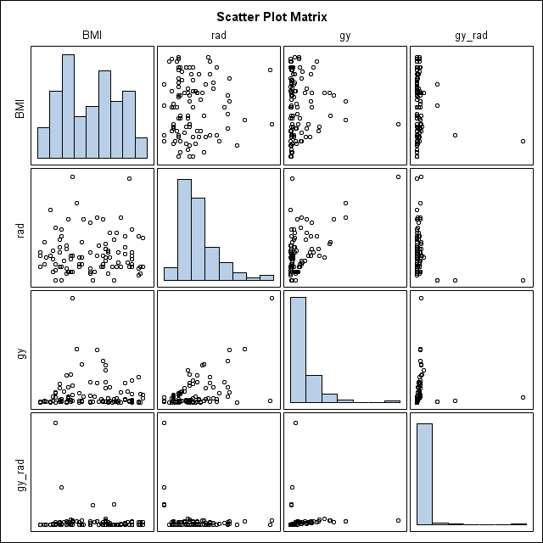

* For BMI>=30:

| **Spearman Correlation Coefficients, N = 124  Prob > |r| under H0: Rho=0** | | | | |
| --- | --- | --- | --- | --- |
|  | **BMI** | **rad** | **gy** | **gy_rad** |
| |  | | --- | | **BMI** | | BMI | | |  | | --- | | 1.00000 | |  | | |  | | --- | | 0.15740 | | 0.0808 | | |  | | --- | | 0.17296 | | 0.0547 | | |  | | --- | | 0.12733 | | 0.1588 | |
| |  | | --- | | **rad** | | RAD Time (sec) | | |  | | --- | | 0.15740 | | 0.0808 | | |  | | --- | | 1.00000 | |  | | |  | | --- | | 0.32342 | | 0.0002 | | |  | | --- | | -0.07200 | | 0.4268 | |
| |  | | --- | | **gy** | | GY (RADIATION EXPOSURE) | | |  | | --- | | 0.17296 | | 0.0547 | | |  | | --- | | 0.32342 | | 0.0002 | | |  | | --- | | 1.00000 | |  | | |  | | --- | | 0.88198 | | <.0001 | |
| |  | | --- | | **gy_rad** | | GY/RAD | | |  | | --- | | 0.12733 | | 0.1588 | | |  | | --- | | -0.07200 | | 0.4268 | | |  | | --- | | 0.88198 | | <.0001 | | |  | | --- | | 1.00000 | |

