1. Prevalence of citrulline depletion (<11µM) at GLN enrollment: 58/146 = 39.7 % with 95%CI=[%32.2 - 47.8]

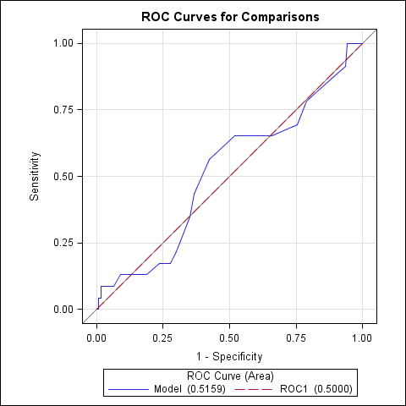

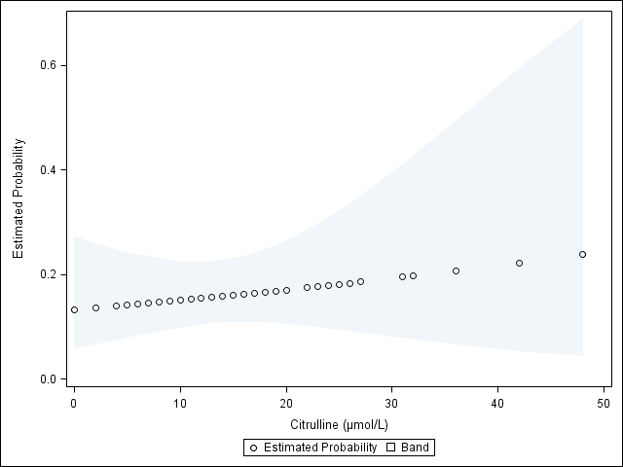

1. Baseline citrulline vs. In-Hospital Mortality(p=0.13)

|  |  |  |  |  |
| --- | --- | --- | --- | --- |
| **Baseline Citrulline Quartile Groups** | **Survivors** | **Non-Survivors** | **Odds Ratio** | **CA Trend Test**  **p-value** |
| **Citrulline< 8µm** | 26/123(21.1%) | 5/23(21.7%) | 1.64[0.40-6.70] | 0.92 |
| **Citrulline= 8~ 12µm** | 33/123(26.8%) | 3/23(13.0%) | 0.77[0.16-3.72] |  |
| **Citrulline= 12~ 17µm** | 30/123(24.4%) | 11/23(47.8%) | 3.12[0.90-10.83] |  |
| **Citrulline>= 17µm** | 34/123(27.6%) | 4/23(17.4%) | 1.00 |  |

Interpretation:

* Test of association of baseline citrulline and in-hospital mortality, p=0.13(Fisher exact test): There is no general association between baseline citrulline and in-hospital mortality;
* The estimated odds of in-hospital mortality is 1.64 times higher (95% CI: 0.40 to 6.70) for patients with low baseline citrulline (first quartile group) compared to patients with high baseline citrulline (the 4th quartile group); similarly the estimated odds ratio for 2nd quartile group vs 4th quartile group is 0.77[0.16-3.72]; the estimated odds ratio for 3rd quartile group vs 4th quartile group is 3.12[0.90-10.83].
* The trend test (p=0.92) indicated the in-hospital mortality has no obvious increasing/decreasing trend with the baseline citrulline level changing from 1st quartile to 4th quartile.

1. Baseline citrulline vs. 6-Month Mortality(p=0.14)

|  |  |  |  |  |
| --- | --- | --- | --- | --- |
| **Baseline Citrulline Quartile Groups** | **Survivors** | **Non-Survivors** | **Odds Ratio** | **CA Trend Test**  **p-value** |
| **Citrulline< 8µm** | 25/102(24.5%) | 6/44(13.6%) | 0.46[0.15-1.41] | 0.067 |
| **Citrulline= 8~ 12µm** | 28/102(27.4%) | 8/44(18.2%) | 0.55[0.20-1.54] |  |
| **Citrulline= 12~ 17µm** | 24/102(23.5%) | 17/44(38.6%) | 1.36[0.55-3.40] |  |
| **Citrulline>= 17µm** | 25/102(24.5%) | 13/44(29.6%) | 1.00 |  |

Interpretation:

* Test of association of baseline citrulline and 6-month mortality, p=0.14(Fisher exact test): There is no general association between baseline citrulline and 6-month mortality;
* The estimated odds of 6 month mortality is 0.46 times lower (95% CI: 0.15 to 1.41) for patients with low baseline citrulline (first quartile group) compared to patients with high baseline citrulline (the 4th quartile group); similarly the estimated odds ratio for 2nd quartile group vs 4th quartile group is 0.55[0.20-1.54]; the estimated odds ratio for 3rd quartile group vs 4th quartile group is 1.36[0.55-3.40].
* The trend test (p=0.067) indicated the 6 month mortality has no obvious increasing/decreasing trend with the baseline citrulline level changing from 1st quartile to 4th quartile.

1. Baseline citrulline vs. Apache II score at Randomization(p=0.26)

|  |  |  |  |  |
| --- | --- | --- | --- | --- |
| **Baseline Citrulline Quartile Groups** | **APACHE <=15** | **APACHE >15** | **Odds Ratio** | **CA Trend Test**  **p-value** |
| **Citrulline< 8µm** | 19/70(27.1%) | 12/76(15.8%) | 0.41[0.16-1.09] | 0.16 |
| **Citrulline= 8~ 12µm** | 15/70(21.4%) | 21/76(27.6%) | 0.91[0.36-2.31] |  |
| **Citrulline= 12~ 17µm** | 21/70(30.0%) | 20/76(26.3%) | 0.62[0.25-1.52] |  |
| **Citrulline>= 17µm** | 15/70(21.4%) | 23/76(30.3%) | 1.00 |  |

Interpretation:

* Test of association of baseline citrulline and Apache II score, p=0.26(Fisher exact test): There is no general association between baseline citrulline and Apache II score;
* The estimated odds of Apache II score>15 is 0.41 times lower (95% CI: 0.16 to 1.09) for patients with low baseline citrulline (first quartile group) compared to patients with high baseline citrulline (the 4th quartile group); similarly the estimated odds ratio for 2nd quartile group vs 4th quartile group is 0.91[0.36-2.31]; the estimated odds ratio for 3rd quartile group vs 4th quartile group is 0.62[0.25-1.52].
* The trend test (p=0.16) indicated the probability of Apache II score>15 has no obvious increasing/decreasing trend with the baseline citrulline level changing from 1st quartile to 4th quartile.

1. Baseline citrulline vs. Apache II score at ICU(p=0.95)

|  |  |  |  |  |
| --- | --- | --- | --- | --- |
| **Baseline Citrulline Quartile Groups** | **APACHE <=15** | **APACHE >15** | **Odds Ratio** | **CA Trend Test**  **p-value** |
| **Citrulline< 8µm** | 5/26(19.2%) | 26/120(21.7%) | 1.39[0.40-4.78] | 0.59 |
| **Citrulline= 8~ 12µm** | 6/26(23.1%) | 30/120(25.0%) | 1.33[0.41-4.31] |  |
| **Citrulline= 12~ 17µm** | 7/26(26.9%) | 34/120(28.3%) | 1.30[0.42-4.00] |  |
| **Citrulline>= 17µm** | 8/26(30.8%) | 30/120(30.3%) | 1.00 |  |

Interpretation:

* Test of association of baseline citrulline and Apache II score at ICU, p=0.95(Fisher exact test): There is no general association between baseline citrulline and Apache II score at ICU;
* The estimated odds of Apache II score>15 is 1.39 times higher (95% CI: 0.40 to 4.78) for patients with low baseline citrulline (first quartile group) compared to patients with high baseline citrulline (the 4th quartile group); similarly the estimated odds ratio for 2nd quartile group vs 4th quartile group is 1.33[0.41-4.31]; the estimated odds ratio for 3rd quartile group vs 4th quartile group is 1.30[0.42-4.00].
* The trend test (p=0.59) indicated the probability of Apache II score>15 at ICU has no obvious increasing/decreasing trend with the baseline citrulline level changing from 1st quartile to 4th quartile.

1. Baseline citrulline vs. SOFA score at Randomization(p=0.40)

|  |  |  |  |  |
| --- | --- | --- | --- | --- |
| **Baseline Citrulline Quartile Groups** | **SOFA<=6(Median)** | **SOFA >6(Median)** | **Odds Ratio** | **CA Trend Test**  **p-value** |
| **Citrulline< 8µm** | 19/76(25.0%) | 12/70(17.1%) | 0.51[0.20-1.34] | 0.10 |
| **Citrulline= 8~ 12µm** | 21/76(27.6%) | 15/70(21.4%) | 0.58[0.23-1.45] |  |
| **Citrulline= 12~ 17µm** | 19/76(25.0%) | 22/70(31.4%) | 0.94[0.39-2.27] |  |
| **Citrulline>= 17µm** | 17/76(22.4%) | 21/70(30.0%) | 1.00 |  |

Interpretation:

* Test of association of baseline citrulline and SOFA >6(median), p=0.40(Fisher exact test): There is no general association between baseline citrulline and SOFA score;
* The estimated odds of SOFA<6(median) is 0.51 times lower (95% CI: 0.20 to 1.34) for patients with low baseline citrulline (first quartile group) compared to patients with high baseline citrulline (the 4th quartile group); similarly the estimated odds ratio for 2nd quartile group vs 4th quartile group is 0.58[0.23-1.45]; the estimated odds ratio for 3rd quartile group vs 4th quartile group is 0.94[0.39-2.27].
* The trend test (p=0.10) indicated the probability of SOFA score<6(median) has no obvious increasing/decreasing trend with the baseline citrulline level changing from 1st quartile to 4th quartile.

1. Baseline citrulline vs. Incidence of BSI(p=0.97)

|  |  |  |  |  |
| --- | --- | --- | --- | --- |
| **Baseline Citrulline Quartile Groups** | **BSI=No** | **BSI=Yes** | **Odds Ratio** | **CA Trend Test**  **p-value** |
| **Citrulline< 8µm** | 25/119(21.0%) | 6/27(22.2%) | 1.28[0.37-4.45] | 0.71 |
| **Citrulline= 8~ 12µm** | 29/119(24.4%) | 7/27(25.9%) | 1.29[0.39-4.28] |  |
| **Citrulline= 12~ 17µm** | 33/119(27.7%) | 8/27(29.6%) | 1.29[0.40-4.14] |  |
| **Citrulline>= 17µm** | 32/119(26.9%) | 6/27(22.2%) | 1.00 |  |

Interpretation:

* Test of association of baseline citrulline and BSI, p=0.97(Fisher exact test): There is no general association between baseline citrulline and BSI;
* The estimated odds of BSI is 1.28 times higher (95% CI: 0.37 to 4.45) for patients with low baseline citrulline (first quartile group) compared to patients with high baseline citrulline (the 4th quartile group); similarly the estimated odds ratio for 2nd quartile group vs 4th quartile group is 1.29[0.39-4.28]; the estimated odds ratio for 3rd quartile group vs 4th quartile group is 1.29[0.40-4.14].
* The trend test (p=0.71) indicated the BSI rates has no obvious increasing/decreasing trend with the baseline citrulline level changing from 1st quartile to 4th quartile.

1. Baseline citrulline vs. Incidence of Pneumonia(p=0.89)

|  |  |  |  |  |
| --- | --- | --- | --- | --- |
| **Baseline Citrulline Quartile Groups** | **Pneumonia =No** | **Pneumonia =Yes** | **Odds Ratio** | **CA Trend Test**  **p-value** |
| **Citrulline< 8µm** | 27/125(21.0%) | 4/21(22.2%) | 0.66[0.17-2.49] | 0.57 |
| **Citrulline= 8~ 12µm** | 31/125(24.4%) | 5/21(25.9%) | 0.71[0.20-2.50] |  |
| **Citrulline= 12~ 17µm** | 36/125(27.7%) | 5/21(29.6%) | 0.62[0.18-2.13] |  |
| **Citrulline>= 17µm** | 31/125(26.9%) | 7/21(22.2%) | 1.00 |  |

Interpretation:

* Test of association of baseline citrulline and Incidence of Pneumonia, p=0.89(Fisher exact test): There is no general association between baseline citrulline and Incidence of Pneumonia;
* The estimated odds of Incidence of Pneumonia is 0.66 times lower (95% CI: 0.17 to 2.49) for patients with low baseline citrulline (first quartile group) compared to patients with high baseline citrulline (the 4th quartile group); similarly the estimated odds ratio for 2nd quartile group vs 4th quartile group is 0.71[0.20-2.50]; the estimated odds ratio for 3rd quartile group vs 4th quartile group is 0.62[0.18-2.13].
* The trend test (p=0.57) indicated the Incidence of Pneumonia has no obvious increasing/decreasing trend with the baseline citrulline level changing from 1st quartile to 4th quartile.

1. Baseline citrulline vs. Incidence of Any Infection(p=0.72)

|  |  |  |  |  |
| --- | --- | --- | --- | --- |
| **Baseline Citrulline Quartile Groups** | **Infection=No** | **Infection=Yes** | **Odds Ratio** | **CA Trend Test**  **p-value** |
| **Citrulline< 8µm** | 17/90(19.9%) | 14/56(25.0%) | 1.78[0.67-4.77] | 0.28 |
| **Citrulline= 8~ 12µm** | 22/90(24.4%) | 14/56(25.0%) | 1.38[0.53-3.59] |  |
| **Citrulline= 12~ 17µm** | 25/90(27.8%) | 16/56(28.6%) | 1.39[0.55-3.51] |  |
| **Citrulline>= 17µm** | 26/90(28.9%) | 12/56(21.4%) | 1.00 |  |

Interpretation:

* Test of association of baseline citrulline and any infection, p=0.72(Fisher exact test): There is no general association between baseline citrulline and any infection;
* The estimated odds of any infection is 1.78 times lower (95% CI: 0.67 to 4.77) for patients with low baseline citrulline (first quartile group) compared to patients with high baseline citrulline (the 4th quartile group); similarly the estimated odds ratio for 2nd quartile group vs 4th quartile group is 1.38[0.53-3.59]; the estimated odds ratio for 3rd quartile group vs 4th quartile group is 1.39[0.55-3.51].
* The trend test (p=0.28) indicated any infection rate has no obvious increasing/decreasing trend with the baseline citrulline level changing from 1st quartile to 4th quartile.

1. Citrulline by Surgery Type: p=0.24(Kruskal-Wallis Test)

| **Analysis Variable : Citrulline (µmol/L)** | | | | |  |  |
| --- | --- | --- | --- | --- | --- | --- |
| **Index Surgery** | **N** | **Mean** | **Std Dev** | **Median** | **Q1** | **Q3** |
| **CABG** | **5** | 22.0 | 11.6 | 16.0 | 15.0 | 22.0 |
| **Cardiac valve** | **5** | 13.2 | 5.3 | 12.0 | 11.0 | 13.0 |
| **Intestinal resection** | **102** | 13.0 | 7.9 | 11.5 | 7.0 | 17.0 |
| **Peritonitis** | **2** | 13.0 | 5.7 | 13.0 | 9.0 | 17.0 |
| **Upper GI resection** | **5** | 14.6 | 4.0 | 15.0 | 13.0 | 16.0 |
| **Vascular** | **31** | 12.7 | 6.2 | 12.0 | 9.0 | 15.0 |

By GI or not: p=0.31

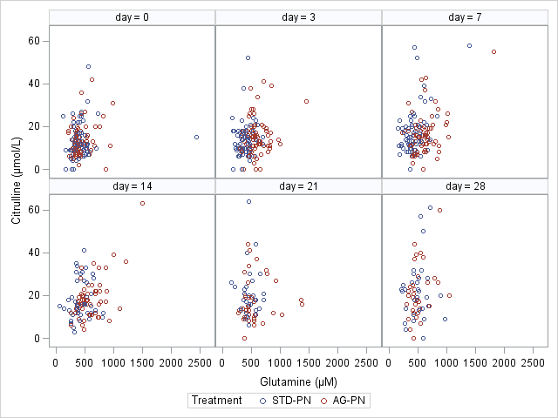

|  |  |  |  |  |  |  |
| --- | --- | --- | --- | --- | --- | --- |
| Day | Citrulline  n | Glutamine  n | Pearson Correlation | p | Spearman  Correlation | p |
| 0 | 146 | 146 | 0.15 | 0.072 | 0.16 | 0.060 |
| 3 | 139 | 139 | 0.18 | 0.038 | 0.12 | 0.16 |
| 7 | 131 | 131 | 0.39 | <0.0001 | 0.22 | 0.0097 |
| 14 | 101 | 99 | 0.41 | <0.0001 | 0.25 | 0.013 |
| 21 | 69 | 69 | 0.02 | 0.90 | 0.11 | 0.35 |
| 28 | 68 | 67 | 0.20 | 0.10 | 0.16 | 0.19 |

Table: Citrulline at Day 7 by Treatment Group Adjusted for Glutamine Using Multiple Linear Regressions

| **Type 3 Tests of Fixed Effects** | | | | |
| --- | --- | --- | --- | --- |
| **Effect** | **Num DF** | **Den DF** | **F Value** | **Pr > F** |
| **glutamine** | 1 | 127 | 34.29 | <.0001 |
| **treatment** | 1 | 127 | 0.04 | 0.8485 |
| **glutamine*treatment** | 1 | 127 | 2.03 | 0.1565 |

|  |  |  |  |
| --- | --- | --- | --- |
| Treatment Group | Sample Size | Adjusted Mean[95%CI] | P value |
| AG-PN | 67 | 15.2[12.7-17.6] | 0.85 |
| STD-PN | 64 | 20.3[17.8-22.9] |  |
|  |  |  |  |

* Mean±SD for Glutamine on Day 7 : 528.4±228.5 (µm)

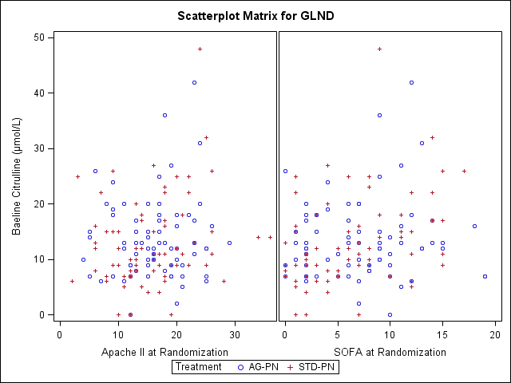

***Table1: Citrulline Related Demo***

| *Characteristic* | *Overall (n=146)* | *Citrulline< 8µm (n=31)* | *Citrulline= 8~12µm (n=36)* | *Citrulline=12~17µm (n=41)* | *Citrulline>=17µm (n=38)* | *p value* |
| --- | --- | --- | --- | --- | --- | --- |
| **Age at Consent** |  |  |  |  |  |  |
| Mean ± SD (N) | 60.2 ± 13.2(146) | 56.3 ± 14.4(31) | 59.3 ± 12.4(36) | 62.6 ± 13.7(41) | 61.8 ± 11.9(38) | 0.20 |
| Median[Q1-Q3] | 61.2[53.7 - 68.6] | 59.6[49.1 - 66.4] | 59.1[53.0 - 68.2] | 64.4[56.0 - 73.4] | 61.9[54.3 - 69.9] |  |
| [Min-Max] | [22.4 - 86.4] | [22.8 - 86.4] | [33.4 - 81.6] | [22.4 - 82.8] | [33.9 - 83.1] |  |
| **Gender** |  |  |  |  |  |  |
| Female | 69/146(47.3%) | 15/31(48.4%) | 18/36(50.0%) | 21/41(51.2%) | 15/38(39.5%) | 0.74 |
| Male | 77/146(52.7%) | 16/31(51.6%) | 18/36(50.0%) | 20/41(48.8%) | 23/38(60.5%) |  |
| **Race** |  |  |  |  |  |  |
| White | 127/146(87.0%) | 26/31(83.9%) | 32/36(88.9%) | 36/41(87.8%) | 33/38(86.8%) | 0.94 |
| Black or African American | 19/146(13.0%) | 5/31(16.1%) | 4/36(11.1%) | 5/41(12.2%) | 5/38(13.2%) |  |
| **Surgery Index** |  |  |  |  |  |  |
| Upper GI resection | 5/146(3.4%) | 0/31(0.0%) | 1/36(2.8%) | 3/41(7.3%) | 1/38(2.6%) | 0.65 |
| Peritonitis | 2/146(1.4%) | 0/31(0.0%) | 1/36(2.8%) | 0/41(0.0%) | 1/38(2.6%) |  |
| Intestinal resection | 98/146(67.1%) | 25/31(80.6%) | 24/36(66.7%) | 23/41(56.1%) | 26/38(68.4%) |  |
| Vascular | 31/146(21.2%) | 6/31(19.4%) | 8/36(22.2%) | 10/41(24.4%) | 7/38(18.4%) |  |
| Cardiac valve | 5/146(3.4%) | 0/31(0.0%) | 2/36(5.6%) | 2/41(4.9%) | 1/38(2.6%) |  |
| CABG | 5/146(3.4%) | 0/31(0.0%) | 0/36(0.0%) | 3/41(7.3%) | 2/38(5.3%) |  |
| **1.3 APACHE II** |  |  |  |  |  |  |
| APACHE >15 | 76/146(52.1%) | 12/31(38.7%) | 21/36(58.3%) | 20/41(48.8%) | 23/38(60.5%) | 0.26 |
| APACHE <=15 | 70/146(47.9%) | 19/31(61.3%) | 15/36(41.7%) | 21/41(51.2%) | 15/38(39.5%) |  |
| **APACHE at Entry** |  |  |  |  |  |  |
| Mean ± SD (N) | 15.8 ± 6.3(146) | 14.5 ± 6.1(31) | 15.8 ± 4.8(36) | 16.1 ± 7.9(41) | 16.4 ± 6.0(38) | 0.49 |
| Median[Q1-Q3] | 16.0[12.0 - 20.0] | 12.0[11.0 - 19.0] | 16.0[13.0 - 19.0] | 15.0[10.0 - 20.0] | 17.0[13.0 - 22.0] |  |
| [Min-Max] | [2.0 - 36.0] | [2.0 - 28.0] | [4.0 - 26.0] | [5.0 - 36.0] | [3.0 - 26.0] |  |
| **Days in SICU prior to study entry** |  |  |  |  |  |  |
| Mean ± SD (N) | 4.4 ± 3.5(146) | 3.8 ± 2.5(31) | 4.4 ± 3.2(36) | 5.1 ± 4.9(41) | 4.1 ± 2.8(38) | 0.51 |
| Median[Q1-Q3] | 4.0[2.0 - 6.0] | 3.0[2.0 - 5.0] | 4.0[2.0 - 6.0] | 4.0[3.0 - 6.0] | 4.0[2.0 - 6.0] |  |
| [Min-Max] | [1.0 - 31.0] | [1.0 - 13.0] | [1.0 - 14.0] | [1.0 - 31.0] | [1.0 - 14.0] |  |
| **Days in ICU post enrollment** |  |  |  |  |  |  |
| Mean ± SD (N) | 11.0 ± 11.7(146) | 11.2 ± 15.5(31) | 10.8 ± 9.8(36) | 10.7 ± 9.5(41) | 11.5 ± 12.4(38) | 0.94 |
| Median[Q1-Q3] | 7.0[3.0 - 16.0] | 6.0[3.0 - 16.0] | 7.0[2.5 - 17.0] | 7.0[3.0 - 19.0] | 8.0[5.0 - 15.0] |  |
| [Min-Max] | [0.0 - 81.0] | [1.0 - 81.0] | [1.0 - 34.0] | [0.0 - 30.0] | [0.0 - 56.0] |  |
| **Days in Hospital prior to study entry** |  |  |  |  |  |  |
| Mean ± SD (N) | 8.5 ± 9.1(146) | 10.7 ± 11.3(31) | 7.5 ± 5.3(36) | 9.4 ± 11.9(41) | 6.6 ± 5.4(38) | 0.54 |
| Median[Q1-Q3] | 6.0[3.0 - 10.0] | 7.0[3.0 - 14.0] | 6.0[4.0 - 9.5] | 7.0[4.0 - 9.0] | 5.5[3.0 - 9.0] |  |
| [Min-Max] | [-1.0 - 71.0] | [1.0 - 52.0] | [2.0 - 24.0] | [1.0 - 71.0] | [-1.0 - 29.0] |  |
| **Days in hospital post enrollment** |  |  |  |  |  |  |
| Mean ± SD (N) | 23.1 ± 21.4(146) | 24.5 ± 18.9(31) | 24.7 ± 15.3(36) | 18.4 ± 12.2(41) | 25.5 ± 32.9(38) | 0.21 |
| Median[Q1-Q3] | 19.0[11.0 - 28.0] | 20.0[12.0 - 29.0] | 20.0[14.5 - 33.5] | 18.0[10.0 - 24.0] | 16.0[11.0 - 27.0] |  |
| [Min-Max] | [1.0 - 201.0] | [7.0 - 81.0] | [6.0 - 85.0] | [1.0 - 65.0] | [4.0 - 201.0] |  |