- Plot of time vs. attempt

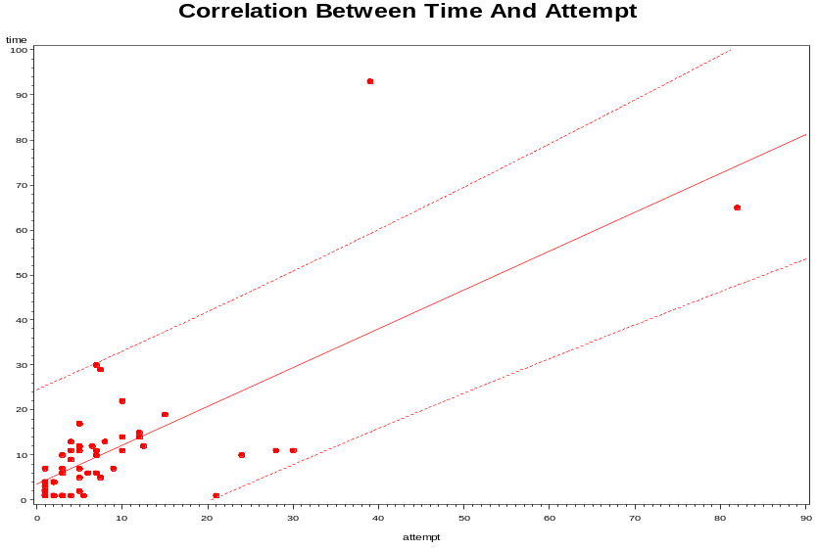
- Correlation Coefficient between time and attempt

Simple Statistics

Variable N Mean Std Dev Sum Minimum Maximum

time 58 10.67241 14.88245 619.00000 1.00000 93.00000
attempt 58 8.33621 12.45391 483.50000 1.00000 82.00000

Pearson Correlation Coefficients, N = 58
Prob > |r| under H0: Rho=0

time attempt

time 1.00000 0.72282
<.0001

attempt 0.72282 1.00000
<.0001

- Summary:
  - The correlation coefficient is 0.72282, it means time and attempt are correlated to some extent, which is different from the discussion in your manuscript.
  - Here the attempt is the average of attempts from both two observers; when the data is missing, the average takes the non-missing value.
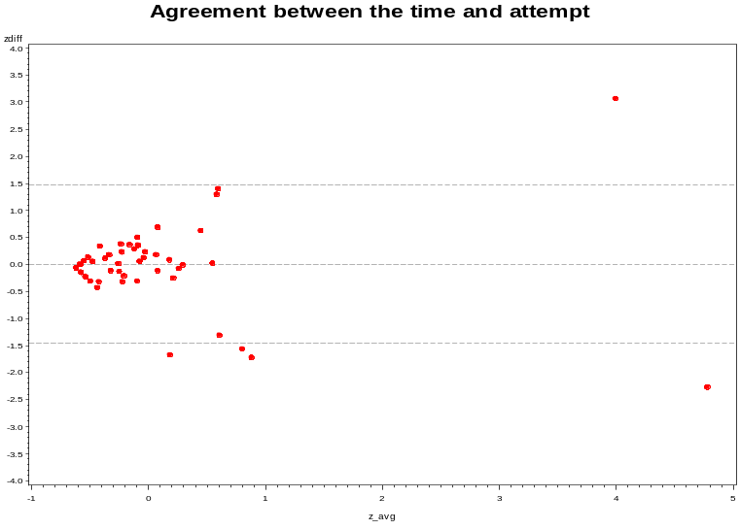
  - The two methods, time and attempt, have different unit, so it is hard to do the agreements analysis directly. Here through comparing the z-score of the measurements from both methods, there are at least 5 points which fall beyond the 95% confidence difference limits (5/58=0.09>0.05), therefore the degree of agreement between these two methods is not acceptable.
- The agreement between the two observers
The MEANS Procedure

Analysis Variable : diff

N Mean Std Dev Minimum Maximum
ƒƒƒƒƒƒƒƒƒƒƒƒƒƒƒƒƒƒƒƒƒƒƒƒƒƒƒƒƒƒƒƒƒƒƒƒƒƒƒƒƒƒƒƒƒƒƒƒƒƒƒƒƒƒƒƒƒƒƒƒƒƒƒƒƒƒ
13 0.1538462 3.4118947 -8.0000000 5.0000000
Ƒƒƒƒƒƒƒƒƒƒƒƒƒƒƒƒƒƒƒƒƒƒƒƒƒƒƒƒƒƒƒƒƒƒƒƒƒƒƒƒƒƒƒƒƒƒƒƒƒƒƒƒƒƒƒƒƒƒƒƒƒƒƒƒƒƒ

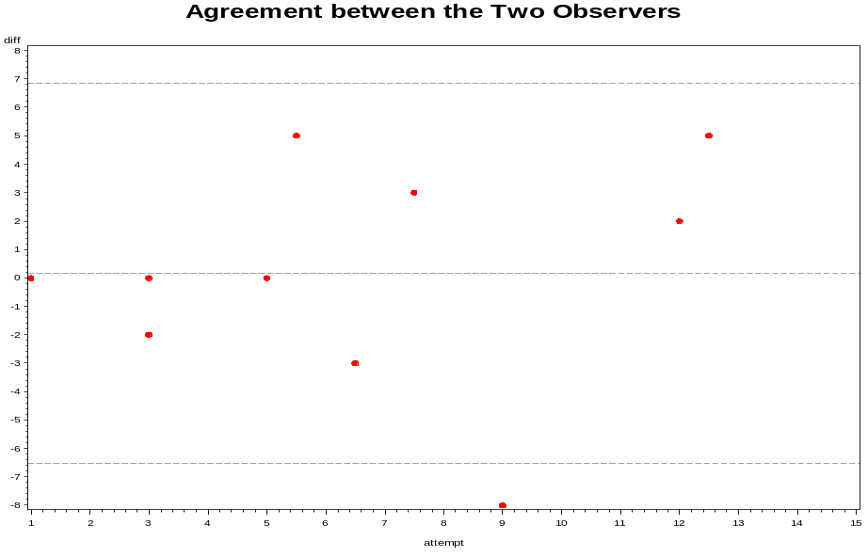
- Some calculations:
  - Assume d (the differences between the two observers) follow a distribution which is approximately normal, the variance of d is estimated as sd²/n=3.4118947²/13=0.8955 with standard error of 0.9463.
  - Provided the differences are normally distributed, the variance of sd is approximately estimated by sd²/ (2n-1).
  - The variance of the limits of agreements is estimated by (1/n+1.96²/ (2n-1)) sd²=2.6843 and the standard error is: 1.6384.
  - For t-distribution with 12 degree of freedom, the t=2.179.
  - The 95% CI for the bias is: 0.1538462±2.179*0.9463=[-1.9079, 2.2156]
  - The lower and upper limits of agreement are: 0.1538462±1.96*3.4118947= [-6.5335, 6.8412].
  - The 95% CI for the lower limits of agreement is: -6.5335±2.179 *1.6384=[-9.5492,-2.9634]
  - The 95% CI for the upper limits of agreement is: 6.8412±2.179*1.6384=[3.2711,10.4113]
- Conclusion:
- Since these intervals are wide, there can be considerable discrepancies between the attempts from the two observers.
- To test the mean difference of 0, the p-value is 0.7969, which means there is not a statistically significant difference between the attempts from the two observers.
- The correlation coefficient between the attempts from the two observers is 0.7093.

