Table B: Comparison between Rating Earlier and Later

TC "The Report Procedure "TC "Detailed and/or summarized report 2"TC "Table 1 "Characteristic | Overall  (n=127) | No  (n=22) | Yes  (n=105) | p value
Cage Type
SynFix | 2/127(1.6%) | 0/22(0.0%) | 2/105(1.9%) | 0.44
PERIMETER | 4/127(3.1%) | 2/22(9.1%) | 2/105(1.9%)
PEEK | 2/127(1.6%) | 0/22(0.0%) | 2/105(1.9%)
LT-Cage (x2) | 20/127(15.7%) | 3/22(13.6%) | 17/105(16.2%)
InFix | 99/127(78.0%) | 17/22(77.3%) | 82/105(78.1%)

Logistic Model:

proc logistic data=image descending plots=roc;
class procedure level nlevel Cage/param=ref ref=first order=internal;
model fused_combine =age BMI procedure level nlevel procmonth /*cage*//lackfit scale=none aggregate rsquare;
format procedure procedure. level level. nlevel num. Cage cage.;
run;

Type 3 Analysis of Effects
Effect | DF | Wald  Chi-Square | Pr > ChiSq
Age | 1 | 0.5481 | 0.4591
BMI | 1 | 0.1072 | 0.7433
procedure | 2 | 6.5454 | 0.0379
level | 1 | 0.7158 | 0.3975
nlevel | 1 | 4.5979 | 0.0320
procmonth | 1 | 11.0698 | 0.0009

Analysis of Maximum Likelihood Estimates
Parameter |  | DF | Estimate | Standard  Error | Wald  Chi-Square | Pr > ChiSq
Intercept |  | 1 | -0.5086 | 2.3281 | 0.0477 | 0.8271
Age |  | 1 | -0.0181 | 0.0245 | 0.5481 | 0.4591
BMI |  | 1 | 0.0278 | 0.0850 | 0.1072 | 0.7433
procedure | ALIF+Post | 1 | -1.6974 | 0.8136 | 4.3521 | 0.0370
procedure | ALIF+Plate | 1 | 1.1184 | 0.8871 | 1.5895 | 0.2074
level | L5-S1 | 1 | -0.5329 | 0.6298 | 0.7158 | 0.3975
nlevel | Num of Levels=2 | 1 | 1.3969 | 0.6515 | 4.5979 | 0.0320
procmonth |  | 1 | 0.4235 | 0.1273 | 11.0698 | 0.0009

Odds Ratio Estimates
Effect | Point Estimate | 95% Wald  Confidence Limits
Age | 0.982 | 0.936 | 1.030
BMI | 1.028 | 0.870 | 1.215
procedure ALIF+Post vs ALIF | 0.183 | 0.037 | 0.902
procedure ALIF+Plate vs ALIF | 3.060 | 0.538 | 17.410
level L5-S1 vs L4-L5 | 0.587 | 0.171 | 2.017
nlevel Num of Levels=2 vs Num of Levels=1 | 4.043 | 1.128 | 14.495
procmonth | 1.527 | 1.190 | 1.960

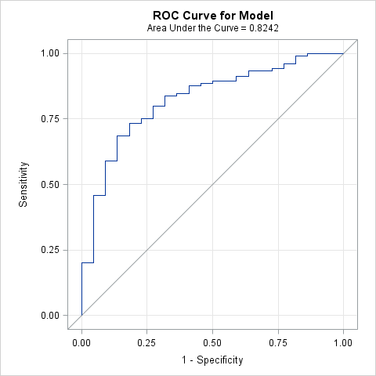

Hosmer and Lemeshow Goodness-of-Fit
Test
Chi-Square | DF | Pr > ChiSq
7.7158 | 8 | 0.4617

