- The difference between the 17 levels(treat right and left with no difference) :
Least Squares Means for effect level
Pr > |t| for H0: LSMean(i)=LSMean(j)

Dependent Variable: v

i/j 1 2 3 4 5 6 7 8 9
1 0.0472 0.0011 <.0001 <.0001 <.0001 <.0001 <.0001 <.0001
2 0.0472 0.1927 <.0001 <.0001 <.0001 <.0001 <.0001 <.0001
3 0.0011 0.1927 0.0048 0.0002 <.0001 <.0001 <.0001 <.0001
4 <.0001 <.0001 0.0048 0.3688 0.0416 0.0020 0.0085 0.0306
5 <.0001 <.0001 0.0002 0.3688 0.2542 0.0278 0.0825 0.2059
6 <.0001 <.0001 <.0001 0.0416 0.2542 0.2887 0.5507 0.9008
7 <.0001 <.0001 <.0001 0.0020 0.0278 0.2887 0.6423 0.3490
8 <.0001 <.0001 <.0001 0.0085 0.0825 0.5507 0.6423 0.6369
9 <.0001 <.0001 <.0001 0.0306 0.2059 0.9008 0.3490 0.6369
10 <.0001 <.0001 <.0001 0.0003 0.0063 0.1111 0.5944 0.3188 0.1419
11 <.0001 <.0001 <.0001 <.0001 <.0001 <.0001 <.0001 <.0001 <.0001
12 <.0001 <.0001 <.0001 <.0001 <.0001 <.0001 <.0001 <.0001 <.0001
13 <.0001 <.0001 <.0001 <.0001 <.0001 <.0001 <.0001 <.0001 <.0001
14 <.0001 <.0001 <.0001 <.0001 <.0001 <.0001 <.0001 <.0001 <.0001
15 <.0001 <.0001 <.0001 <.0001 <.0001 <.0001 <.0001 <.0001 <.0001
16 <.0001 <.0001 <.0001 <.0001 <.0001 <.0001 <.0001 <.0001 <.0001
17 <.0001 <.0001 <.0001 0.0007 0.0130 0.1789 0.7770 0.4546 0.2226

i/j 10 11 12 13 14 15 16 17
1 <.0001 <.0001 <.0001 <.0001 <.0001 <.0001 <.0001 <.0001
2 <.0001 <.0001 <.0001 <.0001 <.0001 <.0001 <.0001 <.0001
3 <.0001 <.0001 <.0001 <.0001 <.0001 <.0001 <.0001 <.0001
4 0.0003 <.0001 <.0001 <.0001 <.0001 <.0001 <.0001 0.0007
5 0.0063 <.0001 <.0001 <.0001 <.0001 <.0001 <.0001 0.0130
6 0.1111 <.0001 <.0001 <.0001 <.0001 <.0001 <.0001 0.1789
7 0.5944 <.0001 <.0001 <.0001 <.0001 <.0001 <.0001 0.7770
8 0.3188 <.0001 <.0001 <.0001 <.0001 <.0001 <.0001 0.4546
9 0.1419 <.0001 <.0001 <.0001 <.0001 <.0001 <.0001 0.2226
10 <.0001 <.0001 <.0001 <.0001 <.0001 <.0001 0.8032
11 <.0001 <.0001 <.0001 <.0001 <.0001 0.0198 <.0001
12 <.0001 <.0001 0.0014 0.0145 0.1777 0.0161 <.0001
13 <.0001 <.0001 0.0014 0.4478 0.0633 <.0001 <.0001
14 <.0001 <.0001 0.0145 0.4478 0.2719 <.0001 <.0001
15 <.0001 <.0001 0.1777 0.0633 0.2719 0.0002 <.0001
16 <.0001 0.0198 0.0161 <.0001 <.0001 0.0002 <.0001
17 0.8032 <.0001 <.0001 <.0001 <.0001 <.0001 <.0001

  - In the output above, the index of 1-17 corresponds the level of t1-t12 (1-12) until l1-l5 (13-17).
  - The highlight number is the p-value of the t-test for H0: LSMean (i) =LSMean (j). The insignificant difference between each levels include: 2-3, 4-5,5-6, 5-8,5-9, 6-7,6-8,6-9,6-10,6-17,7-8,7-9, 7-10,7-17,8-9,8-10,8-17,9-10,9-17,10-17,12-15,13-14,14-15.
  - The least square mean for each level list as below:

level v LSMEAN 95% Confidence Limits
1 14.548780 14.106334 14.991227
2 15.178571 14.741424 15.615719
3 15.589286 15.152138 16.026433
4 16.478571 16.041424 16.915719
5 16.761905 16.324757 17.199052
6 17.121429 16.684281 17.558576
7 17.455952 17.018805 17.893100
8 17.309524 16.872377 17.746671
9 17.160714 16.723567 17.597862
10 17.623810 17.186662 18.060957
11 19.721905 19.284757 20.159052
12 21.216667 20.779519 21.653814
13 22.227381 21.790234 22.664528
14 21.988095 21.550948 22.425243
15 21.641667 21.204519 22.078814
16 20.457143 20.019996 20.894290
17 17.545238 17.108091 17.982385

- The difference between the Right and Left for each level:
Group | Level | Difference(Right-Left) | p-value
Thoracic | 1 | -0.2537 | 0.4456
Thoracic | 2 | -0.1143 | 0.7169
Thoracic | 3 | -0.0357 | 0.9214
Thoracic | 4 | 0.0333 | 0.9230
Thoracic | 5 | 0.0762 | 0.8322
Thoracic | 6 | 0.0333 | 0.9265
Thoracic | 7 | -0.2929 | 0.4029
Thoracic | 8 | -0.0762 | 0.8545
Thoracic | 9 | -0.0119 | 0.9709
Thoracic | 10 | 0.1524 | 0.6858
Thoracic | 11 | 0.2486 | 0.5992
Thoracic | 12 | 0.2762 | 0.5809
Lumbar | 1 | 0.5595 | 0.3923
Lumbar | 2 | -0.0286 | 0.9534
Lumbar | 3 | 0.3262 | 0.5049
Lumbar | 4 | 0.8190 | 0.2029
Lumbar | 5 | 0.2190 | 0.7198
Seen from the p-value of the paired t-test for mean (right) =mean (left), there is no significant difference between right and left.

- For the two inter-observer data, the difference between two readers:
First we compute the difference, then test whether the mean difference equal 0 or not (suppose the difference follow normal distribution). The p-value is about 0.0202<0.05, which means there is significant difference between the values from the two readers.
The TTEST Procedure
Mean 95% CL Mean Std Dev 95% CL Std Dev
0.2197 0.0354 0.4040 0.7613 0.6514 0.9162
DF t Value Pr > |t|
67 2.38 0.0202

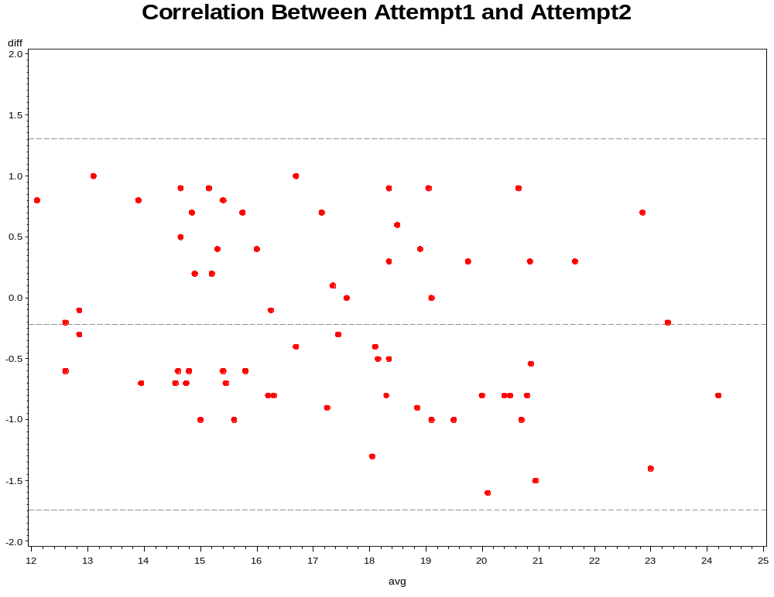
Some confidence interval for the bias:
  - Df=68, d=-0.2197,s=0.7613 t-value(df=68)=1.9955 SE(d)=(s^2/n)^0.5=0.09232, SE(d±2s)=(3s^2/n)^0.5=0.1599
  - The difference d is:-0.2197, upper limit is: d+2s=-0.2197+2*0.7613=1.3029, the lower limit is :d-2s=-0.2197-2*0.7613=-1.7423
  - 95%CI for bias is: -0.2197±1.9955*0.09232=[-0.4039, -0.0355]
  - 95%CI for upper limit is: 1.3029±1.9955*0.1599=[0.9838, 1.6220]
  - 95%CI for lower limit is: -1.7423±1.9955*0.1599=[-2.0614, -1.4232]
Since these confidence intervals are narrow, the value from both readers can be thought exchangeable. However, as the 95% CI for bias = [-0.4039, -0.0355] <0, there is an obvious bias between the two readers.

