Plasma Exchange in Children with Thrombocytopenia-Associated Multiple Organ Failure (TAMOF): The TAMOF Network Prospective Registry Experience

James D. Fortenberry MD FCCM, FAAP; Trung Nguyen; Yong Han; Raj Aneja; Derek Wheeler; Mark Hall; Geoffrey Fleming; Frederick Barr; Rod Tarrago; Sandra Buttram; Heidi Dalton; Kristine Rogers; Kirk A. Easley; Andrea Knezevic; Matt Paden; Joe Carcillo

Introduction
Sepsis remains a major cause of morbidity and mortality for both adults and children. The World Health Organization (WHO) estimates that infection-related sepsis is the leading killer of children worldwide (1), with over 42,000 annual cases of pediatric sepsis in the United States alone, with an estimated cost for care of over two billion dollars (5). Of children hospitalized with sepsis in the United States, 10.3% will die (5). However, outcomes remain much worse in the subset of children with sepsis and multiple organ failure (2-5). Death from sepsis is primarily related to development of multiple organ failure (MOF), defined as the failure of three or more organ systems (6). Pediatric mortality rates increase from 4-7% with single organ failure up to 53-57% with four failing organs (2,7). Up to 16% of children with severe sepsis still progress to MOF. Thus MOF remains a persistent final common pathway to death and a target for improved treatment.
Microvascular coagulation plays a key role in the pathogenesis of MOF and sepsis (8-12). Activation of cellular and biochemical inflammatory pathways stimulates the kinin and complement systems and the expression and release of tissue factor (TF) from macrophages and neutrophils, activating the extrinsic coagulation pathway and generating intravascular thrombin (14). Thrombin is responsible for consumption of coagulant and anticoagulant proteins, activation of platelets and of endothelial cells via thrombin receptor binding (15,16), with subsequent development of microvascular thrombosis. Progressive activation of the coagulation system leads to disseminated intravascular coagulopathy (DIC). The net result of these changes is the conversion of the normal microvascular milieu from an anticoagulant/profibrinolytic condition to a markedly procoagulant/antifibrinolytic state, ultimately creating microvascular thrombosis, tissue hypoperfusion, and organ failure. Increasing evidence suggests thrombotic microangiopathy (TMA) may be been linked with sepsis and poor outcomes even in the absence of DIC.
TMAs are microvascular occlusive disorders characterized by systemic thrombosis from platelet/von Willebrand factor (vWF) interactions which predispose patients to the development of MOF. TMAs are heralded by the onset of thrombocytopenia, microangiopathic hemolysis, and ischemic organ failure (21, 23). Primary TMA is classically seen in thrombotic thrombocytopenic purpura (TTP) or its variant, hemolytic uremic syndrome (HUS), but is also identified as a leading contributor to mortality in children with meningococcemia, dengue hemorrhagic fever, and malarial anemia (1). Altered von Willebrand factor (vWF) proteolysis in organ injury in TMAs has been elucidated (29,30). vWF is released from ECs under physiologic conditions as ultra-large (UL) molecular weight multimers, capable of direct binding and agglutination of platelets. These are normally cleaved by a plasma metalloprotease into smaller MW multimers with less thorombogenic potential. Persistent circulating UL vWF multimers are found in the plasma of some TMA patients (30,31).
The vWF-cleaving metalloproteinase, referred to as ADAMTS-13 (A Disintegrin and Metalloprotease with ThromboSpondin type 1 motif), normally cleaves the hyper-adhesive UL vWF multimers (35,36). ADAMTS-13 deficiency is now ascribed as the primary defect responsible for TTP (37,38). ADAMTS-13 abnormalities are also seen in a range of acquired thrombocytopenic disorders (38) and in children (39). ADAMTS-13 abnormalities have been reported in animal models and clinical sepsis studies (41,42) in both children and adults (43). Clinical outcomes have been correlated with severity of ADAMTS-13 deficiency (50,51).
A subset of children with sepsis or inflammatory disease and high mortality with a thrombotic microangiopathic syndrome has been described (Nguyen) by the term thrombocytopenia-associated multiple organ failure (TAMOF) (7,48). Clinicopathologic elements include fibrin thrombi, thrombocytopenia, increased vWF with decreased percentage of large vWF multimers, and decreased protein C (7,49). A correlation between outcome, thrombocytopenia and ADAMTS-13 activity was seen in a small series of children with multiple organ failure (ref). TAMOF patients in the series had decreased ADAMTS-13 activity compared to children with multiple organ failure without thrombocytopenia; all nonsurvivors had TAMOF, reduced ADAMTS-13 activity, and vWF-rich microvascular thromboses at autopsy.
Plasma exchange (PEx) is considered an effective therapy for patients with TTP/HUS because it removes vWF-cleaving protease antibodies and replaces deficient protease (50). Experience has been expanded to use in patients with TTP/HUS-like syndromes associated with systemic toxin- or infectious episodes (22,53,54,57,58,59), and a prospective randomized trial in 106 septic adults (61) found improved 28 day survival in septic patients treated with PEx compared to conventional therapy alone.
A small randomized controlled open label trial study of a TTP-based PEx protocol for children with TAMOF showed restoration of ADAMTS-13 activity in patients given PEx, with significant reduction in organ dysfunction and improved survival, compared to those with standard therapy (ref). While intriguing, the trial was not powered or designed to determine outcome.
We sought to better characterize TAMOF as a clinical entity and responses with PEx in a broader multicenter population, and to inform further studies and a randomized controlled trial to determine outcome effects of PEx. To do so, we developed a multicenter network to enroll children with TAMOF. Eighty one children were enrolled in the cohort. We hypothesized that children with TAMOF receiving PEx would demonstrate greater improvement in PELOD scores and better survival than children receiving standard therapy alone. We also expected children with TAMOF to demonstrate biochemical findings consist with ADAMTS-13 deficiency and vWF multimer elevation. Biochemical data were available in a subset (approximately 69%) of the cohort.

Materials and Methods

We developed a multicenter network of 9 participating pediatric intensive care units at large children’s hospitals. These included Children’s Healthcare of Atlanta at Egleston, Atlanta, GA (primary center); Children’s Hospital of Pittsburgh, Pittsburgh PA; Cincinnati Children’s Hospital and Medical Center, Cincinnati OH; Phoenix Children’s Hospital; Phoenix, AZ; Children’s National Medical Center, Washington DC; Nationwide Children’s Hospital, Columbus, OH; Monroe Carrell Children’s Hospital, Nashville, TN; CS Mott Children’s Hospital, Ann Arbor, MI; Children’s Hospital of Minnesota, Minneapolis, MN.
The study was a prospective cohort observational trial (ClinicalTrials.gov Identifier: NCT00118664) designed to evaluate the clinical course, biochemical profile, therapies, and outcome of children meeting criteria for thrombocytopenia-induced multiple organ failure (TAMOF) as described below. Screening of patients in center ICUs was performed weekly to assess for patients meeting inclusion criteria. The study was designed to specifically evaluate the use of plasma exchange (PEx) in participating centers. PEx was used in each center based on physician practice and preference. Some centers used PEx routinely, some used PEx intermittently, and some centers did not use PEx. The primary objective of the study was to describe characteristics of a larger cohort of children meeting TAMOF criteria, describe present use of PEx for TAMOF, and evaluate outcomes in the TAMOF cohort. We desired, to determine any association of PEx with 28 day mortality after controlling for severity of illness, and use of other advanced therapeutic interventions.
Patients were enrolled or excluded based on the following inclusion and exclusion criteria:
Inclusion Criteria
Pediatric ICU patients with the following inclusion criteria were eligible for enrollment:
- Age 1 week to 21 years
- Multiple organ failure, defined as organ failure index (OFI) score >3 present for <30 hours (ref)
- New (not present prior to admission) organ failure in at least 3 of the 5 organ systems as defined.
- Thrombocytopenia (platelet count < 100,000/μl) OR (in patients with a baseline platelet count < 100,000/μl) a minimum 50% decrease in baseline platelet count.
- Etiology of multiple organ failure due to systemic infection and shock based on definitions of sepsis from International Pediatric Sepsis Consensus Conference (67)
- Criteria for definition of TAMOF met within 30 hours of study enrollment
Exclusion Criteria:
- Treatment prior to study entry with plasma exchange therapy within 30 days not for TAMOF
- Patients with terminal illness (i.e. not expected to live > 60 days even if they survive this acute illness) or in whom withdrawal of therapy is being considered (DNR/comfort measures only, limited therapy, etc.)
Prior to study enrollment, written informed consent was obtained from a parent/legal guardian. Approval for the study was obtained at institutional review boards at each of the participating centers.
Clinical Observations and Measurement
Patient screening and eligibility was performed at each center. Following obtaining informed consent, data was obtained Longitudinal data collection was initiated, including vital signs, laboratory values, blood product usage, medication use, vasopressor need, and indicators for organ failure scores. OFI and PELOD scores were calculated. Multiple clinical variables (age, gender, race, diagnosis, etiologic organism if infected, daily OFI and MOF scores [PEMOD, PELOD (68,69)]) were measured In patients for whom clinical decision for use of PEx was determined, enrollment was performed prior to initiation of PEx. Patient PEx data (volume replaced, volume used, device and technique used) was recorded daily for up to 14 days. Survival was noted daily up to 28 days. In patients who died, cause of death was determined based on clinical assessment. Concomitant use of renal replacement therapy (intermittent hemodialysis, continuous renal replacement therapy, peritoneal dialysis) or extracorporeal membrane oxygenation (ECMO) and other co-interventions (platelet transfusions, heparin, AT-III concentrate use, etc.) was also captured.
Clinical Management
All centers provided overall management based on institutional standards and guidelines. Study interventions consisted only of data collection, and blood sample removal at specified time points. Study patients received ECMO, CRRT, or additional therapies based on physician decision and clinical condition. Entry into this study did not interfere with use of any other therapies deemed necessary by the treating physicians. Determination of need and use of PEx was made based on physician preference. For patients receiving PEx, determination of number of days of therapy and volume of plasma exchanged was based on institutional guidelines. Delivery of PEx was provided by centrifugation technique at all centers as previously described (ref). Many centers used a modified protocol based on previously published experience with use of PEx in sepsis (Nguyen ref). This protocol recommends exchange of 1.5 x plasma volume (based on a weight-based nomogram and patient hematocrit) on the initial day of therapy, followed by exchange of 1 x plasma volume daily. Determination of duration of daily exchange was at physician discretion, but endpoints included an arbitrary 5 day time point, until resolution of organ failure, or until death. Centers performing PEx used fresh frozen plasma as the exchange product.
Blood Sample Collection and Preparation
Anticoagulated (citrate) whole blood specimens were obtained at the following points: baseline upon study consent (prior to PEx initiation if performed, and at study days 1, 4, 8, and the morning of the day after stopping PEx (or day 15 if not receiving PEx). A final sample was obtained on day 28 if possible. Blood samples were collected from patients with 0.38% sodium citrate as anticoagulant and centrifugated at 150xg for 15 minutes to obtain platelet-poor plasma, frozen at –80°C, and then shipped to a central laboratory at Texas Children’s Critical Care Laboratory at Baylor College of Medicine for batched analysis.
Evaluation of Plasma Profiles
Samples were assayed for the following: vWF antigen, vWF multimer analysis by gel electrophoresis, ADAMTS-13 activity assay and antigen ELISA, protein C, and antithrombin-III. ADAMTS-13 activity was measured as previously described (35). ADAMTS-13 antigen was measured using a commercially available sandwich enzyme-linked immunoabsorbent assay (ELISA). Using scanning densitometry, the density difference in the generated 176 kD fragments in the sample reaction mixtures with and without ethylene-diamine-tetra-acetic acid (EDTA) represents the proteolytic fragments cleaved by ADAMTS-13. The ADAMTS-13 activity was determined by the cleaved 176 kD proteolytic fragments from patient plasma expressed as the percentage of the cleaved 176 kD fragments from pooled control sample on the same gel. For flow activity, ADAMTS-13 deficiency was defined as abnormal when vWF-cleaving activity was less than 57 percent of control.
Plasma vWF antigen was measured using a commercially available ELISA assay (Ramco Laboratories, Houston, TX). Purchased human vWF (Haematologic Technologies Inc., VT, USA) with a concentration of ~500 mcg/ml was exposed to guanidine (1.5 mol/liter) and diluted to a concentration of 15-25 mcg/ml to be used as substrate for ADAMTS-13. The vWF dimers of 176 kD and the 140 kD fragments were separated by sodium dodecyl sulphate polyacrylamide gel electrophoresis. The fragments were visualized by immunoblotting using rabbit anti-human polyclonal VWF antibody (DAKO, Carpinteria CA) labeled with secondary ¹²⁵I-labeled donkey anti-rabbit IgG antibody as mentioned above (Amersham Pharmacia Biotech, NJ, USA).
Statistical Analysis
Continuous variables (e.g., PELOD scores, PRISM scores, biomarkers - ADAMTS-13 Activity,vWF antigen, vWF Ristocetin cofactor) were summarized. Demographic and baseline characteristics of the PEx-treated and standard therapy-treated children with TAMOF were compared with a two-sample t-test for continuous variables or Fisher’s exact test for proportions. Repeated-measures analyses for total PELOD score (and change from baseline), platelet count , ADAMTS-13 activity, vWF antigen and vWF ristocetin cofactor activity were done with a means model with SAS Proc Mixed (version 9, mixed linear models) providing separate estimates of the means by time on study (days 1-7) and treatment group. A compound symmetry variance-covariance form among the repeated measurements was assumed for each outcome and robust estimates of the standard errors of parameters were used to perform statistical tests and construct 95% confidence intervals (Reference: Diggle et al). These same repeated-measures analyses were performed to compare changes over time among plasma exchange-treated children with TAMOF by vital status (survivors versus non-survivors by 28-days of follow-up). T-tests were used to compare the pairwise differences between the model-based treatment means (least-squares means) at each time point. Mean changes over time within a treatment group were tested for linear trend. The model-based means are unbiased with unbalanced and missing data, so long as the missing data are non-informative (missing at random). A dropout process is assumed to be missing at random if; conditional on the observed data, the dropout is independent of the unobserved measurements.
Logistic regression was used to examine the independent effects of baseline PELOD, CVVH, ECMO, MRSA infection and PEx on mortality. The odds ratio and its 95% confidence interval were calculated for each risk factor in the presence of the others in the final model. The goodness-of-fit of the model was evaluated using the Hosmer-Lemeshow chi-square statistic.
Results
Eighty-one patients were enrolled in the study. Clinical characteristics of enrolled patients are described in Table 1. Mean organ failure index was 4.5 + 1.2, mean PRISM score was 18.2+6.8, and mean PELOD score was 21.3 ± 11.420.2 (range 1-52). Primary patient diagnoses are noted in Table 2. Most patients were admitted with a primary or secondary diagnosis of sepsis (69/81; 85.2%). Other common primary diagnoses included xxxxx? (see table below from Andrea). Thirty six patients had organisms identified by positive blood culture (Table 3). Of patients with positive blood cultures, the majority were staphylococcal (12, 33%), including 4 non-MRSA and 8 MRSA. Overall 28 day survival was 54/81 (67%). Thirty seven percent (30/81) of patients received extracorporeal membrane oxygenation (ECMO) support. ?
One or more measurements of ADAMTS-13 were available over time for 56 children (37 at baseline). Baseline ADAMTS-13 levels at time of study entry were low (mean 52.9% of normal; range 0.0%-105.1% ). vWf antigen levels were high (mean 161% of normal; range 64%-331%). Patients with ADAMTS-13 deficiency (<57%) were more likely to receive PEx (20/22,91%) than those patients without ADAMTS-13 deficiency (9/15,60%).

Seventy four percent (60/81) TAMOF patients received PEx. All but 2 patients with TAMOF receiving PEx had sepsis as a primary or secondary diagnosis. Two patients had TAMOF with xxx(Andrea says see table below; we just have ‘TAMOF without sepsis on the CRF??’). Variability was noted in use of PEx for TAMOF among centers. One center exclusively reported PEx use, one exclusively reported not using PEx, and the remainder used both approaches (Table 2). Use ranged from 0 to 100% of enrolled TAMOF subjects (median use xx%).
Jim – below are the Results summarized based on the repeated measures analyses (Figure 1 and 2):

PELOD scores in the two treatment groups changed in significantly different ways during the first week on study (P = 0.0018, test for interaction between time on study and treatment group, Figure 1A). TAMOF patients receiving PEx had significantly higher PELOD scores at study entry than patients receiving standard therapy alone (mean = 22.5, 95% CI: 19.5-25.5 vs. mean = 17.7, 95% CI: 13.7-21.6; p = 0.05) (Figure 1A). Mean PELOD score declined over time for PEx patients (P < 0.0001, test for linear trend) but the mean change over time was not statistically significant for the patients receiving standard therapy alone (P = 0.11, test for linear trend). By day seven, the mean difference in PELOD score between the study cohorts was less than one PELOD point (Day 7 PELOD: 12.1 PEx and 12.6 standard therapy alone). However after adjusting the PELOD analyses for CVVH (p = 0.0008) and ECMO (p = 0.08), the PELOD means were 5.6 (p = 0.12), 6.4 (p = 0.02) and 2.8 points (p = 0.30) lower on study days 5, 6 and 7 for PEx patients compared to patients receiving standard therapy alone. Similarly multivariable analyses of the delta changes in PELOD score indicated the mean PELOD score was 8.8 (p < 0.01), 9.3 (p < 0.01) and 5.6 (p = 0.02) points lower on study days 5,6 and 7 for PEx patients compared to patients receiving standard therapy only (Figure 3).

Figure 1B provides the estimated PELOD means by treatment group using the maximum PELOD score of 71 at all-time points after death (19 PEx patients and 8 standard therapy alone patients died within 28 days). The decline in mean PELOD score was attenuated after day two for the PEx group. For the standard therapy alone group there was an initial increase in mean PELOD score from day 1 to day 2 followed by very little change between days 3 and 6.

Figure 2A summarizes longitudinal changes in PELOD score for TAMOF PEx survivors and PEx non-survivors who received plasma exchange (41 survivors and 19 non-survivors). PELOD scores in the two survival groups were consistently different (p <0.0001), with PEx survivors having a significantly lower PELOD score than PEx non-survivors. Mean difference in PELOD score pooled across time on study was 12.6 points (95% CI: 6.6-18.7). Interaction between days on study and treatment group was not significant for PELOD (p = 0.75), indicating that both survival groups followed the same pattern of decline in PELOD score.

Jim – Figure 1B - analyses of max PELOD at all-time points after death: I would be OK keeping or eliminating Figure 1B (and the second paragraph that describes this analysis). I am not sure this analysis helps with the interpretation nor does it appear to help (?) regarding the potential bias in estimation due to mortality/dropout in the 2 groups. However the approach seems more applicable/helpful to the PE vs. standard therapy alone analysis as a simple technique to address potential bias in estimation when both groups have dropout due to mortality compared to its value in the PEx survivor vs. PEx non-survivor analysis (Figure 2B) when obviously max PELOD score is only used in the non-survivors. For the survivor vs. non-survivor data (Figure 2B) I am not sure we need the max PELOD results. The results change dramatically using the max PELOD after death among non-survivors (instead of a mean difference of 12.6 the mean difference is 41 points).

Neither the pattern of change for mean platelet count over the first week on study (p = 0.65, test for interaction between time on study and treatment group) nor the difference between treatment groups over time was significant (p = 0.93, Figure 1C). Mean platelet counts were similar at baseline for the two treatment groups (63,500 and 57,200 cells/µL for PEx and standard therapy alone). Mean platelet count increased over time for PEx patients (p = 0.0006 test for linear trend) and for the standard therapy group (p = 0.0015, test for linear trend). The mean platelet count on study data seven was 98,500 cells/µL in PEx patients and 113,000 cells/µL for standard therapy alone patients.

Mean platelet counts were usually higher in PEx survivors than in PEx non-survivors (Figure 2C). However, differences were not significant, either when considered as a pattern of change (p = 0.43) or as a persistent difference between treatment groups over time (p = 0.15). Mean platelet counts increased over time in PEx survivors (p = 0.055, test for linear trend) and in PEx non-survivors (p = 0.0031, test for linear trend).

ADAMTS-13 levels were below normative levels at baseline in both treatment groups but were not significantly (P = 0.20) lower in the PEx patients (Figure 1D). Neither the pattern of change of this variable (p = 0.38) nor the difference between treatment groups over time was significant (p = 0.37). Mean ADAMTS-13 levels increased over time in the PEx children (p < 0.0001). ADAMTS-13 levels did not change over time for the standard therapy group (n = 13).

Figure 2D summarizes longitudinal changes in ADAMTS-13 for TAMOF PEx survivors and PEx non-survivors who received plasma exchange (32 survivors and 11 non-survivors). ADAMTS-13 activity in the two survival groups changed in significantly different ways during the first week on study (P = 0.01, test for interaction between time on study and survival group, Figure 2D). Mean ADAMTS-13 activity increased over time in the PEx survivors (P < 0.001). The sample sizes at each time point were very small for the PEx non-survivors but generally the mean ADAMTS-13 activity increased over the first 4 days of follow-up (p = 0.009 change from baseline to day 4).

vWf antigen levels were higher than normal in both treatment groups (Figure 1E). Mean vWf antigen levels in the two treatment groups were consistently different (p =0.0009), with PEx TAMOF patients having significantly lower vWf antigen levels than standard therapy alone TAMOF patients. TAMOF patients receiving PEx had significantly lower vWf antigen levels at study entry than patients receiving standard therapy alone (mean = 140% of normal, 95% CI: 120%-160%) vs. mean = 201% of normal, 95% CI: 161%-240%; p = 0.007) (Figure 1E). Interaction between days on study and treatment group was not significant for vWf (p = 0.67) indicating that both cohorts followed the same pattern over time.

vWF antigen levels for 32 PEx survivors and 11 PEx non-survivors changed in significantly different ways during follow-up (p < 0.0001, test for interaction between time on study and survival group). TAMOF survivors receiving PEx had significantly higher vWf antigen levels at study entry than PEx non-survivors (mean = 150% of normal, 95% CI: 126-174 vs. mean = 110% or normal, 95% CI: 98%-121%; p = 0.003) (Figure 1E). Statistical comparisons at the other time points did not suggest differences between PEx survivors and PEx non-survivors except at day 4 (p = 0.02). No statistical test was performed at day 28 due to limited data.
vWf ristocetin cofactor activity (% of normal) for the two treatment groups tended to change in different ways during follow-up (p = 0.06, test for interaction between time on study and treatment group). Mean vWF ristocetin cofactor activity was elevated in the standard therapy group compared to the PEx group on follow-up days 0, 1, and 4 (p values: 0.15, 0.04, 0.002, 0.06, 0.06, and 0.04 for follow-up days 0,1,4,8,15 and 28 days).
vWF ristocetin cofactor activity for PEx survivors and PEx non-survivors did not change in significantly different ways during follow-up (p = 0.16, test for interaction between time on study and vital status). Mean vWF ristocetin cofactor activity was elevated in the PEx non-survivors compared to the PEx group at day 1 (p values: 0.12, 0.007, 0.83, 0.98, and 0.26 for follow-up days 0, 1, 4, 8 and 15 days. No statistical test was performed at day 28 due to limited data.

Median use of PEx was 5 days (range 1-14 ). In patients receiving PEx for > 3 days ,mortality was xx, delta PELOD was xx (did not get to this).

Jim – I stopped here – will review logistic regression next week
Logistic regression analysis was performed for probability of death. Unviariable analysis identified baseline PELOD score, ECMO, CRRT, MRSA infection, and PEx use as predictors of death or 28 day survival. By multivariable analysis, baseline PELOD score and PEx remained as predictors. Baseline PELOD was associated with 1.734 times increased risk of death for each 5 point increase (p = 0.006). PEx was associated with a reduction in risk of death by 66.8%; the odds of 28 day survival were 3 times higher with PEx (p =0.09). When MRSA infection was included in the modeling, PEx was associated with a reduction of death by 70.6%; the odds of survival were 3.4 times higher with PEx (p = 0.05).
TAMOF survivors had lower baseline PELOD scores and higher ADAMTS-13 levels at baseline.
The following table lists the primary admitting diagnoses for the 12/81 (14.8%) of patients who had a non-sepsis related admitting diagnosis and shows the 2 PeX patients who had TAMOF without sepsis as an indication for PeX. Jim- please summarize for the results section as you see fit.

Patient Id | Group | Primary Diagnosis | Indication for PeX
101008 | PeX | Systemic lupus erythematosus | TAMOF w/suspected or confirmed sepsis
101020 | PeX | Cystic Fibrosis with Pulmonary Manifestation | TAMOF w/o Sepsis
102003 | PeX | extra cardiac conduit fontan | TAMOF w/suspected or confirmed sepsis
102004 | PeX | Subaortic Stenosis Resection | TAMOF w/suspected or confirmed sepsis
104005 | No PeX | Langerhans Cell Histiocytosis | -
109004 | No PeX | Acute hepatic failure | -
109008 | PeX | Interstitial lung disease | TAMOF w/o Sepsis
110002 | PeX | Unknown | TAMOF w/suspected or confirmed sepsis
110004 | PeX | Bundle Branch Block | TAMOF w/suspected or confirmed sepsis
110006 | PeX | Acute respiratory distress syndrome | TAMOF w/suspected or confirmed sepsis
111002 | No PeX | hypovolemic shock | -
111010 | No PeX | Pancytopenia | -

Table X:
 | Plex Survivor | Plex Non-survivor | No Plex Survivor | No Plex Non-survivor
Center 1 | 12 | 10 | 1 | 0
Center 2 | 6 | 0 | - | -
Center 3 | - | - | 2 | 3
Center 4 | - | - | 2 | 0
Center 5 | 1 | 1 | 2 | 3
Center 6 | 10 | 3 | 1 | 0
Center 7 | 3 | 2 | 4 | 1
Center 8 | 8 | 1 | - | -
Center 9 | 1 | 2 | 1 | 1
Total | 41 | 19 | 13 | 8

ADAMTS-13 | >57% | <57% | P-value
 |  |  | 0.04*
Standard Therapy | 6/15 | 2/22
PEx | 9/15,60% | 20/22,91%
* Patients with ADAMTS-13 deficiency (<57%) were more likely to receive PEx (20/22,91%) than those patients without ADAMTS-13 deficiency (9/15,60%).

Discussion
Increasing evidence suggests that these alterations in vWF, platelet concentrations and other coagulation factors are associated with, and possibly implicated in, increasing morbidity and mortality in patients with sepsis. vWF levels are markedly elevated in patients with sepsis/MOF, and new onset thrombocytopenia is an independent risk factor for MOF and mortality in adults (44-48). New onset thrombocytopenia may be an important manifestation of a microangiopathic process, which contributes to outcome in critically ill patients with MOF (47). Children with new onset thrombocytopenia-associated MOF had an increased risk of death (odds ratio 6.3) compared to children with non-thrombocytopenic MOF, even when controlling for severity of illness. Autopsies in 4 of 6 of these thrombocytopenic patients demonstrated systemic thrombosis (44;68).
Ono et al. (50) reported that severe ADAMTS-13 deficiency (defined as < 20% of normal) in adult patients with sepsis-induced disseminated intravascular coagulation was associated with development of acute renal failure, suggesting a role for ADAMTS-13 deficiency in the development of septic organ failure. A large adult study demonstrated a correlation between outcome in sepsis and ADAMTS-13 levels (51). Whether the correlation is causative or merely an association, however, requires much further work in both children and adults.
Laboratory and clinical studies have delineated a constellation of features comprising a thrombotic microangiopathic syndrome associated with sepsis and high mortality in children. The syndrome, described as thrombocytopenia-associated multiple organ failure (TAMOF), was coined to describe this specific entity (7,48). Clinicopathologic elements of TAMOF include fibrin thrombi, thrombocytopenia, greatly increased vWF with decreased percentage of large vWF multimers, and decreased protein C (7,49) (Figure 1). In contrast to disseminated intravascular coagulopathy (DIC), this entity is seen later in the patient’s clinical course, is associated with a normal PT/PTT and lack of marked consumptive coagulopathy (7). Evidence in a small series has suggested a correlation in outcome between thrombocytopenia and ADAMTS-13 activity in children meeting TAMOF criteria. However, preliminary findings from the less strict categorization of septic patients (44) suggest that the association with thrombocytopenia could be even stronger in the TAMOF subgroup of sepsis.
Plasma exchange (PEx) is considered an effective therapy for patients with TTP/HUS because it removes vWF-cleaving protease antibodies and replaces deficient protease (50). This experience has been expanded to use in sepsis. Smaller case series of patients with TTP/HUS-like syndromes associated with systemic toxin- or infectious episodes or DIC have also reported reversal of organ failure using PEx (22,53,54). tration methods of PEx), showed approximately 80% reduction in mortality compared to historical controls (survival rates averaging 76%). Stegmayr reported survival in 20 of 25 patients with septic shock (80% vs. expected survival <20%) and acute renal failure using a median of 3 (range 1-10) plasma exchange procedures (55,56). Exchange was associated with a statistically significant decrease in hospital mortality (0/22 vs. 7/15; p < .001) and lower daily organ failure scores from day 3 to 9 of therapy. McClelland reported “dramatic” improvement using serial plasma exchanges in two patients (meningococcemia and candidemia with liver abscess) with MOF (57). Churchwell reported survival in 7 of 8 patients, ages 3 months to 16 years, using PEx (n=6) or whole blood exchange in children with meningococcemia and coagulopathy (58). Gardlund reported survival in 11 of 13 patients (10 meningococcal, 3 pneumococcal sepsis) using PEx (59).
Four prospective studies show benefit of plasma exchange in sepsis compared with retrospective controls (60). Perhaps the most intriguing report to date is a relatively large randomized controlled trial performed in Russia by Busund et al (61), comparing PEx to conventional therapy in 106 septic adults. Mortality was significantly decreased in septic patients treated with plasma exchange (33.3% vs. 53.8%, p=0.05) at twenty-eight days. This study was limited by differences between the treatment and control groups in age and abdominal sepsis, which diminished significance with correction. In the subgroup of patients with abdominal infections, a significant decrease in mortality was found with plasma exchange (33% vs. 69%, p<0.05). Detailed data on thrombocytopenia and its response during PEx was not obtained.
The interaction of these factors with endothelial cells is critical to the development of microvascular thrombosis. Thrombin/thrombomodulin binding, and activation of protein C, produces a net anticoagulant effect by virtue of inactivating activated factor V and factor VIII. Progressive activation of the coagulation system (increasing TF, TAT, PAI-1, TM and decreasing plasmin/plasmin inhibitor complex) increases with further progression to disseminated intravascular coagulopathy (DIC). DIC is a strong predictor of MOF and death in patients with sepsis (16). Numerous factors associated with sepsis have been shown to activate/injure vascular endothelial cells and lead to their programmed cell death, or apoptosis (18-20). The net result of these changes is the conversion of the normal microvascular milieu from an anticoagulant/profibrinolytic condition to a markedly procoagulant/antifibrinolytic state. This conversion ultimately leads to the development of microvascular thrombosis, tissue hypoperfusion, and organ failure. Increasing evidence suggests thrombotic microangiopathy (TMA) may be been linked with sepsis and poor outcomes even in the absence of DIC.
TMAs are microvascular occlusive disorders that are characterized by systemic thrombosis with thrombi that may consist predominantly of platelets/von Willebrand factor (vWF), fibrin, or a combination. These microthrombi predispose patients to the development of MOF. Clinically, TMAs are heralded by the onset of thrombocytopenia, microangiopathic hemolysis, and ischemic organ failure most often involving the kidney and/or brain, but potentially affecting any organ (21, 23). The classic expression of primary TMA is seen in thrombotic thrombocytopenic purpura (TTP) or its variant, hemolytic uremic syndrome (HUS). TMAs are characterized by systemic or intra-renal aggregation of platelets, as well as thrombocytopenia and mechanical injury to erythrocytes (23). Platelet/vWF thrombi are typically seen in pathologic specimens; however, fibrin deposition may also be noted (21,24,25). DIC also demonstrates profound endothelial injury, microangiopathy (thrombocytopenia +/- hemolysis), but additionally includes consumption of coagulation factors and predominantly fibrin thrombi in microvascular thrombotic lesions (17,26,27).
The pivotal role of vWF proteolysis in organ injury in TMAs has been elucidated (29,30). vWF is released from ECs under physiologic conditions as ultra-large (UL) molecular weight multimers (~ 1-1.5 x 10⁶ daltons), which are cleaved by a plasma metalloprotease into smaller MW multimers under shear conditions present in flowing blood. vWF functions as a key platelet adhesive protein. Its adhesive properties are directly proportional to multimer size. Circulating UL vWF multimers, which directly bind and agglutinate platelets, are found in the plasma of some TMA patients (30,31). The pathogenic role of UL vWF is controversial, however, because it is not consistently found in the acute presentation of TMA and may be found in other conditions not associated with microthrombi. However, an increase in low molecular weight forms, perhaps reflecting preferential removal of higher MW multimers, has been reported as a consistent finding (32). TMA is identified as a leading contributor to mortality in children with meningococcemia, dengue hemorrhagic fever, and malarial anemia (1).
Increasing work supports the role of vWF-cleaving protease abnormalities in TMA injury. The vWF-cleaving protease, now more commonly referred to as ADAMTS-13 (A Disintegrin and Metalloprotease with ThromboSpondin type 1 motif), is a metalloproteinase that processes the hyper-adhesive UL vWF multimers (35,36), breaking them down into smaller multimers and reducing their thrombogenic potential. Absence of ADAMTS-13 can occur due to genetic mutations causing lack of production, acquired losses in consumptive settings, or autoimmune losses due to presence of antibodies to ADAMTS-13 (36). ADAMTS-13 deficiency is now ascribed as the primary defect responsible for TTP (37,38), rendering the host unable to process thrombogenic UL vWF multimers, leading to accumulation with platelets in the microvasculature and subsequent organ damage. Deficiency of ADAMTS-13 to less than 10% activity is associated with an inability to cleave ULVWF (37) Previously thought to be unique to TTP/HUS, new reports indicate that ADAMTS-13 abnormalities are also seen in a range of acquired thrombocytopenic disorders (38) including systemic lupus erythematosus, idiopathic thrombocytopenic purpura, disseminated intravascular coagulopathy (DIC), leukemia and other malignancies, pregnancy, cirrhosis, post-operative patients, inflammatory states, and other conditions, and to be seen in children as well (39). The link between ADAMTS-13 abnormalities and sepsis is also growing. Septic patients share some of the clinical features associated with TTP. Motto et al. (41) demonstrated that ADAMTS-13 deficient mice developed TTP-like phenotypes when challenged with E. coli O157:H7 Shiga toxin. Mild-to-moderate ADAMTS-13 deficiency has been reported in patients with systemic inflammation (42). More recently, Nguyen and colleagues demonstrated moderately reduced ADAMTS-13 activity overall in 21 pediatric patients with severe sepsis (43). Of these, 31 percent had severe ADAMTS-13 deficiency (mean 21.4% activity). Severe ADAMTS-13 deficiency correlated with greater vWF adhesion activity, severity of thrombocytopenia and plasma IL-6 levels. Of note, ADAMTS-13 activity was significantly inversely correlated with severity of illness and organ dysfunction in children with severely reduced activity.
Plasma infusion alone might be expected to offer similar benefit to PEx. However, several studies have questioned this assumption. Rock et al. found an advantage of PEx over infusion in a randomized trial (62) of adults with TMA. A recent prospective, albeit nonrandomized,adult trial (63) comparing infusion to exchange, found that PEx was associated with a statistically significant decrease in hospital mortality compared to plasma infusions alone (0/15 vs. 7/22; p < .001).

Negative studies have also been reported. Reeves described the results of the Plasmafiltration Study Group in which continuous membrane (hollow fiber) plasmafiltration for 34 hours did not decrease mortality in a small group of 32 adult patients with sepsis (64). This study differs substantially from the proposed use of PEx in the current proposal, however, in early timing (within 4-6 hours of presentation), nonspecific use in septic patients (as opposed to just TAMOF patients), and the relatively short duration of therapy. The approach utilized in the current proposal is not aimed at removal of early mediators of sepsis or the treatment of sepsis itself, but rather at minimizing the later consequences of MOF involving sustained endothelial activation.
PEx in conditions such as TTP, HUS and anecdotal reports in sepsis encourages further evaluation of its potential benefit in sepsis. In particular, patients with TAMOF could potentially receive the greatest benefit, as the described alterations in coagulation can be remedied most effectively by complete exchange (allowing removal of vWF, vWF-cleaving peptide antibodies and PAI-1 in addition to replacement of vWF-cp), rather than simple infusions or replacement of isolated anticoagulant factors.
The first report that described this subgroup of critically ill children was published by several of our collaborators (66). In the first portion of the study, children with thrombocytopenia-associated multiple organ failure (n = 28) had decreased ADAMTS-13 activity, but similar plasminogen activator inhibitor-1 activity and prothrombin time compared to children with multiple organ failure without thrombocytopenia (n= 9, p < 0.05). All nonsurvivors (n =7) had TAMOF, reduced ADAMTS-13 activity, and vWF-rich microvascular thromboses at autopsy. In the second phase of the study, a randomized controlled open label trial study of a TTP-based PEx protocol for children with TAMOF was evaluated. Twenty-eight day mortality in patients with PEx was 0 percent (0/5), and PICU mortality was 20 percent (1/5). The 28 day and PICU mortality in patients with standard therapy was 20%. Patients randomized to PEx therapy saw restored ADAMTS-13 activity (p < 0.05), and of note, they had a significant reduction in organ dysfunction compared to those with standard therapy (p < 0.001 by two factor ANOVA; Figure 2). Importantly, this trial was not powered or designed to determine outcome and therefore cannot be interpreted as evidence that PEx therapy will improve outcome in these children.

tration methods of PEx), showed approximately 80% reduction in mortality compared to historical controls (survival rates averaging 76%). Stegmayr reported survival in 20 of 25 patients with septic shock (80% vs. expected survival <20%) and acute renal failure using a median of 3 (range 1-10) plasma exchange procedures (55,56). Exchange was associated with a statistically significant decrease in hospital mortality (0/22 vs. 7/15; p < .001) and lower daily organ failure scores from day 3 to 9 of therapy. McClelland reported “dramatic” improvement using serial plasma exchanges in two patients (meningococcemia and candidemia with liver abscess) with MOF (57). Churchwell reported survival in 7 of 8 patients, ages 3 months to 16 years, using PEx (n=6) or whole blood exchange in children with meningococcemia and coagulopathy (58). Gardlund reported survival in 11 of 13 patients (10 meningococcal, 3 pneumococcal sepsis) using PEx (59).
Four prospective studies show benefit of plasma exchange in sepsis compared with retrospective controls (60). Perhaps the most intriguing report to date is a relatively large randomized controlled trial performed in Russia by Busund et al (61), comparing PEx to conventional therapy in 106 septic adults. Mortality was significantly decreased in septic patients treated with plasma exchange (33.3% vs. 53.8%, p=0.05) at twenty-eight days. This study was limited by differences between the treatment and control groups in age and abdominal sepsis, which diminished significance with correction. In the subgroup of patients with abdominal infections, a significant decrease in mortality was found with plasma exchange (33% vs. 69%, p<0.05). Detailed data on thrombocytopenia and its response during PEx was not obtained.
Plasma infusion alone might be expected to offer similar benefit to PEx. However, several studies have questioned this assumption. Rock et al. found an advantage of PEx over infusion in a randomized trial (62) of adults with TMA. A recent prospective, albeit nonrandomized,adult trial (63) comparing infusion to exchange, found that PEx was associated with a statistically significant decrease in hospital mortality compared to plasma infusions alone (0/15 vs. 7/22; p < .001).
PEx in conditions such as TTP, HUS and anecdotal reports in sepsis encourages further evaluation of its potential benefit in sepsis. In particular, patients with TAMOF could potentially receive the greatest benefit, as the described alterations in coagulation can be remedied most effectively by complete exchange (allowing removal of vWF, vWF-cleaving peptide antibodies and PAI-1 in addition to replacement of vWF-cp), rather than simple infusions or replacement of isolated anticoagulant factors.
The first report that described this subgroup of critically ill children was published by several of our collaborators (66). In the first portion of the study, children with thrombocytopenia-associated multiple organ failure (n = 28) had decreased ADAMTS-13 activity, but similar plasminogen activator inhibitor-1 activity and prothrombin time compared to children with multiple organ failure without thrombocytopenia (n= 9, p < 0.05). All nonsurvivors (n =7) had TAMOF, reduced ADAMTS-13 activity, and vWF-rich microvascular thromboses at autopsy. In the second phase of the study, a randomized controlled open label trial study of a TTP-based PEx protocol for children with TAMOF was evaluated. Twenty-eight day mortality in patients with PEx was 0 percent (0/5), and PICU mortality was 20 percent (1/5). The 28 day and PICU mortality in patients with standard therapy was 20%. Patients randomized to PEx therapy saw restored ADAMTS-13 activity (p < 0.05), and of note, they had a significant reduction in organ dysfunction compared to those with standard therapy (p < 0.001 by two factor ANOVA; Figure 2). Importantly, this trial was not powered or designed to determine outcome and therefore cannot be interpreted as evidence that PEx therapy will improve outcome in these children.
PLEX is presently being used in children with TAMOF, ostensibly to reduce ADAMTS13 deficiency related thrombotic microangiopathy, reverse MOF and improve outcomes. In our cohort study, the largest of its kind to date, we found considerable variability among centers with some using it always, some never, and some intermittently for some and not other patients with TAMOF. In centers that used PLEX for some and not others there appeared to be a preference to use PLEX in the sickest population including those with greater numbers of organs failing and greater severity of organ failure, those receiving CVVH, and those receiving ECMO. There was also a tendency for greater use in patients with MRSA perhaps reflecting the severe state rendered by infection with this multiple drug resistant organism. The observation that blinded physicians tended to use PLEX most in children with ADAMTS 13 deficiency and use it least in those without ADAMTS 13 deficiency may relate to greater severity of illness during MOF in patients with this pathobiology.

We found no differences in 28 day outcome between the cohort that received PLEX compared to the cohort that did not. Because the two cohorts appeared to be different in terms of severity of illness we used multivariate analysis to attempt to assess any associations between use of PLEX, ECMO, or CVVH; severity of organ failure (PELOD); or presence of multiple drug resistant organism infection with 28 day outcome. When evaluating this question in the 8 / 9 centers that had appropriate data collection and entry as assessed by the final quality assurance analysis, only use of PLEX was associated with a significant reduction in 28 day mortality risk. (Alternatively add …The 1 center out of the 9 found to have data that was inconsistent at the time of final quality assurance was asked to perform a second chart by chart retrospective review by a second data collector. When including the data from this reassessed chart review the p value for the cohort study was no longer significant.) Data from our prospective observational TAMOF Network observational trial was used to provide preliminary power analysis. Twenty seven of the 81 children (33%) enrolled in the Network Study died by 28 days (8/22, 36% in the standard therapy alone group and 19/59, 32% in the PEx group). Analysis is summarized in Table 2. A sample size of 109 TAMOF children per group achieves 90% statistical power to detect a difference of 20% between the null hypothesis that 28-day mortality will be 40% in both the control and PEx groups and the alternative hypothesis that the 28-day mortality in the PEx group will be 20% using a two-sided Z test with pooled variance (significance level of 0.05).

and also suggesting a tendency by centers towards using PEx in sicker patients a priori

We conclude that because our study demonstrates that physicians use PLEX preferentially for sicker TAMOF patients and not for less sick TAMOF patients, the cohort design is not adequate to answer whether PLEX should or should not be used for TAMOF patients. A randomized interventional trial is needed to answer this question. Measurement of ADAMTS 13 activity before entry in the trial will assure that 100% of patients have ADAMTS 13 pathobiology as the basis for TAMOF; however, use of physicians’ preference to use PLEX might assure that as high as 90% of patients have ADAMTS13 pathobiology. Stratification for ECMO use at the time of entry will also be warranted
Legends

Table 1: Clinical characteristics
Table 2: List of participating centers, numbers and numbers of PEx, non-Pex
Table 3: characteristics of PEx and nonPex

Table 1:

 |  | Overall  (n = 81) |  | No Plasma Exchange Group  (n = 21) | Plasma Exchange Group  (n = 60) |  | P-value*
 |  | N/Total (%) |  |  |  |  | P-value*
Male Gender |  |  | 34/81 (42.0%) | 8/21 (38.1%) |  | 26/60 (43.3%) | 0.80
Hispanic ethnicity |  |  | 7/81 (8.6%) | 1/21 (4.8%) |  | 6/60 (10.0%) | 0.67
Race | White |  | 53/81 (65.4%) | 13/21 (61.9%) |  | 40/60 (66.7%) | 0.54
 | Black |  | 16/81 (19.8%) | 5/21 (23.8%) |  | 11/60 (18.3%) | 0.54
 | Asian |  | 1/81 (1.2%) | 0/21 (0%) |  | 1/60 (1.7%) | 0.54
 | American Indian/Alaska Native |  | 1/81 (1.2%) | 1/21 (4.8%) |  | 0/60 (0%) | 0.54
 | Other |  | 10/81 (12.3%) | 2/21 (9.5%) |  | 8/60 (13.3%) | 0.54
Admitting Diagnosis | Sepsis (Staph) |  | 8/81 (9.9%) | 1/21 (4.8%) |  | 7/60 (11.7%) | 0.63
 | Sepsis (Non-Staph) |  | 61/81 (75.3%) | 16/21 (76.2%) |  | 45/60 (75.0%) | 0.63
 | Non-sepsis |  | 12/81 (14.8%) | 4/21 (19.0%) |  | 8/60 (13.3%) | 0.63
Indication for Plasma  Exchange Therapy  (Therapy group only) | TAMOF with suspected or confirmed sepsis |  | - | - |  | 58/60 (96.7%) | -
 | TAMOF without sepsis |  | - | - |  | 2/60 (3.3%) | -
Ever on ECMO |  |  | 30/81 (37.0%) | 4/21 (19.0%) |  | 26/60 (43.3%) | 0.07
Ever on CVVH |  |  | 46/81 (56.8%) | 8/21 (38.1%) |  | 38/60 (63.3%) | 0.07

Table
 |  | Mean (SD), N |  |  | P-value†
Baseline PELOD Score |  | 21.3 (11.4), 81 | 17.7 (9.4), 21 | 22.5 (11.9), 60 | 0.09
Baseline PRISM Score |  | 18.2 (6.8), 80 | 16.9 (5.7), 21 | 18.7 (7.1), 59 | 0.29
Baseline OFI Score |  | 4.5 (1.2), 80 | 4.2 (1.0), 21 | 4.5 (1.2), 59 | 0.24
Baseline Platelet Count (1000 cells/µL) |  | 62.2 (42.1), 79 | 57.2 (35.2), 21 | 64.0 (44.5), 58 | 0.53
Baseline ADAMTS-13‡ |  | 52.9 (27.8), 37 | 63.7 (25.9), 8 | 49.9 (28.0), 29 | 0.22
Baseline VWF Ag‡ |  | 161 (66.3), 37 | 217 (72.8), 8 | 146 (56.4), 29 | 0.005
Baseline Ristocetin Cofactor‡ |  | 118 (94.6), 36 | 199 (182), 7 | 98.1 (44.9), 29 | 0.009
*Fisher's Exact Test (2-Tail); †T-Test
‡At least one baseline biomarker value available for 34 patients

Table 2:
Mortality by Center and Plasma Exchange Group
Standard Therapy
(n = 21)
Plasma Exchange Group
(n = 60)
Deaths by Site
CHOA-Egleston 0/1 (0%) 10/22 (45.5%)
Pittsburgh - 0/6 (0%)
Columbus 3/5 (60.0%) -
Cincinnati 0/2 (0%) -
Texas Children’s 3/5 (60.0%) 1/2 (50.0%)
Minnesota 0/1 (0%) 3/13 (23.1%)
Vanderbilt 1/5 (20.0%) 2/5 (40.0%)
Michigan - 1/9 (11.1%)
Phoenix 1/2 (50.0%) 2/3 (66.7%)
All sites 8/21 (38.1%) 19/60 (31.7%)
2

 | Plex Survivor | Plex Non-survivor | No Plex Survivor | No Plex Non-survivor
Center 1
Center 2
Center 3
Center 4
Center 5
Center 6
Center 7
Center 8
Center 9
Total

Table 3:
 | PEx | No PEx | P value
Age
Gender
PELOD
ECMO
CVVH
MRSA
% of patients with ADAMTS 13 < 57%
Platelet count
LDH
OFI

Table 1:

Variable | Descriptive Statistics  No. (%) / Mean (SD) | Estimate | Standard Error | Odds Ratio | 95% CI | P-value
ECMO | 30/81 (37.0%) | 0.4676 | 0.6167 | 1.596 | 0.48-5.4 | 0.45
CVVH | 45/81 (55.6%) | 0.7484 | 0.6215 | 2.114 | 0.63-7.2 | 0.23
Baseline PELOD  (per 5 pt increase) | 21.2 (11.4) | 0.1100 | 0.0321 | 1.734 | 1.27-2.4 | 0.0006
MRSA Infection | 12/81 (14.8%) | 0.8618 | 1.2200 | 2.367 | 0.51-10.9 | 0.27
Plasma Exchange | 60/81 (74.1%) | -1.3213 | 0.6801 | 0.267 | 0.07-1.01 | 0.05

Table 1: Logistic regression analysis. For every 5 unit increase in PELOD score at baseline, the mortality risk increases 1.77 (p=0.0002). Plasma exchange therapy reduces the risk of death by 70.6%, or: the odds of survival are 3.4 times higher with plasma exchange therapy (p=0.05). The outcome for the above logistic regression model is the probability of death. For every 5 unit increase in PELOD score at baseline (day 1 on study) the mortality risk increases 1.73 (p=0.0006). Plasma exchange therapy reduces the risk of death by 73.3%, or: the odds of survival are 3.75 times higher with plasma exchange therapy (p = 0.05).

Table
Univariate Logistic Regressions

Variable | Descriptive Statistics  No. (%) /  Median (Q1-Q3) [Range] | Estimate | Standard Error | Odds Ratio | 95% CI | P-value
Plasma Exchange | 60/81 (74.1%) | -0.2836 | 0.5282 | 0.75 | 0.27-2.12 | 0.59
Baseline PELOD  per 5 pt increase | 21.2 (11.4) | 0.1078 | 0.0289 | 1.71 | 1.29-2.28 | 0.0002
ECMO | 30/81 (37.0%) | 0.939 | 0.487 | 2.56 | 0.96-6.64 | 0.05
CVVH | 45/81 (55.6%) | 1.124 | 0.517 | 3.08 | 1.12-8.47 | 0.03
MRSA Infection | 12/81 (14.8%) | 1.234 | 0.643 | 3.43 | 0.97-12.1 | 0.06
Days on PeX  (0 for standard therapy patients) | 3 (0-6) [0-14] | -0.1532 | 0.086 | 0.858 | 0.73-1.01 | 0.07

Yes this is correct – the ROC curve graphically summarizes S and S but for the multiple logistic regression model where PE was one of the 5 predictors.

Basically there are 2 goals/approaches with the Logistic regression to evaluate predictors of hospital mortality:
First, the risk of hospital mortality was modeled as a function of : PE, ECMO, baseline PELOD, CVVH and MRSA using logistic regression (output odds ratio and 95% CI to quantify association). Second, the value of risk factors performance as predictors was summarized with: classification performance measures such as sensitivity, specificity, predictive values, receiver operating characteristic (ROC) curves, and the corresponding posttest probabilities (the predictive aspect).
The prediction is a bit of a stretch – we did not design the study to look at the predictive aspects and hence no external validation was possible (we did perform some internal validation of the predictive model – this is referred to as “leave one out” cross-validation – method to evaluate the predictive accuracy of the logistic regression model). If we include I’ll need to revise the stat methods for the paper.

Table 1: Number of Days on Plasma Exchange (PE) for Survivors and Non-survivors (n=60)
Tertile Groups :  Days of PE | Non-Survivors  (n=19) | Survivors  (n=41) | P value*
1- 3 days | 58% (11/19) | 22% (9/41) | 0.05
4-6 days | 21% (4/19) | 51% (21/41)
7-14 days | 21% ( 4/19) | 27% (11/91)

*Cochran-Armitage Test for Trend

Table 2: Days of Plasma Exchange(PE) among Survivors and Non-Survivors (n=60)
Days of PE | Non-Survivors  (n=19) | Survivors  (n=41) | P value*
1 | 32% (6/19) | 0% (0/41) | 0.04
2 | 16% (3/19) | 0% (0/41)
3 | 11% ( 2/19) | 22% (9/41)
4 | 5% ( 1/19) | 2% (1/41)
5 | 11% ( 2/19) | 34% (14/41)
6 | 5% ( 1/19) | 15% (6/41)
7 | 5% ( 1/19) | 22% (9/41)
8 | 11% (2/19) | 0% (0/41)
10 | 0% (0/19) | 5% (2/41)
14 | 5% (1/19) | 0% (0/41)

*Cochran-Armitage Test for Trend

The data suggest a dose-response based on days of PE: As the number of PE days increased the hospital mortality decreased (see table 1 (p = 0.05) and table 2 (p=0.04).

References
Diggle PJ, Liang KY and Zeger SL. Analysis of longitudinal data. Oxford: Clarendon Press, 1994.

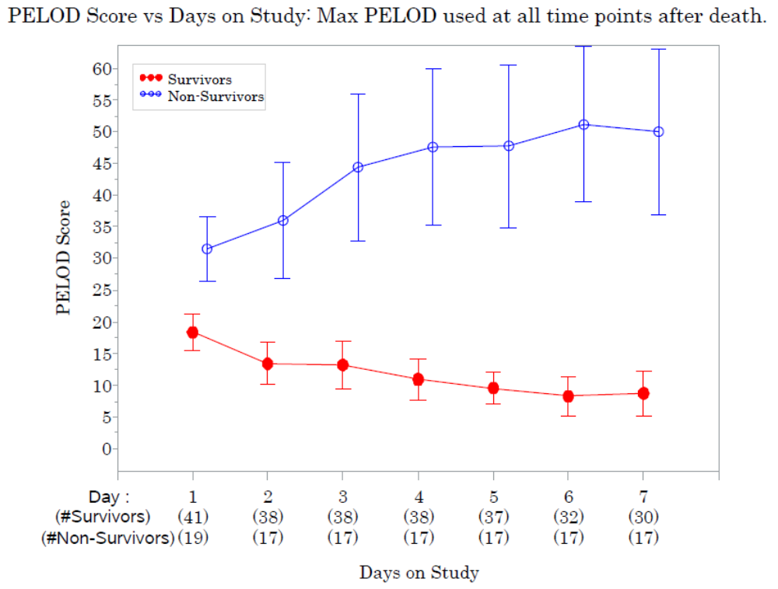

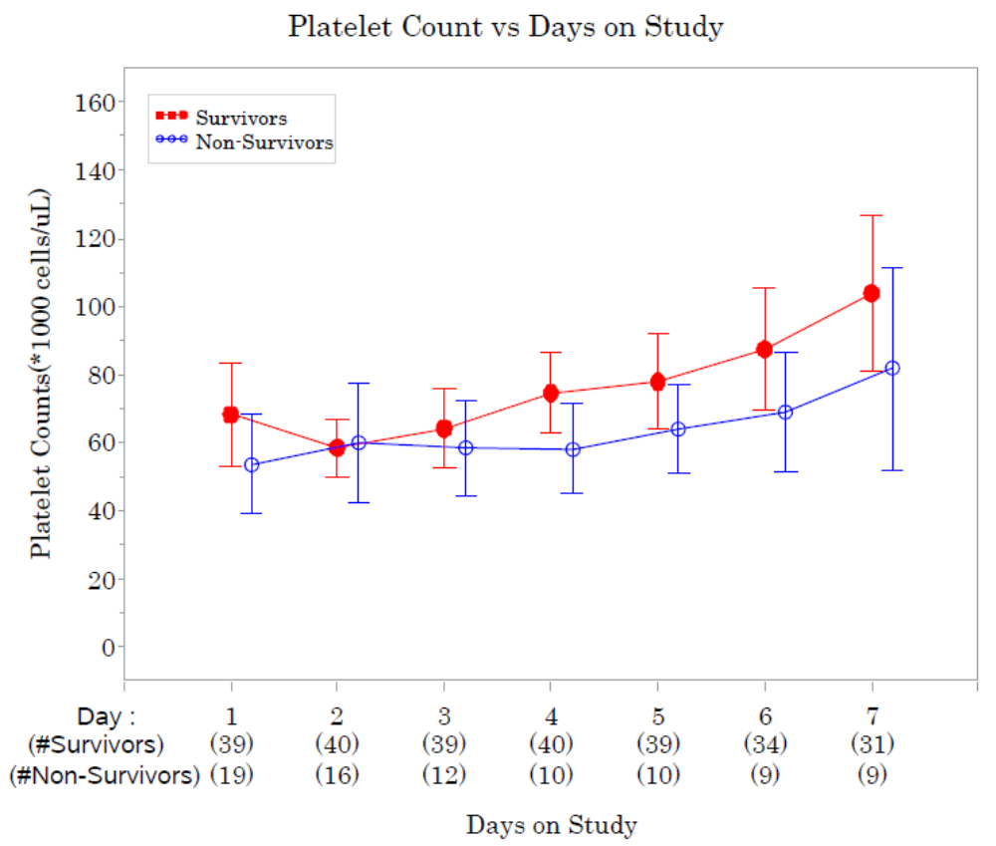

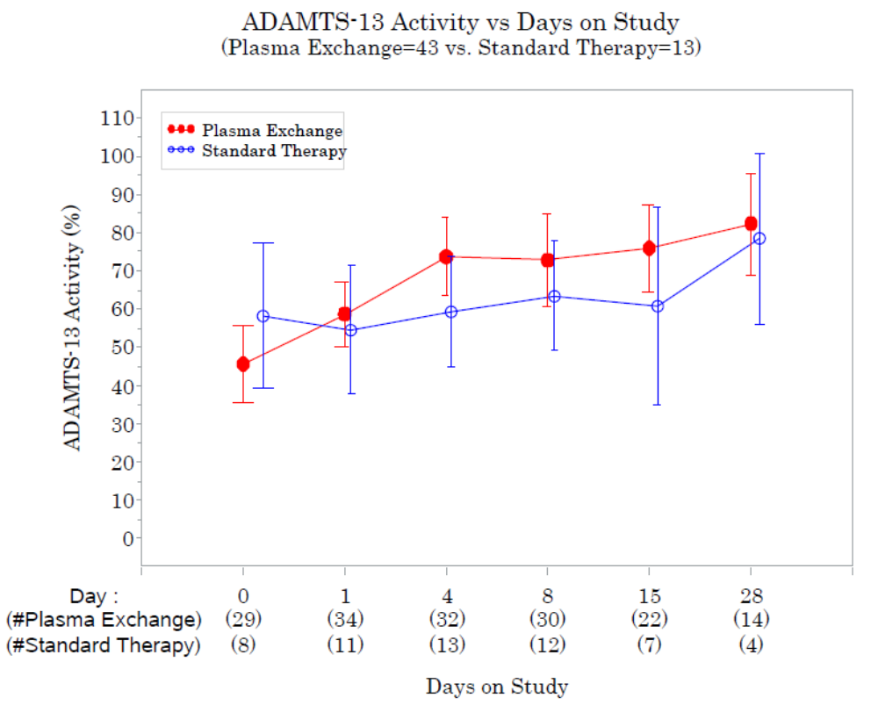

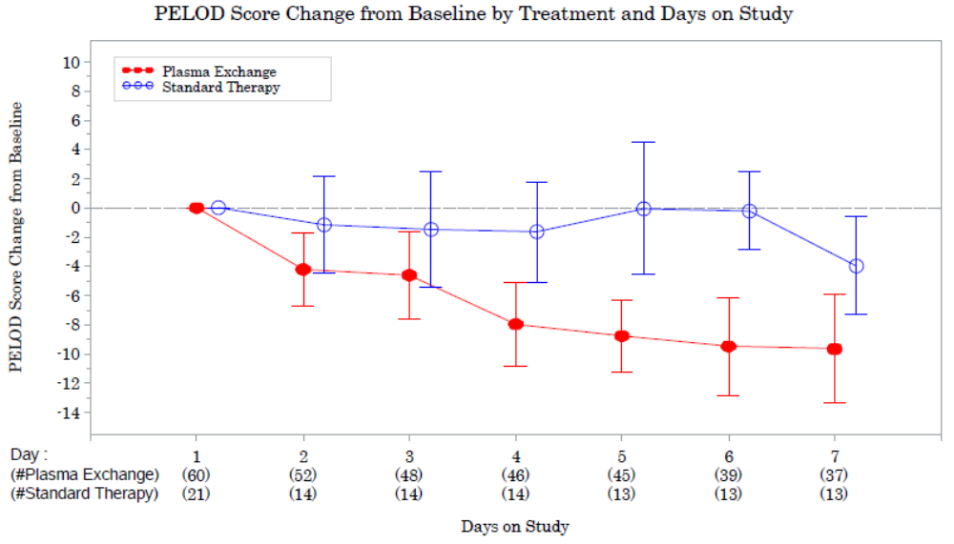

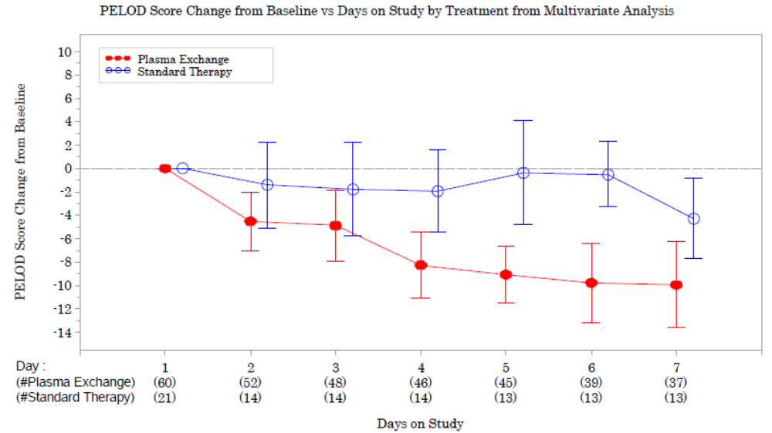

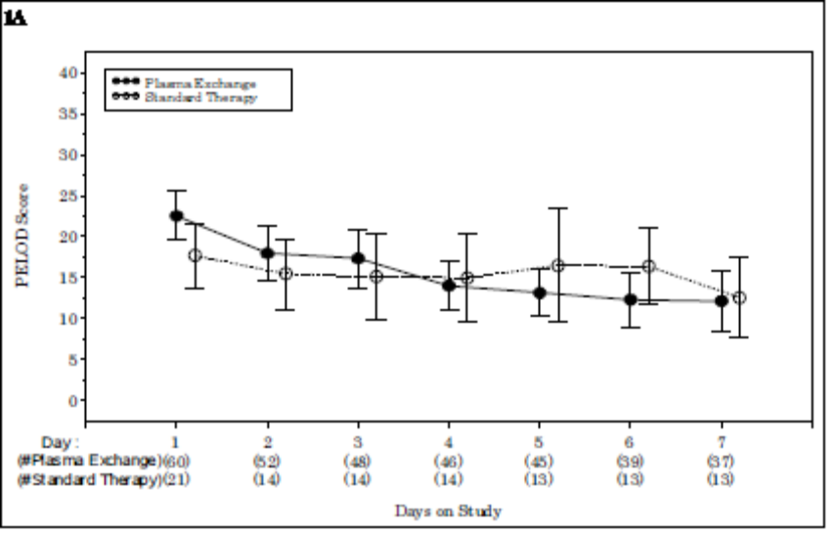

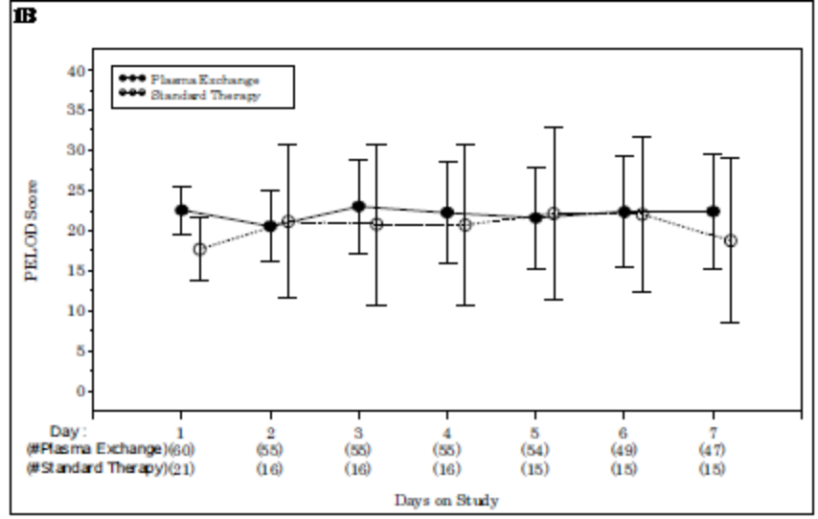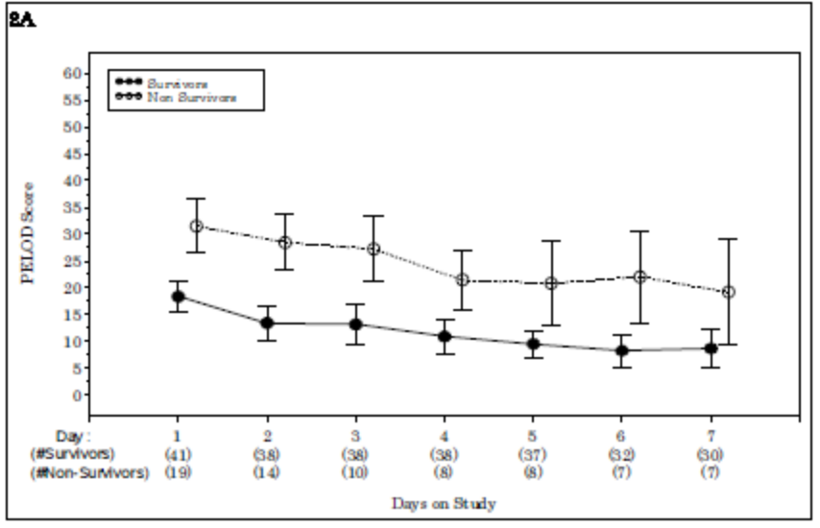

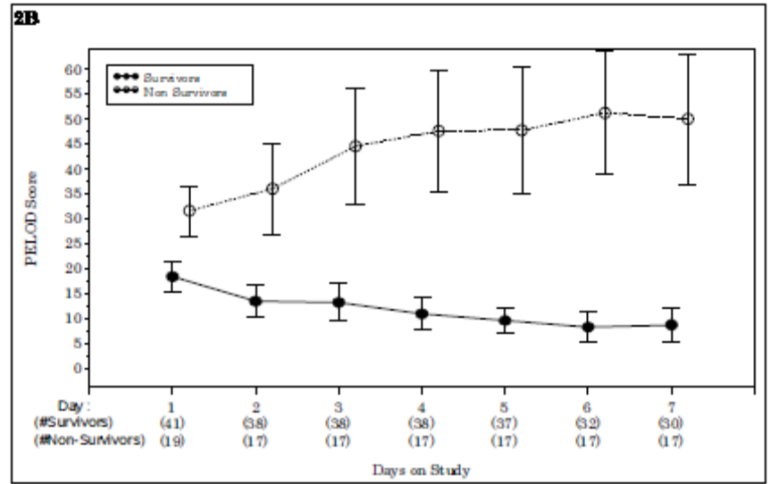

Figure Legends

Figure 1. Longitudinal changes in pediatric logistic organ dysfunction (PELOD) score by treatment group (60 Plasma Exchange TAMOF patients and 21 Standard Therapy TAMOF patients): (A) Mean PELOD score and (B) mean PELOD score using the maximum PELOD score of 71 at all time points after death. Time trend lines are the model-based means and 95% confidence intervals (the vertical bars).

Figure 2. Longitudinal changes in pediatric logistic organ dysfunction (PELOD) score for TAMOF survivors and non-survivors who received plasma exchange (41 survivors and 19 non-survivors): (A) Mean PELOD score and (B) mean PELOD score using the maximum PELOD score of 71 at all time points after death. Time trend lines are the model-based means and 95% confidence intervals (the vertical bars).

Figure 3. Delta changes in pediatric logistic organ dysfunction (PELOD) score by treatment group (60 Plasma Exchange TAMOF patients and 21 Standard Therapy TAMOF patients): Δ-PELOD score is the difference between the baseline score at enrollment and each subsequent day during the first week on study. Time trend lines are the model-based means and 95% confidence intervals (the vertical bars).

