CHAPTER 4: DATA COORDINATING CENTER & DATA MANAGEMENT

4.1 OVERVIEW OF DCC ACTIVITIES & STAFF
The purpose of the Data Coordinating Center (DCC) for the National Heart, Lung and Blood Institute (NHLBI) Program Project (PPG) is to provide design, analysis and study management support for the TT-CMV birth cohort study. The DCC will be responsible for designing and establishing the procedures required for the scientific conduct of the study related to study design, subject screening and eligibility, data management, and statistical reporting and analysis. The DCC will institute quality assurance procedures to ensure the accuracy and reliability of the data including data integrity and consistency checks, tracking completeness of subject follow-up, and monitoring and auditing the participating hospitals. In particular, the DCC will be responsible for the following activities related to the conduct of the study:

- Research Design: Working with the clinical investigators, the DCC will provide statistical and epidemiological expertise in the design of the study. This includes defining the outcomes, choosing the experimental design, estimating sample size and power, determining procedures to control bias, and evaluating the potential impact on the study from future proposed changes to the study design or study procedures.

- Case Report Forms: The DCC will collaborate with the clinical investigators in the design of the case report forms (CRFs). The DCC will produce the case report forms, organize them into subject notebooks, and distribute the notebooks to the participating hospitals.
- Training: The DCC will train and certify clinical center personnel in non-clinical study procedures.
- Subject Screening and Eligibility: The DCC will design and implement the subject screening and eligibility procedures.
- Data Management: The DCC will be responsible for all aspects of data management including data acquisition, data editing for accuracy and completeness, monitoring completeness of follow-up and contacting centers to correct data problems.
- Coordination with Lab: The DCC will coordinate with the laboratories on the collection and processing of lab data.
- Adverse Event Monitoring: The DCC will monitor the occurrence of adverse events.
- Statistical Reporting and Analysis: The DCC will develop statistical reports for the clinical investigators and the internal advisory committee and will determine and carry out appropriate statistical analyses to evaluate study hypotheses.
- Site Monitoring: Monitoring site visits will be made to all clinical centers to ensure that protocol and procedures are being correctly implemented and that patient study data entered on CRFs are complete, accurate, and match the primary source document. The monitor will inspect all work areas and conduct meetings with personnel involved in study activities.
4.2 DCC STAFF & RESPONSIBILITIES
- Michael H. Kutner, Ph.D. (Core C Director) – As Director of the Biostatistics and Data Mangement Core, Dr. Kutner is responsible for coordinating and supervising statistical activities for the PPG to ensure all investigators have ready access to high quality statistical and data management support.
- Kirk Easley, M.S. (Co-Director) – Mr. Easley will have the primary responsibility for the statistical and data management aspects of the TT-CMV study. He will oversee all the activities of the DCC and will coordinate the interactions between the DCC and the other study centers. In year one, he will attend the weekly Case Report Forms development meeting, and will conduct the weekly DCC operations meeting throughout the 4-year study period. He will oversee the production of the reports for the internal advisory board and will present the reports to the board. He will oversee and be directly involved in the data management and quality assurance aspects of the study including case report form (CRF) design, definition and implementation of edit checking procedures, design of quality assurance reports, and database software issues. He will review quality assurance reports to monitor the progress of the study. He will supervise and participate in the statistical design and analysis activities of the DCC. He will have administrative responsibility for the operation of the DCC. He will participate in the data analysis and manuscript preparation of the primary outcome paper and the secondary papers.
- George Cotsonis, M.S. (Statistical Programmer) – Mr. Cotsonis will be responsible for developing and maintaining the reporting and analysis programs. There will be numerous reports required to monitor the progress and data quality of the study including clinical center performance reports for recruitment, completeness of follow-up, and the timely submission of CRFs. He will also maintain the programs that extract the CRF data from DataFax and import that data to SAS on a biweekly basis. Mr. Cotsonis will provide statistical programming support for producing the required analyses for the primary paper and the various secondary papers.
- Neeta Shenvi, M.S. (Database Programmer) – Ms. Shenvi will be responsible for developing and maintaining all the software systems required for the computer database management of the study. Ms. Shenvi will develop and maintain the edit checks written in the DataFax language to be applied during interactive data validation (the process of comparing the database record to the faxed image) as well as in batch mode. When errors are found, the edit checks write quality control notes to the database, which are sent to the clinical centers in quality control reports. She will interact with the UNIX systems manager of the Rollins School of Public Health (RSPH) to insure that the software is functioning properly and that the system is able to receive CRFs faxed from the clinical centers.
- Andrea Knezevic, B.S. and Eli Rosenberg, B.S (Data Analysts) – Ms. Knezevic and Mr. Rosenberg will be responsible for several processes related to data collection and quality assurance. They will be responsible for generating and modifying the CRFs using Adobe InDesign software. They will be responsible for the production of the CRF binders. They will also produce the forms that are necessary for central reading or adjudication if necessary. They will be responsible for the DataFax setup for all these forms. This includes importing the postscript version of the form from InDesign into DataFax and defining each of the fields. They will also maintain other parts of the DataFax setup including the Page Map and the Visit Map with help from Ms Shenvi. They will oversee the Research Assistant who will be responsible for the data validation process (the process of comparing the database record to the faxed image). They will select, train and oversee the graduate research assistant who will perform data validation. They will be responsible for generating the quality control reports that are faxed to the clinical centers. Both will troubleshoot problems that are uncovered during the validation process and will correspond with clinical coordinators regarding issues related to completing the CRFs.
- Eva Politzer, M.M.Sc. (Data Auditor) – Ms. Politzer will be responsible for monitoring several aspects of the study related to data quality, training, clinical center performance and subject safety. She will ensure that the study protocol is followed and that all study data is complete, accurate, and matched to sources at the clinical site. She will field questions from the clinical coordinators regarding queries on the quality control reports sent to the clinical centers and will perform data quality monitoring by reviewing case report forms in DataFax.
- Abir Kundu, B.A. (Graduate Research Assistant) – Mr. Kundu will perform various tasks, primarily validating the case report forms that are received by fax from the clinical centers. He will also help with other quality assurance tasks and with generating reports and analyses.
4.3 DATA COLLECTION & DATA MANAGEMENT
4.3.1 Data Collection Instruments. This section gives an overview of the data collection instruments to be used in the TT-CMV study. The final versions of the CRFs are located on the study’s webpage: https://cfusion.sph.emory.edu/BMI/PPG/login.cfm. The clinical center personnel within each neonatal ICU will complete case report forms (CRFs) during subject examinations. The clinical center will be provided with a set of CRF binders at the beginning of the study and will receive additional patient binders as needed. After completion, the CRFs will be faxed to the DCC.
4.3.2 Overview of Data Flow and Management. The CRFs are completed at each clinical center and faxed to the DCC. The faxed CRFs are received at the DCC by the DataFax data management system that uses optical character recognition software to create data records for the CRFs. The data entry clerk validates the records by comparing them to the faxed images. Edit checks are applied to the data and any problems are marked by a quality control note (QC Queries) that describes the problem. On a regular schedule, the QC Notes are faxed to the clinical center as a Quality Control Report (QC Report). Clinical coordinators will fix most problems by making changes to the CRFs and then re-faxing the CRF to the DCC. DataFax identifies that a CRF has been re-faxed. DCC staff reviews the changes to the CRFs and resolves the QC Notes.
DataFax can export data in a form that can be input to the Statistical Analysis System (SAS), a statistical analysis and reporting system that has extensive data manipulation capability. SAS is used to merge data from CRFs, make calculations, perform additional edits and provide statistical reports and analyses.
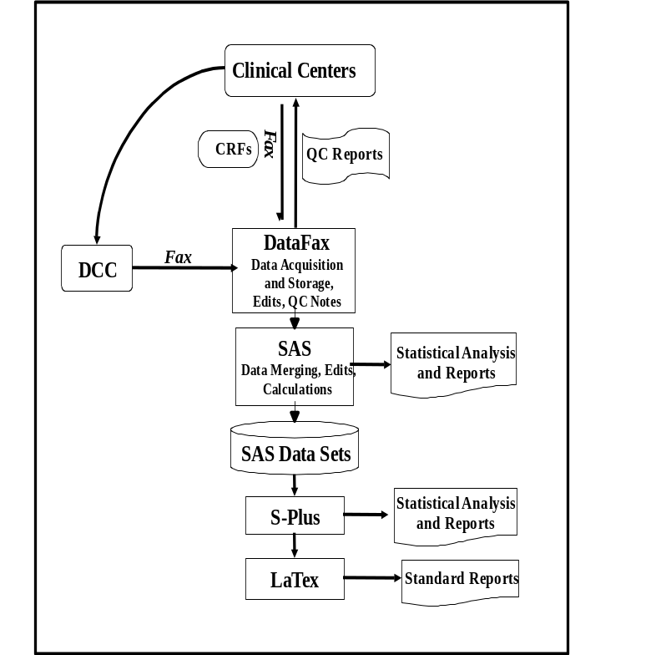
S-Plus is another statistical analysis system that will be used, primarily as a mechanism for producing standard automated reports such as Internal or External Advisory Board meeting reports. S-Plus reads data from the SAS data sets. Department of Biostatistics personnel have developed S-Plus functions that produce the code for making tables and graphs in LaTex, a mark-up language commonly used in mathematical fields for document processing. A schematic of data flow and management for the TT-CMV study is shown in the Figure.

4.4 CASE REPORT FORMS (CRFs)

4.4.1 Study Start-Up Binder The Study start-up binder contains all the forms needed to enroll patients in the study.
- Screening Log: The screening process for an LBWI begins with the screening log, which is used to obtain the next available sequential MOC ID.
- The MOC ID is the site number, followed by a four digit sequential ID (X-0001, X-0002, etc.). The Screening log will help you keep track of which sequential number to assign next.
All LBWI in the NICU with weight < 1500 grams are to be screened. The Eligibility Form is completed for all screened LBWI and all screened LBWI are assigned an LBWI ID.
- The LBWI ID is the MOC ID followed by two digits.
  - The first digit is a sequential number designed to distinguish between multiple LBWI screened from one pregnancy (e.g. twins). In the case of a singleton birth or if only one LBWI is screened from a multiple birth, this number will be ‘1’. A mother may have twins, triplets, etc. who are all screened. In that case, the siblings will share the same MOC ID with different sequential digits (1, 2, 3, …) following.
  - The second digit following the MOC ID indicates enrollment in the study of this LBWI. If the LBWI is enrolled, the digit is a ‘1’. If the LBWI is not enrolled, the digit is a ‘9’.
After completing the Eligibility Form, the nurse completes the screening log entry with Date Screened, Enrolled (yes/no), LBWI ID and Notes. Do not photocopy pages of the Screening Log. Contact Andrea Knezevic (aknezev@emory.edu; 404-712-9573) for a new binder if necessary.
- Eligibility Form: The first tab in the Study start-up binder contains blank Eligibility Forms. This form is completed for all screened LBWI. The form assigns the LBWI a study ID and determines if the LBWI will be enrolled in the study. Note that all screened LBWI are assigned a study ID, regardless of enrollment. Screened LBWI are enrolled if (1) eligible by the inclusion/exclusion criteria and (2) LBWI and MOC are consented to be in the study.
- Consent Form: IRB- Approved consent forms are provided in the second tab of this binder.
- LBWI: DOB Specimen Collection Form & MOC: Enrollment Blood Collection Form: Blank specimen/blood collection forms for the LBWI and MOC are provided in the third and fourth tabs of this binder. Once an LBWI has been enrolled in the study, these two forms should be completed immediately and faxed together with the Eligibility Form.
- Completed Eligibility, Consent and LBWI & MOC Collection forms for LBWI enrolled in the study are to be moved to the LBWI Patient Binder.
- Completed Eligibility forms for LBWI not enrolled in the study are to be moved to the back of this binder under the tab “Completed Eligibility Forms for Non-Eligible LBWI”.

*** Study-start up binders are loaded with two pages of the screening log (40 entries), 40 blank copies of the Eligibility Form and 20 blank copies each of the consent and specimen collection forms. When a study start-up binder is spent, contact Andrea Knezevic (aknezev@emory.edu; 404-712-9573) and the DCC will provide another one.

4.5 LBWI PATIENT BINDER
4.5.1 Scheduled Forms Checklist and As-Needed Forms Checklist. These checklists are located in the front pocket of the LBWI patient binder. Together they list all the CRFs in the binder. The Scheduled Forms checklist should be used as a to-do list for each DOL on which data is collected. The As-Needed Forms checklist may be used to keep track of Transfusions, Outcomes, AEs and other events that have occurred. Do not fax the checklists to the DCC.
4.5.2 Patient Contact Information. Also in the front pocket of the LBWI patient binder is a contact information form for the MOC. Do not fax the patient contact information sheet to the DCC.
4.5.3 Scheduled Forms. The first set of tabs in the LBWI patient binder is for the Scheduled Forms. There is one tab for each of the days of life (DOL) on which data is collected. The following grid summarizes which forms are completed on which days:
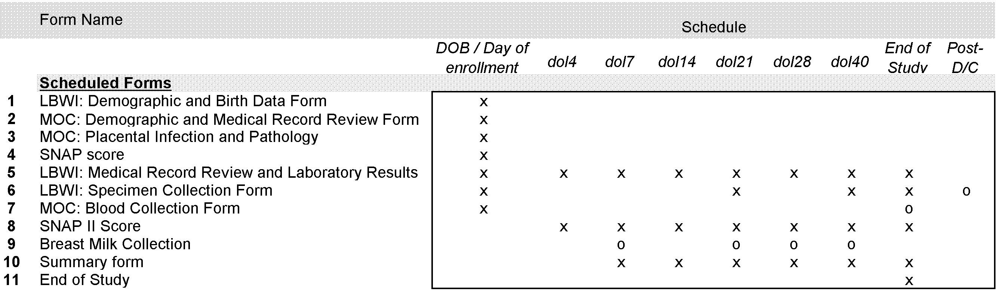
4.5.4 Data collection for SNAP form
Data on the SNAP form is recorded on DOB. Generally speaking, the first available values for labs and vital signs should be used to answer the SNAP questions. Some questions ask about maximum and minimum value (e.g. heart rate, sodium); in this case, if only ONE value is available from DOB, use that one value to answer both questions, and if SEVERAL values are available from DOB (e.g. vital signs), use the minimum value to answer the minimum question and the maximum value to answer the maximum question.
4.5.5 Optional forms
Most forms are required (represented by an ‘x’ in the grid). Some forms are optional (only required under certain circumstances) at certain time points (represented by an ‘o’ in the grid).
- LBWI: Specimen Collection Form is required Post-Discharge if the LBWI received a transfusion in the 7 days before discharge.
- MOC: Blood Collection Form is required at End of Study if the MOC tested CMV seronegative at the beginning of the study.
- Breast Milk Collection Forms are required if the LBWI is being fed breast milk.
4.5.6 Faxing schedule: Forms are to be faxed in as soon as possible. A query will be generated for overdue forms. All DOB / Enrollment Forms are due at enrollment with the exception of MOC: Placental Infection Form which is due within 20 days of enrollment. All longitudinal forms are due within 7 days of the Target date/window.
4.5.7 Date field requirements:Certain essential date fields on the scheduled forms should be equal to the Target date. For example, the “date SNAP data collected” field on the SNAP Score Form should be the date of the LBWI’s DOB. Acceptable time window indicates the short window of time around the target date, where data collected at that time still counts as part of that time point. For example, the SNAP Score Form is still acceptable if DOB is missed for an LBWI and the “date SNAP data collected” field is the LBWI’s DOL 3. A query will be generated for dates outside of their acceptable time windows, and a protocol deviation will be logged by the DCC.

TABLE 1. Date field requirements by form
Form |  | Date field(s) |  | Target day/window |  | Acceptable time window
SNAP Score |  | Date SNAP data collected |  | DOB* |  | DOB – DOL 5.
LBWI: Medical Record Review and Laboratory Results Form |  | “Date anthropometric measurements taken” and “Blood collection date” |  | DOB* |  | DOB – DOL 1.
 |  |  |  | DOL 4, 7, 14, 21, 28, 40 |  | Acceptable time window is target day +/- 2 days.
LBWI Blood or Blood/Urine Collection Form |  | All “Date blood (or urine) collected” fields |  | DOB* |  | DOB – DOL 1.
 |  |  |  | DOL 21, 40 |  | Acceptable time window is +/- 4 days outside of target date.
MOC: Blood Collection Form |  | “Date blood collected” |  | Day of Enrollment |  | Acceptable time window includes 7 days prior to enrollment.
SNAP II Score |  | “Day of life follow-up date” |  | DOL 4, 7, 14, 21, 28, 40 |  | Acceptable time window is target day +/- 2 days.
Breast Milk Collection |  | “Date pooled sample prepared” |  | DOB – DOL 7, DOL 15 – 21, DOL 22 – 28, DOL 34 – 40 |  | Acceptable time window is +/- 2 days outside of target window.
* If LBWI is enrolled after DOB, the data and specimens from DOB should be sought out for these forms.
Form | Date field(s) |  | Scheduled time point |  | Target days |  | Acceptable time window
Summary Form | “Dates of this time interval” start/end |  | DOL 7 Form |  | DOB / DOL 7 |  | There are no Acceptable time windows outside of these targets.
Summary Form |  |  | DOL 14 Form |  | DOL 8 / DOL 14
Summary Form |  |  | DOL 21 Form |  | DOL 15 / DOL 21
Summary Form |  |  | DOL 28 Form |  | DOL 22 / DOL 28
Summary Form |  |  | DOL 40 Form |  | DOL 34 / DOL 40
Summary Form |  |  | End of Study Form |  | 7 days prior to D/C date or DOL 60 / D/C date or DOL 60

NOTE: There is an EXCEPTION to Summary Form date requirements in case the LBWI transfers hospitals. The “Unscheduled” Summary Form is completed by the transferring nurse and the second time interval field on the Unscheduled form should be the date of transfer. The nurse who receives the LBWI completes the scheduled Summary Form for the portion of the time period the LBWI spent in the new hospital. In this case, on the scheduled Summary Form, the first time interval field should be the date of transfer and the second time interval field should be the scheduled end of the time period.
4.5.8 Required fields: Required fields indicate those fields which can never be missing. A query will be generated if these fields are missing, and a protocol deviation will be logged by the DCC. LBWI ID and MOC initials are always required on every page of every form.
TABLE 2. Required fields by Form
Form | Required fields
LBWI: Demographic and Birth Data Form | Section 1: All Questions and Section 2: Questions 1 and 2.
MOC: Demographic and Medical Record Review Form | Section 1: Questions 1, 3 and 4.
SNAP Score | All questions (including “Date SNAP data collected”). Every question has a “missing” option which can be marked if the data are unavailable.
LBWI: Medical Record Review and Laboratory Results Form | Section 1: Question 1 and Section 2: Question 1 (also Question 2, if Question 1 is ‘yes’).
LBWI Blood or Blood/Urine Collection Form | All questions. A ‘yes’ or ‘no’ answer is required for every question which asks “Has a blood sample been collected…” If the answer is ‘yes’, then the date collected is required.
MOC: Blood Collection Form | All questions. A yes or no is required for every question which asks “Has a blood sample been collected…” If the answer is ‘yes’, then the date collected is required.
SNAP II Score | All questions (including “Day of Life Follow-up Date”). Every question has a “missing” option which can be marked if the data are unavailable.
Breast Milk Collection | Question 1 (also Question 2, if Question 1 is ‘yes’).
Summary Form | All questions in Sections 1-5 (including “Dates of this time interval”). All questions require a ‘yes’ or ‘no’ answer. If Section 4: Question 2 is ‘yes’, parts (a) and (b) of that question are required.
End of Study | Section 1: Questions 1 and 2.

4.5.9 Logs: The logs are designed to be long enough to accommodate data entry for the entirety of the study (e.g. it is not likely that the LBWI will start and stop feeding breast milk more than 15 time during the course of the study). However, if you run out of space on any of the logs, contact the DCC and we will provide an additional page for that log. Do not photocopy a page of a log to make an additional page. If you need additional pages contact us and we will provide them.
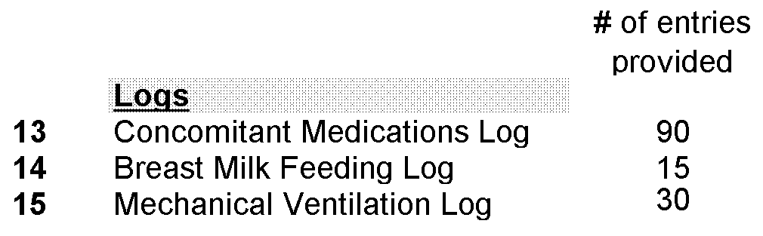
4.5.10 Transfusion Forms: We have provided enough transfusion forms for each blood product to cover all the transfusions that will likely occur (e.g. it is not likely that the LBWI will receive more than 20 platelet transfusions during the course of the study). However, if more are needed (e.g. the LBWI receives a 21st platelet transfusion), contact the DCC and we will provide additional forms. Do not photocopy Transfusion forms; please contact DCC for additional forms.
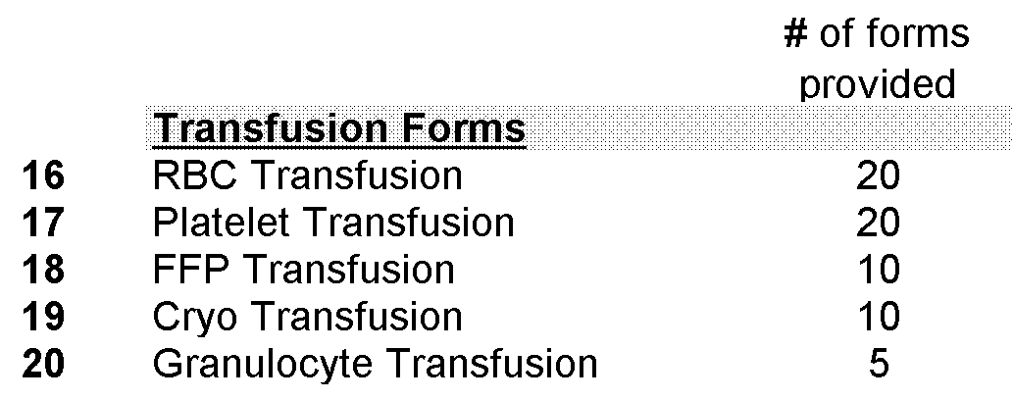
4.5.11 Outcome, AE and Other Forms: Outcome, AE and Other forms are as-needed forms and are not provided in the binder. If you need these forms you must download and print them from the website (see the Study Website section in this chapter for instructions on printing from the website). However, labeled tabs for these forms are provided in the binder for organization purposes. Once printed from the website, hole punch the form or sets of forms and file under the appropriate tab.
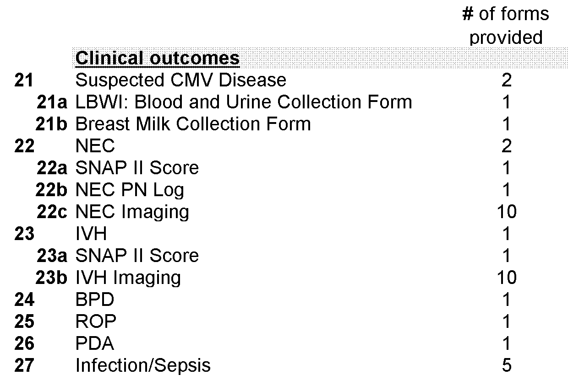
The following outcomes can only occur once and thus one form or set of forms has been provided to track them: IVH, BPD, ROP and PDA.
- In case of IVH, 10 imaging forms have been provided. If more than 10 IVH imaging forms are needed, contact the DCC and we will provide additional forms.
- The following outcomes may occur multiple times and 2 sets of forms have been provided to track their occurrence: suspected CMV and NEC.
- For each case of NEC, 10 imaging forms have been provided. If more than 10 NEC imaging forms are needed, contact the DCC and we will provide additional forms.
- Infection can occur multiple times and 5 forms have been provided. If infection occurs more than 5 times, contact the DCC and we will provide additional forms.
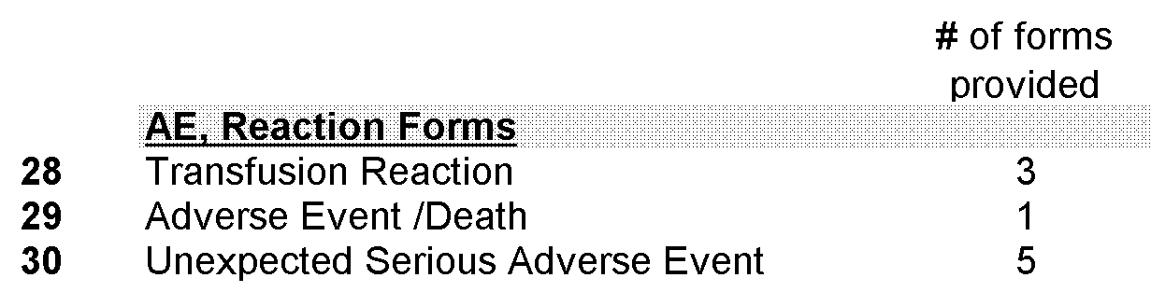
One AE/Death Form is provided in case of death. We do not expect you will need more than 3 transfusion Reaction Forms nor more than 5 Unexpected SAE Forms. If more forms are required, contact the DCC and we will provide additional forms.
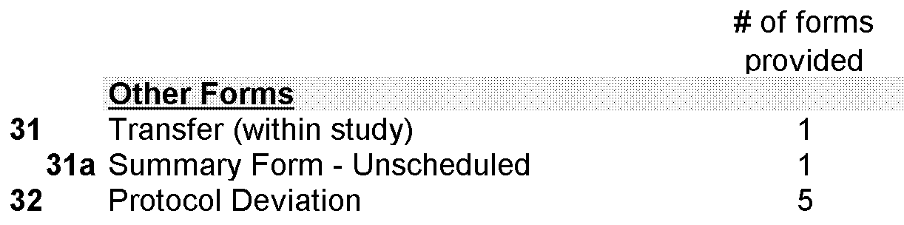
In the event that an LBWI is transferred to Egleston or Scottish Rite, two forms need to be completed and faxed by the transferring hospital nurse: the Transfer Form and the Unscheduled Summary Form.
√ The Unscheduled Summary Form covers the portion of the time interval spent in the transferring hospital (e.g. if the LBWI is transferred in the middle of week 3, the Unscheduled Summary Form covers the dates from the beginning of week 3 to the date of transfer).
√ The LBWI Patient Binder travels to the CHOA Hospital to which the LBWI is transferred.
√ We have provided 5 Protocol Deviation Forms. Certain queries on Quality Control reports generated by the DCC will prompt you to complete a Protocol Deviation form.
If you need additional forms (e.g. a 3rd Suspected CMV Form, a 6th Protocol Deviation Form, etc.) do not photocopy one form to make another. Contact us and we will provide additional forms.
4.5.12 Antibiotic code sheet: In the back pocket of the LBWI binder is an Antibiotic Code Sheet. This reference sheet might be necessary to complete question 4.2 on the MOC: Demographic and Medical Record Review Form.
4.5.13 Special Instructions: Twins in the study:
Assigning IDs:
The LBWI ID is the MOC ID followed by two digits, the first of which is a sequential number designed to distinguish between multiple LBWI screened from one pregnancy (e.g. twins). If one mother has twins, triplets, etc. who are all screened, the siblings will share the same MOC ID with different sequential digits (1, 2, 3, …) following. The IDs will be of the form: X-XXXX-1X, X-XXXX-2X, X-XXXX-3X, ….
NOTE: the LBWI with the highest chance of being enrolled in the study should be screened first (ID: X-XXXX-1X).
Completing MOC and breast milk collection forms:
If multiple LBWI from one pregnancy are enrolled in the study, all MOC forms (Blood collection, Demographic, placental infection) and breast milk collection forms are completed only once for the multiple infants. This means that data for one mother does not have to be recorded in more than one LBWI patient binder. All MOC and breast milk collection forms have the following instructions printed on them: “A mother may have multiple children in the study (i.e. twins); be sure to complete this form only ONCE for the mother.”
Each LBWI will nevertheless have his or her own binder. MOC and breast milk collection forms are to be completed from the binder of the first enrolled LBWI from the pregnancy – this LBWI will have an ID of the form X-XXXX-11. All MOC and breast milk forms are pre-printed with the last two digits of the LBWI ID as “11”. MOC and breast milk forms from the binders of the other LBWI from that pregnancy should not be completed; they can be discarded.

4.6 Blood Unit Tracking Forms Binder
This binder holds the: Blood Unit Tracking and Storage Form. This form is completed for every blood unit from which blood is transfused to an LBWI on study.
4.6.1 Section 1 of this form is completed at the hospital blood bank and the form is then faxed to the DCC. The form should be photocopied, and the copy stored at the hospital blood bank. The original copy of the form then travels with the blood unit aliquot to Central PERL (Pathology Emory Research Lab) where the aliquot is stored.
4.6.2 At the bottom of every Blood Unit Tracking and Storage Form, in the box marked “FOR DCC ONLY” is a pre-printed, unique ID for that unit. The DCC needs to assign this ID to each unit for internal purposes. Every form has a different unique ID at the bottom. Do not photocopy these forms. The DCC will provide additional Blood Unit Tracking and Storage Forms.

4.6.3 ***The Blood Unit Tracking Forms Binder is loaded with 100 blank Blood Unit Tracking and Storage Forms. When all of these forms have been used, contact Andrea Knezevic (aknezev@emory.edu; 404-712-9573) and the DCC will provide another binder of blank forms.

4.7 Study Case Report Forms – Lab Forms
¶ Please note: The LBWI Lab Forms Binder contains all “patient level” laboratory results forms (LBWI, MOC, breast milk forms) and the Blood Unit Lab Forms Binder contains the “unit level” laboratory results forms (NAT and residual WBC test result forms). See Below.

4.7.1 LBWI Lab Forms Binder: Each LBWI Lab Forms Binder contains all the Laboratory results and Breast milk storage forms for 8 LBWI. Forms for each LBWI are organized into 4 separate tabs, described below.
- “LBWI#: _-____-__”.
- For organization purposes, the paper slip inside the plastic tab may be removed and the LBWI ID number written on it. Inside this section is the Lab Forms Checklist which lists all of the forms that may be completed for the MOC/LBWI pair during the study. This checklist allows you to indicate whether or not a sample was received and then check if/when the form was completed and faxed to the DCC. If a lab sample is not received, it is not necessary to complete and fax the form.
- “CMV NAT Test Result Forms”: includes blood, urine and breast milk NAT test result forms for MOC and LBWI.
- “CMV Serology Test Result Forms”
- “Breast Milk Freezer Location Forms”

4.7.2 Blood Unit Lab Forms Binder: This binder contains the: a) Blood Unit CMV NAT Results Form and b) Blood Unit WBC Results Form. These forms are completed for every blood unit from which blood is transfused to an LBWI on study.
- At the bottom of every Blood Unit CMV NAT Results Form and Blood Unit WBC Results Form, in the box marked “FOR DCC ONLY” is a pre-printed, unique ID for that unit. The DCC needs to assign this ID to each unit for internal purposes. Every form has a different unique ID at the bottom. Do not photocopy these forms. The DCC will provide additional Blood Unit Forms.
- *** The Blood Unit Lab Forms Binder is loaded with 100 blank Blood Unit CMV NAT Results Form and 100 blank Blood Unit WBC Results Form. When these forms have been used, contact Andrea Knezevic (aknezev@emory.edu; 404-712-9573) and the DCC will provide another binder of blank forms.

4.8 USING THE DataFax SYSTEM

4.8.1 What is DataFax? DataFax is a data management system which integrates fax and computer technologies. It provides the data coordinating center with tools which facilitate the collection, review, correction and tracking of study case report forms (CRFs). DataFax simply requires a standard office fax machine. Completed CRFs are faxed from the clinical centers participating in a study to the Data Coordinating Center (DCC) over ordinary phone lines using ordinary fax machines. The DCC receives the faxes through fax modems connected to a computer running the DataFax software.
4.8.2 How DataFax works? When a fax arrives at the DCC, DataFax breaks it into pages and proceeds to process each page. It identifies which study each page belongs to, reads the data from each page, enters the data into the study database, and stores all pages from the fax on disc. Data management staff then use a split-screen validation tool to review all pages received, complete data entry and flag any problems they identify (e.g. missing data) with quality control notes or queries. The original paper CRFs will remain on file at each participating center. At the DCC the faxed CRFs and corresponding data records can be reviewed simultaneously on-screen at any time during the study, thus eliminating the need to print, file and track paper CRFs. If we have requested the modification on a quality control report, DataFax will keep track of whether or not it has been made.

4.8.3 Completing CRFs
- Use a black ball point pen. Avoid using wide tipped pens. A pen which produces crisp dark characters is best.
- For check boxes a simple “X” inside the box is preferred, instead of a check mark. You do not need to shade the boxes in.
- Write leading zeroes; do not leave a box blank to indicate zero (e.g., if there are four boxes and the value is 1.54, fill in 01.54).
- All dates are in mm/dd/yy format. Enter a two digit number for each part of the date. If a portion of the date is unknown, write ‘00’ for that part.
- If data is not available print "N/A" beside the boxes.
- The LBWI ID Number and MOC Initials must be written at the top of each page (if the patient does not have a middle initial, put a hyphen instead).
- Write each digit or “X” mark entirely inside its bounding box. The optical character recognition (OCR) software included in DataFax attempts to identify which boxes have been marked with an X and to read numerical data written in boxes. It is only successful on numbers if they are written entirely inside of the boxes.
- Print all text (drug names, complications, etc.) as clearly as possible. In the narrative sections, try to be brief. Answer questions explicitly without shortcut symbols like ditto marks.
- Correcting Errors: Do not erase or "white out" errors. If you make a mistake and need to correct a number or check box put a single line through the error and print the correct number above the box, or put an “X” in the correct box. If you think it is important, print explanatory notes in blank areas of the forms; however, avoid printing over data boxes or check boxes. All corrections should be initialed and dated.

4.8.4 Faxing CRFs: Fax CRFs in as soon as possible after they have been completed. Fax the CRFs using the DataFax number 404-727-1297 without using a fax cover page. Since they don’t have barcodes, cover pages get separated from the CRFs in the DataFax system and are therefore rendered useless. Any necessary supplemental information should be written in open space on the CRF page (but not above the barcode or within a half inch of the edge of the page). It is important to verify that the fax has been properly sent and successfully transmitted.

4.8.5 Procedures to assure data quality: In the DataFax system, QC reports are the way in which the DCC communicates to the clinical center any problems with the data reported. QC Reports are faxed to the clinical center which sends back either re-faxed CRFs with corrected information or responses written on the QC report, which is faxed back to the DCC.
QC problems found in the CRF are flagged during the validation process and QC Notes are added to the problematic data fields. The QC Notes are used to request the clinical center for clarification and correction. Characteristics of QC Notes include:
- Type of problem: Categories for the type of problem include: missing, illegal, inconsistent, illegible, fax noise, other.
- How the clinical center will respond: The QC Note is marked as requiring the clinical center to either refax a CRF or write a response on the QC Report received from the DCC and fax the QC Report back to the DCC. (Please see the next section on QC Reports).
- A query or comment: The person validating or the programmed edit check can add a question or comment for clarification that will appear on the QC Report.
4.8.6 QC Reports. A standard DataFax QC report contains three sections
- Patient Status Report: lists all patients currently being followed at the center and includes each patient’s enrollment date, last follow-up date, and the target date for the next scheduled follow-up. The status report also shows whether there are any outstanding problems with each patient’s CRFs.
- The Fax/Refax List: identifies problems which need to be resolved by either faxing in something which was never received or correcting a page and faxing it in again. Each problem is identified by Patient ID number, CRF form number, and data field. This is followed by the current value read from the fax (after the = sign) and the problem type (in brackets). If the nature of the problem remains unclear re: problem type, data management staff will add a note to clarify the nature of each problem. ** If a form has more than one page, only pages with corrections should be re-faxed.
- Question & Answer List: This list may or may not be included in the QC Report, and will only be included if questions arise requiring an explanation, e.g., a discrepancy between two separate fields sometimes on separate pages, where it is unclear which item is to be corrected. In such cases the question is listed using the same format as on the refax list, and space is provided directly below the question for your reply. Please print your reply clearly in the space provided. When all Q&A questions have been answered, fax in only the Q&A pages of the QC Report, along with any CRF pages that have been corrected in response to the queries. **A regular schedule for faxing QC Reports to the TT-CMV clinical centers will be established.

4.9 Study Website
4.9.1 Study website address: https://cfusion.sph.emory.edu/BMI/PPG/login.cfm and is managed by Neeta Shenvi (nshenvi@emory.edu; 404 712 9670). Study personnel must log-on to see the website. Person-specific log-on names and passwords will be distributed by Neeta; contact her if you need access to the site. Use Microsoft Internet Explorer to view the website.
4.9.2 Website contents: As Needed Case Report Forms: Some forms are required on an as-needed basis and are not included in the patient binders distributed to the sites. These forms can be downloaded (in PDF format) and printed from the site. As-needed forms are organized by the yellow-highlighted headers Section, Tab and Form Name.
- Sections are Clinical Outcomes, AE, Reaction Forms and Other Forms and should guide you to the type of form you need.
- Tabs should help guide you to the form or set of forms needed. For example, in case the LBWI develops NEC, 4 forms are needed and these 4 can be found under the “NEC #1” or “NEC #2” tabs.
- Form names are links to the PDFs of the forms. Left-click on a link and a new Internet Explorer window with the PDF will pop-up. PDFs may be printed from this window.
- Protocol and Reports: A Current version of the study Protocol and MOP, as a copy of the study brochure for each site will be maintained on the website. Monthly and biannual data summary reports produced by the DCC will be regularly uploaded to the site.
- Personnel/ Contact: A comprehensive list of all study personnel will be maintained along with their contact information.
4.10 IMPORTANT CRF PRINTING INSTRUCTIONS
CRFS MUST BE PRINTED using these instructions; other methods will render them UNUSABLE.
- In Internet Explorer, select File → Print. Printing options should appear. Under the Page Handling section, set Page Scaling to None and uncheck Auto-Rotate and Center.
- The PDFs need to be printed exactly as they appear on the screen. Any scaling, rotating or centering by the printer will upset the placement of the barcode at the top of the page and make the form unreadable to DataFax.

4.11 STUDY SITE AUDITS
4.11.1 Monitoring site visits These will be conducted at all clinical centers to ensure that protocol and procedures are being correctly implemented and that subject study data entered on case report forms are complete, accurate, and match the primary source document. The visits will be conducted by a study monitor from the DCC. The initial monitoring visit will occur within three to six months following the enrollment of the first subject. The frequency of additional site visits will be based on the enrollment activity and an assessment of the site’s oversight needs.
4.11.2 A Monitoring Visit: The following activities will take place during a monitoring visit:
- A tour of the neonatal ICU (initial visit)
- Observation of all study activity areas including the area(s) where blood is drawn, processed, stored, and shipped
- Determination that subject binders and all subject-sensitive material are stored in secure areas
- Intermittent meetings with the clinical coordinator
- Review of case report forms and primary sources to ensure all information recorded on the case report forms is documented in the primary sources
- Closeout meeting to review monitoring findings with the PI and Research Manager.

4.11.3 Written Report: Within two weeks the study monitor will prepare a written report of the visit identifying the site personnel met, activities completed, strengths and weaknesses of the site and required follow up actions. This report will be sent to the site P.I. who will share the contents with his/her team and the Lead Study Coordinator who will share the information with the study Principal Investigator. A copy of this report will be filed at the DCC.

4.12 MANANAGEMENT OF STUDY FILES
4.12.1 Good Clinical Practices (GCP) This cohort study will be conducted in compliance with GCP and refers collectively to those regulations and guidelines governing the conduct of clinical research. The intent of these regulations is to safeguard subjects’ welfare and assure the validity of data resulting from the clinical research. All information and materials will be obtained for research purposes only and the data will be kept in strict confidence. All subject records will be kept in locked file cabinets in the P.I.’s/coordinator’s research offices at each study site and at the DCC and will be accessible only to the P.I. and the investigative team. All data will be coded by subject identification numbers. The master list connecting the codes to identifying information will be secured in the DCC. All data maintained in the computerized data base will be accessible only with a login and protected password. After the study is completed, all data will be kept according to NIH regulations.
4.12.2 IRB-Investigator interactions. The Institutional Review Board (IRB) is the committee responsible for review of clinical research and protection of subject rights and welfare at each participating institution. In the context of GCP regulations, this committee is critical to the research process and operates independently of the investigator and sponsor. The IRB reviews the protocol and consent form and provides ongoing review of the study. It is the Principal Investigator’s responsibility and each site investigator's responsibility to assure the IRB operates in compliance with GCP regulations and that the study is appropriately reviewed.
4.12.3 CRF casebooks and source data. Investigators will keep adequate and accurate case histories for each subject. In this study, the case history consists of 1) the CRFs; and 2) the supporting source documents in the subject’s medical record. A three-ring binder will be assembled for each subject by the DCC to hold the CRFs arranged by time on study. Upon completion of the study the binder will be kept intact.
4.12.4 Archiving Study Records. Study records, including source documents, as well as the original copies of the CRFs, must be retained for a minimum of two years after discontinuation of the study. Records will not be destroyed without authorization from the DCC and Principal Investigator.

4.13 COMPUTER SECURITY AND BACKUP
4.13.1 Database Server Backup and Security: The database server is backed up using the local drive. There is a full system backup once per week plus a daily incremental backup the other days of the week. Two tapes are used per week: one to hold the full backup plus some of the daily incremental backups and the other to hold the remaining daily incremental backups for that week. The tapes are cycled through every three months. In addition, the first full backup of each month is archived and will be kept for seven years. A copy of the first full backup of each month is stored in a vault at an off-site location.
4.13.2 Secured Access: Access to the server is restricted to those connected to the RSPH network which can only be accessed from within the RSPH building. The modems connected to the server are set so that they only receive incoming faxes and do not respond to a computer attempting to dial in. Only study staff and systems administrators have accounts on the server. These accounts are password protected. The DataFax system also has security procedures in which individual users can be restricted access on the basis of study, DataFax tool and validation level. All staff have a password protected screen saver on their desktop PC.
4.13.3 PC Applications Backup and Security. In addition to the database server used for data management, reporting and analysis, there will be DCC applications that are PC-based such as word processing, forms creation and spreadsheets for tracking processes in the DCC. The RSPH maintains a Windows NT based PC network and TT-CMV applications will be stored on a network drive. Access to the network drive will be password protected and only TT-CMV staff will be connected to this drive. The network drive is backed up on the same schedule and in the same manner as the database server.

