1. Files:

readme.doc,

serving-web-content-0.0.1-SNAPSHOT.jar,

serving-web-content.zip(with all code)

2. Dependencies:

java version:16.0.1

maven version: 3.8.1

3. Start the application:

java -jar serving-web-content-0.0.1-SNAPSHOT.jar

The .jar can be built after unzipping the serving-web-content.zip, cd serving-web-content/ folder and run “mvn clean package”. It appears under serving-web-content/target/ folder

4. The results are on the website

Part1: <http://localhost:8080/part1>

Part2: <http://localhost:8080/part2>

5. Deduction for gradients in part2:

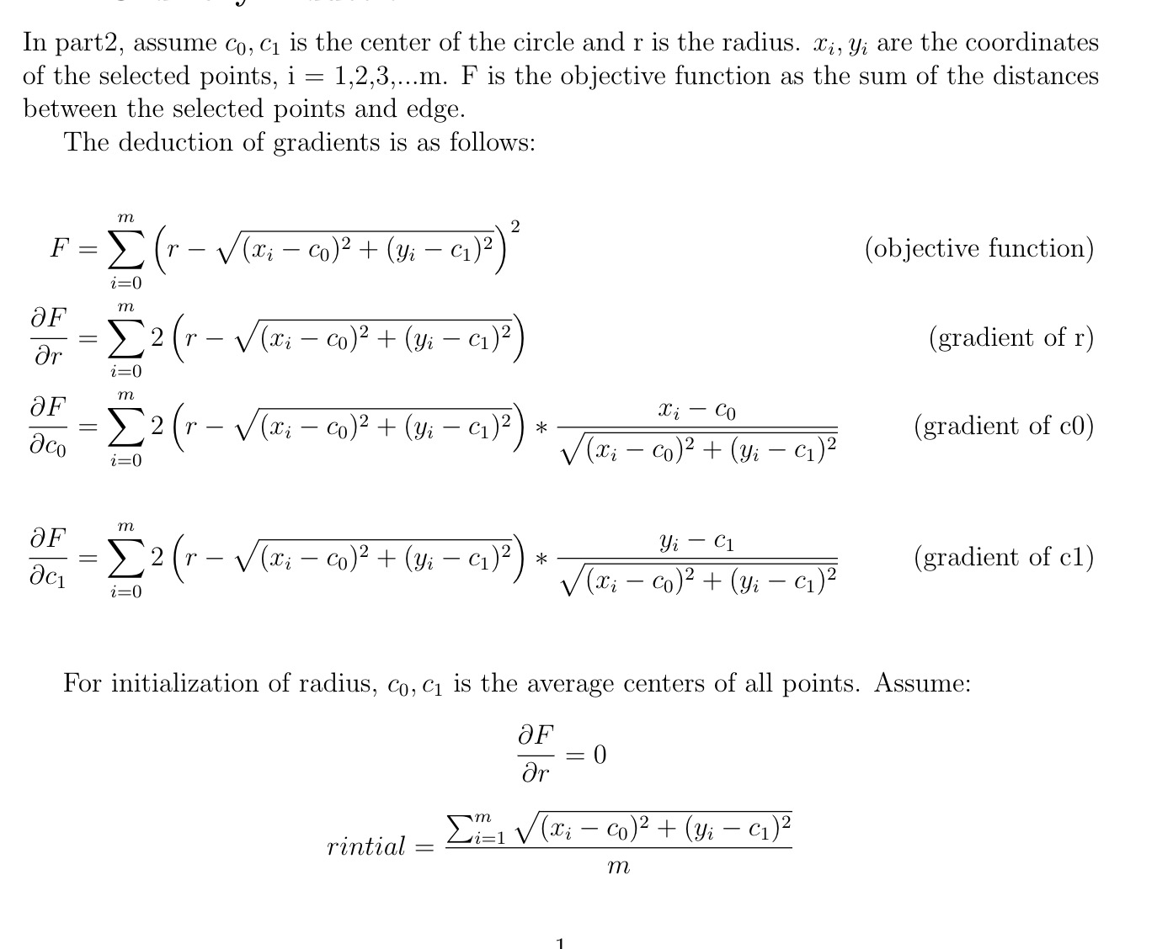

6.Reference:

<https://spring.io/guides/gs/serving-web-content/>

<https://www.w3schools.com/howto/howto_css_shapes.asp>

<https://stackoverflow.com/questions/57550082/creating-a-16x16-grid-using-javascript>

<https://stackoverflow.com/questions/9851878/is-there-a-download-function-in-jsfiddle>

<http://plnkr.co/edit/DPa9km1hHAAsCBCbnGvB?p=preview&preview>

<https://stackoverflow.com/questions/33811677/html-canvas-draw-a-circle-on-mouse-click-and-drag-it-untill-the-required-radius>

https://www.emis.de/journals/BBMS/Bulletin/sup962/gander.pdf