Quantifying the Invisibility of Transient Phenomena Through Gravitational Lensing
15

- Introduction
  - What does “invisible” mean in astronomy?
An astronomical object is undetectable due to extrinsic, intrinsic, temporal reasons.

Temporal: The object emits signals, but our observational window misses it. We need high-cadence calibration for this.
“Large, high-cadence, unbiased low-z samples could also be used to refine and extend new models for SN Ia standardization (e.g., Guy et al. 2007; Burns et al. 2011; Saunders et al. 2018; L´eget et al. 2020; Mandel et al. 2020), to better constrain relationships between SN Ia distance measurements and host galaxy properties (Rigault et al. 2013; Jones et al. 2018b; Roman et al. 2018; Rigault et al. 2018), to improve our understanding of common sources of CC SN contamination in SN Ia cosmology measurements (Jones et al. 2018a; Popovic et al. 2020; Vincenzi et al. 2020), and to increase the number of independent photometric systems on which SNe are observed in order to reduce photometric calibration uncertainties — typically the dominant systematic uncertainty in dark energy measurements.”[5]

Extrinsic: The object originally emits visible and detectable signals, but the universe prevents signals from reaching us. (Absorption; dilution; cosmological events, like high-redshift objects)
“The most often used local rate measurements were measured from a galaxy targeted survey (Li et al. 2011b), and therefore the rates and luminosity functions are heavily biased by the correlations between SNe and their galaxy environments (Smith et al. 2007; Quimby et al. 2011; Sanders et al. 2012; Taggart & Perley 2019).
Other contributing factors may include biases in the photo-z determinations, as reliable redshifts are more difficult to estimate for faint or undetected host galaxies.” [2]

Intrinsic: The object exists, but it emits no detectable signals in any known channel because of its physical nature.
“Thus the “missing mass” problem was born—excess matter in the universe that does not shine as stars and is invisible on ordinary photographs.”[1]
“If the disk or halo dark matter is in the form of BOs, it is therefore important to consider whether they can be detected via this infrared emission.” [3]

  - The scientific cost of blindness
Systematic incompleteness: we are missing 50% of the universe. If we don’t close this gap, the universe is biased on the fundamental level.
“We identify a “supernova rate problem:” the measured cosmic core-collapse supernova rate is a factor of ∼2 smaller (with significance ∼2σ) than that predicted from the measured cosmic massive-star formation rate.” [6]
Where is the New Physics? We miss new classes of astronomical events that don’t fit our mental model.
“Progenitor models for the “luminous” subclass of Fast Blue Optical Transients (LFBOTs; prototype: AT2018cow) are challenged to simultaneously explain all of their observed properties…” [8]
“Luminous fast blue optical transients (LFBOTs) are a class of extragalactic transients notable for their rapid rise and fade times, blue color, and accompanying luminous X-ray and radio emission.” [7] (identify LFBOTs as a distinct class)
Non-representative results. We might contaminate the cosmology measurements because of selection bias.

(Why it matters to us as general audience? Think about it after the research process.)
  - Personal note
The project originates from a personal experience of “being overlooked”. Through this, I realize it resonates with the conditions of many astrophysical objects that are too faint, too distant or in wrong EM waveband to be detected. It led me to investigate the phenomenon of “invisibility in the universe” as a quantifiable physics problem.

- Three types of invisibility

  - Extrinsic - Technological limitation
gISNe [13]
Emitting EM waves that are in visible waveband, but too distant to investigate by human eyes or telescope.

  - Temporal domain misalignment (Transients)
Fast Radio Bursts [10]
Unlike many radio sources, the signal from a burst is detected in a short period of time with enough strength to stand out from the noise floor. The burst usually appears as a single spike of energy without any change in its strength over time. The bursts last for several milliseconds (thousandths of a second). The bursts come from all over the sky and are not concentrated on the plane of the Milky Way. Known FRB locations are biased by the parts of the sky that the observatories can image.

Gamma-ray Bursts [11]
extremely energetic events occurring in distant galaxies which represent the brightest and most powerful class of explosion in the Universe. These extreme electromagnetic emissions are second only to the Big Bang as the most energetic and luminous phenomena known. Gamma-ray bursts can last from a few milliseconds to several hours. After the initial flash of gamma rays, a longer-lived afterglow is emitted, usually in the longer wavelengths of X-ray, ultraviolet, optical, infrared, microwave or radio frequencies.

  - Intrinsic - Physical limitation
Stellar black holes [12]
“It is often assumed that gravitational wave (GW) events resulting from the merger of stellar-mass black holes are unlikely to produce electromagnetic (EM) counterparts.”

- A Unified Solution: gravitational lensing
  - Magnification – glSNe
Making the faint sources bright enough.
“One of the most useful signatures of baryonic dark matter candidates is undoubtedly their gravitational lensing effects. Indeed it is remarkable that lensing could permit their detection over the entire mass range 10- 7Me to 1012Me. All sorts of astronomical objects can serve as lenses (Blandford & Narayan 1992) but the crucial advantage of Population III objects is that they are compact and spherically symmetric and this makes their effects very clean.”
“There are two distinct lensing effects and these probe different but nearly overlapping mass ranges: macrolensing (the multiple-imaging of a source) can be used to search for objects larger than 104Ma. while micro lensing (modifications to the intensity of a source) can be used for objects smaller than this.”[4]
  - Time delay – FRBs & GRBs
Turning transients to multi-messenger events.
“Gravitational lenses act equally on all kinds of electromagnetic radiation, not just visible light, and also in non-electromagnetic radiation, like gravitational waves. Weak lensing effects are being studied for the cosmic microwave background as well as galaxy surveys. Strong lenses have been observed in radio and x-ray regimes as well. If a strong lens produces multiple images, there will be a relative time delay between two paths: that is, in one image the lensed object will be observed before the other image.”
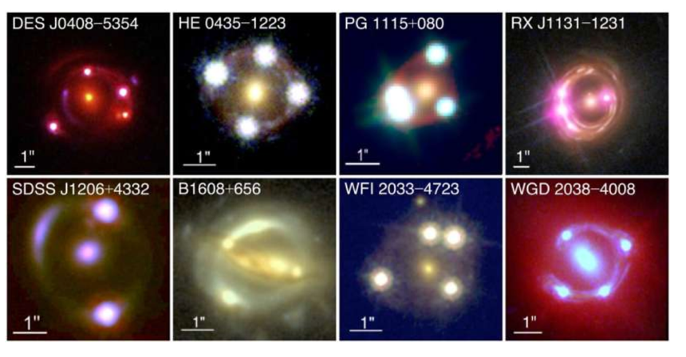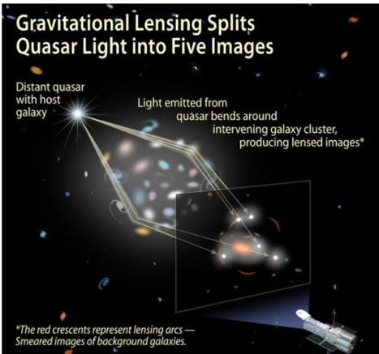 [9]

  - Gravity is the only messenger. Stellar black holes
GW lensing. [12]

- Research questions
General question: How does ‘gravitational lensing’ enhance our ability to detect the astronomical phenomena that are otherwise invisible due to technological, temporal, and physical limitations?
Sub-question1(primary): To what extent does gravitational lensing magnify the light of distant supernovae, how does it increase the possibility of being detected?
Sub-question2(secondary): How does strong gravitational lensing produce multiple time-delay images, and what fraction of the events can be identifiable as lensed?
Sub-question3(future): For events with no electromagnetic counterparts, can gravitational lensing provide additional information that is otherwise inaccessible?

- Methodologies
Sub-question1:
While A. Townsend+ already identified seven transients as the glSN la candidates using AMPEL platform with ZTF survey [15], my aim is to calculate the percentage of SN getting brighter, and the expectation of SN detection.
Monte Carlo: Create a large sample of virtual SN (Expected 10,000), given specific details of SN, including RA, Dec and z. Create a large sample of glSN at the foreground of SN, given details. Use ZTF data base for the samples.
Algorithm: For each “SN-gl” vision, use SIS model to calculate the Einstein Radius. Use angular distance to calculate the magnification factor. Investigate to selection bias of ZTF: is the brightness of the glSN enough for ZTF to detect?
Conclusion: graph scattergram of magnification factor/ curve of detection rate under redshifts. Investigate the ratio difference of detected virtual NS between two cases of “with lens” and “without lens”.

Paper章节 | 对应网站部分 | 内容
Abstract | Home（标题+副标题） | 一句话概括项目
1. Introduction | The Problem | three invisibilities + scientific blindness
2. Methodology | The Model | Monte Carlo simulation + SIS
3. Results | The Results + The Map | Detection rate curve + 3D scattergram
4. Discussion | / | Explain conclusion, limitation
5. Conclusion | The Stories（人文升华）

2 Title: Seeking the Signals copied by the Universe
- Are There Lensed FRBs?

Intro: If a fast radio burst is copied by the gravitational lens, we would see two identical signals arriving at different times. In the 546 existing FRBs, I found two candidates.
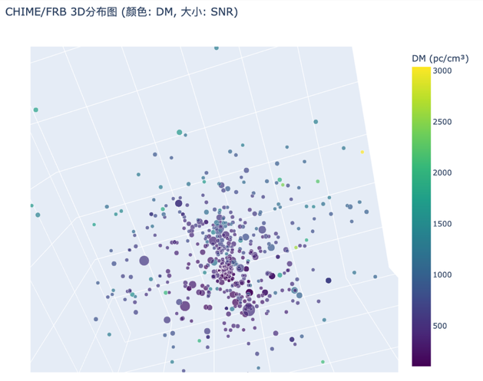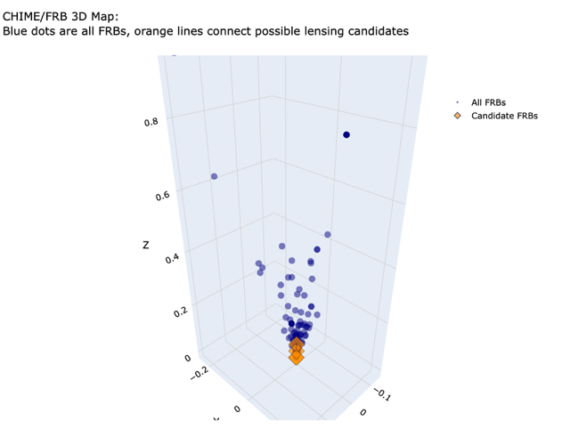
LHS: the visible FRBs reflected in a 3D graph. DM refers to the number of free electrons travelled by FRB signals on the Earth, which indicates the distance from us.
RHS: the candidate FRBs.

2/546 = 0.37% ratio between candidates and full sample

frb1 frb2 dm_diff time_diff_days
66 FRB20181129A FRB20181224A 0.0 24.931106
79 FRB20190425B FRB20190609B 5.2 44.945751
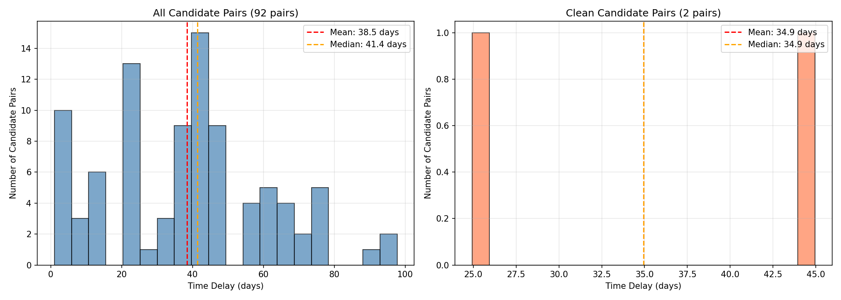
Those candidates require further verification, providing the new clue for lensed FRBs.

