安装anaconda
下载网址https://www.continuum.io/downloads

安装命令：
bash Anaconda2-4.1.0-Linux-x86_64.sh

查看安装kernel命令：
jupyter kernelspec list

生成config配置文件
jupyter notebook --generate-config
Writing default config to: /root/.jupyter/jupyter_notebook_config.py

修改配置文件
vi /root/.jupyter/jupyter_notebook_config.py
c.NotebookApp.ip='172.31.18.14'
c.NotebookApp.open_browser = False
c.NotebookApp.port = 7888

启动jupyter
jupyter notebook
http://172.31.18.14:7888/tree

创建测试python用例
import matplotlib
import numpy as np
import matplotlib.pyplot as plt
%matplotlib inline
x = np.linspace(0, 20, 1000)
y1 = np.sin(x)
y2 = np.cos(x)

plt.plot(x, y1, '-y', label = 'sin')
plt.plot(x, y2, '-g', label = 'cos')
plt.legend(loc = 'upper right')
plt.ylim(-1.2, 1.8)

点击cell run执行

查看版本
jupyter --version

安装jupyter scala kernel
https://github.com/alexarchambault/jupyter-scala

生成密码
网页里按右上角的 new，然后选python。
输入第一行
from notebook.auth import passwd
alt + enter 来执行这个命令并进入下一行；
在下一行里面输入：
passwd()
按回车，它会提示你输入密码，记住！！！这就是你要设置的密码！！输一遍验证一遍是国际惯例，然后你就把密码设好了。
这段值按如下格式粘贴到配置文件jupyter_notebook_config.py末尾
c.NotebookApp.password = u'sha1:XXXXXXX'
重启jupyter，重新打开网页即可

sha1:1d5b9cb7ef44:73afdedf26460035bdb87b38a2875eae9b1ec97e
root@1234

sha1:5a7c394b6a22:c40215194482a12b36367d9bc6e6642eb52e5d25
whsh@1234

./.local/share/jupyter/kernels/scala/kernel.json
./.local/share/jupyter/kernels/spark/kernel.json

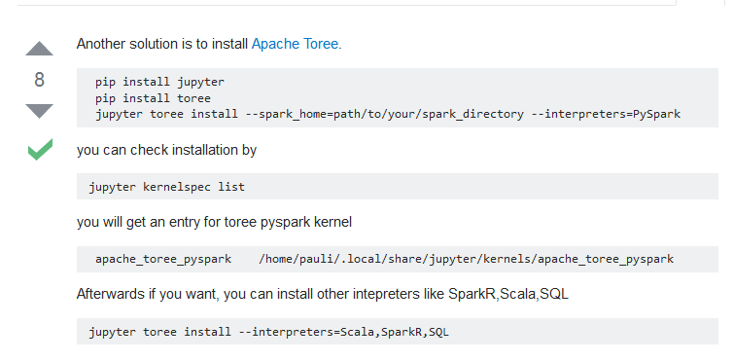

Another solution is to install Apache Toree.
pip install jupyter
pip install toree
jupyter toree install --spark_home=path/to/your/spark_directory --interpreters=PySpark
you can check installation by
jupyter kernelspec list
you will get an entry for toree pyspark kernel
apache_toree_pyspark /home/pauli/.local/share/jupyter/kernels/apache_toree_pyspark
Afterwards if you want, you can install other intepreters like SparkR,Scala,SQL
jupyter toree install --interpreters=Scala,SparkR,SQL

源文档 <https://stackoverflow.com/questions/39149541/integrate-pyspark-with-jupyter-notebook>

pip3 install ipykernel
conda create -n py36-test python=3.6
source activate py36-test
python -m ipykernel install --name py36-test
source deactivate

conda create --name py27 python=2
>conda create -n py35 python=3.5
>activate py35
>pyspark

sc
from operator import add
print(sc.parallelize(range(1, 100)).reduce(add))

