Data Wrangling QBS 181

Homework -2-Due 10/17/2018

Instructions:

* Print random 10 rows to show these changes. Please also include the code
* Insert the answers directly into this document.
* You may collaborate on the homework but you must write it up yourselves.
* Please save the files in this format:
* Name of the file should be username(database)_HW2_QBS181
* Email the file with the subject line same as the file name.

1. Create a new column “Enrollment group” in the table Phonecall
2. Insert EnrollmentGroup=Clinical Alert :code is 125060000
3. Insert EnrollmentGroup =Health Coaching :code is 125060001
4. Insert EnrollmentGroup =Technixal Question: Code is 125060002
5. Insert EnrollmentGroup =Administrative: Code is 125060003
6. Insert EnrollmentGroup =Other: Code is 125060004
7. Insert EnrollmentGroup =Lack of engagement : Code is 125060005
8. Obtain the # of records for each enrollment group
9. Merge the Phone call encounter table with Call duration table.
10. Find out the # of records for different call outcomes and call type. Use 1-Inbound and 2-Outbound, for call types; use 1-No response,2-Left voice mail and 3 successful. Please also find the call duration for each of the enrollment groups
11. Merge the tables Demographics, Chronic Conditions and TextMessages. Find the # of texts/per week, by the type of sender.
12. Obtain the count of texts based on the chronic condition over a period of time (say per week)

select * into wwu.Phonecall from PhoneCall

select * into wwu.CallDuration from CallDuration

--select * from wwu.Phonecall

-- drop table wwu.Phonecall

-- drop table wwu.CallDuration

--Problem 1

alter table wwu.Phonecall add Enrollment_group VARCHAR(255)

update wwu.Phonecall set Enrollment_group='Clinical Alert' where [EncounterCode]='125060000';

update wwu.Phonecall set Enrollment_group='Health Coaching' where [EncounterCode]='125060001';

update wwu.Phonecall set Enrollment_group='Technixal Question' where [EncounterCode]='125060002';

update wwu.Phonecall set Enrollment_group='Administrative' where [EncounterCode]='125060003';

update wwu.Phonecall set Enrollment_group='Other' where [EncounterCode]='125060004';

update wwu.Phonecall set Enrollment_group='Lack of engagement' where [EncounterCode]='125060005';

--Problem 2

select Enrollment_group, count(*) as 'Number'

from wwu.Phonecall

group by Enrollment_group

--Problem 3

select A.*, B.* into wwu.fstjoin from wwu.Phonecall A

inner join

wwu.CallDuration B

on A.CustomerId=B.tri_CustomerIDEntityReference;

select * from wwu.fstjoin

--Problem 4

select CallOutcome, count(*) as 'Number'

into wwu.callcounts

from wwu.fstjoin

group by CallOutcome;

select * from wwu.callcounts

alter table wwu.callcounts add Call_Outcome varchar(255)

update wwu.callcounts set Call_Outcome='No response' where [CallOutcome]= 1

update wwu.callcounts set Call_Outcome='Left voice mail' where [CallOutcome]= 2

update wwu.callcounts set Call_Outcome='successful' where [CallOutcome]= 3

select * from wwu.callcounts

select CallType, count(*) as 'Number'

into wwu.typecounts

from wwu.fstjoin

group by CallType;

select * from wwu.typecounts

alter table wwu.typecounts add Call_Type varchar(255)

update wwu.typecounts set Call_Type='Inbound' where [CallType]= 1

update wwu.typecounts set Call_Type='Outbound' where [CallType]= 2

select * from wwu.typecounts

select Enrollment_group, sum(CallDuration) as 'Total Duration'

from wwu.fstjoin group by Enrollment_group order by Enrollment_group

--Problem 5

select A.*, B.*, C.* into wwu.scdjoin from [dbo].[Text] A

left join [dbo].[ChronicConditions] B

on A.tri_contactId=B.tri_patientid

left join [dbo].[Demographics] C

on A.tri_contactId=C.contactid;

select SenderName, datediff(wk,min(wwu.scdjoin.TextSentDate),max(wwu.scdjoin.TextSentDate)) as 'weeks'

from wwu.scdjoin

group by SenderName

--Problem 6

Select * into wwu.texts from text

left join ChronicConditions

on ChronicConditions.tri_patientid=text.tri_contactId

select SenderName, datediff(wk,min(wwu.scdjoin.TextSentDate),max(wwu.scdjoin.TextSentDate)) as 'weeks'

from wwu.scdjoin

group by SenderName

select tri_name, count(*) SentTexts,

datediff(wk,min(wwu.scdjoin.TextSentDate),max(wwu.scdjoin.TextSentDate)) as 'weeks'

from wwu.scdjoin

where TextSentDate is not null

group by tri_name

Problem1:

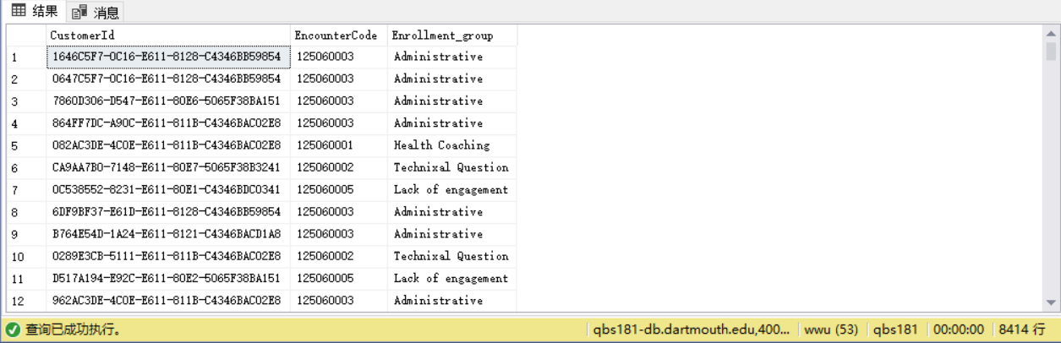

Problem2:

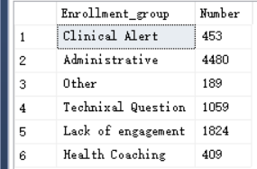

Problem3:

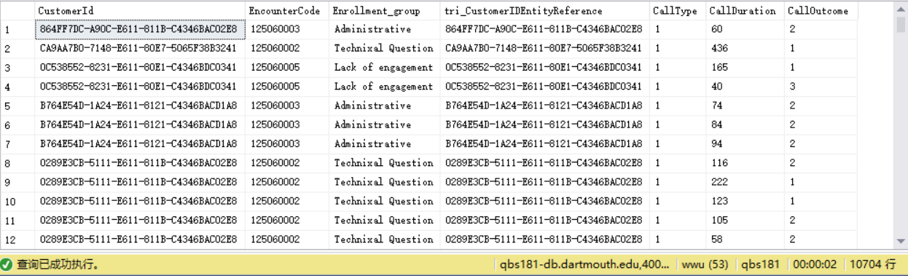

Problem4:

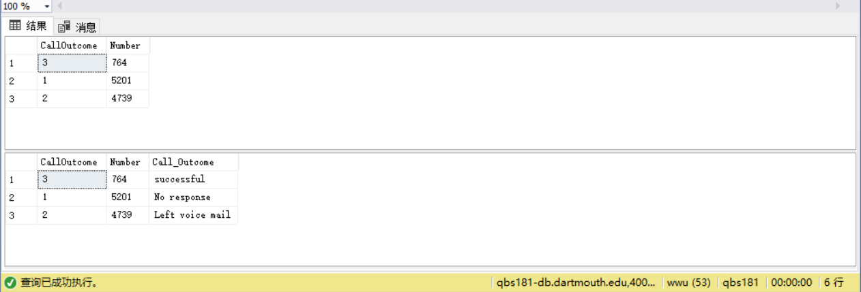

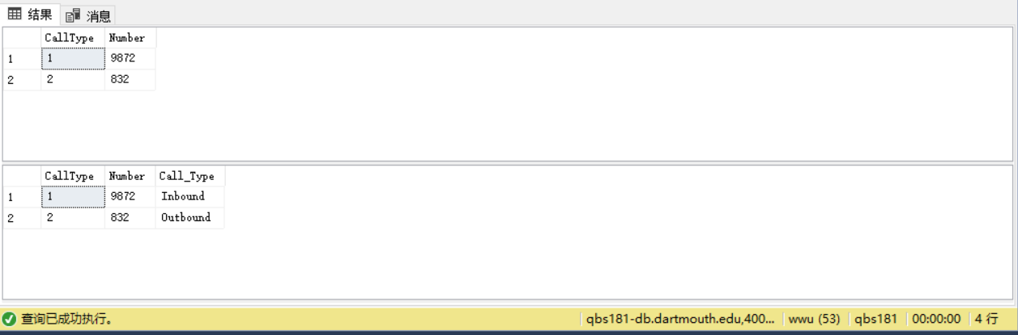

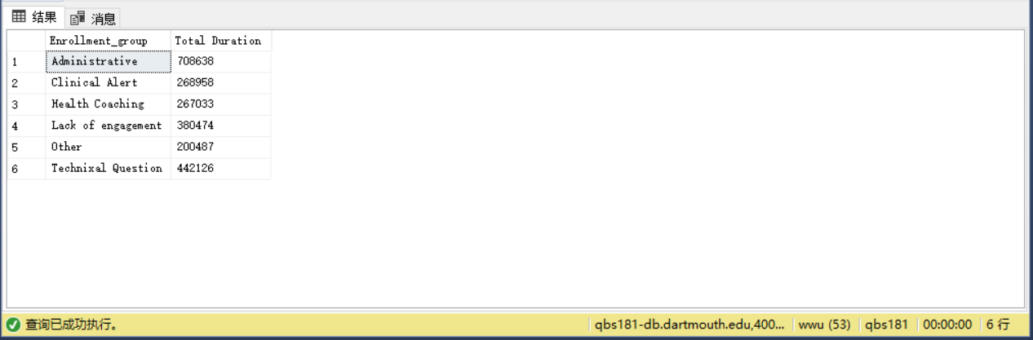

Problem5:

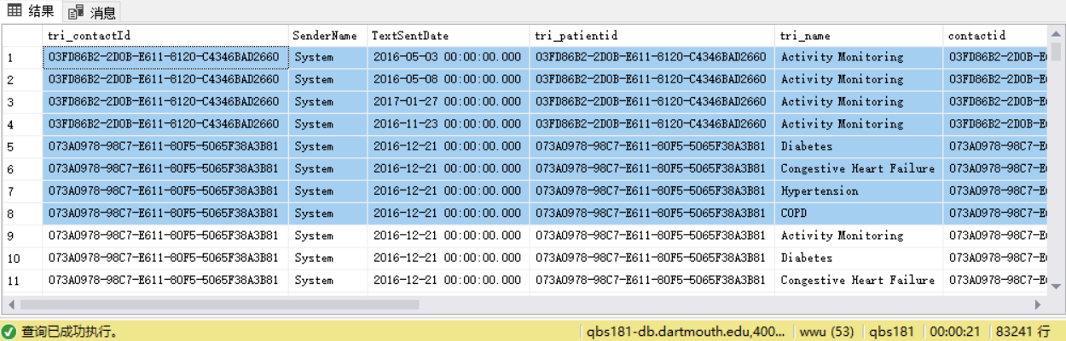

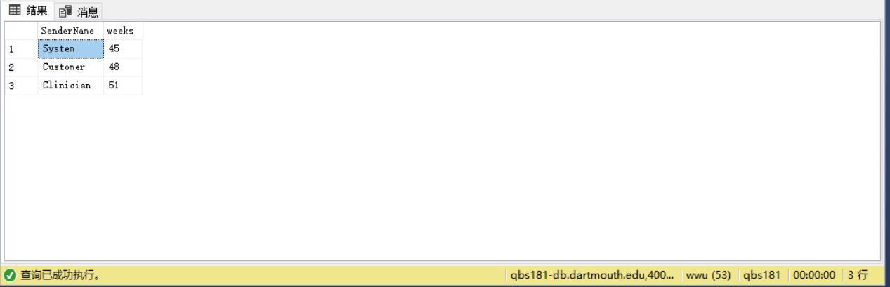

Problem6:

