How to remove local call number of SFX targets in batch:

1. Export a “txt” file from “Export Tool” -> “Basic Export Queries”

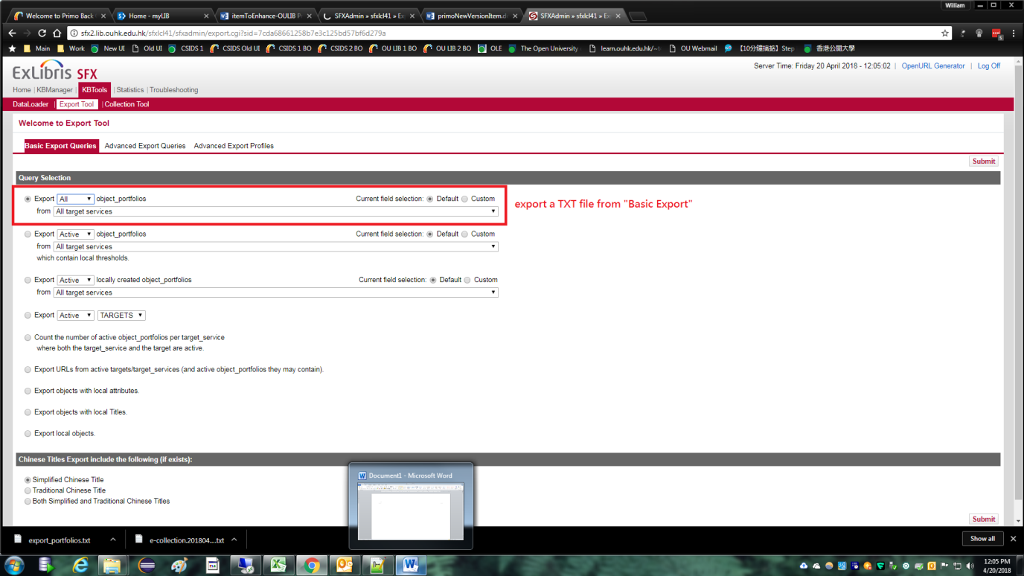

1. Download the exported result:

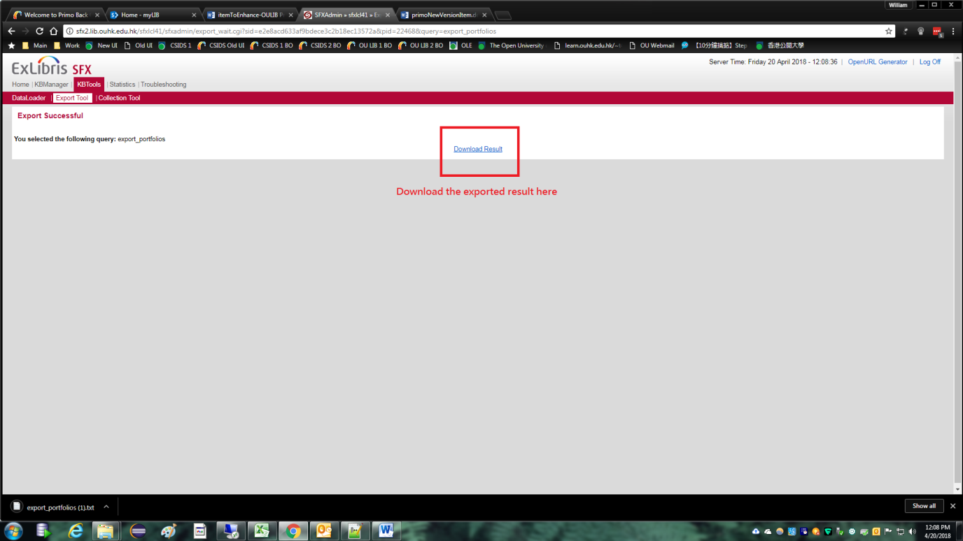

1. Import the exported file onto an Excel sheet:

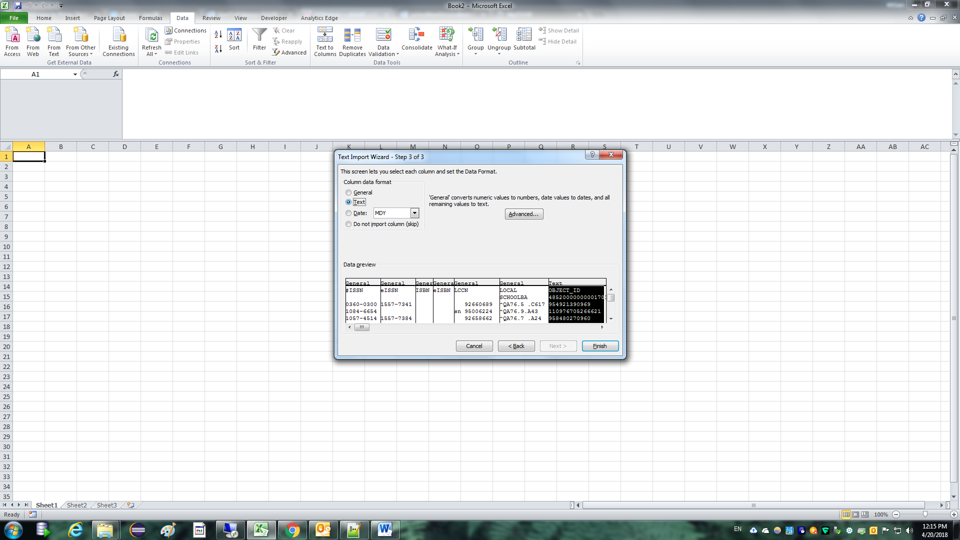

1. Remove strings starting with ‘^’ by find and replace in Excel, replace with a space ‘ ‘:

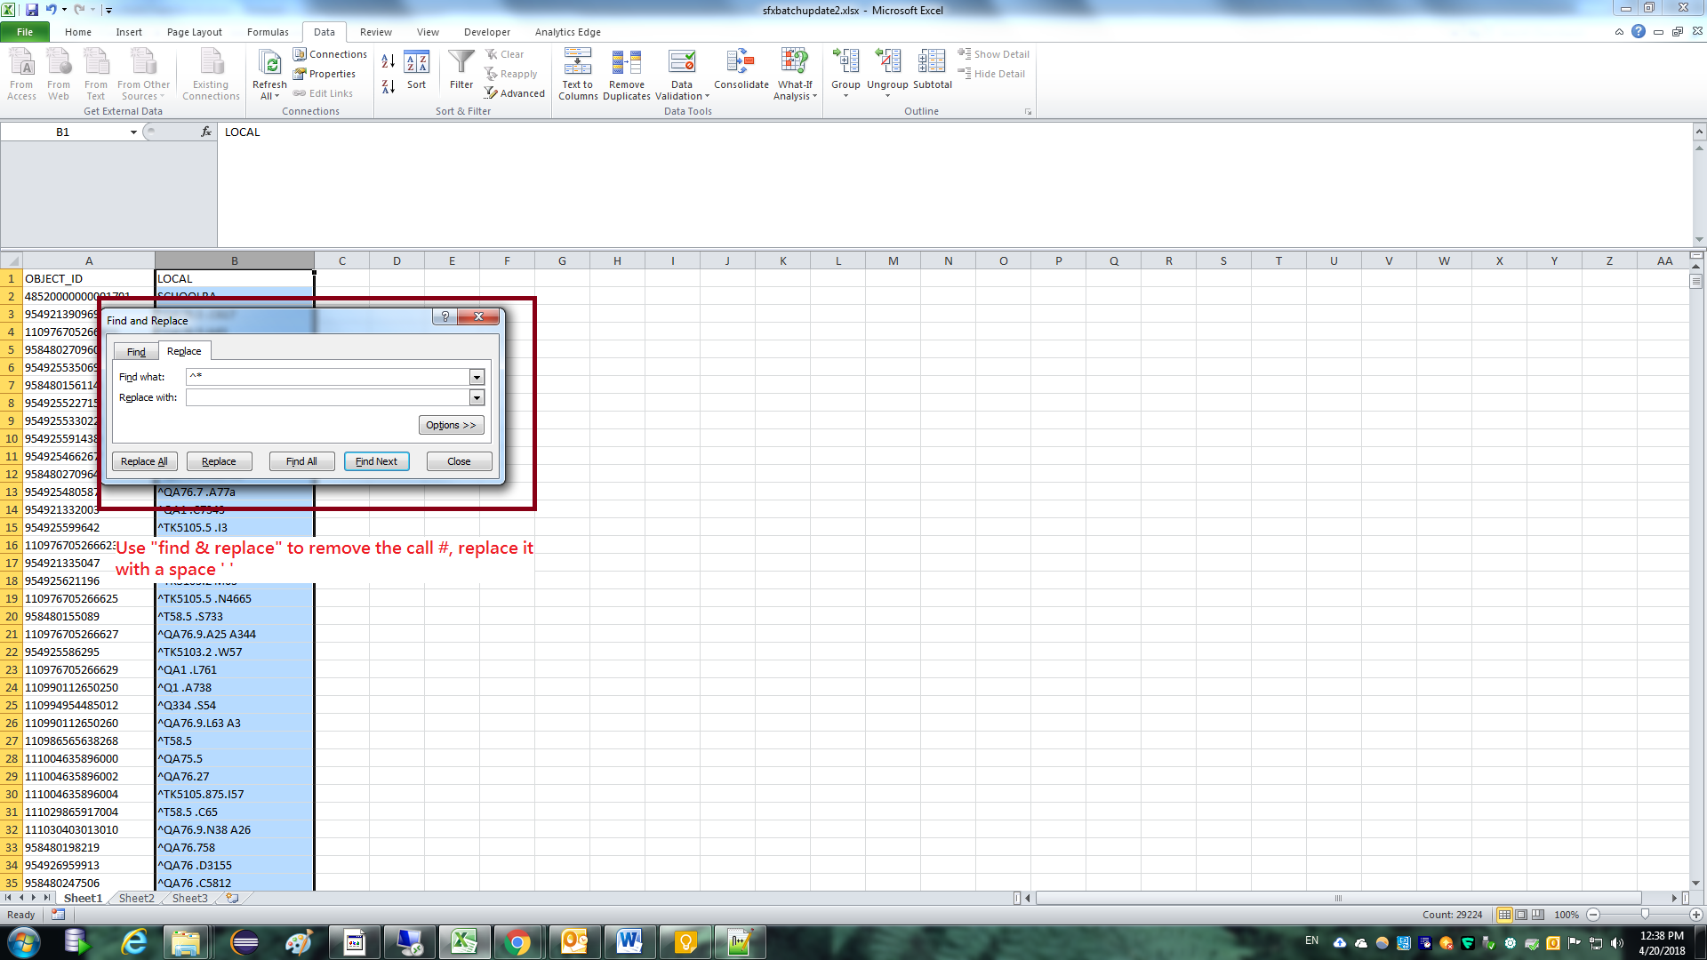

1. Make the “OBJECT_ID” as the 1st column:

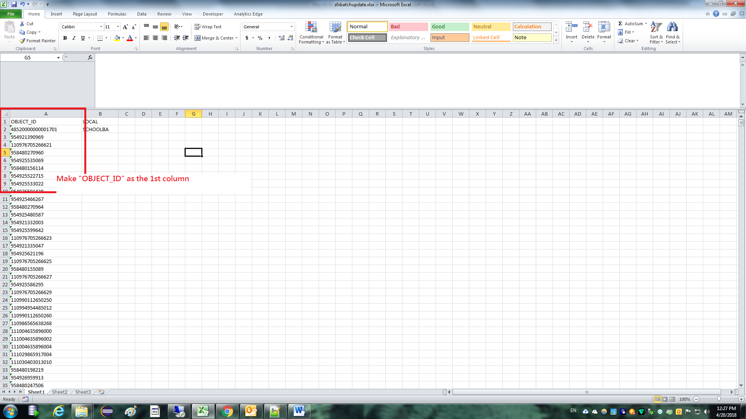

1. Save the Excel into the “txt” format:

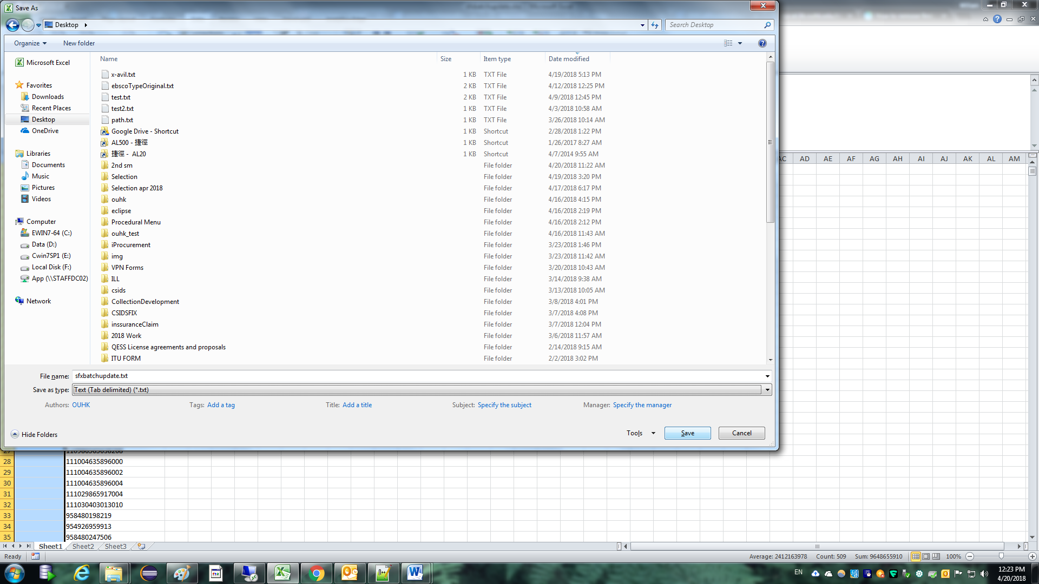

1. Load the text in 6. according to the instruction in below:

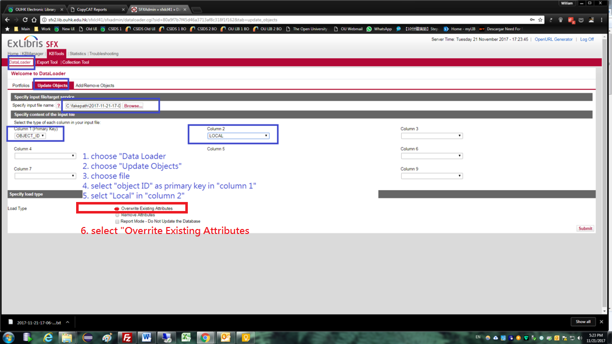

1. Completed:

