1. Go to SFX admin console.
2. Export XML file for enrichment:

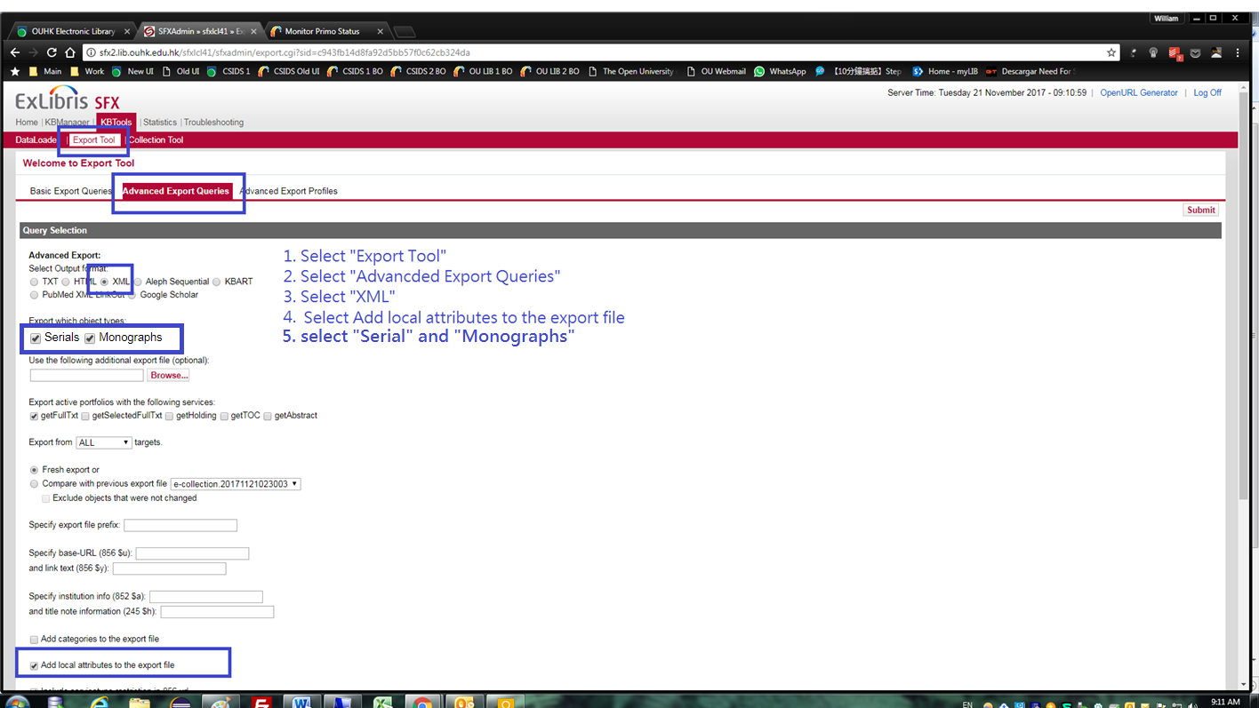

1. Download the exported file:

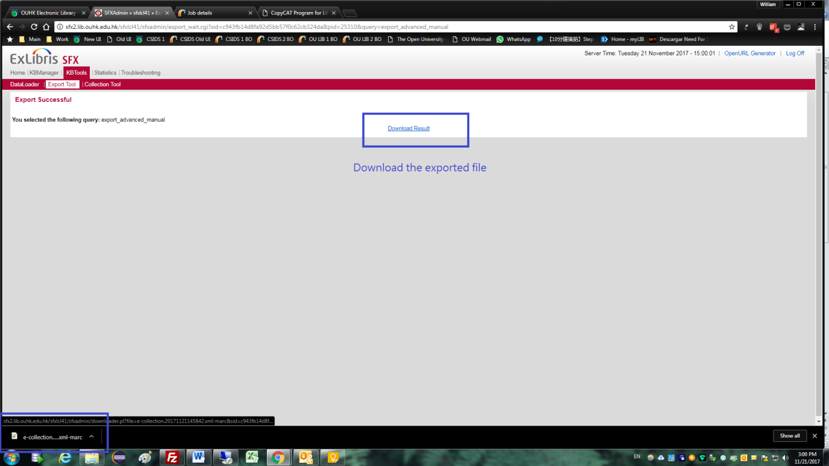

1. Goto <http://cpcat.lib.ouhk.edu.hk:8080/copycat/> (production site) or <http://cpcat.lib.ouhk.edu.hk:8080/copycat/> (testing site)
2. Run SFX Entrenchment report

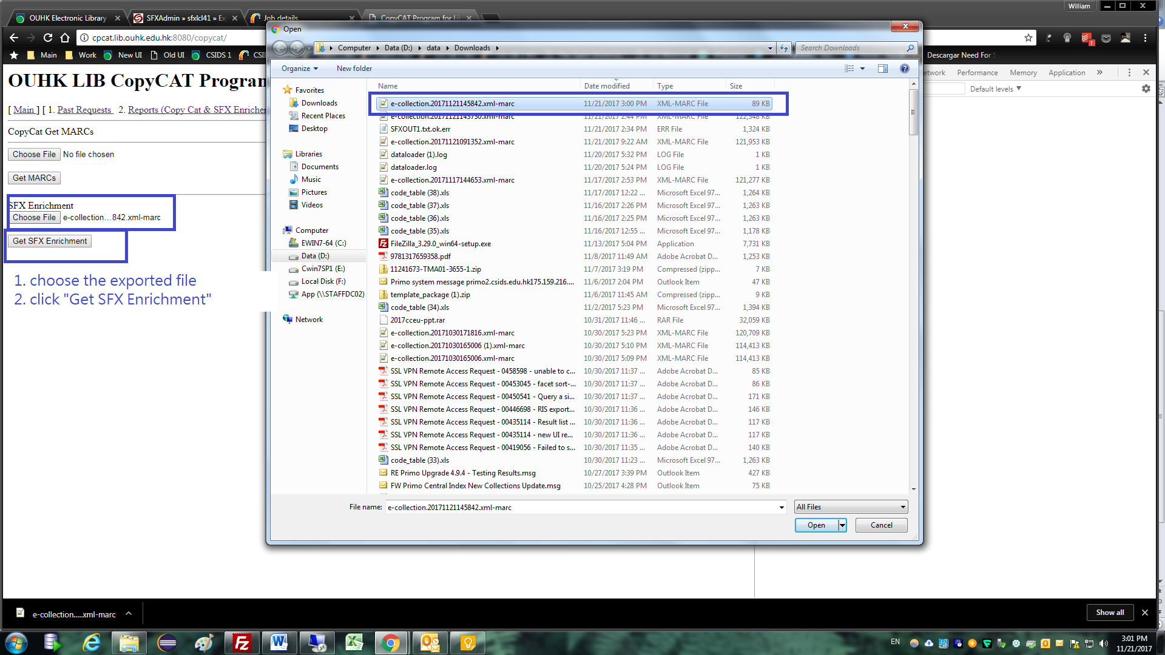

1. Download the SFX enrichment report:

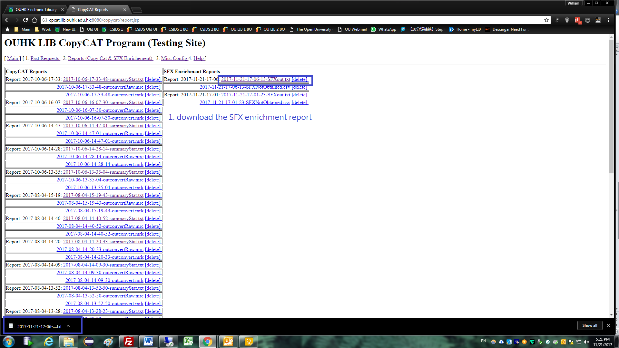

1. Go back to SFX admin console:

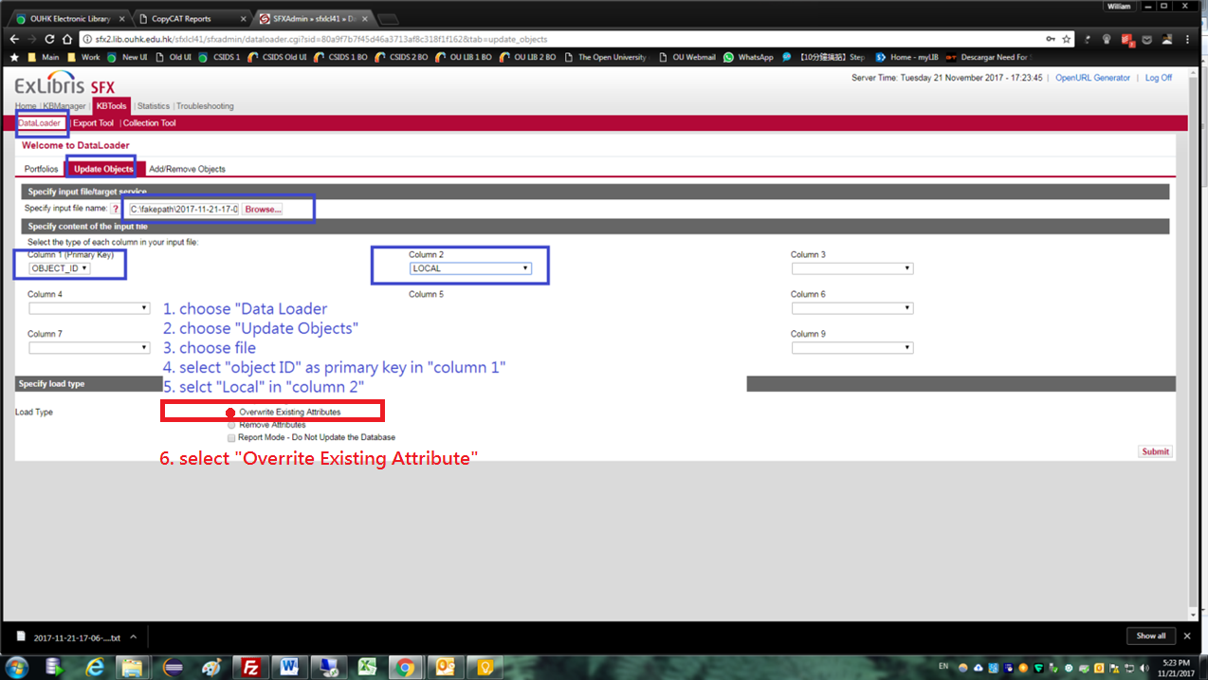

1. Objects updated:

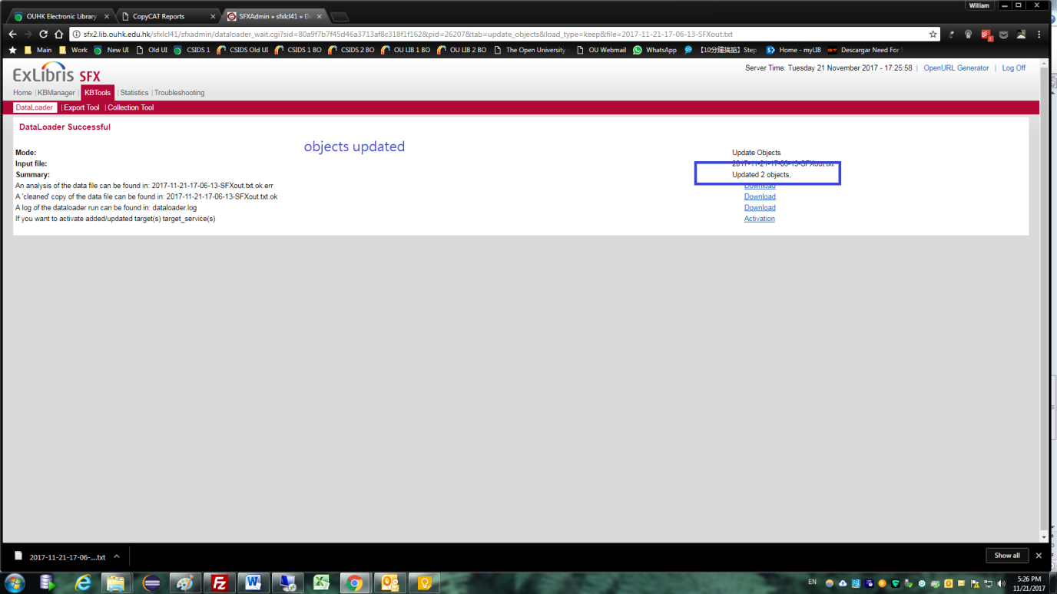

1. Since the updated files are local fields which don’t invoke SFX to export the data for Primo to harvest, pls inform SYS for updating the SFX’s data to Primo.