|  |  |
| --- | --- |
| A picture of a winding road and trees  Assignment 1  Student Result Support System | Abstract  An online system to help the student to check the result.  Yuhan Wang & Deisheng Liu  IT7320 |

Contents

Summary 2

Planning 3

Requirements 9

Tools Requirements 10

Technique Requirements 11

Conclusion 12

# Summary

We want to create a system for every student to help them to check the result because when I did some research that I found some student result check systems are not transparent to use for students and intricacy to maintenance for the tutor operation team. So my teammate and I want to build a simple website to identify solve this problem for tutors and students also can help them improve the efficiency. My team is planning to use the HTML language and PHP technique to demonstrate how this system works. By the way, our online system also can use on the mobile browser for Android and iOS platform as well.

# Planning

Firstly we will create a homepage that the student can log in straightly on this page. The design view looks like in figure 1-1. For the homepage is clear to use for every student, they only need to type their name and the password, and then they can log in. By the way, if the student does not have our system’s account, no worries the student can sign up the account when they click ‘sign up’ link under the login button. Then they can register an account for our system. For the techniques or methods, we will use the PHP language to implement the login function, we will check the username, and password with the database if all correct the student login success if not system prints the wrong message to alert. After the student login, we will use the session to store the student information, so the information can help the system find the courses they did. 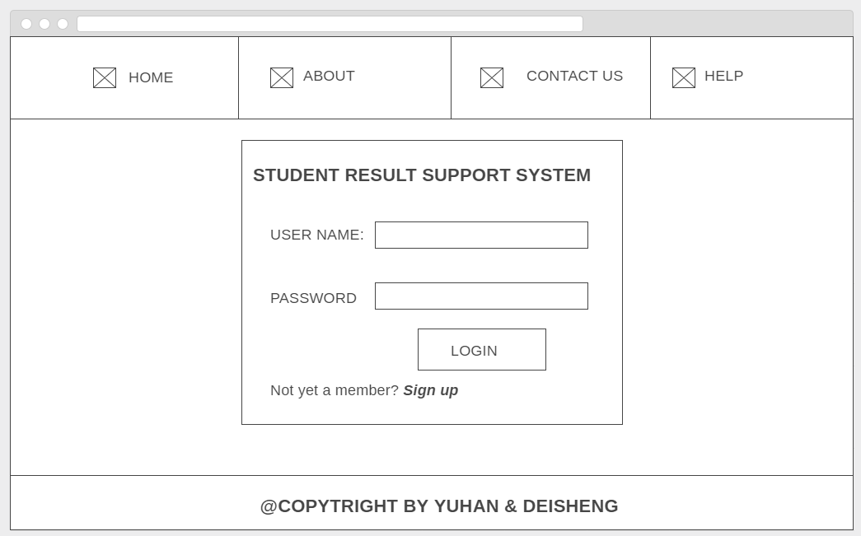

Figure 1-1

If the student click sign up button they will jump to registration page. In this page student need to set their username, password and also need to write the email address, because of if the student forget the password they can contact and we will ask them the original email address they wrote in this page, so email address is a backup for this situation. The design view looks like figure 1-2. The techniques or methods we will use is PHP to help us to implement this part. If the user inputs wrong password in ‘confirm password’ box the system will give the user an alert message to remind the student. Then if the student forget input username or email address the system also will print the alert message. When the student finish registration their information will be store in the database.

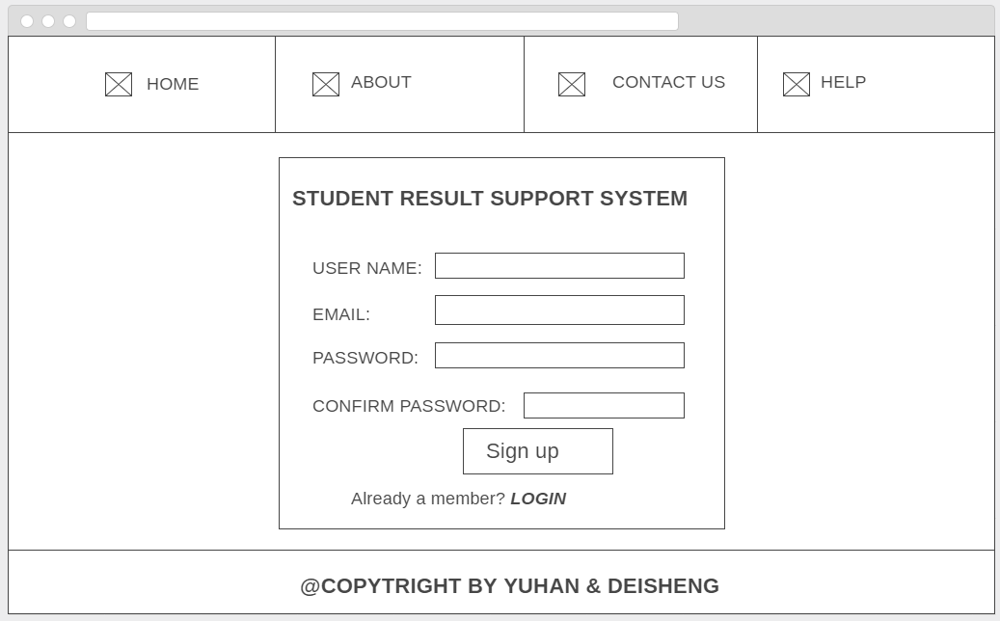

Figure 1-2

After the student login to the system, because of the session storage, this page will print the student’s name. The system will use the student name to find the courses and results for each student and print to implement those techniques and methods we will use PHP as well. So they can check the result of every course. The design view it looks like figure 1-3. In this page, the student can check the result when the tutor uploads into the database. If the student has any problems such as no result display, the wrong result, please go to CONTACT US page to email us (student.support@gmail.com). Finally, when you finished checking the result do not forget to log out to our system if you use the public computer.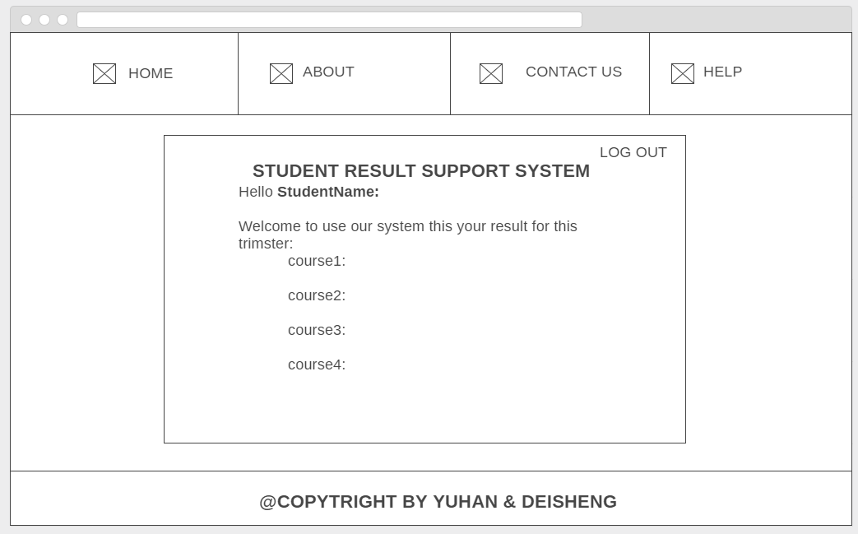

Figure 1-3

Any of students or tutor can find our support email address in contact us page. For this page, the design looks like figure 1-4. Because this is a straightforward online system for checking result, so I did not put any interesting elements or pictures on our website. However, we will use the bold and large font size for our email address. 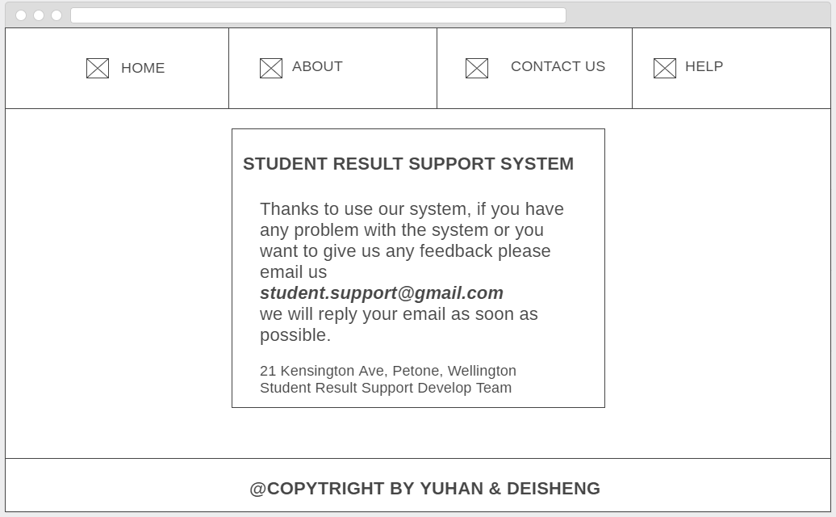

Figure 1-4

In about page, we want to do some introduction about our system. The important thing on this page is to tell the user why to choose our system and also talk about the future implementation of our system. For the design view it looks like figure 1-5, for the design of this page, I will use a different font size and probably different colors to demonstrate our information in this page.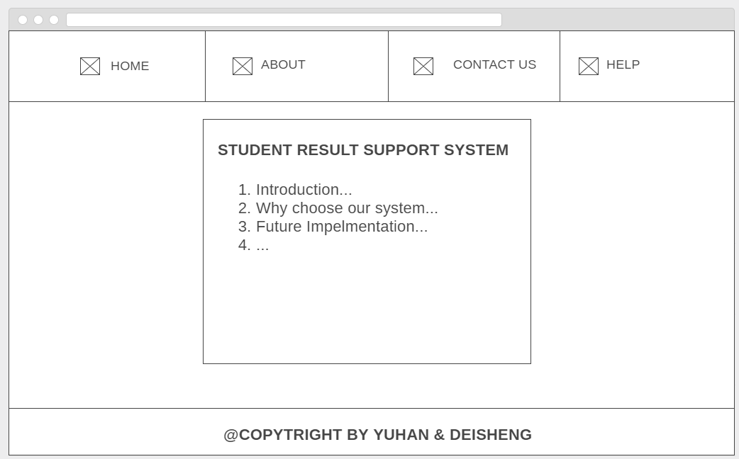

Figure 1-5

Finally is the help page, for this page our team are planning to add some screenshots and descriptions for our system, if the user has any problems they can look our help page first then if still cannot solve the problem, the user can contact our support department. The basic design view it looks like figure 1-6. 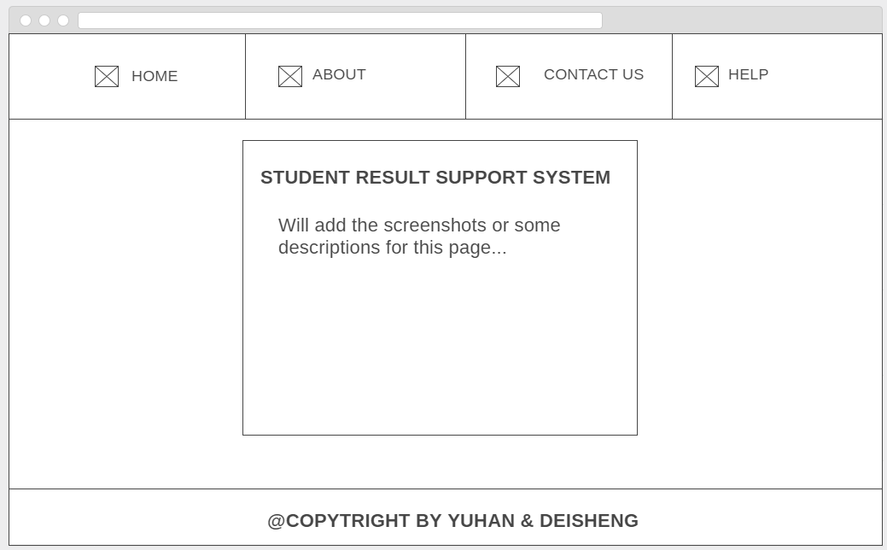

Figure 1-6

# Requirements

The student result check system will be built online and can use in a most operating system for example windows, mac and also can use on mobile phone for Android, iOS platform.

In this system can implement student login and registration functions. For instance, the student uses our website they can log in to our system with the username and password if they do not have the account for the system they can register an account. All information from the students will be stored in the database. After a successful login to the system, the student can see the result for this trimester. The result for each course will be updated in the database by the administrator. The administrator has the privilege to use the database, depending on how many users to use the system, if we have more users in the future, we will add more administrator but for now, there are two administrators can have the database’s privilege. The school tutor and administrator will provide all the result will be put the data in the database. When the student finished using the system, we provide the logout function to clear current login student to keep them private for everyone. This is the basic structure for this phase.

For the future implementation of the system will behave more functions such as attendance checker, book appointment and something else into our system.

# Tools Requirements

* Wampserver
* MySQL
* Notepad++
* Sublime Text
* Windows & Mac System
* Android & iOS platform
* Chrome, Firefox, IE…
* Git

# Technique Requirements

To build the system, we used the necessary CSS, HTML and JavaScript for the front-end. For the back-end, the most technique we used is PHP and MySQL. For connecting the database and HTML, we used PHP, when user login to the system we used session to store the username and display the username in the check result page then for student logout the system, the back-end will close the session to keep the private security level.

For database we will use MySQL to update the student result and then use PHP to print on result page.

# Conclusion

During the first development phase, we learnt the team management skills and how to use time reasonable because my teammate also needs to work on the project, so we need to improve our efficiency. We used the simple progress report and the time sheet to track the work for every day, every two or three days we will organize the team meeting to talk about the current constraints we have, and help each other to solve the obstacles. At the end of the meeting we listed the action items for the next meeting and we will check the work in next meeting. Those necessary management skills we already learnt before, but during this development, we improved them. The most important thing is our team without any conflicts, everyone can work on their part responsible. A good relationship and community with the team member are essential.

For the development and technique parts, we still need to improve in the future. In current development, we did a good idea, and excellent design in the wireframe, however, is not anything on the wireframe has been implemented. I think the first reason is we know the theory of the knowledge but we cannot use the knowledge in the practical part efficiently, sometimes we need to research and spend lots of time on that. The second reason is we should not do too much assume next time. Sometimes we keep considering everything. If we can fix those two problems, we can do better in the future. In the technique part, after the project we can use Git now, this is a useful tool for sharing and tracking the coding work online.

We did testing when we finished the coding work. In the testing part, I spend some time to check the specification and requirements. Actually, lots of bugs will hide in the specification and requirements. If we cannot find the error the error will become fault then will become the failure to crash our system. I am using the Risk Matrix to demonstrate the risk in multi-dimension with three levels (high, mid, low) then depending on the risk level we can decide which part we need to test first and which part need most to test and which part does not need the test.

In the future implementation of the system, we will use the framework to make the UI (user interface) better and implement the navigation bar on every page. Planning to add more functions for checking attendance, checking the tutor timetable and booking an appointment with the tutor. Next phase also will add about, help and contact us pages in the navigation bar. For back-end, improve security and also need to think about the SQL injection problem. Those things will be implemented in the next phase. After that we think to create a small app for the system on Android platform.

Finally this is a memorable development experience for us, from this project we find which part we did well and which part we need to improve in the future.