Supplementary Material

Table S1. Demographic information and completion of scales for the relatively balanced sample set.
Item | All | PSQI / BDI / GAD-7 / MMSE | DST / IQCODE
Number (male / female) | 101 (39 / 62) | 99 (38 / 61) | 64 (26 / 38)
Age (yrs) | 48.62 ± 19.75 (22-88) | 48.31 ± 19.82 (22-88) | 60.14 ± 14.07 (31-88)
Education (yrs) | 14.05 ± 4.32 (8-23) | 14.06 ± 4.35 (8-23) | 11.47 ± 2.73 (8-16)

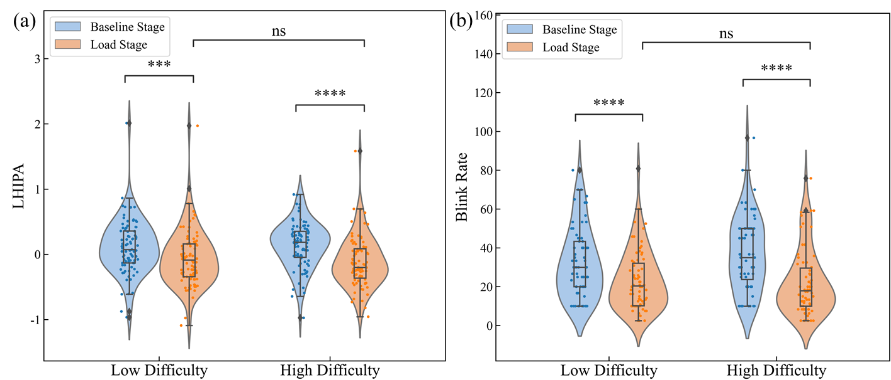
Fig. S1 Cognitive load differences in speech dual tasks assessed by pupillometry metrics on the relatively balanced sample set. (a) and (b) show the group differences in the LHIPA and blink rate metrics across different speech dual tasks and their respective phases. *p < 0.05, **p < 0.01, ***p < 0.001, and ****p < 0.0001 indicate significance levels, ns = no significance.
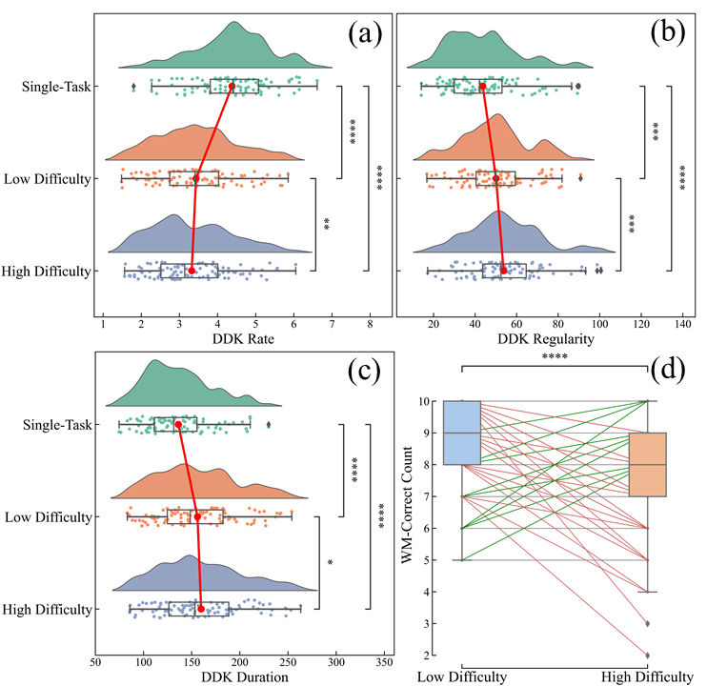
Fig. S2 Differences in speech features during tasks on the relatively balanced sample set. (a) to (c) present the group differences in speech features across different speech dual tasks, respectively. (d) depicts the performance differences in the accuracy of responses (WM-Correct Count) for the secondary task, namely the visual working memory task, across the two difficulty levels of the speech dual tasks. The green and red lines in (d) represent samples where metrics increase and decrease from low to high-difficulty tasks, respectively.

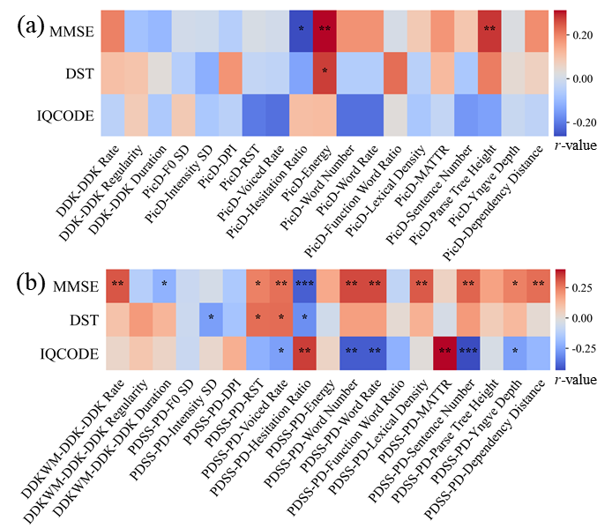
Fig. S3 Correlations between each type of speech feature and cognitive scores on the relatively balanced sample set. (a) and (b) are correlations between speech single-task and dual-task with cognitive scores, respectively.
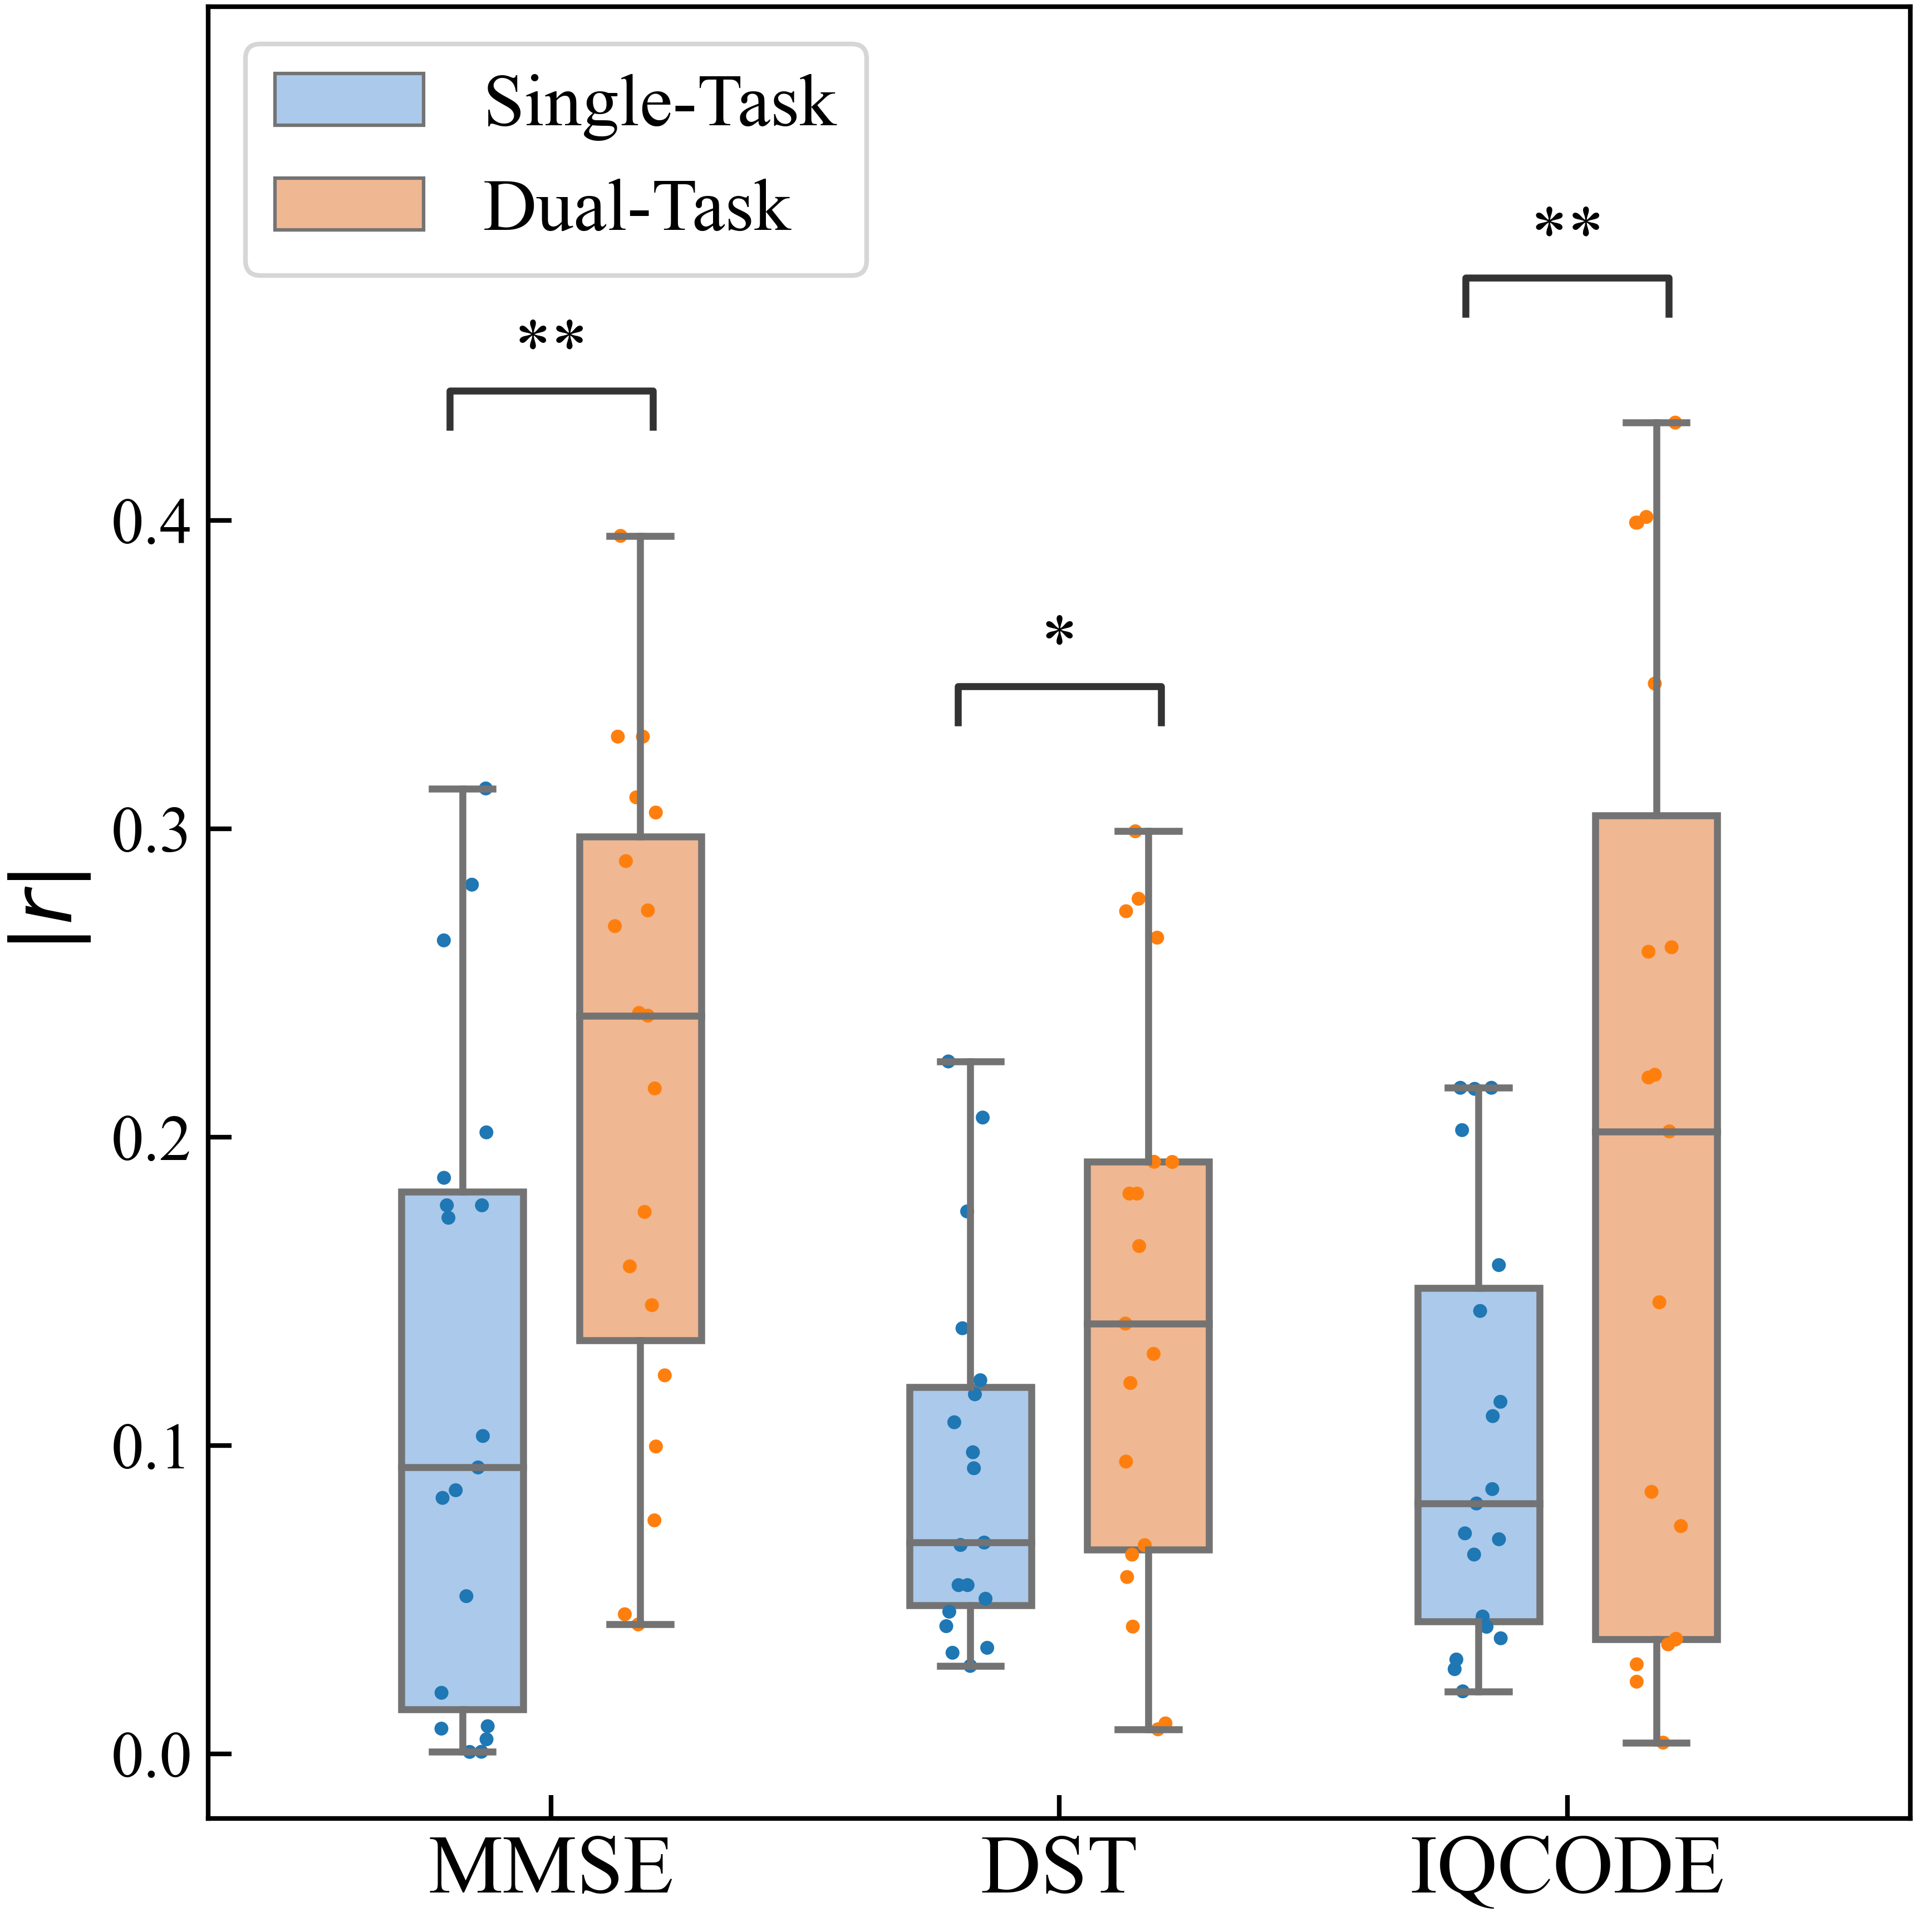
Fig. S4 Statistical tests of significance results for each type of speech feature on the relatively balanced sample set.
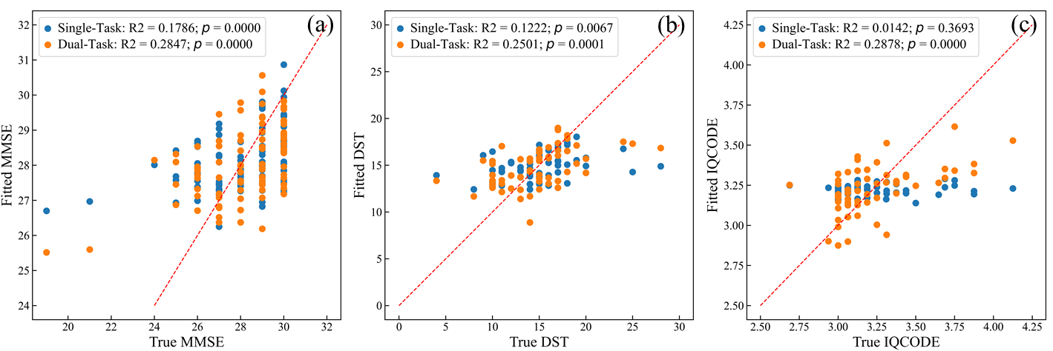
Fig. S5 Fitting results of each type of speech feature on cognitive scores on the relatively balanced sample set. (a)-(c) present the results of linear regression for MMSE, DST, and IQCODE, respectively. The red dashed lines indicate the best fit.

