我们把清洁能源的使用评价分为两部分，一个是清洁能源在各州的使用总量的情况，即清洁能源有没有被使用，以及总体的使用情况；其次是清洁能源的使用效率，我们不认为为了完成清洁能源的占比任务而大幅提高清洁能源的使用是一种好的行为，这不仅会使得经济下滑成本提高，而且还会浪费清洁能源，与我们希望使用清洁能源的初衷背道而驰。由国家的主要能源机构，加载订单政策指示加州的能源在考虑新一代之前，首先要通过效率和需求响应来满足需求。根据第一个部分，我们使用可再生能源在占总消耗的比，各行业中使用可再生能源的比以及可再生能源使用的增长来判断。我们用人均能源使用和可再生能源/GDP来衡量能源使用效率。

标准

1. 总清洁能源的比例
2. 各行业可再生能源比例
3. 人均能源使用效率
4. GDP能源使用

因为可再生能源在总能源中的占比越高越好，能源使用的效率越高越好，所以第一和第二个指标越大越好，指标三四越小越好，由此我们可以把四个州的指标分别进行排序并按名次从高到低给他们4~1分，算出总成绩，由此判断那一个州的能源使用情况最好。

We divide the evaluation of the use of clean energy into two parts. One is the total amount of clean energy used in each state, that is, whether clean energy is used or not, and the overall usage. Secondly, the efficiency of the use of clean energy, we do not think It is good behavior to significantly increase the use of clean energy in order to fulfill the mission of clean energy, which will not only increase the cost of economic downturn but also waste clean energy, which runs counter to our original intention of using clean energy. By the country's leading energy agency, the loading order policy instructs California's energy sources to respond first to demand through efficiency and demand response, before considering a new generation. According to the first part, we use the ratio of renewable energy to total consumption, the ratio of renewable energy used in various industries, and the growth of renewable energy use. We use the per capita energy use and renewable energy / GDP as a measure of energy efficiency.

Standard

1.The proportion of total clean energy

2. The proportion of renewable energy in various industries

3 per capita energy consumptions

4. GDP energy use

Because the higher the proportion of renewable energy in total energy is, the higher the efficiency of energy use is, the better the first and second indicators are. The smaller the index is, the better the indicator is. So we can use The four states' indices are sorted by rank and ranked 4 to 1 according to their ranking, and the total score is calculated to determine which state has the best energy use.

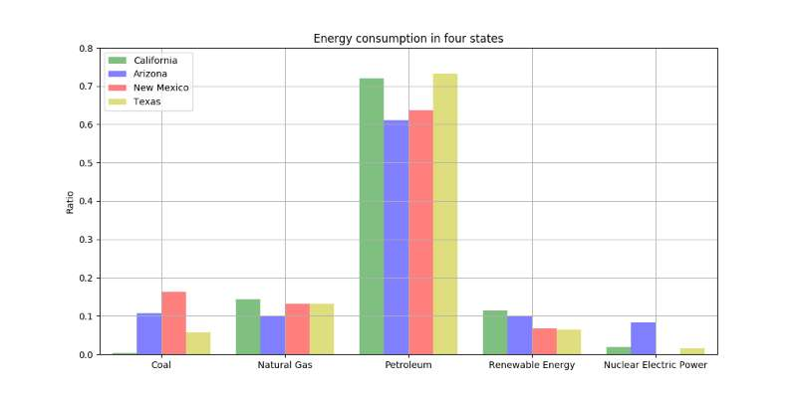

[](http://www.energy.ca.gov/renewables/tracking_progress/documents/energy_efficiency.pdf)

|  |  |  |  |  |  |  |  |  |  |  |
| --- | --- | --- | --- | --- | --- | --- | --- | --- | --- | --- |
|  | | California | | Arizona | | New Mexico | | | Texas | |
| Total Energy | | 0.277315137 | | 0.280504339 | | 0.199562256 | | | 0.2117417 | |
| Transportation | | 0.027915381 | | 0.081253826 | | 0.077170234 | | | 0.060563895 | |
| Commercial | | 0.453105418 | | 0.402439537 | | 0.471068597 | | | 0.402016452 | |
| Residential | | 0.449876906 | | 0.271042873 | | 0.517646726 | | | 0.263184657 | |
| Industry | | 0.577198851 | | 0.410523359 | | 0.543505237 | | | 0.411461443 | |
| Energy Intensity | | 8.759357628 | | 15.27066222 | | 23.89183739 | | | 26.99290275 | |
| per capita TEC | | 447.4832 | | 589.0201 | | 885.3947 | | | 1243.675 | |
|  | Total Energy | Transportation | Commercial | | Residential | | Industry | Energy Intensity | | per capita TEC |
| CA | 3 | 1 | 3 | | 3 | | 4 | 4 | | 4 |
| AZ | 4 | 4 | 2 | | 2 | | 2 | 3 | | 3 |
| NM | 1 | 3 | 4 | | 4 | | 3 | 2 | | 2 |
| TX | 2 | 2 | 1 | | 1 | | 1 | 1 | | 1 |
|  |  |  |  | |  | |  |  | |  |

SUM：CA：22

AZ：20

NM：19

TX：9

综上所说：使用清洁能源最好的州是加利福尼亚州。

To sum up: the best state to use clean energy is California.

http://www.energy.ca.gov/renewables/tracking_progress/documents/energy_efficiency.pdf