CD4094 位移位存储总线寄存器: CD4094是带输出锁存和三态控制的串入/并出高速转换器，具有使用简单、功耗低、驱动能力强和控制灵活等优点。
CD4094的引脚定义如图1。其中(1)脚为锁存端，(2)脚为串行数据输入端，(3)脚为串行时钟端。(1)脚为高电平时，8位并行输出口Q1～Q8在时钟的上升沿随串行输入而变化；(1)脚为低电平时，输出锁定。利用锁存端可方便地进行片选和级联输出控制。(15)脚为并行输出状态控制端，(15)脚为低电平时，并行输出端处在高阻状态，在用CD4094作显示输出时，可使显示数码闪烁。(9)脚QS、(10)脚Q′S是串行数据输出端，用于级联。QS端在第9个串行时钟的上升沿开始输出，Q′S端在第9个串行时钟的下降沿开始输出。838电子
当CD4094电源为5V时，输出电流大于3．2MA，灌电流为1 MA。串行时钟频率可达2．5MHZ。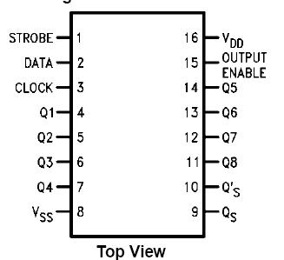
CD4094引脚图
CD4094真值表：
Clock | Output Enable | Strobe | Data | Parallel Outputs 并行输出 |  | Serial Outputs 串行输出
 |  |  |  | Q1 | QN | QS (Note 1) | Q S
↑ | 0 | X | X | 三态 | 三态 | Q7 | 不变
↓ | 0 | X | X | 三态 | 三态 | 不变 | Q7
↑ | 1 | 0 | X | 不变 | 不变 | Q7 | 不变
↑ | 1 | 1 | 0 | 0 | Q_{N}-1 | Q7 | 不变
↑ | 1 | 1 | 1 | 1 | Q_{N}-1 | Q7 | 不变
↓ | 1 | 1 | 1 | 不变 | 不变 | 不变 | Q7
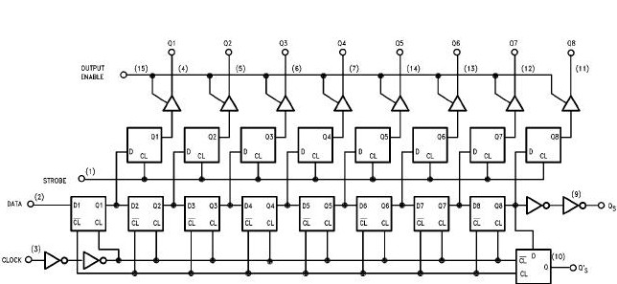
CD4094内部电路方框图
Absolute Maximum Ratings 绝对最大额定值：
Supply Voltage电源电压(VDD) | -0.5 to +18 VDC
Input Voltage输入电压 (VIN) 838电子 | -0.5 to VDD +0.5 VDC
Storage Temperature Range储存温度范围 (TS) | -65℃ to +150℃
Power Dissipation功耗 (PD)
Dual-In-Line 普通双列封装 新艺图库 | 700 mW
Small Outline 小外形封装 | 500 mW
Lead Temperature 焊接温度(TL)
Soldering, 10 seconds)（焊接10秒） | 260℃
Recommended Operating Conditions 建议操作条件：
DC Supply Voltage 直流供电电压 (VDD) | +3.0 to +15 VDC
Input Voltage输入电压 (VIN) 838电子 | 0 to VDD VDC
Operating Temperature Range工作温度范围 (TA) | -40℃ to +85℃

DC Electrical Characteristics 直流电气特性：
Symbol符号 | Parameter参数 | Conditions 条件 |  | -40°C |  | +25°C |  |  | +85°C |  | Units 单位
Symbol符号 | Parameter参数 |  |  | 最小 | 最大 | 最小 | 典型 | 最大 | 最小 | 最大 | Units 单位
IDD | Quiescent Device Current静态电流 | VDD = 5.0V |  |  | 20 |  |  | 20 |  | 150 | μA
IDD | Quiescent Device Current静态电流 | VDD = 10V |  |  | 40 |  |  | 40 |  | 300 | μA
IDD | Quiescent Device Current静态电流 | VDD = 15V |  |  | 80 |  |  | 80 |  | 600 | μA
VOL | LOW Level Output Voltage 输出低电平电压 | VDD=5.0V | |IO|≤1.μA |  | 0.05 |  | 0 | 0.05 |  | 0.05 | V
VOL | LOW Level Output Voltage 输出低电平电压 | VDD=10V | |IO|≤1.μA |  | 0.05 |  | 0 | 0.05 |  | 0.05 | V
VOL | LOW Level Output Voltage 输出低电平电压 | VDD=15V | |IO|≤1.μA |  | 0.05 |  | 0 | 0.05 |  | 0.05 | V
VOH | HIGH Level Output Voltage 输出高电平电压 | VDD=5.0V | |IO|≤1μA | 4.95 |  | 4.95 | 5.0 |  | 4.95 |  | V
VOH | HIGH Level Output Voltage 输出高电平电压 | VDD=10V | |IO|≤1μA | 9.95 |  | 9.95 | 10.0 |  | 9.95 |  | V
VOH | HIGH Level Output Voltage 输出高电平电压 | VDD=15V | |IO|≤1μA | 14.95 |  | 14.95 | 15.0 |  | 14.95 |  | V
VIL | LOW Level Input Voltage 输入低电平电压 | VDD = 5.0V, VO = 0.5V or 4.5V |  |  | 1.5 |  |  | 1.5 |  | 1.5 | V
VIL | LOW Level Input Voltage 输入低电平电压 | VDD = 10V, VO = 1.0V or 9.0V |  |  | 3.0 |  |  | 3.0 |  | 3.0 | V
VIL | LOW Level Input Voltage 输入低电平电压 | VDD = 15V, VO = 1.5V or 13.5V |  | 838电子 | 4.0 |  |  | 4.0 |  | 4.0 | V
VIH | HIGH Level Input Voltage 输入高电平电压 | VDD = 5.0V, VO = 0.5V or 4.5V |  | 3.5 |  | 3.5 |  |  | 3.5 |  | V
VIH | HIGH Level Input Voltage 输入高电平电压 | VDD = 10V, VO = 1.0V or 9.0V |  | 7.0 |  | 7.0 |  |  | 7.0 |  | V
VIH | HIGH Level Input Voltage 输入高电平电压 | VDD = 15V, VO = 1.5V or 13.5V |  | 11.0 |  | 11.0 |  |  | 11.0 |  | V
IOL | LOW Level Output Current 输出低电平电流 (Note 4) | VDD=5.0V,VO=0.4V |  | 0.52 |  | 0.44 | 0.88 |  | 0.36 |  | mA
IOL | LOW Level Output Current 输出低电平电流 (Note 4) | VDD=10V,VO=0.5V |  | 1.3 |  | 1.1 | 2.25 |  | 0.9 |  | mA
IOL | LOW Level Output Current 输出低电平电流 (Note 4) | VDD=15V,VO=1.5V |  | 3.6 |  | 3.0 | 8.8 |  | 2.4 |  | mA
IOH | HIGH Level Output Current 输出高电平电流 (Note 4) | VDD=5.0V,VO =4.6V |  | -0.52 |  | -0.44 | 0.88 |  | -0.36 |  | mA
IOH | HIGH Level Output Current 输出高电平电流 (Note 4) | VDD =10V,VO= 9.5V |  | -1.3 |  | -1.1 | 2.25 |  | -0.9 |  | mA
IOH | HIGH Level Output Current 输出高电平电流 (Note 4) | VDD=15V,VO =13.5V |  | -3.6 |  | -3.0 | 8.8 |  | -2.4 |  | mA
IIN | Input Current 输入电流 | VDD =15V,VIN =0V |  |  | -0.3 |  |  | -0.3 |  | -1.0 | μA
IIN | Input Current 输入电流 | VDD=15V,VIN =15V |  |  | 0.3 |  |  | 0.3 |  | 1.0 | μA
IOZ | 3-STATE Output Leakage Current 3态输出漏电流 | VDD=15V,VIN=0V or 15V |  |  | 1 |  |  | 1 |  | 10 | μA
AC Electrical Characteristics 交流电气特性：
Symbol 符号 | Parameter 参数 838电子 | Conditions 条件 | 最小 | 典型 | 最大 | Units 单位
tPHL, tPLH | Propagation Delay Clock to QS | VDD = 5.0V |  | 300 | 600 | ns
tPHL, tPLH | Propagation Delay Clock to QS | VDD = 10V |  | 125 | 250 | ns
tPHL, tPLH | Propagation Delay Clock to QS | VDD = 15V |  | 95 | 190 | ns
tPHL, tPLH | Propagation Delay Clock to Q¢ S | VDD = 5.0V |  | 230 | 460 | ns
tPHL, tPLH | Propagation Delay Clock to Q¢ S | VDD = 10V |  | 110 | 220 | ns
tPHL, tPLH | Propagation Delay Clock to Q¢ S | VDD = 15V |  | 75 | 150 | ns
tPHL, tPLH | Propagation Delay Clock to Parallel Out | VDD = 5.0V |  | 420 | 840 | ns
tPHL, tPLH | Propagation Delay Clock to Parallel Out | VDD = 10V |  | 195 | 390 | ns
tPHL, tPLH | Propagation Delay Clock to Parallel Out | VDD = 15V |  | 135 | 270 | ns
tPHL, tPLH | Propagation Delay Strobe to Parallel Out | VDD = 5.0V |  | 290 | 580 | ns
tPHL, tPLH | Propagation Delay Strobe to Parallel Out | VDD = 10V |  | 145 | 290 | ns
tPHL, tPLH | Propagation Delay Strobe to Parallel Out | VDD = 15V |  | 100 | 200 | ns
tPHZ | Propagation Delay HIGH Level to HIGH Impedance | VDD = 5.0V |  | 140 | 280 | ns
tPHZ | Propagation Delay HIGH Level to HIGH Impedance | VDD = 10V |  | 75 | 150 | ns
tPHZ | Propagation Delay HIGH Level to HIGH Impedance | VDD = 15V |  | 55 | 110 | ns
tPLZ | Propagation Delay LOW Level to HIGH Impedance | VDD = 5.0V |  | 140 | 280 | ns
tPLZ | Propagation Delay LOW Level to HIGH Impedance | VDD = 10V |  | 75 | 150 | ns
tPLZ | Propagation Delay LOW Level to HIGH Impedance | VDD = 15V |  | 55 | 110 | ns
tPZH | Propagation Delay HIGH Impedance to HIGH Level | VDD = 5.0V |  | 140 | 280 | ns
tPZH | Propagation Delay HIGH Impedance to HIGH Level | VDD = 10V |  | 75 | 150 | ns
tPZH | Propagation Delay HIGH Impedance to HIGH Level | VDD = 15V |  | 55 | 110 | ns
tPZL | Propagation Delay HIGH Impedance to LOW Level | VDD = 5.0V |  | 140 | 280 | ns
tPZL | Propagation Delay HIGH Impedance to LOW Level | VDD = 10V |  | 75 | 150 | ns
tPZL | Propagation Delay HIGH Impedance to LOW Level | VDD = 15V |  | 55 | 110 | ns
tTHL, tTLH | Transition Time过渡时间 | VDD = 5.0V |  | 100 | 200 | ns
tTHL, tTLH | Transition Time过渡时间 | VDD = 10V |  | 50 | 100 | ns
tTHL, tTLH | Transition Time过渡时间 | VDD = 15V |  | 40 | 80 | ns
tSU | Set-Up Time Data to Clock 建立时间数据时钟 | VDD = 5.0V | 80 | 40 |  | ns
tSU | Set-Up Time Data to Clock 建立时间数据时钟 | VDD = 10V | 40 | 20 |  | ns
tSU | Set-Up Time Data to Clock 建立时间数据时钟 | VDD = 15V | 20 | 10 |  | ns
tr, tf | Maximum Clock Rise and Fall Time最大时钟上升和下降时间 | VDD = 5.0V | 1 |  |  | ms
tr, tf | Maximum Clock Rise and Fall Time最大时钟上升和下降时间 | VDD = 10V | 1 |  |  | ms
tr, tf | Maximum Clock Rise and Fall Time最大时钟上升和下降时间 | VDD = 15V | 1 |  |  | ms
tPC | Minimum Clock Pulse Width最小时钟脉冲宽度 | VDD = 5.0V | 200 | 100 |  | ns
tPC | Minimum Clock Pulse Width最小时钟脉冲宽度 | VDD = 10V | 100 | 50 |  | ns
tPC | Minimum Clock Pulse Width最小时钟脉冲宽度 | VDD = 15V | 83 | 40 |  | ns
tPS | Minimum Strobe Pulse Width | VDD = 5.0V | 200 | 100 |  | ns
tPS | Minimum Strobe Pulse Width | VDD = 10V | 80 | 40 |  | ns
tPS | Minimum Strobe Pulse Width | VDD = 15V | 70 | 35 |  | ns
fmax | Maximum Clock Frequency 最大时钟频率 | VDD = 5.0V | 1.5 | 3.0 |  | MHz
fmax | Maximum Clock Frequency 最大时钟频率 | VDD = 10V | 3.0 | 6.0 |  | MHz
fmax | Maximum Clock Frequency 最大时钟频率 | VDD = 15V | 4.0 | 8.0 |  | MHz
CIN | Input Capacitance 输入电容 | Any Input |  | 5.0 | 7.5 | pF

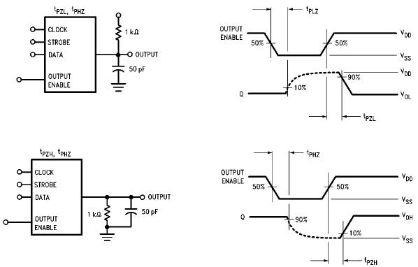
测试电路和3态时序图
