针对的是office365 ProPlus和office365，如果是其他版本office365，也可以试一下这个办法，步骤十分简单，如果不成功再寻找其他办法也不迟。
1、新建文本文档，将以下内容复制进去：
1|@echo off
2|title Activate Office 365 ProPlus for FREE - MSGuides.com&cls&echo ============================================================================&echo #Project: Activating Microsoft software products for FREE without software&echo ============================================================================&echo.&echo #Supported products: Office 365 ProPlus (x86-x64)&echo.&echo.&(if exist "%ProgramFiles%\Microsoft Office\Office16\ospp.vbs" cd /d "%ProgramFiles%\Microsoft Office\Office16")&(if exist "%ProgramFiles(x86)%\Microsoft Office\Office16\ospp.vbs" cd /d "%ProgramFiles(x86)%\Microsoft Office\Office16")&(for /f %%x in ('dir /b ..\root\Licenses16\proplusvl_kms*.xrm-ms') do cscript ospp.vbs /inslic:"..\root\Licenses16\%%x" >nul)&(for /f %%x in ('dir /b ..\root\Licenses16\proplusvl_mak*.xrm-ms') do cscript ospp.vbs /inslic:"..\root\Licenses16\%%x" >nul)&echo.&echo ============================================================================&echo Activating your Office...&cscript //nologo ospp.vbs /unpkey:WFG99 >nul&cscript //nologo ospp.vbs /unpkey:DRTFM >nul&cscript //nologo ospp.vbs /unpkey:BTDRB >nul&cscript //nologo ospp.vbs /inpkey:XQNVK-8JYDB-WJ9W3-YJ8YR-WFG99 >nul&set i=1
3|:server
4|if %i%==1 set KMS_Sev=kms7.MSGuides.com
5|if %i%==2 set KMS_Sev=kms8.MSGuides.com
6|if %i%==3 set KMS_Sev=kms9.MSGuides.com
7|if %i%==4 goto notsupported
8|cscript //nologo ospp.vbs /sethst:%KMS_Sev% >nul&echo ============================================================================&echo.&echo.
9|cscript //nologo ospp.vbs /act | find /i "successful" && (echo.&echo ============================================================================&echo.&echo #My official blog: MSGuides.com&echo.&echo #How it works: bit.ly/kms-server&echo.&echo #Please feel free to contact me at msguides.com@gmail.com if you have any questions or concerns.&echo.&echo #Please consider supporting this project: donate.msguides.com&echo #Your support is helping me keep my servers running everyday!&echo.&echo ============================================================================&choice /n /c YN /m "Would you like to visit my blog [Y,N]?" & if errorlevel 2 exit) || (echo The connection to my KMS server failed! Trying to connect to another one... & echo Please wait... & echo. & echo. & set /a i+=1 & goto server)
10|explorer "http://MSGuides.com"&goto halt
11|:notsupported
12|echo.&echo ============================================================================&echo Sorry! Your version is not supported.&echo Please try installing the latest version here: bit.ly/odt2k16
13|:halt
14|pause
- 文件更名为：“1click.cmd”（主要在于后缀），以管理员身份运行。
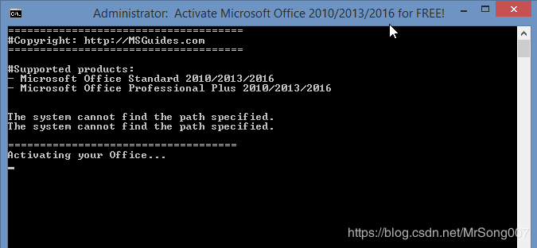
3、出现下图所示，就代表激活成功。
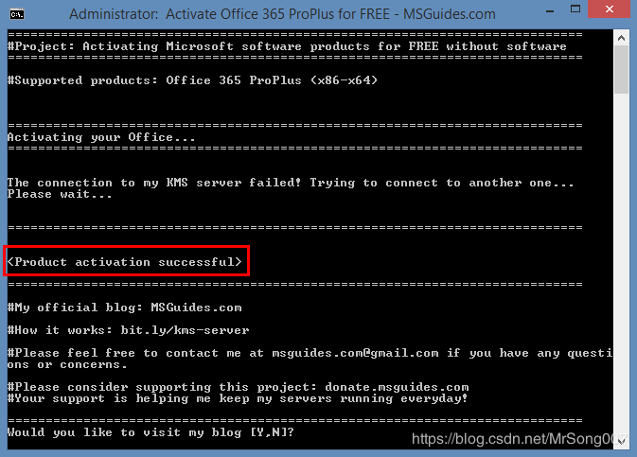
4、在offie软件里，查看：“文件”–“账户”，会发现变成了已激活的状态。
（对其他版本的文件源码：
1|@echo off
2|title Activate Microsoft Office 2016 ALL versions for FREE!&cls&echo ============================================================================&echo #Project: Activating Microsoft software products for FREE without software&echo ============================================================================&echo.&echo #Supported products:&echo - Microsoft Office Standard 2016&echo - Microsoft Office Professional Plus 2016&echo.&echo.&(if exist "%ProgramFiles%\Microsoft Office\Office16\ospp.vbs" cd /d "%ProgramFiles%\Microsoft Office\Office16")&(if exist "%ProgramFiles(x86)%\Microsoft Office\Office16\ospp.vbs" cd /d "%ProgramFiles(x86)%\Microsoft Office\Office16")&(for /f %%x in ('dir /b ..\root\Licenses16\proplusvl_kms*.xrm-ms') do cscript ospp.vbs /inslic:"..\root\Licenses16\%%x" >nul)&(for /f %%x in ('dir /b ..\root\Licenses16\proplusvl_mak*.xrm-ms') do cscript ospp.vbs /inslic:"..\root\Licenses16\%%x" >nul)&echo.&echo ============================================================================&echo Activating your Office...&cscript //nologo ospp.vbs /unpkey:WFG99 >nul&cscript //nologo ospp.vbs /unpkey:DRTFM >nul&cscript //nologo ospp.vbs /unpkey:BTDRB >nul&cscript //nologo ospp.vbs /unpkey:CPQVG >nul&cscript //nologo ospp.vbs /inpkey:XQNVK-8JYDB-WJ9W3-YJ8YR-WFG99 >nul&set i=1
3|:server
4|if %i%==1 set KMS_Sev=kms7.MSGuides.com
5|if %i%==2 set KMS_Sev=kms8.MSGuides.com
6|if %i%==3 set KMS_Sev=kms9.MSGuides.com
7|if %i%==4 goto notsupported
8|cscript //nologo ospp.vbs /sethst:%KMS_Sev% >nul&echo ============================================================================&echo.&echo.
9|cscript //nologo ospp.vbs /act | find /i "successful" && (echo.&echo ============================================================================&echo.&echo #My official blog: MSGuides.com&echo.&echo #How it works: bit.ly/kms-server&echo.&echo #Please feel free to contact me at msguides.com@gmail.com if you have any questions or concerns.&echo.&echo #Please consider supporting this project: donate.msguides.com&echo #Your support is helping me keep my servers running everyday!&echo.&echo ============================================================================&choice /n /c YN /m "Would you like to visit my blog [Y,N]?" & if errorlevel 2 exit) || (echo The connection to my KMS server failed! Trying to connect to another one... & echo Please wait... & echo. & echo. & set /a i+=1 & goto server)
10|explorer "http://MSGuides.com"&goto halt
11|:notsupported
12|echo.&echo ============================================================================&echo Sorry! Your version is not supported.&echo Please try installing the latest version here: bit.ly/odt2k16
13|:halt
14|pause >nul
如果激活其它版本，只需要把title Activate Microsoft Office后的版本号改掉即可。第一行有两个版本号需要改的，需注意）
（另附365版本激活秘钥，未验证，待考究
BHXN7-MQB36-MTHQ4-8MHKV-CYT97
8DJJQ-8NR7B-7QY7D-VCGPF-TVJ92 ）
（网络来源：https://blog.csdn.net/MrSong007/article/details/88845969）

