1. clish源码下载地址: git clone https://github.com/JackieXie168/clish.git

2. cd clish

3. ./configure

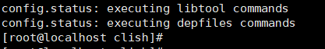

4. make

5. make install

6. 在源码目录下执行: CLISH_PATH=xml-examples/. bin/clish

