**Monte Carlo simulations of European call option price of XOM.**

For the Monte Carlo simulation, we do maximum of 100000 iterations (N) for each run and we observe improving convergence as N increased.

As for parameters, we assume: Initial stock price of XOM = $85.75; Strike price 1 = $80; Strike price 2 = $85; Maturity = 0.5; Dividend rate = 3.5%; Interest rate = 0.5%; Volatility =60%.

The theoretical price of European call option using Black-Scholes model is **15.9851**.

The European call option price based on Monte Carlo Simulation is as follows

|  |  |  |  |
| --- | --- | --- | --- |
|  | **Number of iterations** | **Time** | **Price** |
| **Run 1** | N=1000 | 1.948 s | 16.0238 |
| **Run 2** | N=1000 | 1.829 s | 15.4794 |
| **Run 3** | N=1000 | 1.813 s | 16.0356 |
| **Run 4** | N=1000 | 1.895 | 16.1515 |

|  |  |  |  |
| --- | --- | --- | --- |
|  | **Number of iterations** | **Time** | **Price** |
| **Run 1** | N=10000 | 185.160 s | 16.1814 |
| **Run 2** | N=10000 | 182.464 s | 15.9247 |
| **Run 3** | N=10000 | 200.406 s | 15.8696 |
| **Run 4** | N=10000 | 191.320 s | 15.9058 |

|  |  |  |  |
| --- | --- | --- | --- |
|  | **Number of iterations** | **Time** | **Price** |
| **Run 1** | N=100000 | 17064.812 s | 16.0142 |
| **Run 2** | N=100000 | 19421.458 s | 15.9982 |
| **Run 3** | N=100000 | 19729.808 s | 15.9243 |
| **Run 4** | N=100000 | 19468.089 s | 16.0488 |

(The CPU running time is based on Intel G3900. The variation of the running time might be subject to other background tasks.)

**Implied volatility of XOM based on plain vanilla option prices.**

Firstly, for each call or put price, we take the average of the best bid and ask prices in the market. And we use this price to obtain forward price of the XOM using put-call-parity(Therefore we get rid of the data that misses bid or ask price in the market).

$$F=Strike+e^{rT}(C-P)$$

Then we use Black’s Formula and plugin forward price to get the implied volatility.

$$C=e^{-rT}[F⋅N\left(d_{1}\right)-K⋅N(d_{2})]$$

$$P=e^{-rT}[K⋅N\left(-d_{2}\right)-F⋅N(-d_{1})$$

$$d_{1}=\frac{\ln\left(\frac{F}{K}\right)+\left(\frac{σ^{2}}{2}\right)T}{σ\sqrt{T}}$$

$$d_{2}=d_{1}-σ\sqrt{T}$$

Using this method, we try to acquire Implied Volatility for $T_{1}=2$ days, $T_{2}=152$ days, $T_{3}$ = edays.

For the interest rates, we use the data from Federal Reserve as of Nov. 1st, 2016 and rates are:

|  |  |  |  |  |  |  |  |
| --- | --- | --- | --- | --- | --- | --- | --- |
|  |  | 3 Months |  | 6 Months | 1 Year |  | 2 Year |
| Interest rate |  | 0.35 |  | 0.5 | 0.65 |  | 0.83 |

Using linear interpolation, we get the interest rates for each maturity:

|  |  |  |  |  |  |  |  |
| --- | --- | --- | --- | --- | --- | --- | --- |
|  | **2 days** | 3 Months | **152days** | 6 Months | 1 Year | **429 days** | 2 Year |
| Interest rate | **0.35** | 0.35 | **0.453** | 0.5 | 0.65 | **0.6845** | 0.83 |

Finally, we obtain Implied Volatility for the 3 difference maturities:

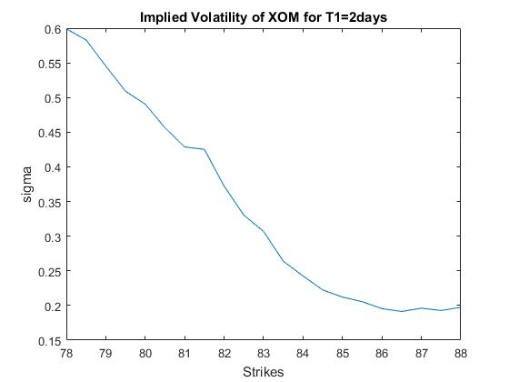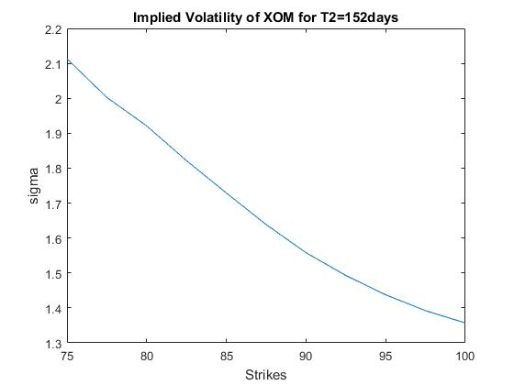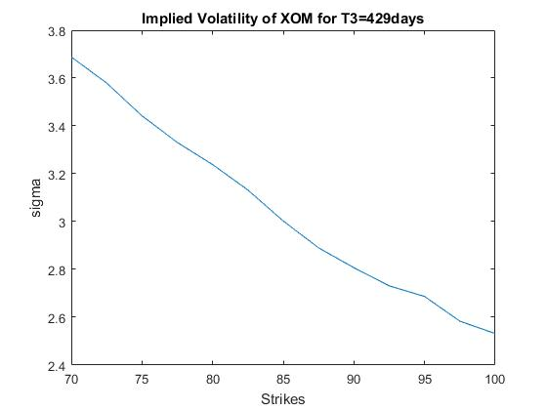

**Recover the implied risk-neutral distribution for some T from market vanilla option prices.**

Under Risk-Neutral measure $Q$**, w**e can derive that:

$$C\left(K,T\right)=E^{Q}\left[e^{-rT}{\left(S_{T}-K\right)}^{+}\right]=e^{-rT}\int_{K}^{+∞}{\left(x-K\right)f\left(x\right)dx}$$

Where f(x) is the distribution of $S_{T}$ under measure $Q$**.** Then we obtain:

$$f\left(K\right)=e^{rT}\frac{\left(∂^{2}C\left(K,T\right)\right)}{∂K^{2}}, K>0$$

Numerically, if we choose T = 152 days, we obtain the distribution as follows:

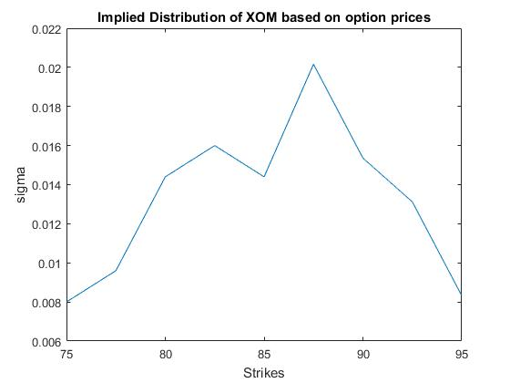

We observe that the distribution curve is not very smooth around $K=S_{0}=\$85.75$ due to the limitation of the data but it still remains representative.