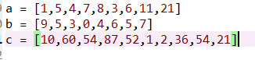

Three lists to test with median number

List a for BubbleSort:





List a for MergeSort:





List a for QuickSort:





List b for BubbleSort:





List b for MergeSort:





List b for QuickSort:

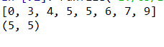



List c for BubbleSort:





List c for MergeSort:





List c for QuickSort:





Running Time:

BubbleSort O(n^2)

MergeSort O(nlogn)

QuickSort O(n^2)