Prompt the user to choose a table implementation (binary search tree or hash table with chaining).

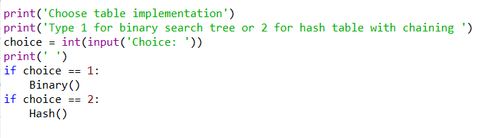

This part is to ask to choice BST or Hash Table. By create an choice value and save the input to check run which function.

BST:

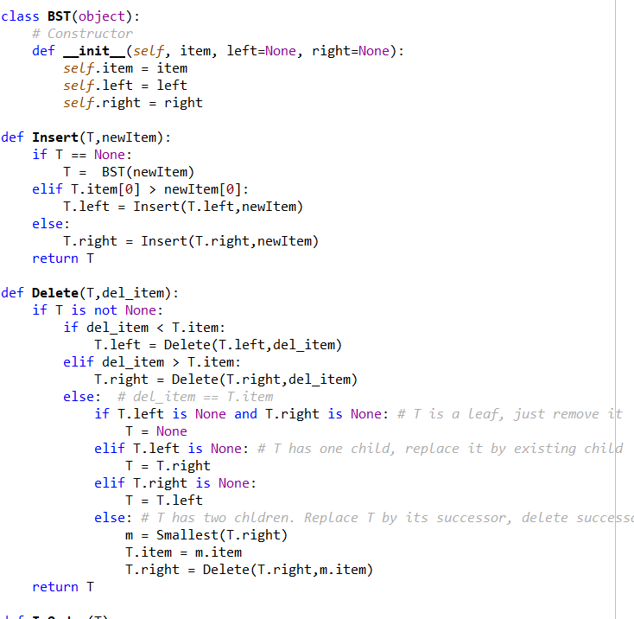

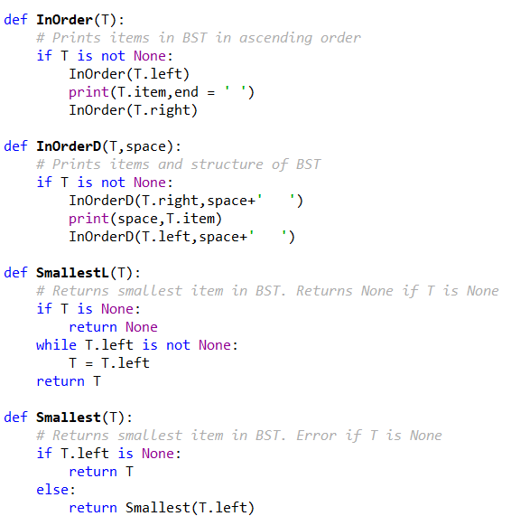

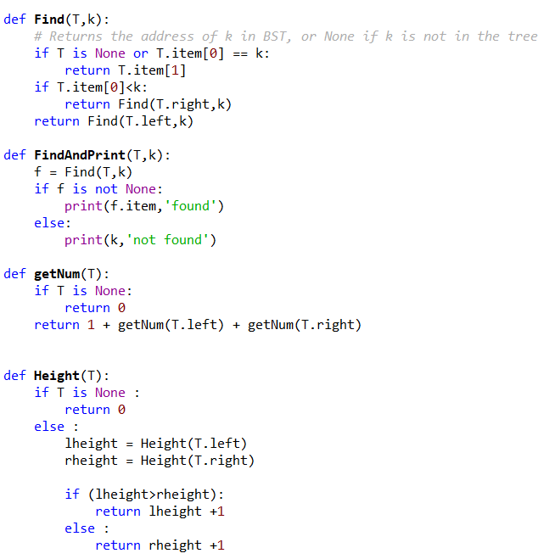

The code of BST is from the class web, the change of it is add the [] to each item, because in this way can select any one the the array otherwise will choice the whole thing. For the getNum and Height is go to left and right side, the height only count level and the other one count all the node.

Hash Table:

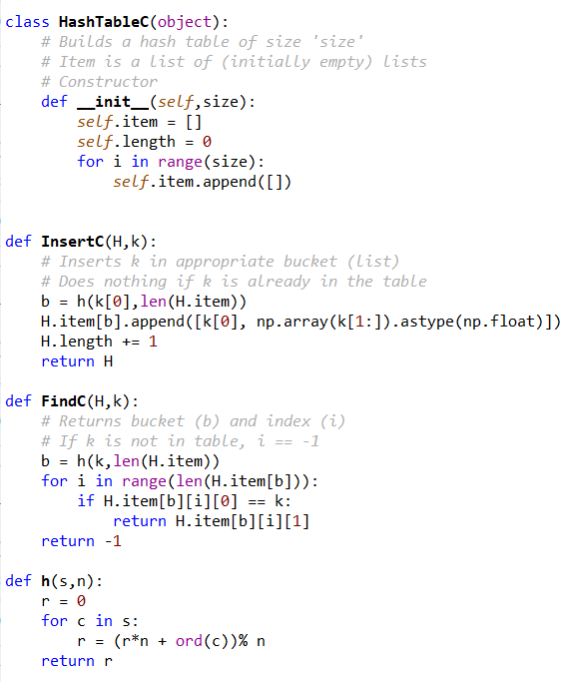

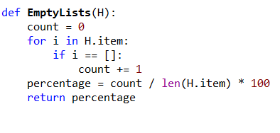

The Hash Table function also from the class web. The change is add [] to the item, since it’s not the single number any more. Also change some return statement and code to let function work in the array or list. The empty set is to count number of them and divide by the total number of the element.

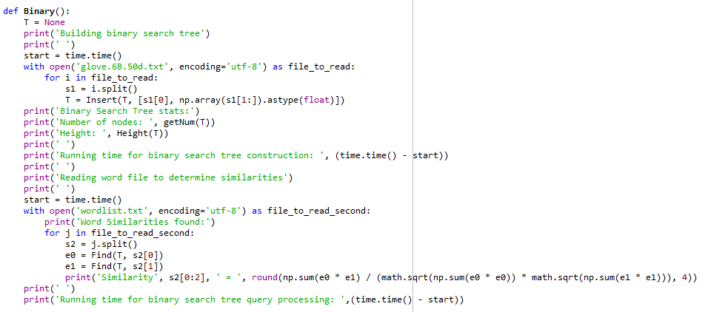

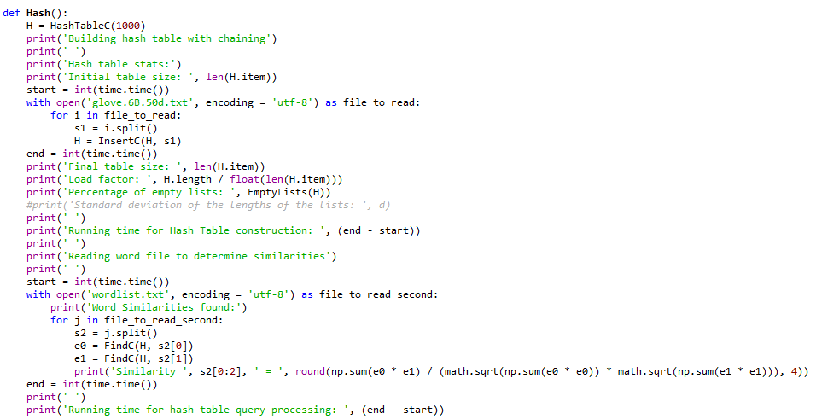

These two parts is just to read the glove file and save each word with their numbers. The file is read and split by the space. Then set e0 and e1, and calculate by the equation provide in the PDF.

Result:

