The goal of the lab is to create a maze size by 10*15

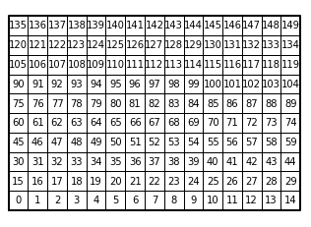

If 135 is start and 14 is end, then each space need connect to these two points.

The idea of this lab is to use the disjoint set to create a new set that have the size of col * row

(use the code provide on the web, but in the union and union_c functions add return statements for the next step)

Create a loop that have double maze long, because sometimes one maze long is not enough to let all spaces connect, but double can.

Then use the union/union_c function in the dsf(Disjoint set forest), to check two walls are connect or not. If yes, keep going, if not, delete the wall.

After delete all the walls, draw the maze.

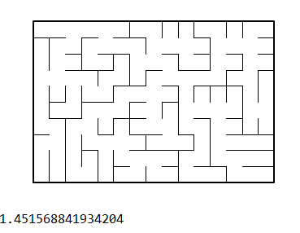

The running time is 1.4 second.

“I certify that this project is entirely my own work. I wrote, debugged, and tested the code being presented, performed the experiments, and wrote the report. I also certify that I did not share my code or report or provided inappropriate assistance to any student in the class.”