1. (Randomized algorithms) Write a program to ”discover” trigonometric identities. Your program should test all combinations of the trigonometric expressions shown below and use a randomized algorithm to detect the equalities. For your equality testing, generate random numbers in the −π to π range.

For this part, I create 15 functions that match to the function on the pdf. And I used math and mpmath to import the sin, cos, tan and sec.

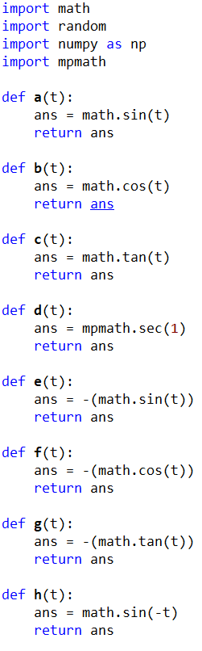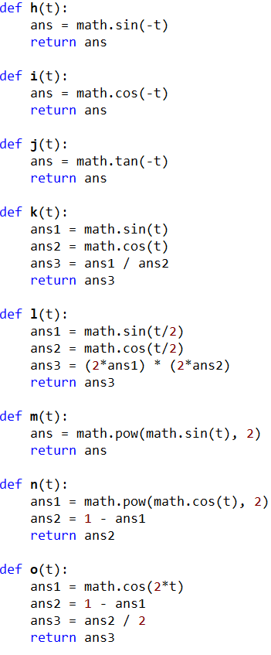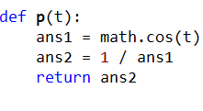

Then I put all the function in a set.



The function of compare is to get a random number from 3.14 to -3.14, and the function will compare it to itself and all other function.

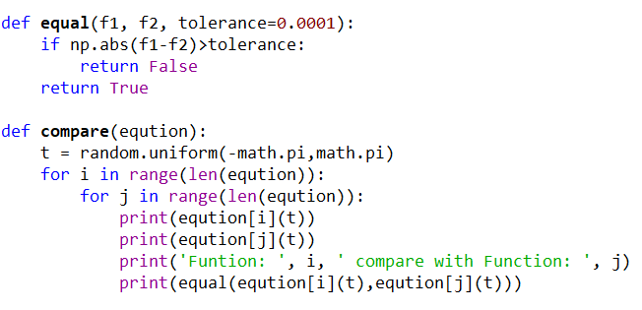

Result:

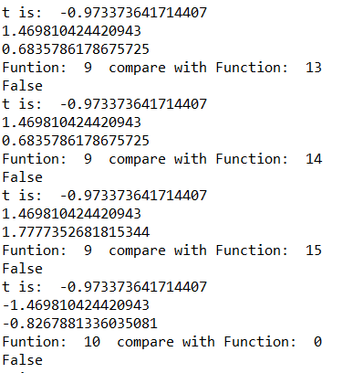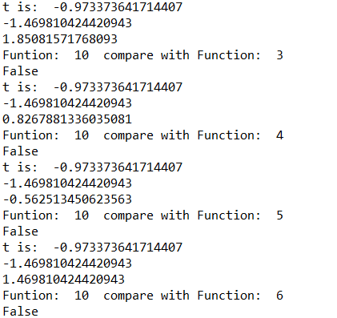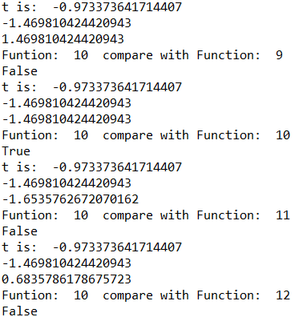

The results are too many of them, so I just put a part of result.

(function 0 is function a, function 1 is function b,etc)

1. (Backtracking) The partition problem consists of determining if there is a way to partition a set of integers S into two subsets S1 and S2 such thatPS1 =PS2. Recall that S1 and S2 are a partition of S if and only if S1∪S2 = S and S1∩S2 = {}. Write a function that solves the partition problem using backtracking. If a partition exists, your program should display it; otherwise it should indicate that no partition exists. For example, if S = {2,4,5,9,12}, your program should output the partition S1 = {2,5,9} and S2 = {4,12} and if S = {2,4,5,9,13} your program should indicate that no partition exists.

For this part I use the function on the class web. But that code only return 1 set, so I change it to sets. The idea is track a pass, that will return a set and the rest of the numbers should be the other set. And for every time, the function will check is there any number in other set or used more than one time.

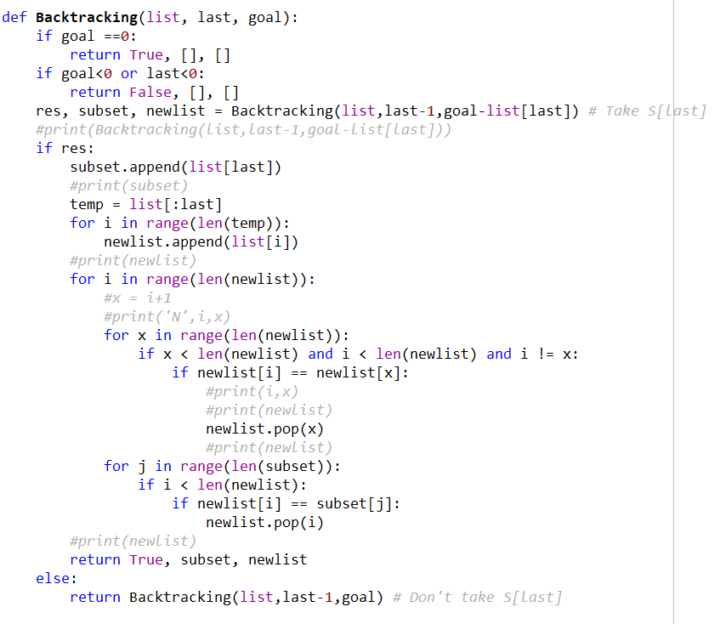

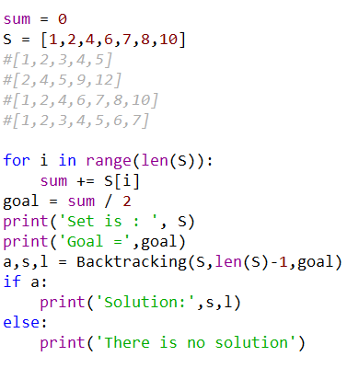

Result:

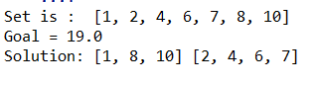

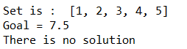

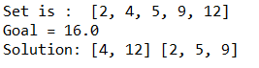

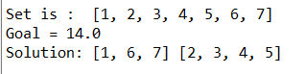

“I certify that this project is entirely my own work. I wrote, debugged, and tested the code being presented, performed the experiments, and wrote the report. I also certify that I did not share my code or report or provided inappropriate assistance to any student in the class.”