1. To draw 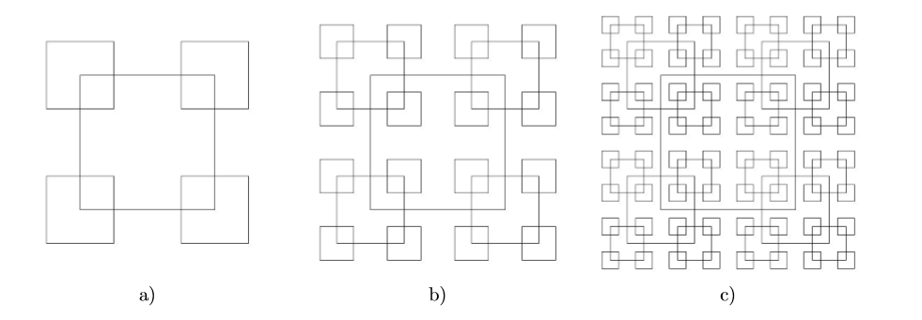

The idea of this function is to create four small squares, and the center are four points of the big square. Use t and q to locate the center, and -1 is the reverse of the center.

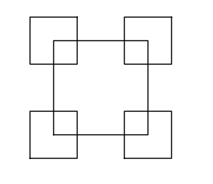

Didn’t finish b and c.

1. To draw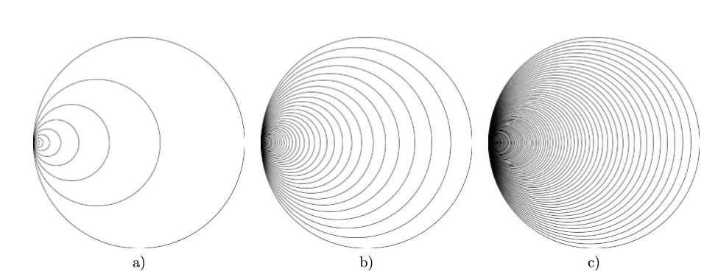

This function is to set the center to 0 at the beginning, then move the center to right one by one.

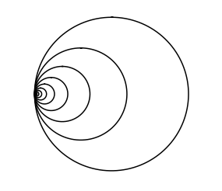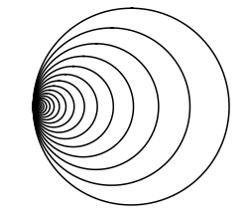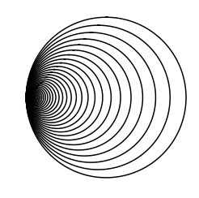

1. Didn’t finish
2. 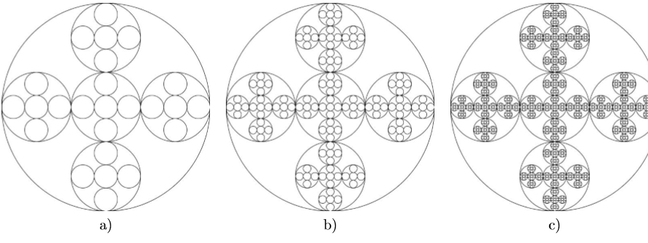

This function is to draw a big circle. Inside of the big circle, use the origin center to draw a circle that radius only 1/3 of the big circle. And for the rest small circle should be at top/bot,left,right, the center is 1/3 of the radius.

