This lab is implementing two types of balanced trees, AVL and Red-Black. Asking the user and using that tree to store a file of many words with its embeddings and returning many methods outlined out in the assignment.

I use the AVL and the Red-Black Tree from ZyBook. This lab ask for some functions to finish it.

1. Number of node
2. Height
3. Depth
4. Similarity
5. How to get two words

For the similarity, is to open the file and find the words in the tree. If the word is miss then will print err. Then create dot product, w1 and w2, follow the function get the result.

In the depth, is able to find the get the depth but can choose how depth want to have.

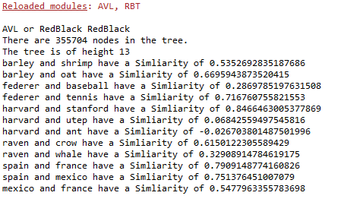

Other than that, every is working well.