This lab is to use the file from last week, use it to insert and populate a hash table and improve the time complexity of certain operations than that of the balanced search trees. It also require to use multiple hash function to test the code.

In the HashTable file, have four function, one is to insert the hash and other three is different ways to do it.

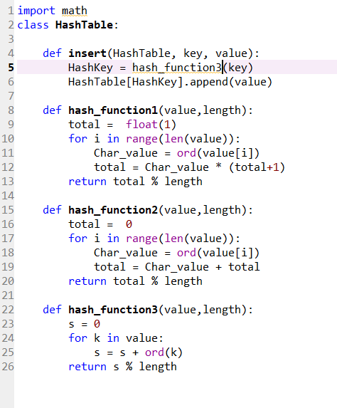

In the main file is to read the file, calculate Load Factor and Average Number Of Comparisons.

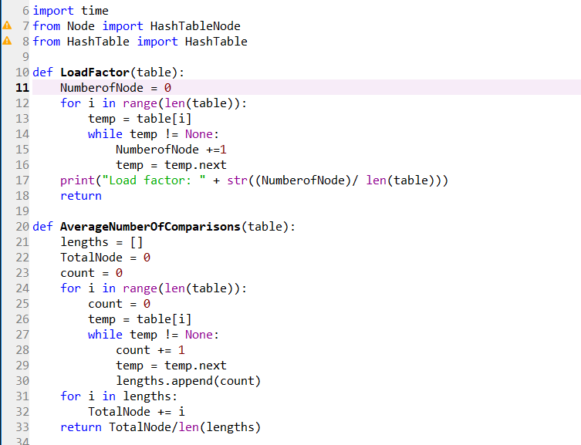

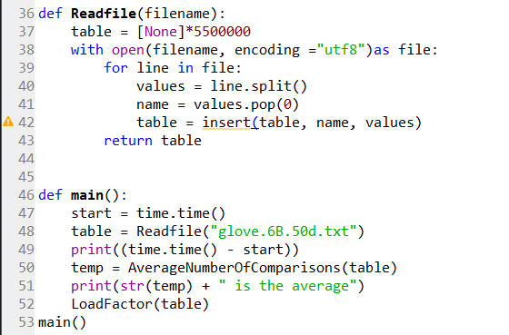

In the ReadFile, set the size of table first. Because the txt file is give to us, so we already know the length of the table.

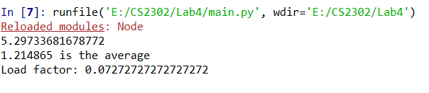

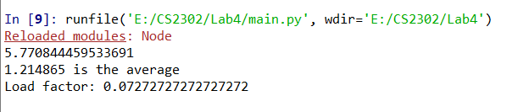

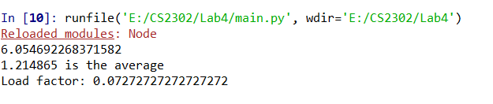

This is the result of the code, but it still doesn’t work very well.